Reasoning: Thinking Beyond Grounding
Agentic Design Patterns for Enterprise Reasoning Systems
A field guide for Cloud Solution Architects: translating frontier reasoning research into customer solutions on Microsoft Foundry and Fabric
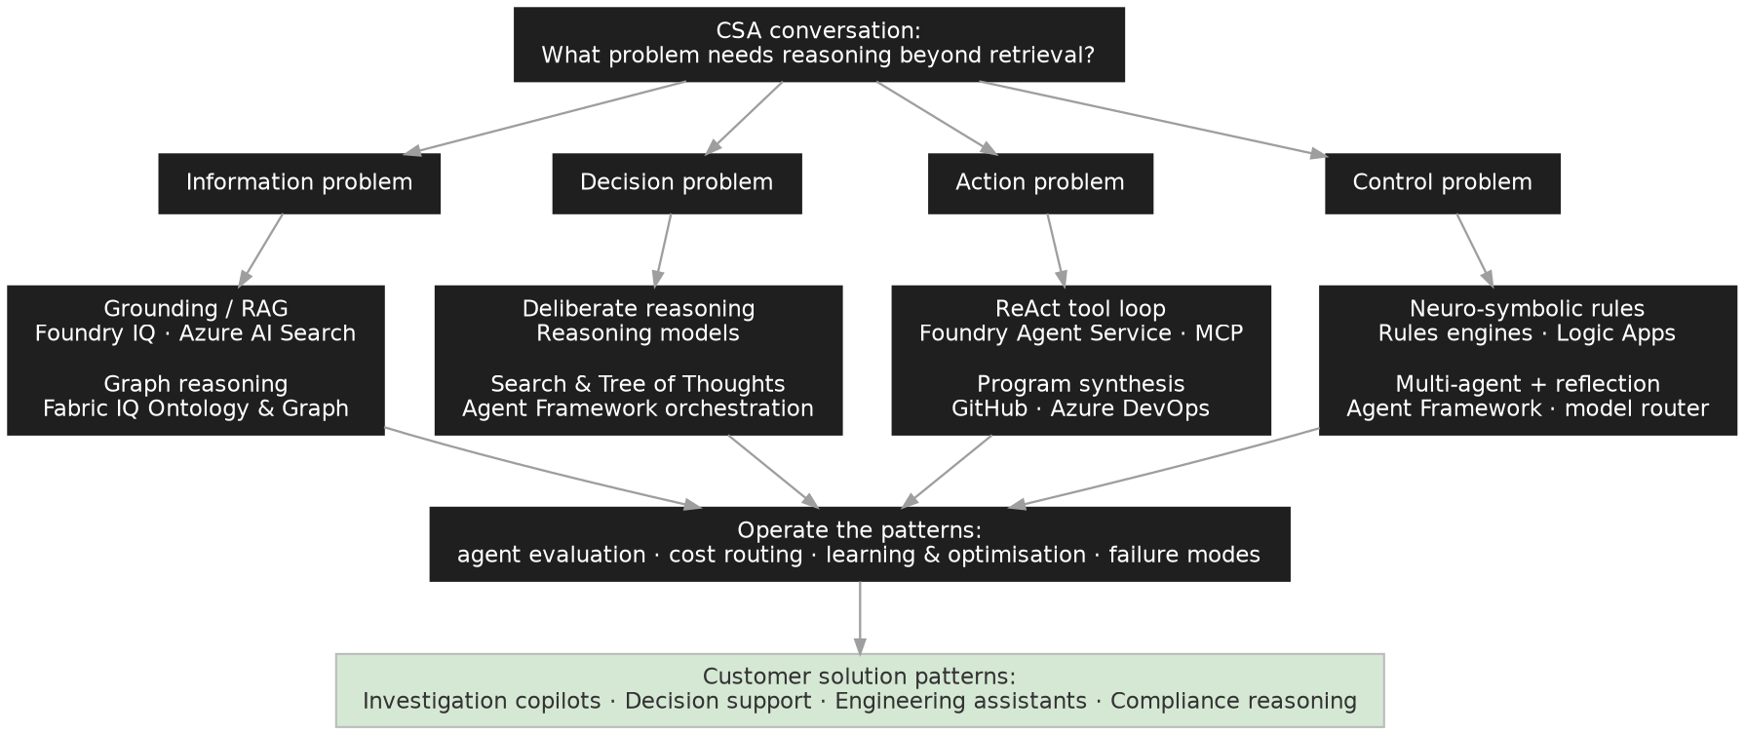
How to use this guide: identify the problem class in the customer conversation, select the matching pattern, then apply the operating disciplines that every pattern shares.

Contents

Preface: The Thesis
Short answer. Reasoning research gives CSAs a control-plane vocabulary for agent design: decomposition, tool-grounded action, search, verification, reflection, memory, rule enforcement, graph traversal, repair and evaluation. Implemented as agentic design patterns, these ideas move part of the reasoning effort outside the model, into orchestration, tools, memory, verifiers and business rules, where it can be observed, governed, tested and, for bounded tasks, executed with smaller and cheaper models.
Longer answer. Enterprise AI has made major progress on information access through grounding, retrieval, tools and data integration. For many mature implementations, retrieval is no longer the bottleneck. Systems retrieve the correct documents yet still produce weak recommendations, miss exceptions, choose poor plans or fail to justify decisions. The limitation is not retrieval; it is reasoning.
Grounding answers one question: what information should the system use? Reasoning answers another: what should the system do with that information? Reasoning is the control process that transforms evidence, goals, constraints and feedback into a decision, plan, recommendation or validated action.
Two precision notes the whole guide depends on. First: frontier reasoning models earn their behaviour at training time. Reinforcement learning is a post-training process that shapes the model; at inference time the model is not “running RL internally”. Enterprise agents borrow RL-shaped control ideas (exploration, scoring, feedback, retry, verification) without doing online RL. Agent patterns are externalised reasoning control loops, not RL inside the agent.
Second: architecture amplifies model intelligence; it does not replace it. ReAct works because the model knows which tool to call; Tree of Thoughts works because the branches are worth exploring; reflection works because the critiques are meaningful. Architecture can compensate for weaker reasoning in bounded domains, where intermediate states are observable, feedback is reliable, success criteria are written down and failure costs are contained. It cannot substitute for general reasoning capability. Every pattern in this guide is a lever on a capable model, not a workaround for an incapable one.
Because every pattern below contains an evaluator, evaluation is introduced up front as a concept (Section 3) and operationalised at the end as a practice (Section 17): the evaluator is the architecture. The guide is organised as a pattern catalogue, not a maturity curve. Sections 4–16 are patterns you select, not stages you progress through; Sections 17–20 are the operating disciplines every pattern shares.

Part A — Foundations
A shared vocabulary before the patterns

1. A Taxonomy of Reasoning
“Reasoning” covers four different layers. Conflating them is the most common source of confused architecture conversations, so separate them explicitly with customers:
- Model-internal reasoning. Behaviour learned during pre-training, supervised fine-tuning, reinforcement learning with verifiable rewards, process supervision or distillation. You select or tune it; you do not orchestrate it. (Section 19.)
- Inference-time reasoning. Extra compute at runtime: extended thinking, self-consistency, branching, search, reflection. Spent inside a single agent call or across a loop. (Sections 5–10.)
- System-level reasoning. Agent orchestration, tools, workflow state, memory, evaluators, multi-agent structures. This is where CSAs add most value. (Sections 6–16.)
- Enterprise-control reasoning. Deterministic rules, approval boundaries, audit trails, policy enforcement, security trimming. Decides which proposed actions are permitted. (Sections 13, 14, 20.)
The layers compose: a production system typically uses a reasoning-capable model (1), inside a bounded loop (2), orchestrated with tools and evaluators (3), constrained by rules and approvals (4).

Reasoning primitives: the middle layer
Between the research papers and the enterprise patterns sits a small set of reasoning primitives: the verbs every pattern is built from. Naming them makes the bridge explicit. Each research result contributes a primitive; each enterprise pattern composes several. When a customer problem doesn't fit a catalogued pattern, compose from the primitives directly.
Primitive | Research anchor | Enterprise pattern | §
Generate alternatives | Self-consistency (Wang et al., 2022) | Deliberate reasoning | 5
Act & observe | ReAct (Yao et al., 2022) | Tool-grounded agents | 6
Search a space | LATS (Zhou et al., 2023) | Controlled exploration | 7
Branch hypotheses | Tree of Thoughts (Yao et al., 2023) | Branching architectures | 8
Remember | MemGPT (Packer et al., 2023) | Memory-augmented reasoning | 9
Reflect & learn | Reflexion; Voyager (2023) | Improvement loops · skill acquisition | 10
Coordinate roles | AutoGen (Wu et al., 2023) | Multi-agent orchestration | 12
Constrain | Logic-LM (Pan et al., 2023) | Neuro-symbolic architecture | 14
Verify | Process supervision (Lightman et al., 2023) | Evaluation as control plane | 3, 17

A bridge for customers who know RL follows, with the explicit caveat that these are borrowed control ideas, not online RL:
RL concept | Agentic equivalent | Caveat
Policy | Planner / model / action selector | Not trained online in enterprise agents
Reward | Evaluator, verifier, score | Often heuristic or rule-based, not learned
Environment | Tools, APIs, workflow state, data | Must be safe and observable
Rollout | Candidate plan or tool trajectory | Expensive; sometimes unsafe to execute
Value function | LLM judge, rule, test, business metric | Can be wrong or reward-hacked
Credit assignment | Step-level telemetry, trace evaluation | Rarely mature in enterprise systems
Exploration | Branching, retries, candidate generation | Must be budget-bounded

2. Pattern Selection Guide
Diagnose the customer problem first, then select the pattern. The decision tree on the title page gives the conversation flow; this matrix gives the direct mapping:
Customer problem | Pattern | Section
Missing or stale facts | Grounding / RAG (and stop there if it is enough) | 4
Correct facts, weak judgement | Deliberate reasoning | 5
Needs tools, data lookups, actions mid-reasoning | ReAct tool loop | 6
Planning under constraints; many valid options | Search with controlled exploration | 7
Multiple plausible interpretations; first answer often wrong | Tree of Thoughts / branching | 8
Needs recall across sessions; personalised or accumulating context | Memory-augmented reasoning | 9
Repeated task; should improve run over run | Reflection & dynamic skill acquisition | 10
Long-running business process with defined stages | Workflow-state reasoning | 11
Workflow too large or heterogeneous for one agent | Multi-agent orchestration + model routing | 12
Human judgement is part of output quality, not just a gate | Human-in-the-loop reasoning | 13
Deterministic policy compliance required | Neuro-symbolic rules | 14
Relationship discovery; no single document has the answer | Graph reasoning (Fabric IQ) | 15
Validated artefacts, not advice | Program synthesis & test-repair | 16
“Is it actually good?” (always) | Agent evaluation | 3, 17
Cost or latency pressure at scale | Model routing & reasoning budgets | 18
Stable workload; orchestration cost dominates | Learning & optimisation (RFT, distillation) | 19

Patterns combine. A fraud investigation copilot might use graph reasoning (15) for context, branching (8) for hypotheses, ReAct (6) for evidence gathering, and neuro-symbolic rules (14) before any recommendation leaves the system, evaluated throughout with the flywheel in Section 17.

3. Evaluation as the Control Plane
Before any pattern: every pattern in this guide is a variation of one control loop: generate → evaluate → select → repair → escalate. Deliberate reasoning evaluates candidates; search evaluates paths; branching evaluates hypotheses; reflection evaluates trajectories; multi-agent review evaluates outputs; program synthesis evaluates artefacts against tests. The generator differs; the evaluator is the common component, which is why the evaluator is the architecture. If the evaluator is weak, search amplifies error, reflection reinforces mistakes and reviewers rubber-stamp. If the reward is wrong, the system optimises the wrong target.
So ask the evaluator questions first, for every pattern in Parts B and C:
- Type: is the verifier model-based, rule-based, tool-based, test-based, human, or hybrid? Prefer deterministic checks the business already trusts; use model judges where semantics require it, and calibrate them against human labels
- Target: does it judge the final answer, or the trajectory? Process supervision research (Lightman et al., 2023) showed final-answer scoring is too coarse for long reasoning chains: judge the steps
- Robustness: can it be fooled, gamed or flattered? Whatever the evaluator rewards, the loop will produce more of
- Cost: is it cheap enough to run inside the loop, at loop frequency? Evaluator cost quietly dominates pattern economics (Section 18)
Section 17 turns this concept into operational practice on Foundry: datasets, synthetic data, built-in evaluators, release gates, continuous evaluation. Read each pattern below with this section's questions in hand; the “Production controls” blocks assume them.

Part B — Core Agentic Reasoning Patterns
How agents think before they answer

4. Grounding Is Not Reasoning

Why it matters
Grounding lets models answer from enterprise data; it does not ensure the model solves the customer's problem. A financial services assistant can retrieve every relevant policy and still make a weak transaction recommendation that depends on customer type, jurisdiction, risk, history, exceptions and approval thresholds. The information was available; the reasoning was insufficient. The diagnostic rule for architecture reviews: improve retrieval when information is missing; improve reasoning when the system cannot compare, plan, verify or justify.

Core idea
A grounded system follows a linear retrieve-and-answer pattern:
A reasoning system adds operations over the retrieved evidence: decomposition, comparison, planning, verification, revision:
The difference is small in diagram form and large in production. The first system answers; the second investigates before answering, introducing cost, latency, observability, testability and control concerns. That is why reasoning is an architecture topic, not only a model capability. The layered separation (grounding retrieves evidence, reasoning evaluates paths, verification checks the result, response generation explains it safely) is what makes governance, evaluation and human escalation possible.

Customer scenario
A global insurer's policy assistant accelerates document search, but when underwriters ask it to accept, reject or escalate cases, it retrieves the correct clauses and produces inconsistent recommendations. The fix is not more retrieval: it is a reasoning layer that compares interpretations, tests exceptions, validates against policy evidence and separates evidence from judgement, plus an explicit decision about which steps must be deterministic and when to escalate.

Microsoft mapping (by architecture role)
- Retriever: Azure AI Search (hybrid/vector); Foundry IQ knowledge bases for agentic, multi-source retrieval
- Reasoner: reasoning-capable models from the Foundry catalogue (GPT-5.x, Claude, DeepSeek-R1)
- Orchestrator: Microsoft Agent Framework (the open-source successor unifying Semantic Kernel and AutoGen) on Foundry Agent Service
- Governed data: Microsoft Fabric / OneLake
- Telemetry: Foundry tracing + Application Insights

CSA prompts
- Must the system retrieve, interpret, or decide? Where does it fail today in search, context, reasoning, verification or trust?
- Which business rules constrain the decision, and what evidence must accompany the answer?
- How will reasoning quality be measured? (If there is no answer, start with Sections 3 and 17, not with a model upgrade.)

5. From Chain-of-Thought to Deliberate Reasoning

Why it matters
Customers meet reasoning through “think step by step” prompting (Wei et al., 2022). Intermediate steps help, but longer explanations are not more accurate: a plausible chain fails confidently when its first assumption is wrong. Research moved from single-path chains to deliberate reasoning: generating multiple candidates and checking them, e.g. via self-consistency voting (Wang et al., 2022). The enterprise translation: treat the answer as something to be constructed and verified, not merely generated.

Core idea
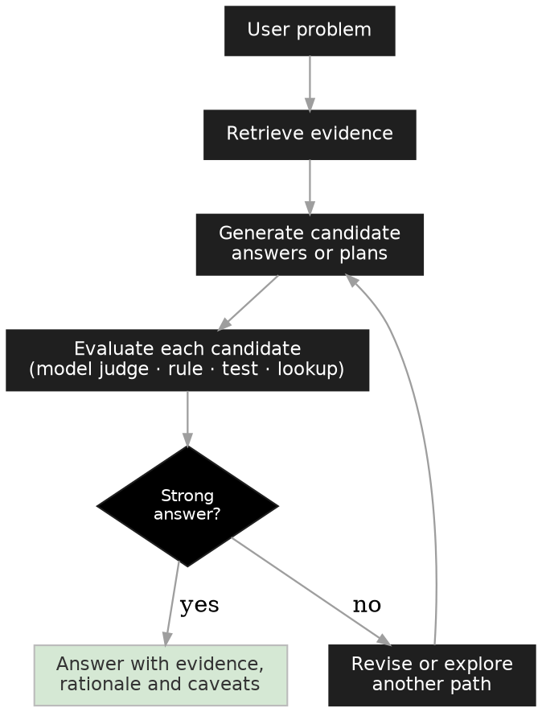
The candidate evaluator is the load-bearing component (Section 3), and it need not be another model: a deterministic rule, database lookup, unit test or workflow-state check often encodes something the business already trusts. Reasoning architecture is not always “more LLM”; often it is better orchestration. A grounded answer says “approval is required”. A deliberate system generates three candidate paths (standard approval, enhanced review, regional exception), rejects the exception on jurisdiction evidence, and escalates with a rationale. The answer is not longer; it is better controlled.

Customer scenario
A manufacturer's diagnostics assistant retrieves incidents and procedures but tends to commit to the first plausible fault. Deliberate reasoning generates competing hypotheses, compares them against sensor evidence, requests missing data, and proposes the safest next diagnostic step, with the rejected hypotheses logged for the engineer.

Production controls
- Bound candidate count by task risk, cost and latency
- Evaluate with rules and tools before model judges
- Expose a concise rationale; protect internal reasoning logs (they may contain sensitive data)
- Stop on confidence, cost or business limits
- Test ambiguous, edge, exception and escalation cases

Microsoft mapping
- Reasoning models with visible effort control: GPT-5.x / o-series reasoning effort, Claude extended thinking; selectable in the Foundry catalogue
- Evaluator hosting: Azure Functions for deterministic checks; Logic Apps for approval integration
- Experimentation & evaluation: Foundry evaluations and the Azure AI evaluation SDK (which supersede Prompt Flow for this purpose)

CSA prompts
- Are there known failure modes where the first plausible answer is often wrong?
- What external check can validate a candidate answer, and how cheap is that check?
- Should users see reasoning, a concise rationale, or only evidence?

6. Reasoning and Acting: The ReAct Loop

Why it matters
This is the bridge between reasoning research and agents: reasoning that acts. ReAct (Yao et al., 2022) interleaves reasoning traces with tool actions: the thought decides what is missing, the action fetches it, the observation updates the plan. Every agent framework you will meet (Agent Framework, LangGraph, the OpenAI and Anthropic agent SDKs) implements a descendant of this loop. Without it, “reasoning” stays advice; with it, reasoning becomes tool-grounded decisions and governed actions.

Core idea
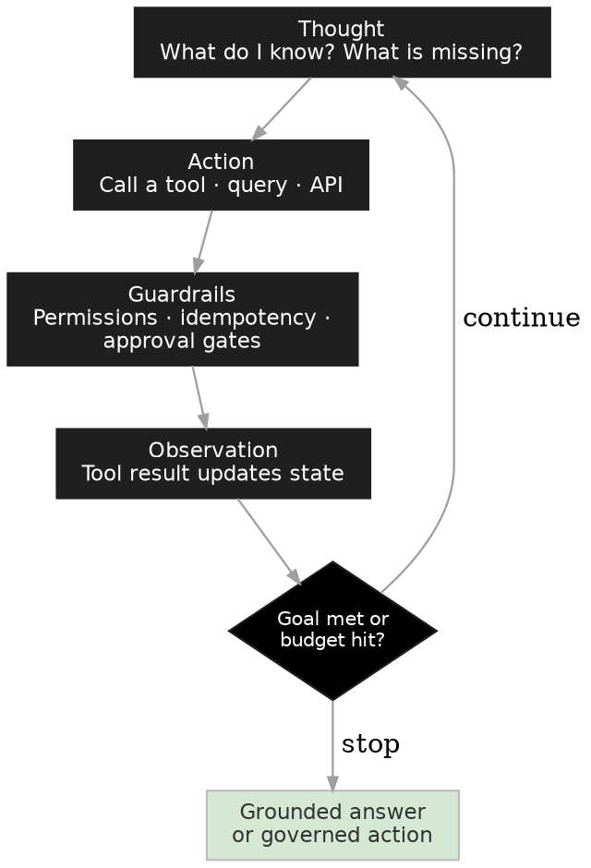
The loop looks trivial. The enterprise engineering is in the guardrails box: which tools the agent may call, with what identity and least-privilege permissions; which actions are idempotent and safely retryable; which are irreversible and require an approval gate; what happens on rollback; and when the agent should stop rather than act. Distinguish decision support (the loop drafts, a human commits) from decision automation (the loop commits within tight boundaries). Section 13 treats the human side of that boundary as a pattern in its own right.

Customer scenario
A renewals copilot reasons over a customer account, example sequence:
- thought: usage is declining but support tickets spiked
- action: query the ticket system for severity
- observation: two open Sev-A incidents
- thought: retention risk, check contract terms
- action: retrieve renewal clause
- final output: a draft retention offer routed to the account manager for approval
Reasoning selected the tools; tools grounded the reasoning; a human owned the commitment.

Choosing the runtime
Three hosting models cover most agent deployments; the choice is about who owns the loop and the operational plumbing:
Runtime | What it is | Choose it when
Foundry prompt agents (the declarative model of the classic Agent Service) | Portal- or SDK-defined agents: instructions + tools + knowledge, on a fully managed runtime with built-in tracing and evaluation hooks. You configure the loop; Foundry runs it. | Straightforward tool-using assistants; fastest path to production; teams who want platform defaults for identity, tracing and evaluation rather than custom loop code.
Foundry hosted agents | Your agent code (Agent Framework, LangGraph, OpenAI Agents SDK or Claude Agent SDK) packaged as a container that Foundry runs with a managed endpoint, scaling, managed identity and observability. | Custom control loops (the patterns in this guide), multi-agent workflows, or an existing framework investment you want to carry into Foundry's operational envelope.
Azure Functions (self-managed agent code) | Plain serverless code calling Foundry models via the Responses API. No agent-platform runtime: you own tracing, identity wiring, evaluation integration and state. | Lightweight event-driven agents, deterministic evaluators and tools (their best role), custom MCP servers, or constraints that rule out the managed runtimes. Pair with Durable Functions when the lifecycle is long-running (see Section 11).

Production controls
- Permissions: per-tool identity (managed identities / on-behalf-of), least privilege
- Idempotency: classify tools as read, reversible-write, irreversible-write; gate the last class
- Observation hygiene: treat tool outputs and retrieved content as untrusted input; prompt injection enters agent loops through observations, so validate and constrain before the next thought
- Loop bounds: max steps, max tool calls, token budget, wall-clock timeout

Microsoft mapping
- Runtime: per the table above
- Tools: MCP servers (including custom ones on Azure Functions), Foundry Tools, Logic Apps connectors
- Gateway controls: Azure API Management AI Gateway for token limits, semantic caching, and tool-call policy at the boundary

CSA prompts
- Which tools may the agent call, and which actions are irreversible?
- What identity does each tool call run under: the agent's or the user's?
- Who owns the loop: platform defaults (prompt agent), your code on managed runtime (hosted), or fully self-managed (Functions)?

7. Search-Based Reasoning and Controlled Exploration

Why it matters
Many enterprise tasks are decision tasks with a space of valid options: migration sequencing, redistribution plans, remediation strategies. Search-based reasoning treats the answer as one point in that space: generate options, evaluate options, repeat. The generation–evaluation loop is the practical heart of the pattern, and it directly connects to research such as Tree of Thoughts, Language Agent Tree Search (LATS), which combines reasoning, acting, planning, environment feedback and reflection in an MCTS-inspired agent loop, and ReST-MCTS*, which uses process-reward-guided tree search at training time. One correction to common framing: production reasoning models mostly do learned long chain-of-thought in a single pass; explicit MCTS at inference remains rarer than the literature suggests. What transfers to enterprise architecture is the resource-allocation idea: spend more reasoning budget where a better decision is most likely, and stop spending on weak paths.

Core idea
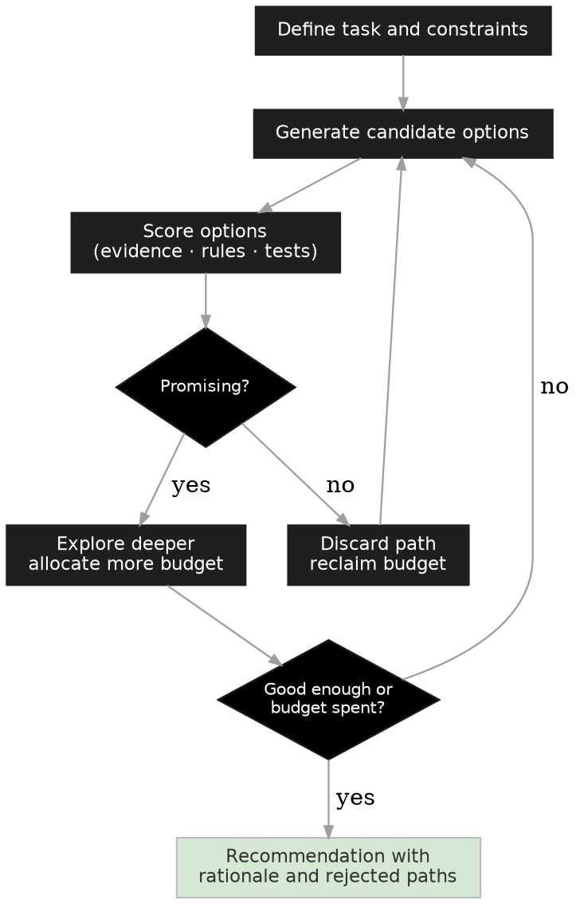
Search adds two things to deliberate reasoning: explicit constraints that make options invalid before scoring (business rules do this cheaply), and dynamic budget allocation. A migration planner generating twenty candidate sequences should deepen analysis on the three most promising, not evaluate all twenty equally. Where enterprise controls fit: constraints from business rules; evidence from search, databases, APIs and graphs; evaluation from scoring functions, rules, tests or human review; output including rejected alternatives and risk notes.

Customer scenario
A retailer plans legacy modernisation. “What should we migrate first?” is planning, not retrieval: the system compares migration waves against dependencies, downtime windows, criticality, data gravity, security and capacity; rejects constraint-violating plans early; deepens analysis on the leading three; and recommends a sequence with the rejected alternatives attached.

Production controls
- Bounds on candidates, depth, model calls, tokens, and time
- Scoring quality: a poor evaluation function makes search worse than direct generation because search amplifies whatever the evaluator rewards
- Reproducibility requirements set by task risk
- Telemetry recording explored and rejected paths for debugging

Microsoft mapping
- Orchestration: Agent Framework workflows for generate–score–prune loops; Durable Functions for long-running, checkpointed searches (Section 11)
- Scoring hosts: Azure Functions (deterministic), Foundry-hosted judge models (semantic)
- Data for constraints and evidence: Fabric semantic models and OneLake

CSA prompts
- How many valid solutions exist, and what makes one better? Can the business write the scoring function down?
- What constraints invalidate an option outright (cheap to check first)?
- Is decision quality worth more than response speed here?

8. Tree of Thoughts and Branching Reasoning

Why it matters
Chain-of-thought gives the model a line; Tree of Thoughts (Yao et al., 2023) gives it branches with self-evaluation, lookahead and backtracking. Business systems fail by committing to the first plausible interpretation; branching delays commitment and keeps alternatives alive until evidence discriminates. Use it for ambiguous, constrained problems with several defensible readings.

Core idea
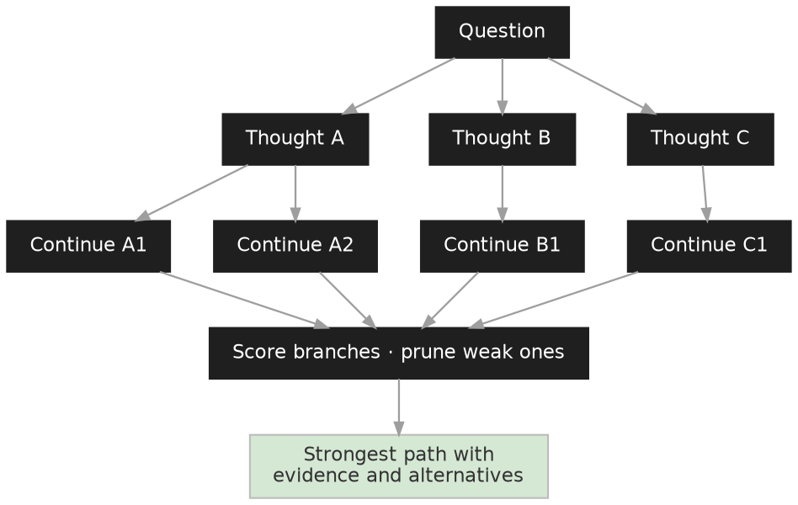
Not every branch continues and not every thought deserves another model call: the architecture needs pruning and a scoring method. Score on evidence alignment, rule compliance, factual consistency, risk, cost, expected business value. This scoring step is exactly where enterprise architecture meets the research: a paper scores puzzle progress; a customer solution scores business constraints.

Customer scenario
A security team investigates unusual authentication. Branching reasoning holds five hypotheses simultaneously (benign travel, compromised identity, risky OAuth app, service-account misuse, configuration-change false positive), tests each against identity logs and prior incidents, discards unsupported branches, requests missing signals, and returns the leading hypothesis with evidence, confidence and next action. This mirrors how analysts actually work, which is why it earns trust.

Production controls
- Branching: limit branch count, depth, cost, latency
- Evaluation: combine model scoring with deterministic checks
- Explanation: present recommendation, evidence, and key alternatives
- Security: branch data and logs inherit access and retention controls

Microsoft mapping
- Security context: Sentinel and Defender XDR signals as branch evidence
- Orchestration & scoring: Agent Framework + Azure Functions pruning logic
- Telemetry: Foundry tracing to inspect kept and pruned branches

CSA prompts
- Does this problem have multiple plausible interpretations, and is the first plausible answer often risky?
- What evidence would eliminate a hypothesis, and can the system fetch it?
- Should users see alternatives considered, or only the conclusion?

9. Memory-Augmented Reasoning

Why it matters
The context window is working memory, and only working memory. Enterprise agents need recall across sessions: what this customer told us last month, which remediation worked last quarter, how this subsidiary's ledger differs. Treating memory as a first-class pattern rather than a by-product of other loops changes the architecture questions from “how big is the context” to “what is stored, where, under whose policy”. MemGPT (Packer et al., 2023) made the operating-system analogy explicit: the model manages a small fast context and pages information in and out of larger external stores.

Core idea
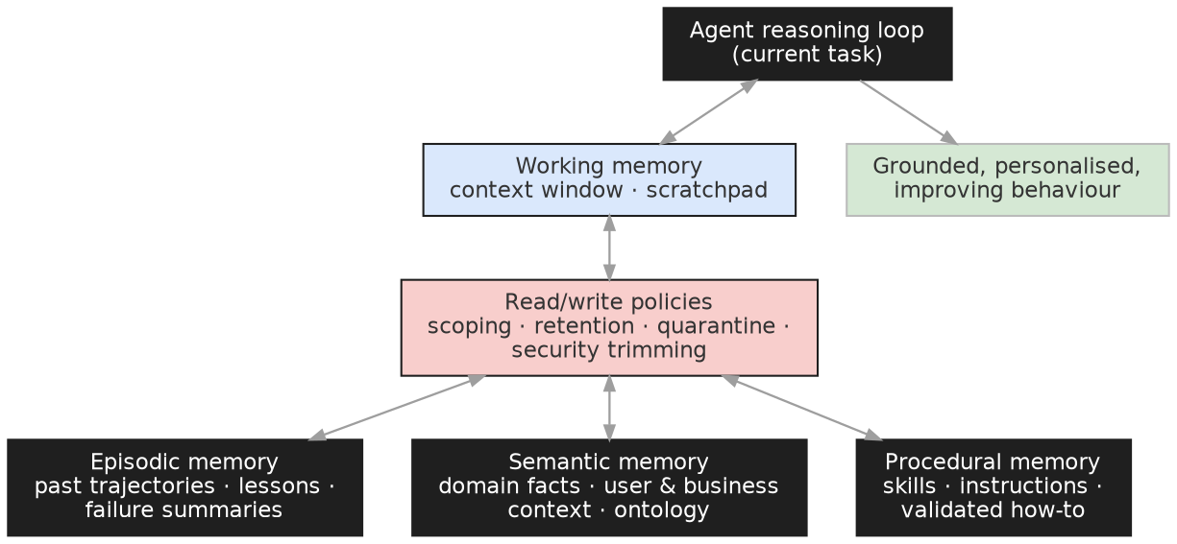
Four memory types, with different stores and policies:
- Working memory: the context window and scratchpad; managed by summarisation and paging
- Episodic memory: past trajectories, lessons and failure summaries; what reflection (Section 10) writes and reads
- Semantic memory: durable facts about the domain, customer and business; the ontology and knowledge bases are its governed form
- Procedural memory: skills, instructions, validated how-to; versioned like code
The read/write policy layer is what makes memory enterprise-grade: scoping (task vs user vs organisation), retention and privacy, quarantine for content derived from untrusted sources, and security trimming so an agent cannot recall on behalf of a user what that user may not see.

Customer scenario
A support copilot without memory re-asks every customer for environment details each session and repeats failed suggestions. With scoped memory: semantic memory holds the verified environment profile; episodic memory holds what was tried and its outcome; procedural memory holds the runbooks that resolved similar cases. The third session starts where the second ended, and the customer notices.

Production controls
- Scoping: explicit boundaries per memory type: task-local, user, team, organisation
- Retention: TTLs and deletion honouring data-subject rights; memories inherit the classification of their sources
- Poisoning defence: memory written from untrusted content is an injection surface; quarantine until reviewed
- Forgetting: stale memory is worse than none; design expiry and contradiction-resolution, not just accumulation
- Trimming: recall must respect the caller's permissions at read time, not write time

Microsoft mapping
- Managed memory: Foundry Agent Service built-in memory (preview) for conversational/episodic recall
- Stores: Cosmos DB or Azure Table Storage for trajectories and skill metadata; Azure AI Search vector indexes for episodic retrieval
- Semantic memory, governed: Fabric IQ Ontology as the shared business-fact layer multiple agents read (Section 15)
- Procedural: git-backed instruction and skill files, deployed through CI

CSA prompts
- What must the agent remember across sessions, and what must it be unable to remember?
- Who can see a memory at read time, and does recall re-check permissions?
- How does a wrong memory get corrected or expired?

10. Reflection and Dynamic Skill Acquisition

Why it matters
Everything so far improves a single run. This pattern improves the next run, without touching model weights. Reflexion (Shinn et al., 2023) showed agents improving through verbal reinforcement: store a critique of the failed trajectory in episodic memory (Section 9) and condition the next attempt on it. Voyager (Wang et al., 2023) went further: the agent authors reusable skills, stores them in a growing library (procedural memory), and retrieves them for later tasks. Together they define a production-relevant loop: the agent's instructions and skill set become versioned, evolving artefacts. Capability is added dynamically between executions rather than baked in at design time.

Core idea
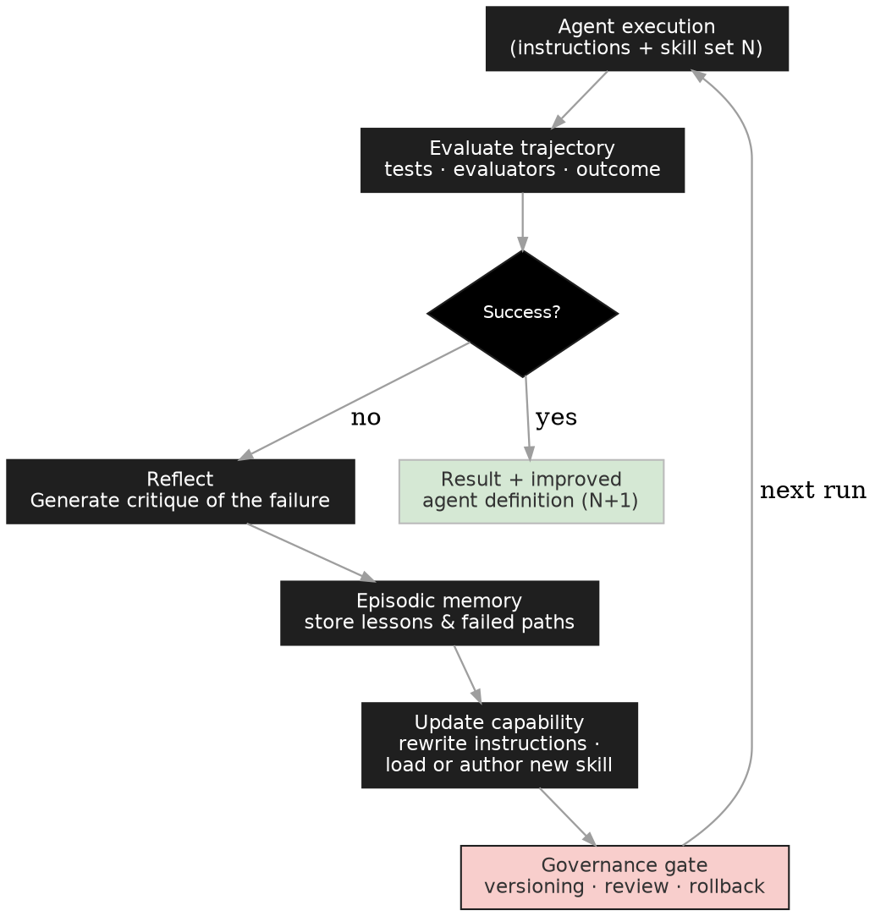
Two update channels exist. Instruction rewriting: the reflection distils “why did this fail” into an amended system prompt for run N+1 (“always check the exchange-rate date before reconciling”). Skill acquisition: recurring sub-tasks are captured as named, tested skills (a tool wrapper, a prompt template, a validated code function) loaded on demand for the next execution. The governance gate is non-negotiable: every instruction or skill change is versioned, diff-reviewed (by human or by a reviewer agent with tests), and rollback-able. Self-modification without a gate is how agents drift.

Customer scenario
A month-end close agent fails on a subsidiary with a non-standard ledger format. It reflects, writes a lesson to memory, authors a “parse-alternate-ledger” skill validated against sample files, and submits both for review. Next close, the skill loads automatically and the run completes. Over quarters, the agent's skill library becomes an audited asset of the finance team, not tribal knowledge in a prompt.

Production controls
- Grounded reflection: critiques must cite evaluator or test evidence, not the agent's own opinion of itself, or reflection becomes self-justification
- Poisoning defence: reflections derived from untrusted content are quarantined until reviewed; memory is an injection surface
- Versioning: instructions and skills in git; deployment via the same CI gates as code
- Rollback: every capability change reversible in one step

Microsoft mapping
- Memory: per Section 9 (episodic lessons in managed memory; skill metadata in Cosmos DB or Table Storage)
- Skill registry: git-backed skill files loaded at agent start; Agent Framework middleware for dynamic tool registration
- Improvement loop automation: Foundry Agent Optimizer runs the evaluate–generate–rank–deploy cycle over agent definitions, the managed version of this pattern

CSA prompts
- Is this task repeated often enough that run-over-run improvement pays for the governance overhead?
- Who reviews an instruction or skill change before it takes effect? How fast can it be rolled back?
- What evidence grounds a reflection: tests, evaluators, or the agent's own judgement?

11. Workflow-State Reasoning

Why it matters
Claims processing, case management, onboarding, procurement: much of the enterprise runs on state machines, and that is where agent budgets actually sit. The pattern error is replacing the state machine with an agent; the pattern success is the inverse: the process stays a governed state machine, and agents occupy specific decision points within it. Deterministic transitions stay deterministic. The agent reasons where judgement lives (intake interpretation, assessment, exception handling) and the workflow engine owns sequence, retries, timeouts and audit. This also solves the lifecycle problem: business processes run for days or weeks, far beyond any agent call.

Core idea
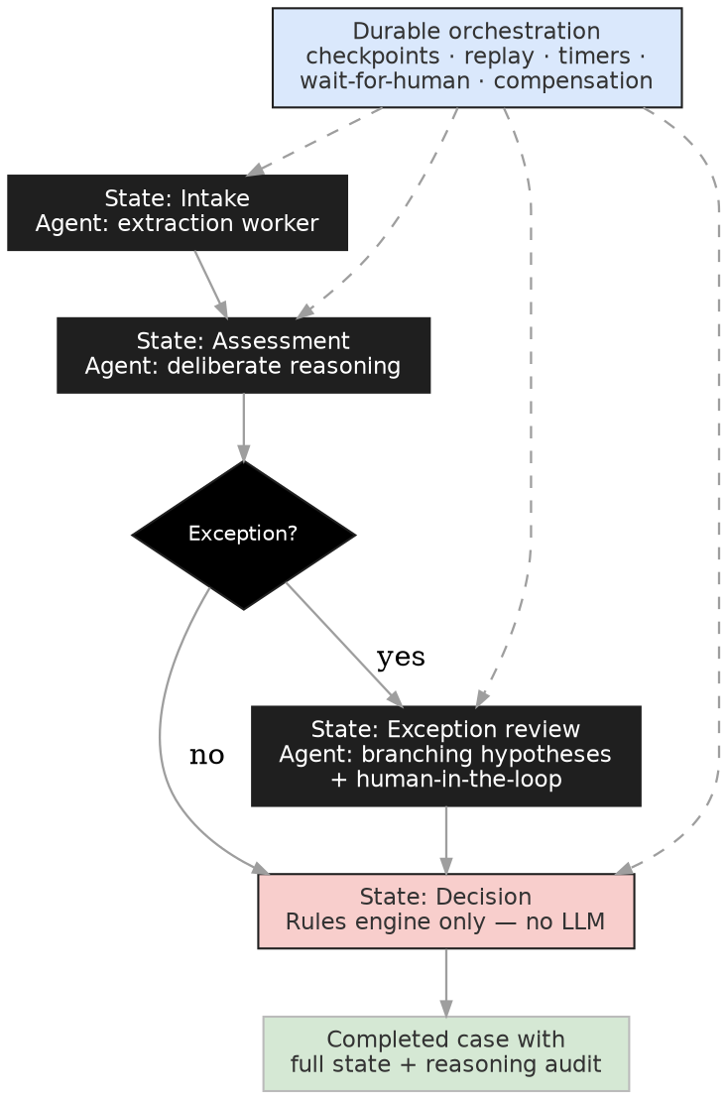
Durable Functions is the natural backbone for this pattern because its execution model matches agent lifecycles directly. Orchestrations are checkpointed and replay-safe, so a week-long case survives restarts with no state lost. Agent invocations run as activities; side-effecting work belongs in activities, never in orchestrator code, which must stay deterministic for replay. The classic Durable patterns map one-to-one onto agent lifecycles:
- Function chaining: sequences agent steps through the process states
- Fan-out/fan-in: runs parallel workers and merges results (the Section 12 pattern, made durable)
- Human interaction: wait-for-external-event plus a durable timer implements approval gates with SLA escalation (Section 13)
- Monitor: eternal orchestrations poll for conditions that should wake an agent
- Durable entities: hold per-case agent state between transitions
- Compensation: saga-style rollback activities when a downstream step fails after an agent already acted
Where Agent Framework workflows orchestrate the agent graph, Durable Functions orchestrates the business process that calls agents. Most real systems use both, and Logic Apps offers the low-code equivalent for approval-heavy processes.

Customer scenario
Claims processing: the intake state runs an extraction worker over submitted documents; the assessment state runs deliberate reasoning over policy and history; exceptions route to a branching-plus-human review state; the payment state is a rules engine with no LLM at all. A durable orchestration carries the case across days, with every state transition, agent rationale and human decision on the audit trail. The customer gets agent judgement exactly where it helps and deterministic behaviour exactly where regulators look.

Production controls
- Determinism boundary: no model calls or I/O in orchestrator code; activities only
- Idempotent activities: replays and retries must be safe
- Versioning in flight: a strategy for cases mid-process when the workflow definition changes
- Timeouts & escalation: every wait has a timer and an owner
- State audit: transitions and agent rationales logged as first-class records, not buried in traces

Microsoft mapping
- Process backbone: Azure Durable Functions (orchestrations, entities, timers, external events); Logic Apps for low-code equivalents
- Agents at decision points: Foundry Agent Service invoked from activities; Agent Framework workflows inside a decision point when the point itself is multi-agent
- Case data & audit: Cosmos DB per-case state; Fabric/OneLake for process analytics over completed cases

CSA prompts
- Which states in the existing process need judgement, and which must remain deterministic?
- What happens to in-flight cases when the workflow or the agent changes?
- Where does compensation live when an agent-triggered action must be undone?

12. Multi-Agent Orchestration and Model Selection

Why it matters
When a workflow outgrows one agent (mixed skills, parallelisable work, or a need for independent review), decompose it into roles. AutoGen (Wu et al., 2023) established conversational multi-agent patterns and is now folded into Microsoft Agent Framework. The durable enterprise patterns are few:
- planner–executor (decompose then do)
- executor–reviewer (generate then independently verify)
- fan-out–merge (parallel workers, serialised integration)
Resist agent sprawl: every additional agent adds latency, cost, and a new failure surface. Use the smallest structure that gives you independent verification and parallelism where it pays.

Core idea
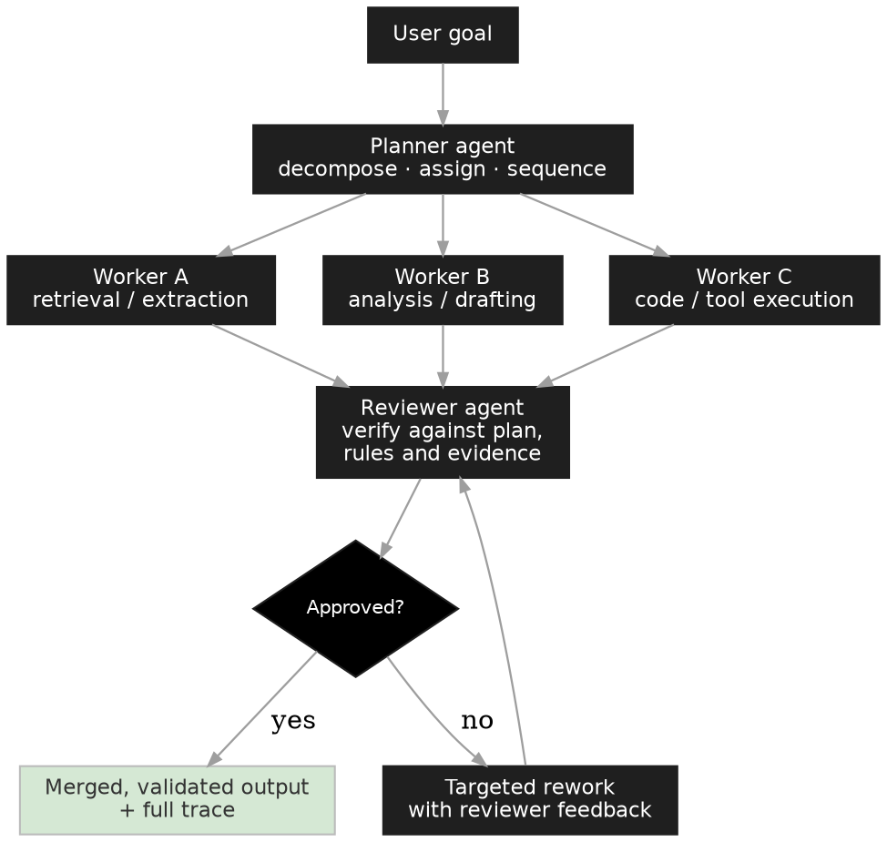
Roles have different cognitive profiles, so they should not all run the same model. Planning is low-volume and hard: pay for frontier reasoning. Worker calls are high-volume and narrow: use small, fast, fine-tunable models. Review benefits from a different model family than generation, so correlated blind spots don't approve each other's mistakes. The table gives a defensible starting point from the Foundry catalogue; validate against current availability, region and price before committing, because the catalogue moves quarterly:
Agent role | Model choice (Foundry catalogue) | Why
Planner / orchestrator | GPT-5.x reasoning or Claude Opus 4.x | Deep decomposition and long-horizon planning; low call volume makes frontier cost acceptable
Worker: retrieval, extraction, classification | Phi-4 family, GPT-5 mini/nano, Llama 3.x 8–70B | High volume, narrow tasks; small models are cheap, fast and fine-tunable on your traces
Worker: coding / tool execution | gpt-5.x-codex or Claude Sonnet 4.x | Strongest sustained tool-use and code generation/repair behaviour
Reviewer / verifier | A different family from the generator (e.g. Claude Sonnet reviewing GPT output, or vice versa) | Cross-family review reduces correlated errors; strong instruction-following matters more than raw capability
Judge (LLM-as-judge in evaluators) | Mid-tier model (GPT-5 mini, Claude Haiku class) | Judging is cheaper than generating; calibrate the judge against human labels before trusting it
Cost-sensitive deep reasoning | DeepSeek-R1 (Microsoft-hosted) | Strong reasoning at low cost; runs on Azure infrastructure; confirm data-governance posture with the customer
Ambiguous / mixed traffic | model-router | GA in Foundry, preview inside Agent Service: per-prompt selection balancing cost, latency and quality

Production controls
- Contracts: typed schemas between agents (e.g. Pydantic/JSON Schema); free-text handoffs are where multi-agent systems silently fail
- Merge discipline: serial merge queue for fan-out outputs touching shared state
- Debate bounds: cap reviewer–executor iterations; escalate to a human instead of looping (Section 13)
- Trace: one correlation ID across the whole workflow

Microsoft mapping
- Framework: Microsoft Agent Framework (workflows, handoffs, group patterns) on Foundry Agent Service hosted agents; multi-agent workflows are first-class in the service
- Routing: model router; APIM AI Gateway for cross-agent quota and caching
- Interop: MCP for tools; A2A/agent-to-agent connectivity for cross-stack agents
- Durable backbone: fan-out/fan-in via Durable Functions when the workflow is long-running (Section 11)

CSA prompts
- What is the smallest agent structure that gives independent verification? Do you need more than executor + reviewer?
- Which handoffs carry typed contracts, and which are still free text?
- Which roles genuinely need frontier models once you look at call volume per role?

13. Human-in-the-Loop Reasoning

Why it matters
In most designs the human appears only as a gate: approve or reject at the end. That wastes the most valuable evaluator in the system. The stronger pattern treats the human as a reasoning participant: the agent proposes with evidence, the human critiques, the agent revises, the human approves, and every critique is captured as data. Human feedback is the original training signal for model behaviour (Ouyang et al., 2022); this pattern is its inference-time analogue, and it feeds the same downstream uses: critiques become evaluation cases (Section 17), episodic memory (Section 9) and, at volume, tuning data (Section 19).

Core idea
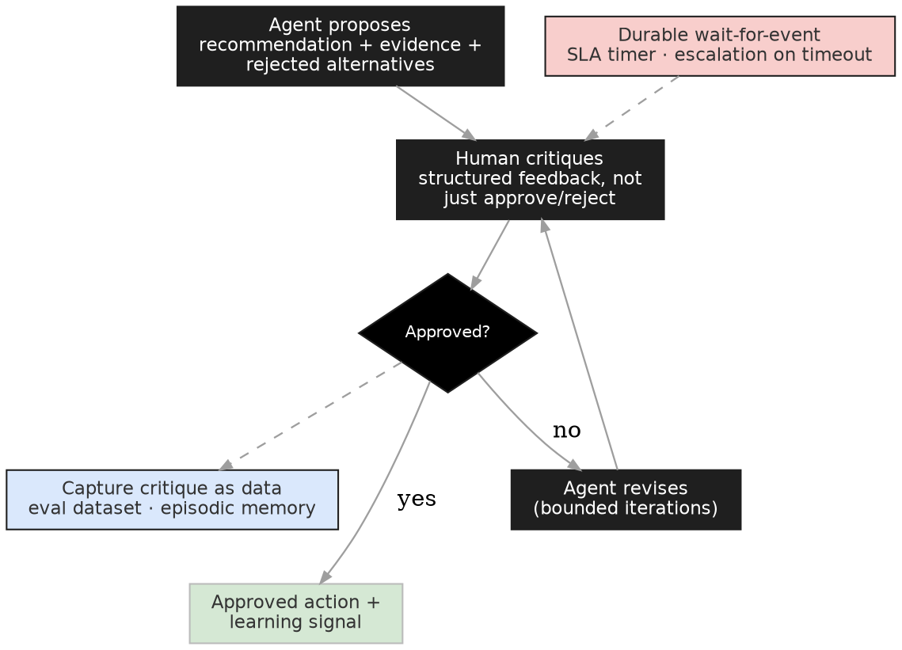
Design the escalation ladder explicitly. For each task class, the agent may: answer; ask for missing data; draft; recommend; request approval; or stop. That ladder is the practical boundary between decision support and decision automation, and it should be a configuration the business owns, not behaviour buried in a prompt. Then design the attention budget: humans reviewing everything review nothing. At volume, gate by risk (high-impact actions always; sampled review elsewhere), and rotate sampled cases into the evaluation set so quality remains measured even where humans no longer look. Finally, make critique structured: “reject, wrong jurisdiction, use the EU threshold” is a learning signal; a bare rejection is noise.

Customer scenario
A credit-decisioning assistant drafts recommendations with evidence and rejected alternatives. Analysts critique in a structured form; the agent revises within two bounded iterations; approval releases the action. Critiques flow nightly into the evaluation dataset. Three months in, the sampled-review pass rate becomes the argument, with evidence, for moving low-value cases from “request approval” down the ladder to “recommend”.

Production controls
- Timers everywhere: every human wait has an SLA timer and an escalation owner; the Durable Functions human-interaction pattern (Section 11) implements this directly
- Rubber-stamp detection: monitor approval latency and rate; instant 100% approval means the review is theatre
- Bounded revision: cap propose–critique–revise cycles; a third rejection escalates to a person-to-person conversation
- Audit: proposal, critique, revision and approval are one linked record

Microsoft mapping
- Approval surfaces: Teams adaptive cards and Approvals via Logic Apps connectors; meet reviewers where they work
- Wait mechanics: Durable Functions wait-for-external-event + timers; Agent Framework checkpoint/HITL support inside agent workflows
- Low-code processes: Copilot Studio approval nodes for M365-centric workflows
- Critique capture: structured feedback into Fabric/OneLake, joined to traces for Section 17

CSA prompts
- For each task class, where on the ladder does the agent sit: answer, ask, draft, recommend, request approval, stop?
- What is the reviewers' attention budget, and what is sampled once volume grows?
- Are critiques structured enough to become evaluation and training data?

Part C — Enterprise Control Patterns
Keeping proposed actions inside the lines

14. Neuro-Symbolic Reasoning

Why it matters
Policies contain rules; regulations contain constraints; financial controls contain thresholds. LLMs find patterns well but are unreliable when a decision must follow an explicit rule every time. Neuro-symbolic architecture pairs them: the neural layer proposes, the symbolic layer constrains. Approaches such as Logic-LM (Pan et al., 2023) translate natural-language problems into formal solvers and back. For most enterprise workloads the future is not neural replacing symbolic; it is neural reasoning operating within symbolic constraints.

Core idea
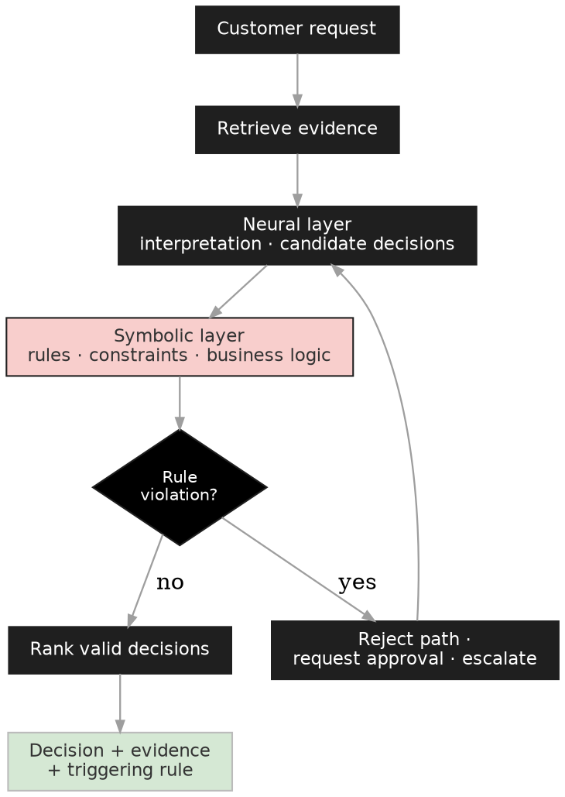
The contrast with learned behaviour matters in customer conversations. A tuned model may learn “similar situations usually require approval”; a rules layer enforces “approval is mandatory whenever exposure exceeds the threshold”. The first is a tendency, the second is a guarantee. Enterprise systems need both: reasoning proposes actions; rules determine which actions are permitted. The architectural shift is that correctness no longer depends entirely on the model. Business logic participates directly in decisions, and policy changes ship without retraining anything.

Customer scenario
A bank's onboarding assistant evaluates multiple compliant paths for a customer while mandatory regulatory controls are enforced symbolically. Every recommendation carries the rule that triggered it, which turns audit conversations from model forensics into rule citations.

Production controls
- Rule lifecycle: ownership, versioning, testing
- Conflict resolution: precedence when rules contradict
- Auditability: decisions cite triggering rules
- Maintainability: rules evolve faster than models; keep them out of prompts

Microsoft mapping
- Rules engines: Power Platform business rules, Logic Apps, custom rule services on Azure Functions; Fabric IQ Ontology can host business rules alongside the data model
- Proposer: Foundry models via Agent Framework
- Approvals: Logic Apps / Teams workflow integration

CSA prompts
- Which decisions must be deterministic every time, and where do those rules live today?
- Can policy changes ship faster than model updates in the current design?
- Can each decision cite the rule that constrained it?

15. Graph Reasoning

Why it matters
Much enterprise knowledge is relationships, not documents: customers to opportunities, systems to dependencies, incidents to identities. Documents answer what exists; graphs answer how it connects. Microsoft Research's GraphRAG (Edge et al., 2024) derives entity graphs from unstructured text for global sensemaking; distinguish that from operational graph reasoning over governed business entities, which is exactly what Fabric IQ now productises: Ontology (preview) defines entities, relationships, rules and constraints in business language; Graph (GA) stores and traverses them at billions-of-relationships scale with GQL (ISO/IEC 39075) and natural-language-to-GQL.

Core idea
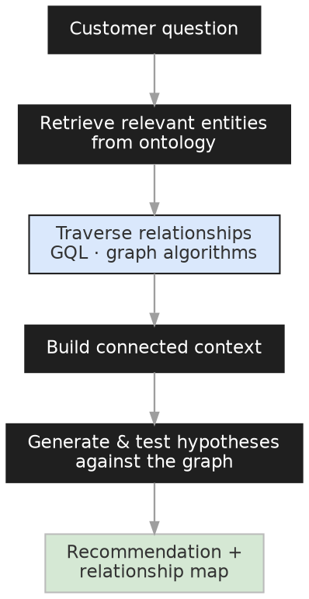
The graph participates in reasoning rather than merely feeding retrieval: the agent retrieves entities, traverses relationships (Order → Shipment → Temperature Sensor → Cold-Chain Breach), builds connected context no single document contains, and tests hypotheses against the structure. Fabric IQ's ontology also grounds Data Agents and Operations Agents in the same shared semantics, so multiple agents reason over one business model instead of private interpretations of tables.

Customer scenario
Fraud investigation: transaction documents look clean individually; the signal is shared devices, addresses and payment methods across accounts. Graph traversal surfaces the ring; the agent presents the relationship map as the evidence, which is also the explanation.

Production controls
- Entity resolution quality: poor resolution poisons everything downstream
- Freshness: automated binding updates keep the graph current
- Security trimming: relationship visibility must respect permissions
- Observability: show which relationships drove the recommendation

Microsoft mapping
- Semantic layer & graph: Fabric IQ Ontology + Graph on OneLake; Data Agent for NL questions grounded in the ontology; the same ontology connects as a knowledge source in Foundry and Copilot Studio
- Org graph: Microsoft Graph
- Unstructured corpora: GraphRAG over Azure AI Search where the source is documents rather than operational data

CSA prompts
- Is this a document problem or a relationship problem? Does the answer require traversal?
- Does an ontology already exist (semantic models to generate from), or is that the first project?
- Who owns entity resolution quality, and how is it measured?

16. Program Synthesis and Test-Repair

Why it matters
Code generation produces code that looks correct; program synthesis produces artefacts validated against tests, static analysis, specifications or formal verifiers (Austin et al., 2021). Be precise with customers: in some domains this approaches proof, but most enterprise workflows get bounded validation, not mathematical proof, and that is still transformative, because the system ships validated artefacts instead of advice. Self-repair loops (Chen et al., 2023) close the cycle: execute, read the failure, repair, revalidate.

Core idea
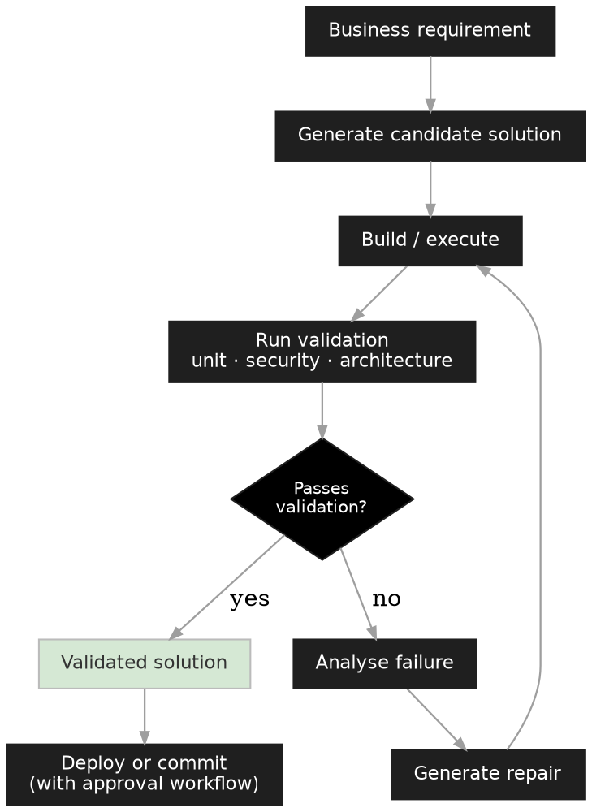

Customer scenario
Migrating thousands of .NET Framework applications: copilots can already explain guidance; the value is a synthesis loop that generates migration changes, executes validation tests, analyses failures, generates repairs and re-validates, inside existing CI/CD, with human approval on high-risk changes. The deliverable is a passing pipeline, not a document.

Production controls
- Validation depth: unit + security + architecture checks, matched to change risk
- Security: generated code is scanned before any deployment path
- Traceability: every generated change linked to requirement, tests, and approvals
- Sandboxing: execution environments are isolated and cost bounded

Microsoft mapping
- Generation & repair: GitHub Copilot coding agent; codex-class and Claude Sonnet models from the Foundry catalogue for pipeline-embedded synthesis
- Validation: GitHub Actions / Azure DevOps pipelines; GitHub Advanced Security (with Defender integration) for scanning
- Orchestration: Agent Framework for multi-step generate–test–repair agents on Foundry Agent Service

CSA prompts
- Does the customer need code, or validated code? What defines validation here?
- Which failures require human approval, and where does the approval live in the pipeline?
- Is the test suite strong enough that passing it means something?

Part D — Operating Reasoning Systems
The disciplines every pattern shares

17. Agent Evaluation in Practice: The Flywheel

Why it matters
Section 3 made the argument: the evaluator is the architecture. This section is the operational half: building and running evaluation on Foundry and Fabric so it gates releases, watches production and feeds improvement. The enterprise translation of process supervision is step-level telemetry plus per-step evaluators, and this is now a managed capability rather than a bespoke build.

The evaluation flywheel
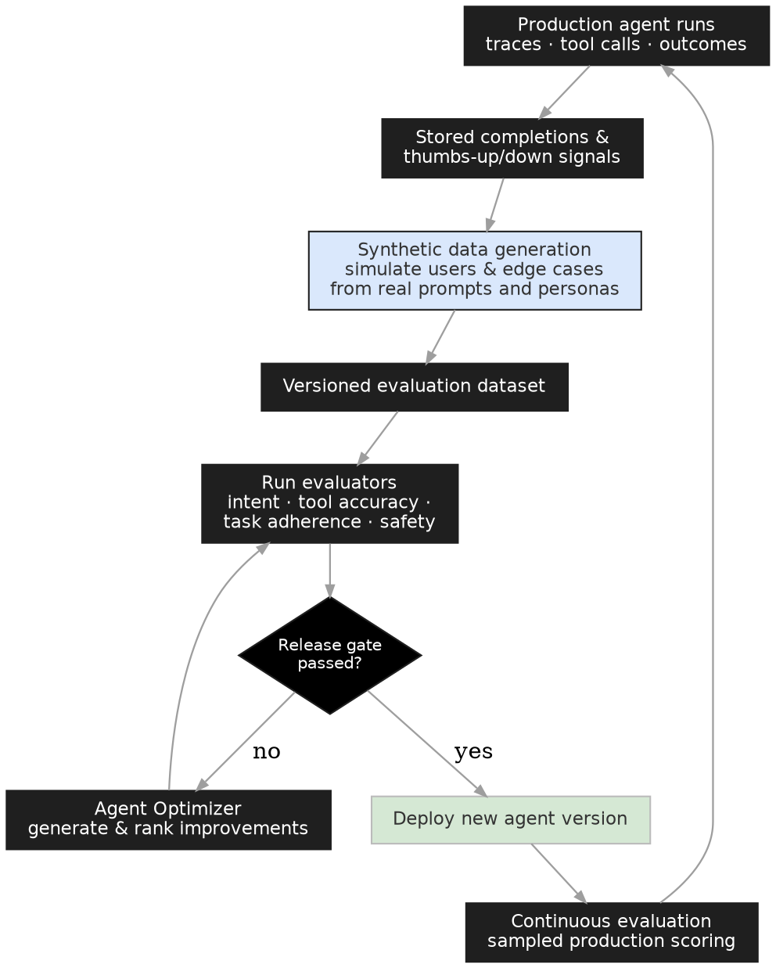

Concrete steps with Foundry and Fabric
- Instrument first. Enable agent tracing on Foundry Agent Service / Agent Framework; connect Application Insights (continuous evaluation requires it, and the project managed identity needs the Foundry User role).
- Seed the dataset from real usage. Capture production prompts and executions: stored completions, thumbs-up/down signals, escalation transcripts. Curate 30–100 real cases with expected outcomes into a versioned golden set in your Foundry project. Fabric/OneLake pipelines are the right place to join traces with business-outcome data (did the recommendation get accepted? did the ticket reopen?) and to version the datasets.
- Expand with synthetic data. Use Foundry's built-in synthetic data generation and simulators to generate test cases from the agent definition, seed prompts, reference documents and user personas; that is, synthesise variations of what real users actually asked, plus the edge cases they haven't yet. Include both sides: cases where the agent should act and cases where it should refuse or escalate. Add the adversarial simulator / AI red-teaming agent for safety coverage.
- Choose evaluators deliberately. From the built-in agent evaluators: Intent Resolution (did it understand the request), Tool Call Accuracy / Tool Selection / Tool Input Accuracy (right tools, right parameters), Task Adherence (followed its instructions and constraints), Task Navigation Efficiency (optimal step sequence vs ground truth), plus RAG evaluators (groundedness, relevance), safety evaluators (always), and custom or auto-generated rubric evaluators where built-ins can't express your rules. Each result returns pass/fail with the judge's reasoning; the reasoning is what tells you what to fix.
- Gate releases. Run the evaluation on every agent change; define thresholds as release gates (e.g. ≥ 85% task adherence or no ship); compare versions side by side; use Foundry Benchmarks (preview) for standardised checks.
- Evaluate continuously in production. Sampled scoring of live traffic flows to Application Insights dashboards; drift and regressions surface as charts, not complaints.
- Close the loop. Every production failure becomes a test case; Foundry Agent Optimizer automates the evaluate–generate–rank–deploy cycle over agent definitions; good traces become RFT or distillation data (Section 19). Structured human critiques from Section 13 join the dataset on the same path. The dataset grows with the agent; treat it as test-driven development for behaviour.

CSA prompts
- What is the verifier for this workload: model-based, rule-based, test-based, human, or hybrid? Can it be fooled?
- Does evaluation judge the final answer only, or the trajectory?
- What are the release-gate thresholds, and who owns them?

18. Cost, Latency and Reasoning Budgets

Why it matters
“Smaller models plus orchestration are cheaper” is conditional, not guaranteed. Every pattern in Part B multiplies calls: candidates, branches, reflections, reviews. A small model called twelve times can cost more, take longer and fail more often than one frontier call. The honest claim: smaller models win only when the loop is bounded, the evaluator is cheap, and the task distribution is narrow enough that orchestration improves reliability faster than it adds cost.

A worked example (illustrative arithmetic)
Assume a frontier model costs 15× a small model's input rate and 15× its output rate. Take a policy-decision task. Route A, one frontier call: 5k input + 1k output tokens → 5×15 + 1×60 = 135 cost units (using 15/60 units per 1k in/out), one round-trip of latency. Route B, a small-model deliberate loop: 12 calls averaging 3k in / 0.6k out at 1/4 units → 12 × (3 + 2.4) = ~65 units: half the cost, but 12 sequential round-trips of latency, and only if the loop's pass rate holds. If a third of runs need a frontier escalation anyway, Route B averages ~110 units plus the added latency, and the margin has nearly vanished. The lesson generalises: the escalation rate and the evaluator's cost decide the economics, not the per-token price list. Instrument both before promising savings.

The routing pattern
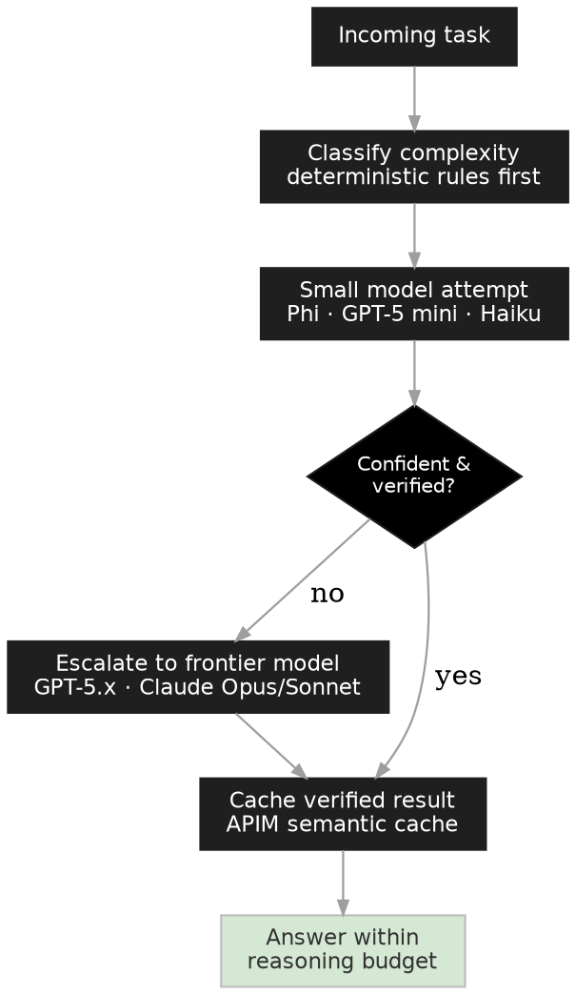
Budget levers: deterministic tools before any LLM call; cheap model first, escalate on low confidence or failed verification; frontier models reserved for synthesis and ambiguous judgement; cache verified results (APIM AI Gateway semantic caching; note the cache-similarity threshold direction is a classic misconfiguration); cap loops, branches, retries; define a reasoning budget per task class and alert on breach. Foundry's model router (GA; preview inside Agent Service) automates per-prompt selection across cost, latency and quality.

CSA prompts
- What is the reasoning budget per task class in tokens, calls, and seconds?
- What is the measured escalation rate from small to frontier models?
- Which results are cacheable, and what invalidates the cache?

19. Learning and Optimisation: When Reasoning Moves into the Model

Why it matters
Unlike the patterns in Parts B and C, this is not an agent pattern you orchestrate; it is the buy-vs-build decision about where reasoning lives. The 2024–2026 reasoning advances came largely from post-training: reinforcement learning against verifiable rewards taught models to search, verify and backtrack inside a single forward pass. DeepSeek-R1 is the canonical public evidence, including its demonstration that distilled small models inherit much of the teacher's reasoning (see also Distilling Step-by-Step). When behaviour moves into weights, your orchestration simplifies and your per-call cost drops; the price is training investment, evaluation infrastructure and a workload stable enough to be worth encoding. Deliberate-reasoning orchestration (Section 5) and model tuning are the same optimisation made at different layers; future systems combine both.

The lifecycle
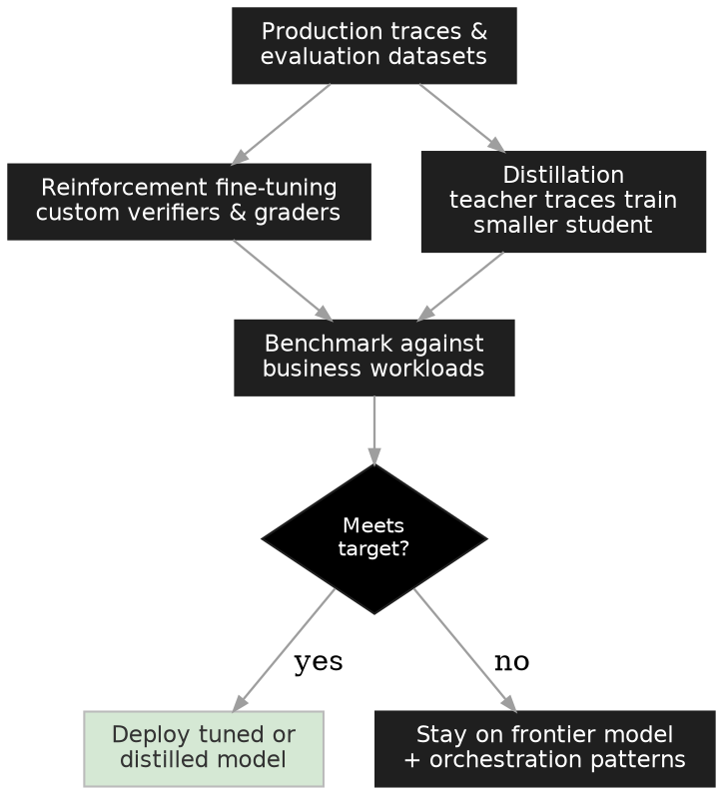
When to move reasoning into the model: workload is high-volume and stable; success is objectively measurable (a verifier exists); evaluation datasets exist (Section 17 built them); the capability loss of a smaller model is testable against business workloads. When not to: the task distribution shifts monthly; success is subjective; no benchmarks exist. In that case you would be distilling yesterday's business logic into tomorrow's brittle assistant. “Many enterprise copilots will use distilled models” is plausible only under the first set of conditions; say so out loud.

Microsoft mapping
- Reinforcement fine-tuning: RFT in Foundry (GA with o4-mini) trains against your custom verifiers and graders; the managed path from “we have a verifier” to “the model internalised it”
- Distillation: stored completions capture production outputs as training/eval data; Foundry model distillation transfers teacher reasoning to a student; synthetic data generation augments training sets
- Data preparation: Fabric/OneLake pipelines assemble and version the datasets
- Serving: fine-tuned models can directly power Foundry Agent Service agents; a Developer Tier (preview) lowers tuning cost using idle GPU capacity

CSA prompts
- Is the workload stable enough to encode, and who re-validates after the business logic changes?
- Does a verifier exist that RFT could train against?
- What would the distilled model be benchmarked on, and what loss is acceptable?

20. When Reasoning Patterns Fail
Credibility with senior audiences comes from naming the failure modes before the customer finds them. Group them by where they bite:
Evaluator failures. Weak or gameable evaluators; search amplifies whatever the scorer rewards (reward hacking); LLM judges drift or flatter; final-answer-only evaluation misses broken trajectories that reached lucky conclusions.
Loop failures. Over-branching and hidden cost explosion; circular agent debates that burn budget without converging; false confidence from longer reasoning (fluent chains read as rigour); ungrounded self-critique in reflection loops that becomes self-justification.
Action and data failures. Hallucinated tool arguments executing against real systems; prompt injection entering through tool observations and retrieved content, then steering the planner; stale or poisoned memory recalled as fact; graph entity-resolution errors silently corrupting relationship reasoning.
Governance failures. Non-determinism in regulated workflows without documented bounds; sensitive reasoning traces leaking through logs or verbose rationales; agents accumulating permissions; self-modifying instructions deployed without review or rollback; approval theatre, where human review exists on paper but rubber-stamps in practice.
Standing mitigations: deterministic checks ahead of model judges; budgets and circuit breakers on every loop; least-privilege, gated tool access; injection-aware handling of all observations; versioned instructions, skills and memory policies; the Section 17 flywheel running continuously; and human approval, with attention budgets, wherever failure is expensive.

21. Customer Conversation Guide
A compact sequence for discovery conversations, mirroring the title-page decision tree:
- Where does the current system fail: finding information, or deciding what to do with it? (Separates retrieval work from reasoning work.)
- Is the failure in judgement, action, memory, process, compliance or relationships? (Selects the pattern family: Sections 5–16.)
- What would “good” look like, and how would we measure it? (If unanswerable, the first project is evaluation: Sections 3 and 17.)
- Which decisions must be deterministic, which actions need approval, and where do humans participate in the reasoning itself? (Draws the control boundary: Sections 13, 14, 20.)
- What are the cost and latency envelopes per task class? (Sets reasoning budgets: Section 18.)
- Is any workload stable and high-volume enough to move reasoning into the model? (Opens the Section 19 conversation.)

Closing: The Premise, Stated for Review
The claim this guide makes, scoped so it can be examined: in enterprise systems, reasoning quality is increasingly determined by the architecture around the model, that is, the loops that generate and evaluate, the state that persists, the rules that constrain and the humans that critique. This is not offered as a new theory. It is established engineering discipline applied to a new component: feedback control manages unreliable elements with external measurement; test-driven development gates change on executable criteria; SRE practice bounds risk with budgets and gates. The guide applies the same discipline to model reasoning, and the patterns in Parts B and C are its concrete forms.
The boundary, restated: architecture amplifies model capability; it does not replace it. Where intermediate states are unobservable, feedback is unreliable or success is undefined, these patterns do not apply, and the honest recommendation is human process with model assistance.
How this premise fails, and what to watch. First: if frontier models internalise verification and planning so completely that an orchestrated loop adds no measurable quality over a single call at acceptable cost, most of Parts B and C collapses into model selection plus enterprise controls. The test is empirical and per workload: keep a “single frontier call” baseline in every evaluation run, and retire any pattern whose margin over that baseline disappears. Second: if evaluator quality cannot be maintained for a workload, the control loops have nothing to steer by, and applying them anyway produces confident, unmeasured systems, which are worse than measured, modest ones.
What survives either outcome is the discipline itself: writing success criteria down, building the evaluator, and gating change on evidence. Models and patterns will turn over; that practice compounds.

References
- Austin et al., Program Synthesis with Large Language Models (2021)
- Wei et al., Chain-of-Thought Prompting Elicits Reasoning in Large Language Models (2022)
- Ouyang et al., Training Language Models to Follow Instructions with Human Feedback (2022)
- Wang et al., Self-Consistency Improves Chain of Thought Reasoning (2022)
- Yao et al., ReAct: Synergizing Reasoning and Acting in Language Models (2022)
- Shinn et al., Reflexion: Language Agents with Verbal Reinforcement Learning (2023)
- Chen et al., Teaching Large Language Models to Self-Debug (2023)
- Hsieh et al., Distilling Step-by-Step (2023)
- Yao et al., Tree of Thoughts: Deliberate Problem Solving with LLMs (2023)
- Pan et al., Logic-LM: Empowering LLMs with Symbolic Solvers (2023)
- Wang et al., Voyager: An Open-Ended Embodied Agent with LLMs (2023)
- Lightman et al., Let's Verify Step by Step (2023)
- Wu et al., AutoGen: Enabling Next-Gen LLM Applications via Multi-Agent Conversation (2023)
- Packer et al., MemGPT: Towards LLMs as Operating Systems (2023)
- Zhou et al., Language Agent Tree Search (LATS) (2023)
- Edge et al., From Local to Global: A GraphRAG Approach to Query-Focused Summarization (2024)
- Zhang et al., ReST-MCTS*: LLM Self-Training via Process Reward Guided Tree Search (2024)
- DeepSeek-AI, DeepSeek-R1: Incentivizing Reasoning Capability in LLMs via RL (2025)
Microsoft documentation: Foundry agent evaluators · Foundry Agent Service · Microsoft Agent Framework · Durable Functions · Fabric IQ · Synthetic data & simulators. Model names, availability and preview status reflect the Foundry catalogue as of July 2026; re-verify before customer commitments.

