Communications Management Process©
For [Project Name]

Document Control

Document Information
© | Information
Document ID | [Document Management System #]
Document Owner | [Owner Name]
Issue Date | [Date]
Last Saved Date | [Date]
File Name | [Name]

Document History
Version | Issue Date | Changes
[1.0] | [Date] | [Section, Page(s) and Text Revised]

Document Approvals
Role | Name© | Signature | Date
Project Sponsor

Project Review Group

Project Manager

Quality Manager
[if applicable]

Procurement Manager
[if applicable]

Communications Manager
[if applicable]

Project Office Manager
[if applicable]

Table of Contents

1 Communications Process 1
1.1 Overview 1
1.2 Create Message 2
1.3 Communicate Message 2
2 Communications Roles 2
2.1 Communications Team 2
2.2 Project Manager 2
3 Communications Documents 2
3.1 Project Status Report 2
3.2 Communications Register 2

Communications Process

Document the process for monitoring and controlling communications within a project by completing this template

Overview

Provide an overview of the Communications Management Process, depicted as follows:

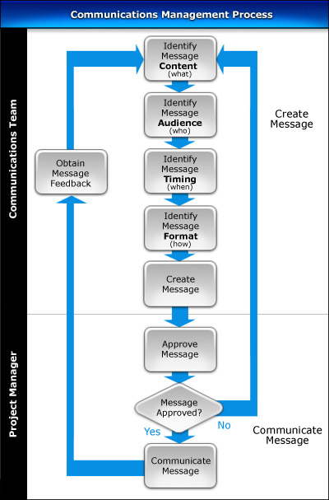

Create Message

List the steps needed to create a communications message for distribution:

- Identify the message to be communicated (i.e. “message content”)
- Identify to whom the message will be communicated (i.e. “message audience”)
- Identify when the message will be communicated (i.e. “message timing”)
- Identify how the message will be communicated (i.e. “message format”)
- Create the first and final drafts of the message
- Seek approval for all communications messages created

Communicate Message

Describe the process for reviewing all communications messages within the project and distributing those messages, once approved, to their respective audiences.

Communications Roles

In this section, describe the key roles and responsibilities involved in the Communications Management Process.

Communications Team

List the responsibilities of the Communications Team in the Communications Management Process.

Project Manager

List the responsibilities of the Project Manager in the Communications Management Process.

Communications Documents

In this section, identify the documents that are used to successfully undertake the Communications Management Process.

Project Status Report

Describe the purpose of the Project Status Report and provide a template for its completion.

Communications Register

Describe the purpose of the Communications Register and provide a template for its completion.

