Issue Management Process©
For [Project Name]

Document Control

Document Information
© | Information
Document ID | [Document Management System #]
Document Owner | [Owner Name]
Issue Date | [Date]
Last Saved Date | [Date]
File Name | [Name]

Document History
Version | Issue Date | Changes
[1.0] | [Date] | [Section, Page(s) and Text Revised]

Document Approvals
Role | Name© | Signature | Date
Project Sponsor

Project Review Group

Project Manager©

Quality Manager
[if applicable]

Procurement Manager
[if applicable]

Communications Manager
[if applicable]

Project Office Manager
[if applicable]

Table of Contents

1 Issue Process 2
1.1 Overview 2
1.2 Raise Issue 3
1.3 Review Issue 3
1.4 Assign Issue Actions 3
2 Issue Roles 3
2.1 Team Member 3
2.2 Project Manager 3
2.3 Project Board 3
3 Issue Documents 3
3.1 Issue Form 3
3.2 Issue Register 4

Issue Process

Document the process for monitoring and controlling issues within a project by completing this template

Overview

Provide an overview of the Issue Management Process, depicted as follows:

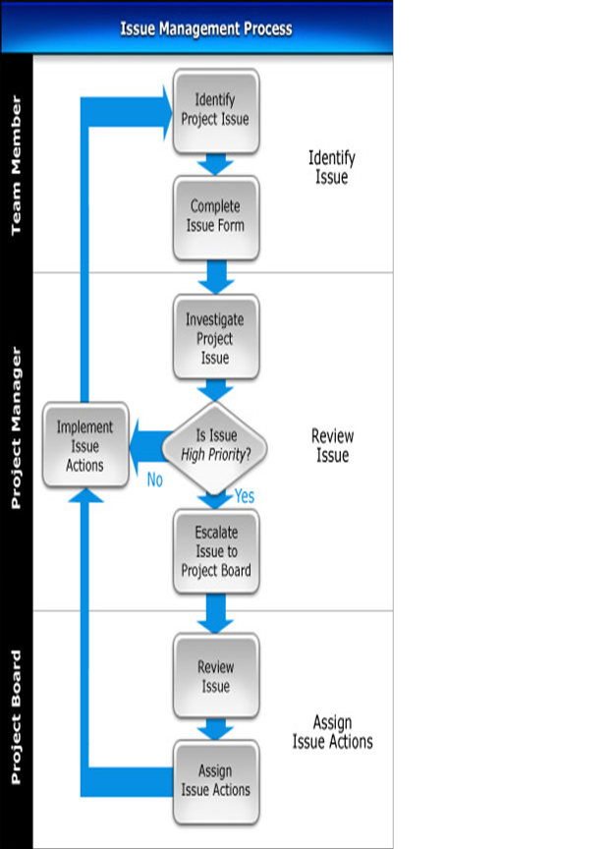

Raise Issue

List the steps needed to identify project issues and document their details on an Issue Form.

Review Issue

Describe the process by which project each issue is to be investigated, and determine its overall priority. Then list the steps involved in addressing issues: taking immediate actions on low and medium priority issues, and raising high priority issues to the Project Board.

Assign Issue Actions

Identify the procedures by which the Project Board is to review project issues and to assign the necessary actions to resolve them. Then describe the steps for implementing the issue actions and reviewing the issue regularly to ensure that those actions have achieved the desired result.

Issue Roles

In this section, describe the key roles and responsibilities involved in the Issue Management Process.

Team Member

List the responsibilities of the Procurement Manager in the Issue Management Process.

Project Manager

List the responsibilities of the Project Manager in the Issue Management Process.

Project Board

List the responsibilities of the Project Board in the Issue Management Process.

Issue Documents

In this section, identify the documents that are used to successfully undertake the Issue Management Process.

Issue Form

Describe the purpose of the Issue Form and provide a template for its completion.

Issue Register

Describe the purpose of the Issue Register and provide a template for its completion.

