Risk Management Process©
For [Project Name]

Document Control

Document Information
© | Information
Document ID | [Document Management System #]
Document Owner | [Owner Name]
Issue Date | [Date]
Last Saved Date | [Date]
File Name | [Name]

Document History
Version | Issue Date | Changes
[1.0] | [Date] | [Section, Page(s) and Text Revised]

Document Approvals
Role | Name | Signature© | Date
Project Sponsor

Project Review Group

Project Manager©

Quality Manager
[if applicable]

Procurement Manager
[if applicable]

Communications Manager
[if applicable]

Project Office Manager
[if applicable]

Table of Contents

1 Risk Process 1
1.1 Overview 1
1.2 Identify Risk 2
1.3 Review Risk 2
1.4 Assign Risk Actions 2
2 Risk Roles 2
2.1 Team Member 2
2.2 Project Manager 2
2.3 Project Board 2
3 Risk Documents 2
3.1 Risk Form 2
3.2 Risk Register 2

Risk Process

Document the process for monitoring and controlling risks within a project by completing this template.

Overview

Provide an overview of the Risk Management Process, as depicted in the following diagram:

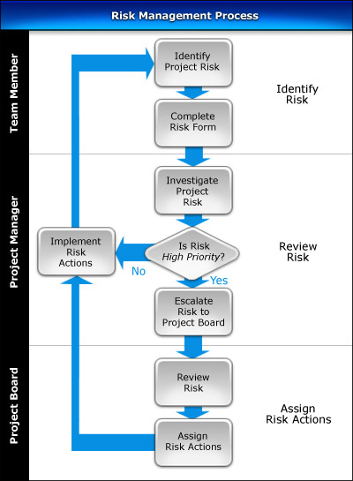

Identify Risk

List the steps needed to identify project risks and document their details on a Risk Form.

Review Risk

Describe the process by which project each risk is to be investigated, and determine its overall priority. Then list the steps involved in addressing risks: taking immediate actions on low and medium priority risks, and raising high priority risks to the Project Board.

Assign Risk Actions

Identify the procedures by which the Project Board is to review project risks and to assign the necessary actions to avoid, transfer or mitigate those risks. Then describe the steps for implementing the risk actions and reviewing the risk regularly to ensure that those actions have achieved the desired result.

Risk Roles

In this section, describe the key roles and responsibilities involved in the Risk Management Process.

Team Member

List the responsibilities of the Team Members in the Risk Management Process.

Project Manager

List the responsibilities of the Project Manager in the Risk Management Process.

Project Board

List the responsibilities of the Project Board in the Risk Management Process.

©

Risk Documents

In this section, identify the documents that are used to successfully undertake the Risk Management Process.

Risk Form

Describe the purpose of the Risk Form and provide a template for its completion.

Risk Register

Describe the purpose of the Risk Register and provide a template for its completion.

