Project Plan©
For [Project Name]

Document Control

Document Information
© | Information
Document ID | [Document Management System #]
Document Owner | [Owner Name]
Issue Date | [Date]
Last Saved Date | [Date]
File Name | [Name]

Document History
Version | Issue Date | Changes
[1.0] | [Date] | [Section, Page(s) and Text Revised]

Document Approvals
Role | Name© | Signature | Date
Project Sponsor

Project Review Group

Project Manager©

Quality Manager
[if applicable]

Procurement Manager
[if applicable]

Communications Manager
[if applicable]

Project Office Manager
[if applicable]

Table of Contents

1 Work Breakdown Structure 2
1.1 Phases 2
1.2 Activities 2
1.3 Tasks 2
1.4 Milestones 3
1.5 Effort 3
2 Project Plan 4
2.1 Schedule 4
2.2 Dependencies 5
2.3 Assumptions 5
2.4 Constraints 5
3 Appendix 5

Work Breakdown Structure

Create a Work Breakdown Structure (WBS) by listing all the phases, activities and tasks required to undertake the project.

Phases

List each project phase in the following table. Provide a description of each phase and sequence the phases, by assigning a phase number (i.e. 1, 2, 3 etc).

Phase Title | Phase Description | Phase Sequence

Activities

List each project activity in the following table, describe the activity and identify the sequencing order where appropriate.

Phase Title | Activity Title | Activity Description | Activity Sequence

Tasks

List each project task in the following table, describe the task and identify the sequencing order where appropriate.

Activity Title | Task Title | Task Description | Task Sequence

Milestones

List each project milestone in the following table, describe the milestone and record the date on which it is likely to occur.

Milestone Title | Milestone Description | Milestone Date

Effort

Identify the human resources required to accomplish each task, by completing the following table below.

Task Title | Resource | Effort

Project Plan

Schedule

Create a detailed project schedule by listing the phases, activities and tasks required to complete the project, as well as the dependencies, sequencing and resources involved. A summarized example follows:
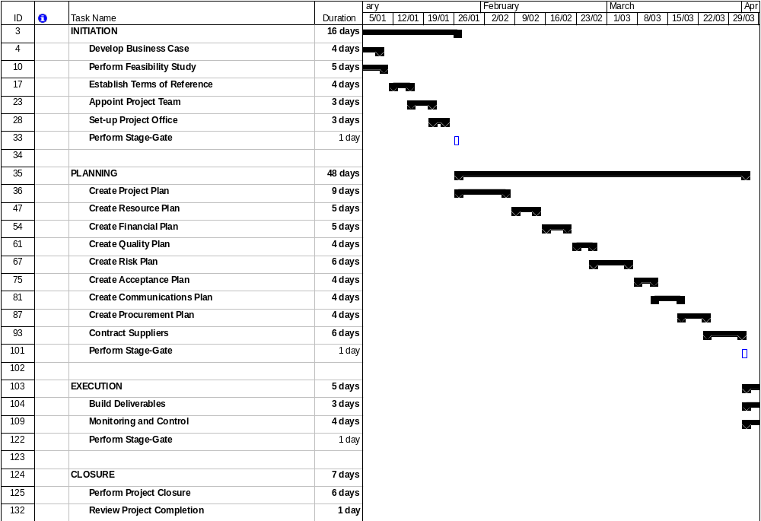

Dependencies

Explicitly state any key dependencies in the Project Schedule in the following table.

Activity Title | Depends on | Dependency Type

Assumptions

List any assumptions made during this project planning process.

Constraints

List any constraints identified during this project planning process.

Appendix

Attach any documentation you believe is relevant to the Project Plan. For example:
- Detailed Project Schedule (listing all project phases, activities and tasks)
- Other documentation (Business Case, Feasibility Study, Terms of Reference)
- Other relevant information or correspondence

