Acceptance Management Process©
For [Project Name]

Document Control

Document Information
 | Information
Document ID | [Document Management System #]
Document Owner | [Owner Name]
Issue Date | [Date]
Last Saved Date | [Date]
File Name | [Name]

Document History
Version | Issue Date | Changes
[1.0] | [Date] | [Section, Page(s) and Text Revised]

Document Approvals
Role© | Name | Signature | Date
Project Sponsor

Project Review Group

Project Manager©

Quality Manager
[if applicable]

Procurement Manager
[if applicable]

Communications Manager
[if applicable]

Project Office Manager
[if applicable]

Table of Contents

1 Acceptance Process 1
1.1 Overview 1
1.2 Complete Deliverable 2
1.3 Complete Acceptance Test 2
1.4 Accept Deliverable 2
2 Acceptance Roles 2
2.1 Project Manager 2
2.2 Customer 2
3 Acceptance Documents 2
3.1 Acceptance Form 2
3.2 Acceptance Register 2

Acceptance Process

Document the process for reviewing deliverables within the project and gaining the customer’s acceptance that they are 100% complete, by completing the following template

Overview

Provide an overview of the Acceptance Management Process, depicted as follows:

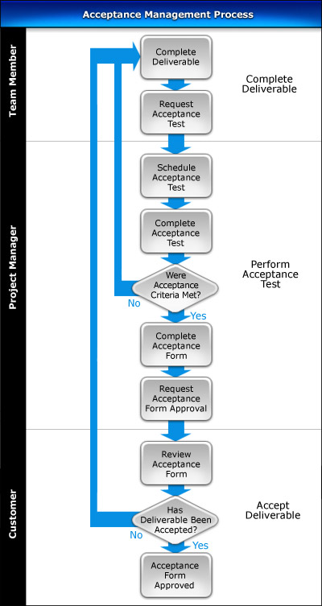

Complete Deliverable

List the steps needed to validate that a deliverable is complete and ready for acceptance testing.

Complete Acceptance Test

Describe the process of scheduling and completing acceptance tests and determining whether the results meet the criteria stated in the Acceptance Plan. Describe the steps to complete the Acceptance Form and forward it to the customer for final approval.

Accept Deliverable

List the activities involved in gaining final acceptance from the customer; that is, the customer accepts that the deliverable(s) produced by the project are 100% complete as they fully meet the acceptance criteria stated in the Acceptance Plan.

Acceptance Roles

In this section, describe the key roles and responsibilities involved in the Acceptance Management Process.

Project Manager

List the responsibilities of the Project Manager in the Acceptance Management Process.

Customer

List the responsibilities of the Customer in the Acceptance Management Process.

Acceptance Documents

In this section, identify the documents that are used to successfully undertake the Acceptance Management Process.

Acceptance Form

Describe the purpose of the Acceptance Form and provide a template for its completion.

Acceptance Register

Describe the purpose of the Acceptance Register and provide a template for its completion.

