Change Management Process©
For [Project Name]

Document Control

Document Information
© | Information
Document ID | [Document Management System #]
Document Owner | [Owner Name]
Issue Date | [Date]
Last Saved Date | [Date]
File Name | [Name]

Document History
Version | Issue Date | Changes
[1.0] | [Date] | [Section, Page(s) and Text Revised]

Document Approvals
Role | Name | Signature© | Date
Project Sponsor

Project Review Group

Project Manager

Quality Manager
[if applicable]

Procurement Manager
[if applicable]

Communications Manager
[if applicable]

Project Office Manager
[if applicable]

Table of Contents

1 Change Process 3
1.1 Overview 3
1.2 Identify Change 4
1.3 Review Change 4
1.4 Approve Change 4
1.5 Implement Change 4
2 Change Roles 4
2.1 Team Member 4
2.2 Project Manager 4
2.3 Project Board 4
3 Change Documents 5
3.1 Change Request Form 5
3.2 Change Register 5

Change Process

Document the process for monitoring and controlling changes within a project by completing this template. To gain a detailed understanding of the Change Management Process,

Overview

Provide an overview of the Change Management Process, depicted as follows:
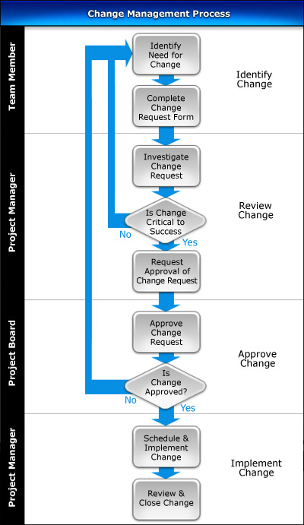

Identify Change

Describe the process for identifying change requests and completing Change Request Forms for your project.

Review Change

List the steps needed to investigate change requests to determine whether they are critical to project delivery.

Approve Change

List the factors the Project Board considers when reviewing each change request, along with each of the possible outcomes from the change approval process.

Implement Change

Identify the procedures for scheduling and implementing changes within a project. List the steps needed to review each implemented change to determine whether it has had the desired effect on the project.

Change Roles

In this section, describe the key roles and responsibilities involved in the Change Management Process.

Team Member

List the responsibilities of the Team Members in the Change Management Process.

Project Manager

List the responsibilities of the Project Manager in the Change Management Process.

Project Board

List the responsibilities of the Project Board in the Change Management Process.

Change Documents

In this section, identify the documents used to successfully undertake the Change Management Process.

Change Request Form

Describe the purpose of the Change Request Form and provide a template for its completion.

Change Register

Describe the purpose of the Change Register and provide a template for its completion.

