Procurement Management Process ©
For [Project Name]

Document Control

Document Information
© | Information
Document ID | [Document Management System #]
Document Owner | [Owner Name]
Issue Date | [Date]
Last Saved Date | [Date]
File Name | [Name]

Document History
Version | Issue Date | Changes
[1.0] | [Date] | [Section, Page(s) and Text Revised]

Document Approvals
Role | Name | Signature© | Date
Project Sponsor

Project Review Group

Project Manager©

Quality Manager
[if applicable]

Procurement Manager
[if applicable]

Communications Manager
[if applicable]

Project Office Manager
[if applicable]

Table of Contents

1 Procurement Process 3
1.1 Overview 3
1.2 Issue Purchase Order 4
1.3 Complete Purchase Order 4
1.4 Manage Supplier Contract 4
2 Procurement Roles 4
2.1 Procurement Manager 4
2.2 Project Manager 4
3 Procurement Documents 4
3.1 Purchase Order Form 5
3.2 Procurement Register 5

Procurement Process

Document the process for sourcing the procurement of items for a project by completing this template.

Overview

Provide an overview of the Procurement Management Process, depicted as follows:

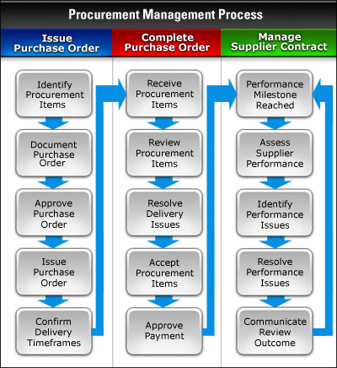

Issue Purchase Order

Describe in detail the steps needed to issue Purchase Orders to suppliers:

- Identify the items to be procured
- Complete a Purchase Order which describes the items being procured
- Approve and issue the Purchase Order to the supplier
- Confirm the estimated delivery timeframes

Complete Purchase Order

Describe in detail the steps needed to complete (i.e. fulfill) Purchase Orders:

- Receive procurement items from suppliers
- Review the items received against the terms of the contract
- Identify and resolve any supplier delivery issues
- Accept the procurement items received, on behalf of the project
- Approve supplier invoices for payment

Manage Supplier Contract

Describe in detail the steps to manage the supplier’s performance through the procurement process:

- Identify when performance milestones have been reached
- Assess the supplier’s performance based on the terms of the contract
- Identify any performance issues and making the supplier aware of those issues
- Resolve all issues identified and continuing with the terms of the contract
- Communicate the outcome of the performance reviews, to all appropriate project stakeholders

Procurement Roles

In this section, describe the key roles and responsibilities involved in the Procurement Management Process.

Procurement Manager

List the responsibilities of the Procurement Manager in the Procurement Management Process.

Project Manager

List the responsibilities of the Project Manager in the Procurement Management Process.

Procurement Documents

In this section, identify the documents that are used to successfully undertake the Procurement Management Process.

Purchase Order Form

Describe the purpose of the Purchase Order Form and provide a template for its completion.

Procurement Register

Describe the purpose of the Procurement Register and provide a template for its completion.

