Quality Management Process©
For [Project Name]

Document Control

Document Information
© | Information
Document ID | [Document Management System #]
Document Owner | [Owner Name]
Issue Date | [Date]
Last Saved Date | [Date]
File Name | [Name]

Document History
Version | Issue Date | Changes
[1.0] | [Date] | [Section, Page(s) and Text Revised]

Document Approvals
Role | Name | Signature© | Date
Project Sponsor©

Project Review Group

Project Manager

Quality Manager
[if applicable]

Procurement Manager
[if applicable]

Communications Manager
[if applicable]

Project Office Manager
[if applicable]

Table of Contents

1 Quality Process 2
1.1 Overview 2
1.2 Define Quality Targets 3
1.2.1 Identify Quality Targets 3
1.2.2 Identify How to Measure & Assure Quality 3
1.3 Measure Quality Achieved 3
1.3.1 Perform Quality Assurance 3
1.3.2 Undertake Quality Control 3
1.4 Enhance Quality Achieved 3
1.4.1 Undertake Quality Improvement Actions 3
1.4.2 Report Level of Quality Achieved 4
2 Quality Management Roles 4
2.1 Quality Manager 4
2.2 Quality Reviewer 4
3 Quality Management Documents 4
3.1 Deliverables Register 4
3.2 Quality Review Form 4

Quality Process

Document the process for monitoring and controlling quality within a project, by completing this template.

Overview

Provide an overview of the Quality Management Process, depicted as follows:
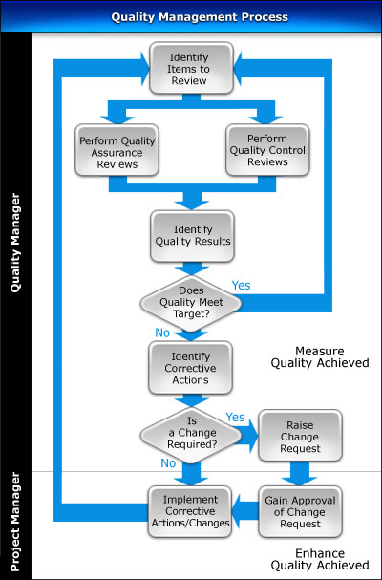

Measure Quality Achieved

List the steps required to:
- Identify the deliverables and processes for review
- Perform Quality Assurance to understand the overall project “performance” and “conformance”
- Perform Quality Control to determine the actual level of quality of project deliverables
- Document the quality review results and identify any deviations from quality targets
- Identify any actions required to correct quality deviations
- Create Change Requests for changes needed to correct quality deviations

Enhance Quality Achieved

Describe the procedures involved in gaining approval of change requests and corrective actions to enhance the quality of project deliverables and processes.

Quality Management Roles

In this section, describe the key roles and responsibilities in the Quality Management Process.

Quality Manager

List the responsibilities of the Quality Manager in the Quality Management Process.

Project Manager

List the responsibilities of the Project Manager in the Quality Management Process.

Quality Management Documents

In this section, identify the documents used to successfully undertake the Quality Management Process.

Quality Register

Describe the purpose of the Quality Register and provide a template for its completion.

Quality Review Form

Describe the purpose of the Quality Review Form and provide a template for its completion.

