Time Management Process©
For [Project Name]

Document Control

Document Information
© | Information
Document ID | [Document Management System #]
Document Owner | [Owner Name]
Issue Date | [Date]
Last Saved Date | [Date]
File Name | [Name]

Document History
Version | Issue Date | Changes
[1.0] | [Date] | [Section, Page(s) and Text Revised]

Document Approvals
Role | Name© | Signature | Date
Project Sponsor

Project Review Group©

Project Manager

Quality Manager
[if applicable]

Procurement Manager
[if applicable]

Communications Manager
[if applicable]

Project Office Manager
[if applicable]

Table of Contents

1 Time Management Process 2
1.1 Overview 2
1.2 Document Timesheet 3
1.3 Approve Timesheet 3
1.4 Update Project Plan 3
2 Time Management Roles 3
2.1 Team Member 3
2.2 Project Manager 3
2.3 Project Administrator 3
3 Time Management Documents 3
3.1 Timesheet 3
3.2 Timesheet Register 3

Time Management Process

Document the process for monitoring and controlling time spent within a project by completing this template.

Overview

Provide an overview of the Time Management Process, as depicted by the following diagram:

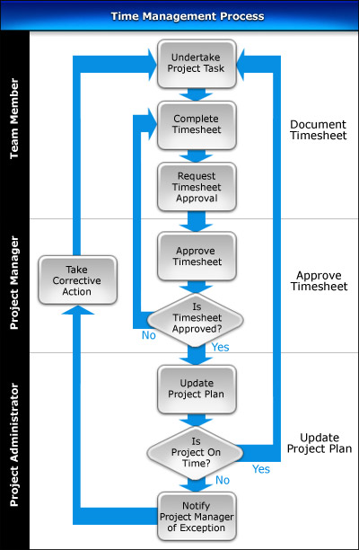

Document Timesheet

Explain the process for completing Timesheets and submitting them to the Project Manager for approval.

Approve Timesheet

List the steps required to approve timesheets and the factors a Project Manager should consider when assessing them.

Update Project Plan

Describe the steps needed to update the Project Plan and determine whether the project is currently being delivered On Time. Describe the process for recording the current Time Management status in the Timesheet Register.

Time Management Roles

In this section, describe the key roles and responsibilities involved in the Time Management Process.

Team Member

List the responsibilities of the Team Members in the Time Management Process.

Project Manager

List the responsibilities of the Project Manager in the Time Management Process.

Project Administrator

List the responsibilities of the Project Administrator in the Time Management Process.

Time Management Documents

In this section, list the documents used to successfully undertake the Time Management Process.

Timesheet

Describe the purpose of the Timesheet, and provide a template for its completion.

Timesheet Register

Describe the purpose of the Timesheet Register, and provide a template for its completion.

