[Project Role]
Job Description for©
[Project Name]

Table of Contents

1 Overview 2
2 Purpose 2
3 Responsibilities 2
4 Organization 2
5 Relationships 3
6 Skills 4
7 Experience 4
8 Qualifications 4
9 Personality 4
10 Performance Criteria 4
11 Work Environment 4
12 Salary 4
13 Special Conditions 4

Overview

Summarize the project and this particular role by describing the following:

- Key objectives and scope of the project
- Background leading to the creation of this role
- Purpose and key responsibilities of the role
- Reporting relationships
- Skills, experience and qualifications required

Purpose

Describe the purpose of this role within the project. For example: “The purpose of the Project Manager's role is to undertake all phases, activities and tasks within specified time, cost and quality constraints to deliver the required project outcome and achieve customer satisfaction.”

Responsibilities

List all the responsibilities associated with this role. Spend the time required to create as full a list of responsibilities as possible, as this list will not only be used to recruit the best candidate to the role, but it will also be referred to by the Project Manager when managing the performance of the individual recruited.

Organization

Show the reporting relationships between this role and the other key roles within the project, by providing an Organization Chart. An example of an Organization Chart follows:
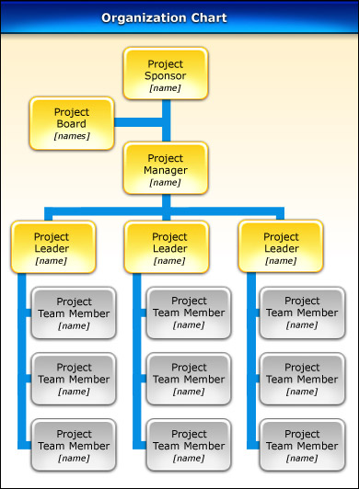

Relationships

Describe in detail the key reporting and communication lines between this role and others within the project.

Skills

List each of the skills and key competencies needed to undertake the role.

Experience

Define the level of experience required to undertake this role successfully.

Qualifications

List the qualifications needed to undertake this role competently. This may include college or university qualifications, as well as relevant specialist courses. Also specify the required qualification discipline where appropriate.

Personality

Describe any particular interpersonal characteristics required by this role.

Performance Criteria

List the criteria which will provide a basis upon which to assess the performance of the person in this role. All performance criteria listed should be specific, measurable, relevant and achievable.

Work Environment

Provide a description of the general work environment to allow potential candidates to understand the working conditions associated with this role.

Salary

Describe the salary package for the role, including commissions and benefits.

Special Conditions

Inform potential candidates of any special conditions associated with this role, such as specialist licenses, travel or after-hours work required.

