Procurement Plan ©
For [Project Name]

Document Control

Document Information
© | Information
Document ID | [Document Management System #]
Document Owner | [Owner Name]
Issue Date | [Date]
Last Saved Date | [Date]
File Name | [Name]

Document History
Version | Issue Date | Changes
[1.0] | [Date] | [Section, Page(s) and Text Revised]

Document Approvals
Role | Name | Signature© | Date
Project Sponsor

Project Review Group

Project Manager©

Quality Manager
[if applicable]

Procurement Manager
[if applicable]

Communications Manager
[if applicable]

Project Office Manager
[if applicable]

Table of Contents

1 Procurement Requirements 3
1.1 Requirements 3
1.2 Market Research 3
2 Procurement Plan 3
2.1 Schedule 3
2.2 Assumptions 6
2.3 Constraints 6
3 Tender Process 6
3.1 Activities 6
3.2 Roles 6
3.3 Documents 6
4 Procurement Process 6
4.1 Activities 6
4.2 Roles 6
4.3 Documents 7
5 Appendix 7

Procurement Requirements

In this section, document the procurement requirements of the project, and complete market research to ensure that you can feasibly source the procurement items when required.

Requirements

Define what you are procuring (or outsourcing). Using the following table, list and describe the procurement items, which must be procured to help the project team to achieve its objectives; offer your reasoning for outsourcing these items to external suppliers; and finally, list the quantities required and the budget available.

Item | Description | Justification | Quantity | Budget

Market Research

Complete research to show that the market includes a range of suppliers and offerings that are able to meet the procurement needs of the project. To prove that suitable offerings are currently available, list examples in the following table:

Item | Supplier | Offering | Price | Availability

Procurement Plan

Schedule
Create a detailed schedule for the selection of a preferred supplier, delivery of procurement items and management of the supplier performance, as follows:

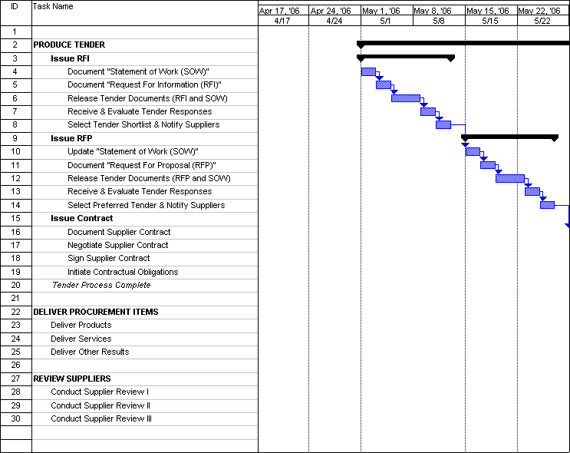

Assumptions

List any assumptions made during this procurement planning process.

Constraints

List any constraints identified during this procurement planning process.

Tender Process

Describe the process for short-listing, selecting, and contracting preferred suppliers to the project.

Activities

List the activities required to select and contract a preferred supplier to the project.

Roles

List the roles and responsibilities involved with appointment of a preferred supplier to the project

Documents

List the documents used to contract a preferred supplier to the project.

Procurement Process

Describe the process for receiving, reviewing and accepting procurement items from suppliers on behalf of the project.

Activities

List the activities required to receive and accept procurement items from suppliers contracted to the project.

Roles

List the roles and responsibilities involved with receiving and accepting procurement items from suppliers contracted to the project.

Documents

List the documents used to receive and accept procurement items from suppliers contracted to the project.

Appendix

Attach any documentation you believe is relevant to the Procurement Plan, such as:

- Project documentation (e.g. Business Case, Feasibility Study, Terms of Reference, Project Plan, Resource Plan, Financial Plan or Quality Plan)
- Requirements Analysis or Needs Analysis documentation
- Market Research materials
- Other relevant information or correspondence

