|  |  |
| --- | --- |
|  | %title%  %local_title% |

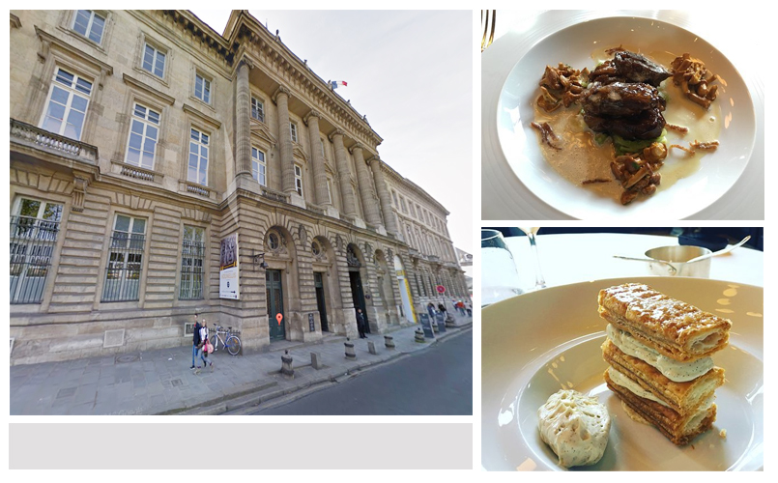

|  |  |
| --- | --- |
| **餐厅经纬度** | %latlng% |
| **餐厅地址** | %address% |
| **推荐美食** | %recommended_dishes% |
| **营业时间** | %openning_hours% |
| **如何抵达** | %route% |