|  |  |
| --- | --- |
|  | %title% |

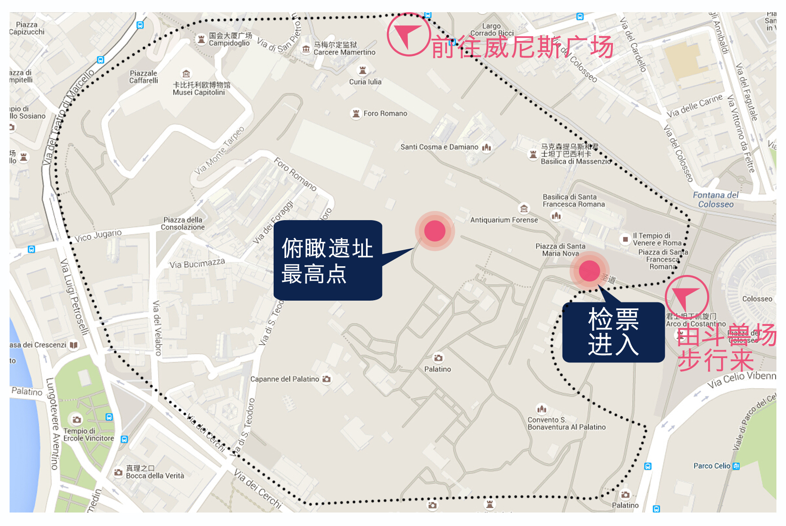

|  |  |
| --- | --- |
| **景点经纬度** | %latlng% |
| **景点地址** | %local_title% |
| **如何抵达** | %route% |
| **开放时间** | %open_close_more% |
| **小贴士** | %tips% |