行程详细路书

%trip_startend%

共%trip_days%日

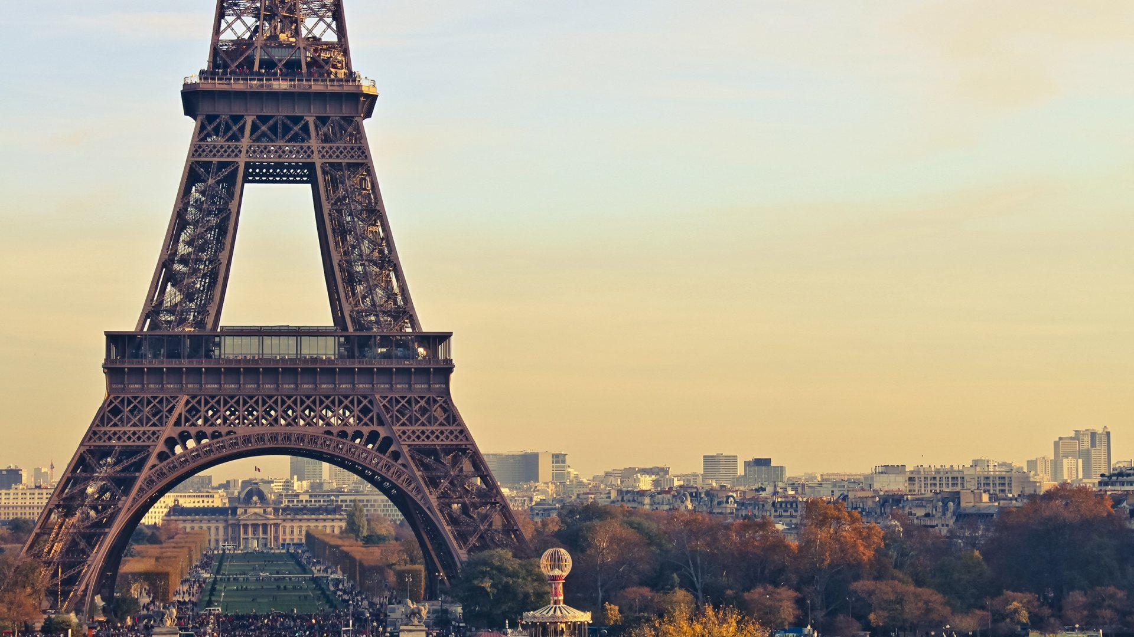

|  |  |  |  |  |
| --- | --- | --- | --- | --- |
| 行 程 概 览 | | | |  |
| 天 | 日期 | 城市 | 每日简略内容 | 住宿 |
| %day_day% | %day_date%  %day_weekday% | %day_cities% | 1. %day_location% | %day_hotel% |