BILLING: Debt & Legal – Section 129 Notices – PART 1

TABLE OF CONTENTS
Contents
Glossary 2
Business requirement 2
Business Objectives 3
In scope 3
3.1 Detailed enhancement REQUIREMENTS – Menu’s and Permissions 3
Program Menu/Execution Path – Menu Changes 3
3.1.1 Permissions 3
3.1.2 Billing >> Debt - Section 129 – Letter of Demand (Menu Item) 4
3.1.3 Billing >> Debt - Section 129 – Letter of Demand (Sub Menu Item) 4
3.1.4 Permissions 4
3.1.5 Billing >> Debt – Authorise Section 129 (Sub Menu Item) 4
3.1.6 Permissions 5
3.1.7 Billing >> Debt – Handover (Menu Item) 5
3.1.8 Billing >> Debt – Handover Process (Sub Menu Item) 5
3.1.9 Permissions 6
3.1.10 Billing >> Debt – Authorise Handover (Sub Menu Item) 6
3.1.11 Permissions 6
3.1.12 Billing >> Reports >> Debt Recovery – Section 129 Letter of Demand Report & Handover Report 6
3.1.13 Permissions 7
3.1.14 Billing >> Reports >> Miscellaneous Reports – SMS Log Report 7
3.1.15 Permissions 7
3.1.16 Const_Status 7
3.1.17 Billing Dashboard – Debt Notification – Section 129 – Letter of Demand to be processed for Handover 8

Glossary

Term/Acronym | Description
SCOA | Standard Chart of Accounts.
Section 129 Notice | This is a final demand notice from the municipality send to the consumer in respective of outstanding amounts owed and not paid.
Handover | This is when an account remained unpaid, and the municipality decides to do a handover to an attorney to try and recover the amounts owed by means of legal processes. This process will make use of a “Handed Over Account”.
Handed Over Account | This is an account created by the Section 129 – Letter of Demand process and linked to the Master Account. There can be more than one Handed Over Account linked to a Master Account
Master Account | This is the original account where the arrears originated from.

Business requirement

The aim is to create functionality whereby a formal legal process can be actioned by the municipality to recover monies owed to the municipality.

To create and issue Section 129 notices (Letter of Demands) which will inform the Account Holder that legal actions will be started if outstanding arrears are not paid, or an acknowledgment of Debt is made within 14 workdays from Letter of Demand issued.

Number | Requirement description
1 | A configuration for legal action functionalities must be created to accommodate various settings required to use these functionalities.
2 | A new function must be created to qualify accounts for Section 129 notices and create these notices.
3 | The Section 129 notices on TRIAL RUN:  - Must be stored on General Enquiries for easy access.  - Must be able to mail them to the account holder.  - Must be able to SMS notification to the account holder  - Must be able to be printed/ mailed to a print house in bulk.
4 | An admin fee to raise during the FINAL RUN must be configurable.
5 | 3 options are required to execute this hand over process:  - Account  - Bulk  - Rotational

Business Objectives
To enable the client to apply credit control to accounts with unpaid balances with the use of formal legal action procedures.

In scope

No | Description
1 | Create a legal action configuration menu item to accommodate the relevant configuration settings.
2 | Create functionality to apply qualification based on parameters/filters for Section 129 notices and create the actual notices.
3 | Create the functionality to create the handover process
4 | Create the section 129 template used for email & print
5 | Create the SMS notification template
6 | Create Dashboard Notification under Debt for “Section 129 Letter of Demand – Process Handovers
7 | Add Status under Const_Status as indicated below

3.1 Detailed enhancement REQUIREMENTS – Menu’s and Permissions

Program Menu/Execution Path – Menu Changes
3.1.1 Configuration Menu >> Billing – Debt & Legal Settings

- Sort and list the menu items to be in alphabetical order.

- Add a new menu item to the “Billing – Debt & Legal” main menu in the correct alphabetical position.
  - Section 129 – Letter of Demand

3.1.1 Permissions
This function must be governed by the standard permissions functionality whereby it must be linked to the roles who are allowed to use it.
Config (Page Control) – Section 129 – Letter of Demand
ManageRolePermissions.aspx

3.1.2 Billing >> Debt - Section 129 – Letter of Demand (Menu Item)

- Add a new menu item to the Debt menu.
  - Sec 129 – Letter of Demand

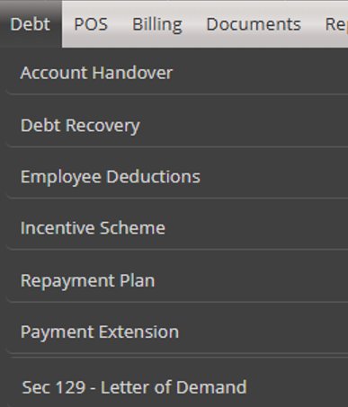

3.1.3 Billing >> Debt - Section 129 – Letter of Demand (Sub Menu Item)

- Add a new sub-menu item to the Section 129 – Letter of Demand
  - Process Section 129 - Letter of Demand

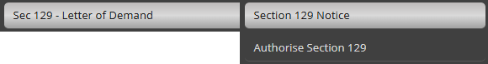

3.1.4 Permissions
This function must be governed by the standard permissions functionality whereby it must be linked to the roles who are allowed to use it.
Workflow (Page) – Section 129 – Letter of Demand
ManageRolePermissions.aspx

3.1.5 Billing >> Debt – Authorise Section 129 (Sub Menu Item)

- Add a new sub-menu item to the Section 129 – Letter of Demand
  - Authorise Section 129



3.1.6 Permissions
This function must be governed by the standard permissions functionality whereby it must be linked to the roles who are allowed to use it.
Workflow (Page) – Authorise Section 129
ManageRolePermissions.aspx

3.1.7 Billing >> Debt – Handover (Menu Item)

- Add a new menu item to the Debt menu.
  - Handover
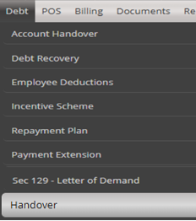

3.1.8 Billing >> Debt – Handover Process (Sub Menu Item)

- Add a new sub-menu item to the Handover
  - Handover Process
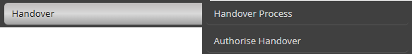

3.1.9 Permissions
This function must be governed by the standard permissions functionality whereby it must be linked to the roles who are allowed to use it.
Workflow (Page) – Handover Process
ManageRolePermissions.aspx

3.1.10 Billing >> Debt – Authorise Handover (Sub Menu Item)

- Add a new sub-menu item to the Handover
  - Authorise Handover


3.1.11 Permissions
This function must be governed by the standard permissions functionality whereby it must be linked to the roles who are allowed to use it.
Workflow (Page) – Authorise Handover
ManageRolePermissions.aspx

3.1.12 Billing >> Reports >> Debt Recovery – Section 129 Letter of Demand Report & Handover Report

- Add a new menu item to the Debt Reports menu.

  - Sec 129 – Letter of Demand Report
  - Handover Report
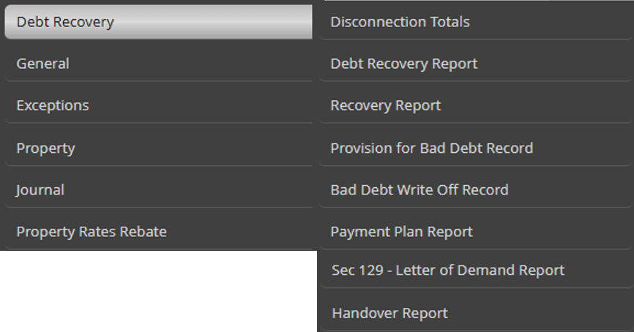

3.1.13 Permissions
This function must be governed by the standard permissions functionality whereby it must be linked to the roles who are allowed to use it.
- Report (Page) – Sec 129 – Letter of Demand Report
- Report (Page) – Handover Report
ManageRolePermissions.aspx

3.1.14 Billing >> Reports >> Miscellaneous Reports – SMS Log Report

- Add a new menu item to the Reports – Miscellaneous Reports menu.

  - SMS Log

3.1.15 Permissions
This function must be governed by the standard permissions functionality whereby it must be linked to the roles who are allowed to use it.
- Report (Page) – SMS Log Report
ManageRolePermissions.aspx

3.1.16 Const_Status

Add a new status ID’s into the Const_Status table that will be used for the Section 129 Letter of Demand process under Billing>>Debt.

StatusDesc | UsedBy | Enabled
Notice Issued – Trial Review | Debt & Legal | 1
Notice Issued – Trial | Debt & Legal | 1
Notice Issued - Final | Debt & Legal | 1
Notice Issued - Expired | Debt & Legal | 1
Handover – Pending | Debt & Legal | 1
Handover - Active | Debt & Legal | 1
Handover - Terminate | Debt & Legal | 1
Handover – Termination Approved | Debt & Legal | 1

3.1.17 Billing Dashboard – Debt Notification – Section 129 – Letter of Demand to be processed for Handover

Add a new notification on the Debt notification label:
Section 129 – Letter of Demand - Process Handovers
- This notification will only be activated if the 14 working days have been reached from the date of the Final Notice being send out.
- When selecting it from the grid it will redirect the user to the Handover Process landing page

