BILLING: Debt & Legal – Section 129 Notices – PART 2

TABLE OF CONTENTS
Contents
Glossary 2
Business requirement 2
Business Objectives 3
In scope 3
3.1 Detailed enhancement REQUIREMENTS – Menu’s & permissions – part 1 (spec) 3
4.1 Program Menu/Execution Path – Section 129 – Letter of Demand Configuration – Part 2 (Spec) 3
4.1.1 Business Rules 3
4.1.2 Use Case Diagram 4
4.1.3 Use Case Narratives – Section 129 Notice Configuration 4
4.1.4 Error Messages 7
4.1.5 Proposed Screen Layout – Section 129 – Letter of Demand Configuration - Landing Page 8
4.1.6 Proposed Screen Layout – Section 129 Notice Configuration - Landing Page Search Grid 9
4.1.7 Proposed Screen Layout – Section 129 Notice Configuration - Detail Page 10
4.1.8 Proposed Grid Layout – Section 129 Notice Configuration - Additional Billing 15
4.1.9 Proposed Grid Layout – Section 129 Notice Configuration - Attorney 16
4.1.10 Section 129 – Email Template 16
4.1.11 Section 129 – SMS Template 20

Glossary

Term/Acronym | Description
SCOA | Standard Chart of Accounts.
Section 129 Notice | This is a final demand notice from the municipality send to the consumer in respective of outstanding amounts owed and not paid.
Handover | This is when an account remained unpaid, and the municipality decides to do a handover to an attorney to try and recover the amounts owed by means of legal processes. This process will make use of a “Handed Over Account”.
Handed Over Account | This is an account created by the Section 129 – Letter of Demand process and linked to the Master Account. There can be more than one Handed Over Account linked to a Master Account
Master Account | This is the original account where the arrears originated from.

Business requirement

The aim is to create functionality whereby a formal legal process can be actioned by the municipality to recover monies owed to the municipality.

To create and issue Section 129 notices (Letter of Demands) which will inform the Account Holder that legal actions will be started if outstanding arrears are not paid, or an acknowledgment of Debt is made within 14 workdays from Letter of Demand issued.

Number | Requirement description
1 | A configuration for legal action functionalities must be created to accommodate various settings required to use these functionalities.
2 | A new function must be created to qualify accounts for Section 129 notices and create these notices.
3 | The Section 129 notices on TRIAL RUN:  - Must be stored on General Enquiries for easy access.  - Must be able to mail them to the account holder.  - Must be able to SMS notification to the account holder  - Must be able to be printed/ mailed to a print house in bulk.
4 | An admin fee to raise during the FINAL RUN must be configurable.
5 | 3 options are required to execute this hand over process:  - Account  - Bulk  - Rotational

Business Objectives
To enable the client to apply credit control to accounts with unpaid balances with the use of formal legal action procedures.

In scope

No | Description
1 | Create a legal action configuration menu item to accommodate the relevant configuration settings.
2 | Create functionality to apply qualification based on parameters/filters for Section 129 notices and create the actual notices.
3 | Create the functionality to create the handover process
4 | Create the section 129 template used for email & print
5 | Create the SMS notification template
6 | Create Dashboard Notification under Debt for “Section 129 Letter of Demand – Process Handovers
7 | Add Status under Const_Status as indicated below

3.1 Detailed enhancement REQUIREMENTS – Menu’s & permissions – Part 1 (spec)

4.1 Program Menu/Execution Path – Section 129 – Letter of Demand Configuration – Part 2 (Spec)
Configurations >> Debt & Legal Settings >> Section 129 - Letter of Demand

4.1.1 Business Rules

Number | Business Rule
1 | The standard Section 129 Notice template must be linked – it must be defaulted as the setting.
2 | SMS notification template must be linked – it must be defaulted as the setting
3 | Number of lapse days from notice before legal procedures initiated cannot be zero – must be defaulted to 14 – this is workdays excluding weekends and public holidays, which is the current prescribed lapse days by law.
4 | The number of PDF notices created per file must be configurable.
5 | Provision must be made for a cost item to be setup to raise a fee (or not) for creating the notice.
6 | The parameters must be set for a specific financial year and cannot be changed once it is saved.
7 | To change a set of parameters a new set of parameters must be added.
8 | Multiple entries for a financial year are possible.  But only 1 entry for a specific financial year can be enabled at any one time.
9 | If a specific entry for a fin-year is enabled by the user – then all other entries for the same year must be auto-disabled by the system.
10 | The same function methodology as “Clearance Cost” can be used with this configuration item.
11 | Provision must be made for Attorney Rotation setup to rotate attorney with the option to equally divide the nr of accounts or equally divide the handed over amount for the appointed attorneys.
12 | Percentage Allocation in Debtor Count OR Percentage Allocation in Handover Amount must be filled in
13 | The percentage total must add up to 100%
14 | Create a dashboard notification for user to know when the execution days has lapsed.

4.1.2 Use Case Diagram

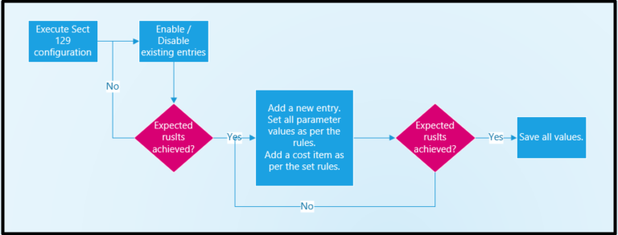

4.1.3 Use Case Narratives – Section 129 Notice Configuration

Use Case Number: | Use Case 1
Description: | Section 129 Notices Configuration
Preconditions: | None
Flow of Events: | Actor | System
 | - Navigate to ‘Configurations’.  - Select the ‘Billing – Debt & Legal Settings’ label.  - Select the ‘Section 129 – Letter of Demand’ menu item.  - Select the relevant fin-year.  - Click the search button.  - Click a line entry in the grid.  - Enable or disable the entry  - Now add a new entry for the current fin-year.  - Link the relevant Section 129 notice template to be used.  - Link the relevant SMS notice template to be used.  - Complete the lapse days parameter.  - Complete the no-of-notices-per-file parameter.  - Notice Cost setup (create label)  Select the additional-billing-type and cost to levy  - Click “Add” to add the entry to the grid.  - To delete the entry from the grid, click the remove (dustbin) button.  - Rotation Attorney used? (Create label)  - Select the Attorney  - Select the Percentage Allocation in Debtor Count  - Percentage Allocation in Handover Amount  - Click “Add” to add the entry to the grid.  Grid Headers  - Validation  - To delete the entry from the grid, click the remove (dustbin) button.  - If “Cancel” is clicked.  - If “Submit” is clicked. | - The system must load the Configuration menu page.  - The system must load the Billing – Debt & Legal Settings sub-menu.  - The system must load the landing page.  - The system will:  - Display a dropdown containing financial years to select from.  - The system will:  - Display all entries already captured for the fin-year in a grid.  - Enable each line in the grid to be clicked by the user.  - The system will:  - Load the details page displaying all details for the selected item.  - Allow the user to only access the “Enabled” button – which can by changed.  - The system will:  - Disable or enable the specific entry as requested.  - Do the opposite to all the other entries for the same year.  - The system will display an empty detail page to be completed.  - The system will:  - Default the setting to the standard notice template if no template has been selected yet.  - Avail a dropdown to choose templates from.  - A template must be selected.  - The system will:  - Default the setting to the standard notice template if no template has been selected yet.  - Avail a dropdown to choose templates from.  - A template must be selected.  - The system will:  - Default the setting to the prescribed number of days of 14.  - The number cannot be less than 14 or greater than 99.  - Hint – Only applicable to Workdays  - The system will:  - Default the setting to 500.  - The number cannot be less than 1.  - The system will:  Provide a dropdown list of add-bill-types to choose from.  Allow the user to enter the cost amount.  Both or none of these 2 parameters must be supplied.  Display the relevant error message as per section 3.3.6 if both not supplied.  - Save the selected add-bill-type and amount to the grid.  - The system will remove the entry from the grid.  - The system will:  Provide a check box – enabled = 1 “Yes”, 0 = “No”  - The system will:  Provide a dropdown list of Attorneys to choose from. (Const_Attorney)  - The system will:  Allow the user to enter the percentage Value with NO decimals  - The system will:  Allow the user to enter the percentage Value with NO decimals  Either/OR of these 2 parameters must be supplied.  Display the relevant error message as per section 3.3.6 if both not supplied.  - Create the following headers for the grid:  Nr.  Attorney  Percentage Allocation in Debtor Count  Percentage Allocation in Handover Amount  - These Percentages must sum to 100%  - The system will remove the entry from the grid.  - The system will not save any changes made and navigate back to the menu page.  - The system will save the changes made to the parameters and navigate back to the menu page.
Exception Conditions: | - Validation – Percentage must add to 100%
Post Conditions: | The required values for the Section 129 notices will now be set.

4.1.4 Error Messages

Number | Action | Description
1 | When the user completes the lapse-days, and the value is not > 0 and less than 100. | The Section 129 – Letter of Demand lapse days must be > 0 and < 100.
2 | When the user completes the no-of-notices-per-file field, and the value is < 1. | The No-of-notices-per-file cannot be less than 1.
3 | When any of the mandatory parameters are not supplied. | Please supply a value for xxxxxxxxxxxxx.
4 | If only 1 of the cost parameters is supplied and not both. | Both or none of the cost parameters must be supplied.
5 | If the user attempt to load a duplicate additional billing type & attorney into the cost grid & Attorney Rotation. | Duplicate for additional-billing-type & attorney <add-bill-type> not allowed.
6 | If the user attempt to load both Percentage fields | Either/OR one of the percentage parameters must be supplied.

4.1.5 Proposed Screen Layout – Section 129 – Letter of Demand Configuration - Landing Page
Configurations > Billing – Debt & Legal Settings > Section 129 – Letter of Demand

- Create the below new landing page.
Note that this layout is only for illustrative purposes.
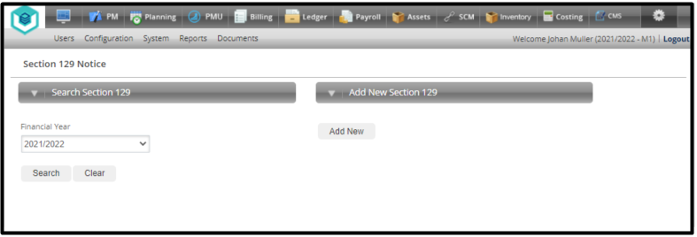
Field Name | Dropdown / Input / Display | Mandatory | Notes
Financial Year | Dropdown | Yes | Default to the current financial year.  Populate the dropdown list as follows:  - Display sequence must be ascending – oldest fin-year 1st in the list.  - Always display the current fin-year and the next fin-year.  - Display all the previous fin-years for which entries can be found in this configuration table.

Button | Description
Search | For the selected fin-year.  Find all the already registered entries.  Populate the search grid.  Display the search grid.
Clear | Re-instate the default landing page parameter values.  Close the search grid if it was displayed.  Re-display the landing page.
Add New | Display the Section 129 Notice detail page as per section 3.3.10.

4.1.6 Proposed Screen Layout – Section 129 Notice Configuration - Landing Page Search Grid
Configurations > Billing – Debt & Legal Settings > Section 129 – Letter of Demand > Search

- Create the below new search grid to be displayed with the landing page.
Note this screen is only for illustration purposes
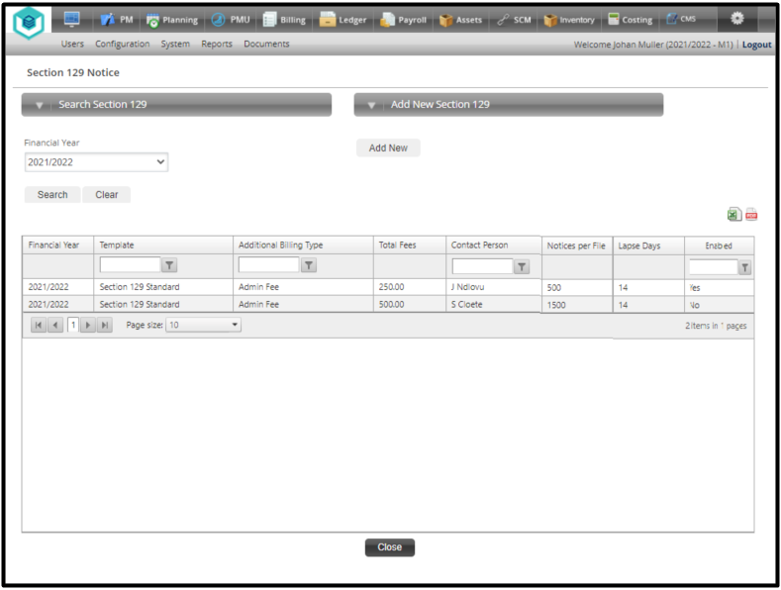

- The search grid will be displayed when the “Search” button has been clicked.
- Apply all standard grid functionalities – e.g. export to Excel and PDF.
- All registered entries for the selected financial year must be displayed in the grid.
- The display sequence must be:
  - Primary – Fin-year
  - Secondary – Internal record-ID in ascending order
- The lines in the grid must be active for the user to click on a line which will trigger the detail screen for that line to be displayed.

Field Name | Dropdown / Input / Display | Mandatory | Notes
Financial Year | Display | N/A | - The registered fin-year.
Section 129 Template | Display | N/A | - The template linked to the line item.
SMS Template | Display | N/A | - The template linked to the line item.
Additional Billing Type | Display | N/A | - The add-bill-type for the admin fees if any.
Total Fees | Display | N/A | - The fee amount.
Notices per File | Display | N/A | - The number of notices to be in a single file.
Lapse Days | Display | N/A | - The number of lapse days before further legal action is to be taken.
Rotation Activated | Display | N/A | - Display “Yes” if enabled else display “No”.
Enabled | Display | N/A | - Display “Yes” if enabled else display “No”.

Button | Description
Active Line Item in the Grid | If a populated line in the grid is clicked – then the detail page must be displayed containing the relevant line item’s details.
Close | Abandon transaction.  Navigate back to the Configuration menu.

4.1.7 Proposed Screen Layout – Section 129 Notice Configuration - Detail Page
Configurations > Billing – Debt & Legal Settings > Section 129 Notices > Add New or Enquire

- Create the below new detail page.
- This page must be displayed:
  - When the “Add New” button was clicked:
    - All fields must be available to be edited by the user.
    - The “Add” button for the Notice Cost setup must be active.
    - The “Add” button for the attorney setup must be active.
    - The below field definitions must be applied.
  - When a line item in the search grid was clicked:
    - All fields must be protected and CANNOT be changed.
    - This is display only.
Note that this layout is only for illustrative purposes.
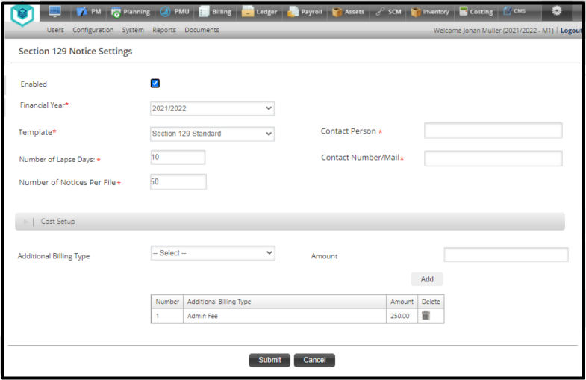
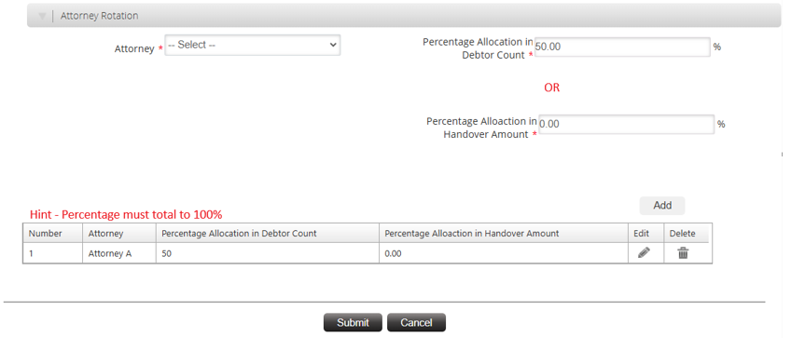
- The below field rules must be applied on “Add New”.
- If more than one cost item is loaded – then add a new line to the grid. The grid must grow and shrink depending on the number of cost items loaded.

Field Name | Dropdown / Input / Display |  | Mandatory | Notes
Enabled | Check Box |  | No | Default to “Enabled” (Checked)
Financial Year | Input |  | Yes | Default to the current financial year based on the calendar date.
Section 129 Template | Dropdown |  | Yes | Default to value “Section 129 Standard”.  At this point the dropdown list must only have the 1 option to select from:  - Section 129 Standard.  This template is as per the definition in Annexure A.2.1
SMS Notification Template | Dropdown |  | Yes | Default to value “Section 129 Standard”.  At this point the dropdown list must only have the 1 option to select from:  - SMS Notification.  This template is as per the definition in Annexure A.2.2
No of Lapse Days | Input |  | Yes | Default to value “14”.  Format is integer – no decimals.  The value cannot be < 14 (Fourteen) or > 99 (ninety-nine).  (14 days are prescribed by Law)  Hint – Only applicable to workdays  Display the relevant error message if the validation is not met as per section 3.3.6.
No of Notices per File | Input |  | Yes | Default to value “500”.  Format is integer – no decimals.  The value cannot be < 0 (zero).  Display the relevant error message if the validation is not met as per section 3.2.6.
Additional Billing Type | Dropdown |  | No | The additional billing type if fees are to be levied.  Default to “—Select—“.  Populate dropdown list with:  - --Select—  - All “Enabled” add-bill-types of cost-type “Add-bill-cost”.  Mandatory if Amount is supplied.  Duplicate Additional-Billing-Types cannot be loaded into the grid. If attempted display the relevant error message as per section 3.3.6.
Amount | Input |  | No | Default to zero.  Cannot have a value of less than zero.  Mandatory if Additional Billing Type is supplied.  This amount will override the amount registered on the add-bill-type at run-time when the fee is levied.
Grid | Display |  | No | Display information added into the grid  If no information the display the wording – “No information”
Activate Rotation? | Check Box |  | No | Default to “Enabled” (Checked)
Attorney | Dropdown |  | No | The active Attorneys will be displayed.  Default to “—Select—“.  Populate dropdown list with:  - --Select—  - All “Enabled” Attorneys.  Mandatory if Activate Rotation? is checked.  Duplicate Attorney Descriptions cannot be loaded into the grid. If attempted display the relevant error message as per section 3.3.6.
Percentage Allocation in Debtor Count | Input |  | No | Default to value “0”.  Format is integer – no decimals.  The value cannot be < 0 (zero) or > 100 (hundred).  Total entries on percentage must sum to 100%  Either/OR one of the percentages can be captured  Display the relevant error message if the validation is not met as per section 3.3.6.
Percentage Allocation in Handover Amount | Input |  | No | Default to value “0”.  Format is integer – no decimals.  The value cannot be < 0 (zero) or > 100 (hundred).  Total entries on percentage must sum to 100%  Either/OR one of the percentages can be captured  Display the relevant error message if the validation is not met as per section 3.3.6.
Grid | Display |  | No | Display information added into the grid  If no information the display the wording – “No information”
Button |  | Description
Add |  | Do the validations on the notice cost parameters & attorney.  Add the information as supplied in the notice cost parameters & attorney to the grid.  Each Additional Billing and Attorney will have their own grids  The Number field in the grid starts at 1 for the 1st item added and is incremented by 1 for every additional item added.
Remove (Dustbin) |  | Remove the relevant line item from the grid.  If there were multiple items in the grid repopulate and re-sequence the grid.
Submit |  | Run the required validations.  Display error messages where required.  Save all captured values.  Navigate back to the landing page.
Cancel |  | Do not save any values changed on the page.  Navigate back to the landing page.

4.1.8 Proposed Grid Layout – Section 129 Notice Configuration - Additional Billing
- The grid will be displayed below the Additional Billing label after information.
- The display sequence must be:
  - Primary – Internal record-ID in ascending order

Field Name | Dropdown / Input / Display | Mandatory | Notes
Nr | Display | N/A | Display in ascending order
Additional Billing Type | Display | N/A | The add-bill-type for the admin fees if any.
Total Fees | Display | N/A | The fee amount.
Remove (Dustbin) |  |  | Remove the relevant line item from the grid.  If there were multiple items in the grid repopulate and re-sequence the grid.

Button | Description
Add | Add entered information into the grid

4.1.9 Proposed Grid Layout – Section 129 Notice Configuration - Attorney
- The grid will be displayed below the Rotation Attorney’s label after information.
- The display sequence must be:
  - Primary – Internal record-ID in ascending order

Field Name | Dropdown / Input / Display | Mandatory | Notes
Nr | Display | N/A | Display in ascending order
Attorney | Display | N/A | The Attorney name.
Percentage Allocation in Debtor Count | Display | N/A | Percentage added (Total must sum to 100%)
Percentage Allocation in Handover Amount | Display | N/A | Percentage added (Total must sum to 100%)
Remove (Dustbin) |  |  | Remove the relevant line item from the grid.  If there were multiple items in the grid repopulate and re-sequence the grid.

Button | Description
Add | Add entered information into the grid

4.1.10 Section 129 – Email Template
Billing >> Debt >> Section 129 Notices

- The below definition/format is for the “Section 129 Standard” template.
- This template must be used for both the mail and print distribution types during the section 129 notices run.
- More site-specific templates may follow at a later stage.

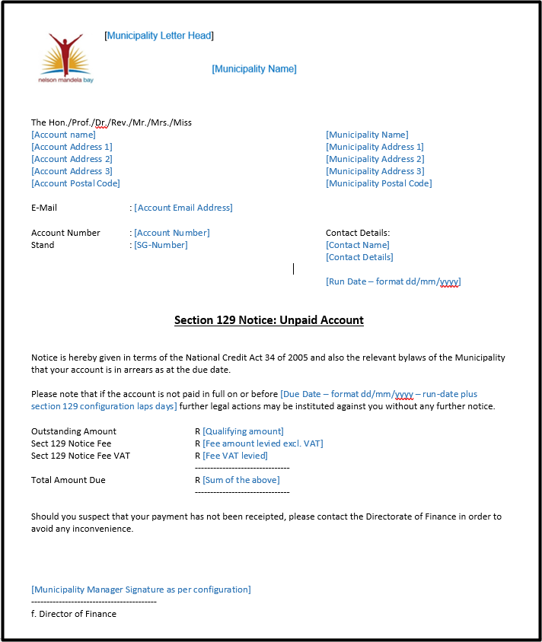

Field | Comments
Municipality Letter Head | Print the municipality logo here as per the Municipality Details configuration.
Municipality Name | Display the municipality name here – centered – in a font 50% larger than used in the rest of the document.
Account Name | Display the account holder’s name.
Account Address 1  Account Address 2  Account Address 3  Account Postal Code | Display the account holder’s delivery address as per Account Management.
Municipality Name | Display the municipality name.
Municipality Address1  Municipality Address2  Municipality Address3  Municipality Postal  Code | Display the municipality address details as per the municipality Details configuration.
Account Email Address | If the account has a valid email address registered – display it here. Do not display garbage.
Account Number | The account number.
Stand | The SG-number belonging to the account.
Contact Name | The contact’s name as per the Final Run.
Contact Details | The contact details as per the Final Run.
Contact Email Address | The contact email address as per the Final Run.
Run Date | The date on which the note was created – format dd/mm/yyyy.
Due Date | This date must be calculated as follows:  - Take the run date  - Add the laps days as per the Section 129 configuration to the run date  - Take going into the next month in consideration.  Format is dd/mm/yyyy.
Qualifying Amount | The qualifying amount that was calculated during the run.
Fee Amount Levied | The fees that were levied on the account during the run – excl. VAT.
Fee VAT Levied | The VAT that was levied iro the fees.
Sum of the Above | The sum of:  - Qualifying Amount  - Fee Amount Levied  - Fee VAT levied
Municipality Manager Signature | If a signature has been registered as per the Municipality Details configuration – display it here.

4.1.11 Section 129 – SMS Template
Billing >> Debt >> Section 129 Notices

- The below definition/format is for the “Section 129 Standard” template.
- This template must be used for SMS distribution types during the section 129 notices run.
- More site-specific templates may follow at a later stage.
Template:

Dear “Account holder”. The arrear balance of “BALANCE OF NOTICE” is outstanding on account nr “AccountID” and a Letter of Demand was issued. Please settle the amount or sign an acknowledgement of debt to avoid handover within 14 working days from date of issue.

Field | Comments
Account Name | Display the account holder’s name.
Qualifying Amount | The qualifying amount that was calculated during the run.
Account Number | The account number.

