BILLING: Debt & Legal – Section 129 Notices – PART 3

TABLE OF CONTENTS
Contents
Glossary 2
Business requirement 2
Business Objectives 3
In scope 3
3.1 Detailed enhancement REQUIREMENTS – Menu’s & permissions – Part 1 (spec) 3
4.1 Program Menu/Execution Path – Section 129 – Letter of Demand Configuration – Part 2 (Spec) 3
5.1 Program Menu/Execution Path – Billing Debt - Section 129 Letter of Demand – Actual Process 4
AS-IS Business Process 4
TO-BE Business Process 4
5.2 Business Rules - Trial Run 4
5.3 Use Case Narrative - Billing Debt - Section 129 - Letter of Demand – Landing Page 5
5.4 Proposed Screen Layout – Billing Debt - Section 129 - Letter of Demand – Sub Landing Page – 1st Trial Run Review – REVIEW REPORT 8
5.5 Proposed Screen Layout – Billing Debt - Section 129 - Letter of Demand – Show Files Page – 1st Trial Run Review – Review Workbook – SHOW FILES GRID 13
5.6 Proposed Screen Layout – Billing Debt - Section 129 - Letter of Demand – 1st Trial Run Review – Review Workbook – To Make Changes to 1st Trial Run Review 14
5.7 Proposed Screen Layout – Billing Debt - Section 129 - Letter of Demand – Landing Page – Notice Files Grid on Trial Run – SEARCH FUNCTION ON TRIAL RUN REVIEW 16
5.8 Proposed Screen Layout – Billing Debt - Section 129 - Letter of Demand – Sub Landing Page – 2nd Trial Run – This will be used on the Authorisation screen 17
5.9 Section 129 Notices – Back-End Processing for Trial Run 21
5.10 Proposed Screen Layout – Billing Debt - Section 129 - Letter of Demand – Landing Page – Notice Files Grid on Trial Run – SEARCH FUNCTION AFTER TRIAL RUN 24
5.11 Annexure A 26
A.1 – Section 129 Notices – Run Report 26
A.2.1 – Section 129 Notice Standard Template – Template Definition 27
A.2.2 – SMS Notice Standard Template – Template Definition 30
5.12 Proposed Screen Layout – Section 129 Notices – Landing Page – Section 129 Authorisation 31

Glossary

Term/Acronym | Description
SCOA | Standard Chart of Accounts.
Section 129 Notice | This is a final demand notice from the municipality send to the consumer in respective of outstanding amounts owed and not paid.
Handover | This is when an account remained unpaid, and the municipality decides to do a handover to an attorney to try and recover the amounts owed by means of legal processes. This process will make use of a “Handed Over Account”.
Handed Over Account | This is an account created by the Section 129 – Letter of Demand process and linked to the Master Account. There can be more than one Handed Over Account linked to a Master Account
Master Account | This is the original account where the arrears originated from.

Business requirement

The aim is to create functionality whereby a formal legal process can be actioned by the municipality to recover monies owed to the municipality.

To create and issue Section 129 notices (Letter of Demands) which will inform the Account Holder that legal actions will be started if outstanding arrears are not paid, or an acknowledgment of Debt is made within 14 workdays from Letter of Demand issued.

Number | Requirement description
1 | A configuration for legal action functionalities must be created to accommodate various settings required to use these functionalities.
2 | A new function must be created to qualify accounts for Section 129 notices and create these notices.
3 | A new screen must be created to qualify or remove accounts for Section 129 notices and create these notices, the TRIAL RUN REVIEW will trigger this new screen
4 | The Section 129 notices on TRIAL RUN:  - Must be stored on General Enquiries for easy access.  - Must be able to mail them to the account holder.  - Must be able to SMS notification to the account holder  - Must be able to be printed/ mailed to a print house in bulk.
5 | An admin fee to raise during the FINAL RUN must be configurable.
6 | 3 options are required to execute this hand over process:  - Account  - Bulk  - Rotational

Business Objectives
To enable the client to apply credit control to accounts with unpaid balances with the use of formal legal action procedures.

In scope

No | Description
1 | Create a legal action configuration menu item to accommodate the relevant configuration settings.
2 | Create functionality to apply qualification based on parameters/filters for Section 129 notices and create the actual notices.
3 | Create the functionality to create the handover process
4 | Create the section 129 template used for email & print
5 | Create the SMS notification template
6 | Create Dashboard Notification under Debt for “Section 129 Letter of Demand – Process Handovers
7 | Add Status under Const_Status as indicated below

3.1 Detailed enhancement REQUIREMENTS – Menu’s & permissions – Part 1 (spec)

4.1 Program Menu/Execution Path – Section 129 – Letter of Demand Configuration – Part 2 (Spec)

Program Menu/Execution Path – Billing Debt - Section 129 Letter of Demand – Actual Process
Billing >> Debt >> Section 129 Letter of Demand

This functionality will qualify accounts for section 129 notices – Letter of Demands based on the relevant front-end parameters/filters supplied. The notices will be created and saved – and made available for mail/print.

AS-IS Business Process

N/A – New process.

TO-BE Business Process

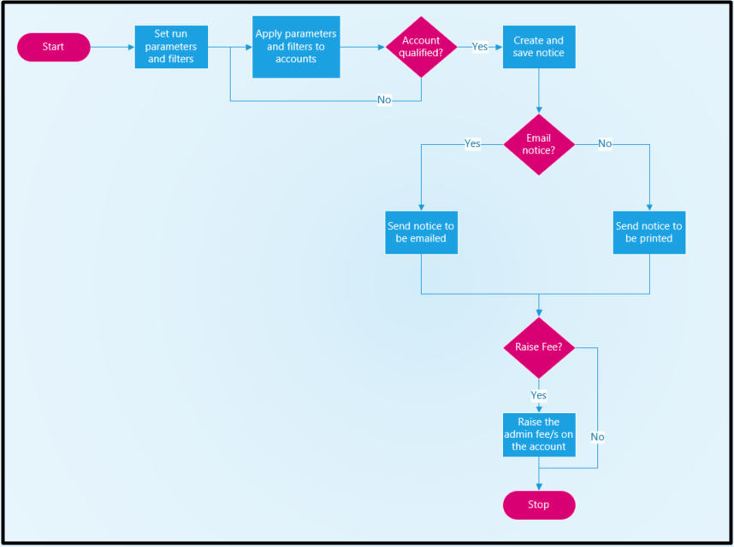

Business Rules - Trial Run

Number | Business Rule
1 | Apply all the front-end supplied parameters and filters to the accounts to qualify an account for a Section 129 Notice.  The main qualifying criteria will be which services must be used and then what ageing for outstanding balances must be used.
2 | This process must be available in 3 (three) options:  - Single Account  - Bulk  - Rotational
3 | NO AccountTypeID = 5 – Handed Over Account must be considered – they cannot get Section 129 Notices.
4 | RPP remaining balances must be ignored completely – as there are contracts on those already.
5 | Accounts on a stand which have an active valid clearance at the time of the run must be ignored – cannot get a section 129 notice.
6 | If an account qualifies – create the notice, save it and make it available for distribution.
7 | There are no constraints on how often a notice can be generated for the same account. If an account qualifies during a run – then it must get a notice – even if a notice was generated for the same account a day before.
8 | The notice issued must be saved in a grid and cannot be deleted.
9 | The last notice date and qualifying amount must be recorded in the general Account Details display block.
10 | Both the email, SMS and print files for a run must be saved in a grid for possible “re-print or re-mail” actions. Delete functionality must be available for entries in the grid.

Use Case Narrative - Billing Debt - Section 129 - Letter of Demand – Landing Page
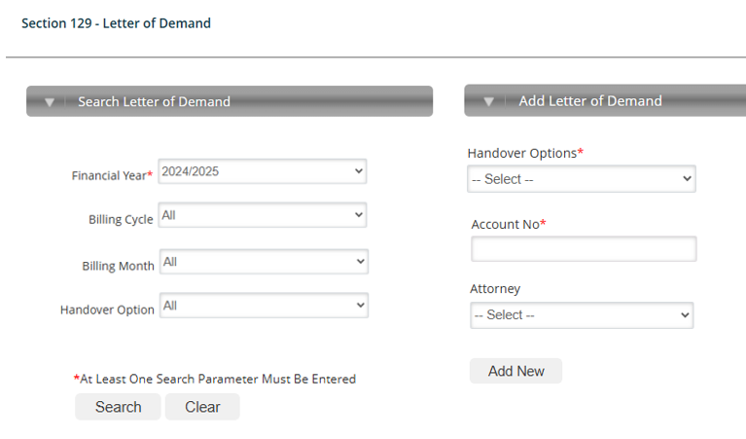
Note that this layout is only for illustrative purposes.

Use Case Number: | Use Case 1
Description: | Section 129 – Letter of Demand Landing Page
Preconditions: | None
Flow of Events: | Actor | System
Menu Path
 | Navigate to ‘Debt’.  Select the ‘Section 129 Letter of Demand’ label. | - The system must load the Debt menu page.  - The system must load the Billing – Debt > Section 129 Letter of Demand sub-menu – Landing Page

Flow of Events: | Actor | System
1st Landing Page – Left-hand side – Search Letter of Demand
Financial Year  Billing Cycle  Billing Month  Handover Option  Search button.  GRID - Click a line entry in the grid. | Select the relevant fin-year drop down.  Select the Billing_Cycle drop down.  Select the Month drop down.  Handover Option drop down.  Click the search button.  Click a line entry in the grid. | The system will:  - Display a dropdown containing financial years to select from.  The system will:  - Display a dropdown containing the various Billing Cycles if more than 1 is setup  - “Default to display All”  The system will:  - Display a dropdown containing Months to select from.  - If no months select, then display all processes  - Default to “—Select—“.  The system will:  - Display the 3 options:  Account  Bulk  Rotation  - “Default to display All”  The system will:  - Display all entries already actioned for the fin-year, Month & Option in a grid that will be discussed lower down.  - Enable each line in the grid to be able to download the required report.  The system will:  - Load the details page displaying all details for the selected item.  - Allow the user to download the required reports. See attachment A.1

Flow of Events: | Actor | System
1st Landing Page – Right-hand side – Add Letter of Demand
Handover Options  Account No  Attorney  Add New | Handover Options dropdown.  “ACCOUNT” – input field  Attorney drop down.  “Add New” to access the next landing page | The system will:  - display the following detail in the dropdown:  Account  Bulk  Rotation  The system will:  - Based on “Account” on the Handover Options selection the system will display the account nr field.  - Default to blank  - If value is supplied – provide auto-complete after 3 digits.  - This Account No field will NOT display if NOT selected in the Handover Option = Account  The system will:  - Based on “Attorney” on the Handover Options selection the system will display the Attorney field.  - Default to “—Select—“.  - On selecting the dropdown display all enabled Attorney Descriptions from the Const_Attorney configuration  - This Attorney field will NOT display if NOT selected in the Handover Option = Account  Hint on Handover Options  - Account  If Account is selected, then the Account Nr and Attorney field will display  - Bulk  If Bulk is selected, then the Account Nr will NOT display  If Bulk is selected, then the Attorney field will display  - Rotation  If Bulk is selected, then the Account Nr will NOT display  If Bulk is selected, then the Attorney field will NOT display  The system will:  - Display the next Sub Landing page

5.4 Proposed Screen Layout – Billing Debt - Section 129 - Letter of Demand – Sub Landing Page – 1st Trial Run Review – REVIEW REPORT
- Note that this layout of the warning notices of the disconnection processis only for illustrative purposes.

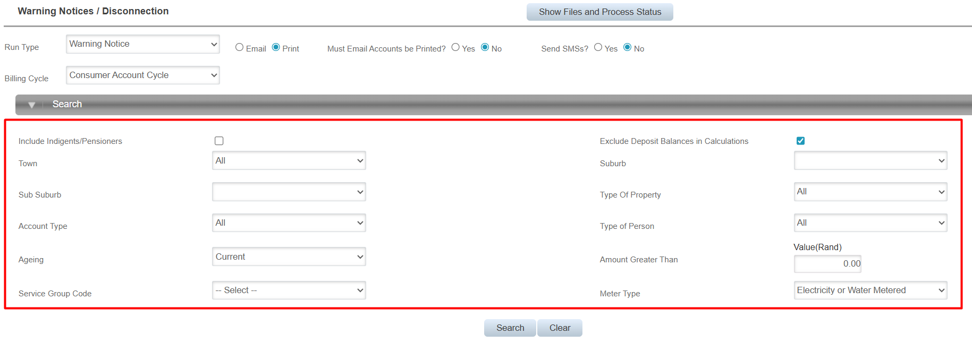
- Create a new screen as defined below.

Field Name | Dropdown / Input / Display | Mandatory | Notes
Run Type | Dropdown | Yes | Default to value “Trial”.  Dropdown values to select from:  - Trial Review  - Trial Run  - Final
Execution Date | Display | No | This will NOT apply to a Trial Run Review
Email | Radio Buttons | No | This will NOT apply to a Trial Run Review – Greyed Out
SMS | Radio Buttons | No | This will NOT apply to a Trial Run Review – Greyed Out
Print | Radio Buttons | No | This will NOT apply to a Trial Run Review – Greyed Out
All | Radio Buttons | No | This will NOT apply to a Trial Run Review – Greyed Out
Must Email Accounts be Printed? | Radio Buttons | Yes | This will NOT apply to a Trial Run Review – Greyed Out
Billing Cycle | Dropdown | No | Default to “---Select---“.  Display the registered billing cycle as per the configuration in the dropdown list for selection by the user – Ascending on ID  If the Account Option was selected:  - Default the value to space (empty).  Protect the parameter so that it cannot be modified (greyed out)
Section 129 – Demand Letter | Display | N/A | This will NOT apply to a Trial Run Review – Greyed Out
SMS Notification | Display | N/A | This will NOT apply to a Trial Run Review – Greyed Out
Admin Fees Amount | Display | N/A | Find the enabled section 129 notice configuration for the current financial year based in the calendar date.  If admin fees are loaded to be levied – add the amounts together and display the total here.
Include Indigents/Pensioners | Check Box | No | Default to value “Not Checked” (No).  If the Account Option was selected:  - Default the value to space (empty).  Protect the parameter so that it cannot be modified (greyed out)
Exclude Deposit Balances in Calculations | Check Box | No | Default to value “Not Checked”.  If the Account Option was selected:  - Default the value to space (empty).  Protect the parameter so that it cannot be modified (greyed out)
Town | Dropdown | Yes | Default to value “All”.  Values to display in the dropdown list:  - All  - All towns as selected for “Falls within Municipality” in the Town configuration of status “Enabled”.  If the Account Option was selected:  - Default the value to space (empty).  Protect the parameter so that it cannot be modified (greyed out)
Suburb | Dropdown | No | Default to space (Empty).  If the “Town” parameter has a specific value selected (not All):  - Populate the dropdown list with suburbs linked to the selected “Town” as registered in the Suburb configuration with status “Enabled”.  If the “Town” parameter has the value “All”:  - The dropdown must be empty – none to select.  If the Account Option was selected:  - Default the value to space (empty).  Protect the parameter so that it cannot be modified (greyed out)
Sub-Suburb | Dropdown | No | Default to space (Empty).  If the “Town” and “Suburb” parameters have a specific value selected (not All or empty):  - Populate the dropdown list with sub-suburbs linked to the selected “Town” and “Suburb” as registered in the Sub-Suburb configuration with status “Enabled”.  If the “Suburb” parameter has no specific value selected:  - The dropdown must be empty – none to select.  If the Account Option was selected:  - Default the value to space (empty).  Protect the parameter so that it cannot be modified (greyed out)
Property Category | Dropdown | No | Default to value “All”.  Values to display in the dropdown list:  - All  - All property categories as registered in the Property Category configuration of status “Enabled”.  If the Account Option was selected:  - Default the value to space (empty).  Protect the parameter so that it cannot be modified (greyed out)
Account Type | Dropdown | No | Default to value “All”. EXCLUDE AccountTypeID = 5 Handed Over Accounts  Values to display in the dropdown list:  - All  - Occupier  - Owner/Occupier  - Owner  If the Account Option was selected:  - Default the value to space (empty).  Protect the parameter so that it cannot be modified (greyed out)
Type of Person | Dropdown | No | Default to value “All”.  Values to display in the dropdown list:  If the Account Option was selected:  - Default the value to space (empty).  Protect the parameter so that it cannot be modified (greyed out)
Magisterial District | Dropdown | No | Default to value “All”.  Values to display in the dropdown list:  - All values registered in the magisterial district configuration – which are enabled.  - If there are duplicate magisterial districts display only 1 entry – no duplicates in the list.  If the Account Option was selected:  - Default the value to space (empty).  Protect the parameter so that it cannot be modified (greyed out)
Service Group Code | Dropdown | Yes | Default to “—Select—“.  Populate the dropdown list with registered values as per the Service Group Code configuration which is of status “Enabled”.
Ageing | Dropdown | Yes | Default to value “30 Days”.  Values to display in the dropdown:  - 30 Days  - 60 Days  - 90 Days  - 120 Days  - 150 Days  180 Days Plus
Amount Greater Than | Input | No | Default to value 0 (zero).  Decimals not allowed – must be integer.  Cannot be less than 0 (zero).

Button | Description
Submit | Validate all parameters supplied and display relevant error messages if required.  Kick off the back-end process – which must not be an online process – to create “Review Report” into the grid.  - Naming convention for Trial Run Review Report loaded into the “Generated Notice Files” GRID:  - “Sect_129” + “_” + <Option> + “_” + <billing-cycle > + “_” + <run-date and run-time> + <sequence-number> + “_” + “Trial_Run_Review”  The status of this report will be set as Notice Issued – Trial Review  Navigate back to the landing page.  HINT: This Trial Run Review will update NOTHING as this will only be reviewed and seen as a working document for the supervisor to review and remove accounts.
Clear | Set all values in the “landing page” to its original values and re-display the page.
Cancel | Abandon transaction, navigate back to the landing page.

5.5 Proposed Screen Layout – Billing Debt - Section 129 - Letter of Demand – Show Files Page – 1st Trial Run Review – Review Workbook – SHOW FILES GRID
- When the user selects the Trial Run Review out of the search grid this this new page will apply
- Create a new screen grid as defined below.
- This page is based on the warning notice/disconnection page whereby the user can remove accounts while the report is still in the Notice Issued – Trial Review stage
- When the user selects the “SHOW FILES” button the below grid will display for the user to select the file he/she wants to work on.
- ONLY files NOT yet processed via the Trial Run (2nd) will display here
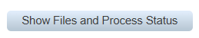
Selecting the Show Files button displays this grid:
Field Name | Dropdown / Input / Display | Mandatory | Notes
Run ID | Display | N/A | The Run-ID assigned to the run.  All files/reports generated during the run and loaded into the grid must be linked to this ID.
Status | Display | N/A | Trial run, then the status would be – Notice Issued – Trial Run Review  This will read from the Const_Status table (new ID’s that was added
Distribution Type | Display | N/A | Display as “Trial Run Review”
Actioned by: | Display | N/A | User information of the user that did the process
Date Created | Display | N/A | The date on which the file was created (run-date). Date & time

Button | Description
Cancel | Abandon grid, navigate back to the landing page.

5.6 Proposed Screen Layout – Billing Debt - Section 129 - Letter of Demand – 1st Trial Run Review – Review Workbook – To Make Changes to 1st Trial Run Review
- Create a new screen as defined below.
- This page is based on the warning notice/disconnection page whereby the user can edit/remove/add accounts while the report is still in the Notice Issued – Trial Run Review stage
- The user will be able to remove accounts on the original trial run before the final notices are sent via the 2nd Trial Run.
- When the user selects the Run ID (Only trial run review status may display here) the below screen display will appear.
Field Name | Dropdown / Input / Display | Mandatory | Notes
Selected | Tick box | Yes | Default to value “Checked”  - Checked – then the account will be part of the notice report  - Not Checked - then the account will be removed from the notice report
Account | Display | N/A | Display account numbers that qualified based on the criteria selected
Address | Display | N/A | This will be the location address on Property Management
Indigent Status | Display | N/A | This will be obtained from the Indigent applications for all where the StatusID = 140 = Active
Rebate Status | Display | N/A | This will be obtained from the Pensioner applications for all where the StatusID = 18 = Approved
SG Number | Display | N/A | This will be the location address on Property Management
Outstanding Days | Display | N/A | Add all outstanding amounts of the selected ageing and all older ageing’s than the selected ageing on a matched service to the qualifying amount.
Qualifying Amount | Display | N/A | Total outstanding amount as per the total balance debt per ageing bracket
Notice Fees | Display | N/A | Display as per Configuration set up
Final Review Complete | Tick Box | N/A | If this tick is enabled, then the Submit Button will update the Status to “Notice Issue - Trial Run”  If this tick is NOT enabled, then the supervisor can work on the Trial Run Review Report until satisfied.

Button | Description
Submit | Final Review Complete - ENABLED – Update status to “Notice Issue - Trial Run” for the user to action the 2nd Trial Run  - Update the original trial run report with any account removed not be on the final run to process notices.  - Remove the Trial Run Review from this grid to disable the user NOT to make any changes  - The Original report will still be on the “Main” grid with the updated changes  Final Review Complete - DISABLED – Keep status to “Notice Issue - Trial Run Review” for the supervisor to still adjust.
Cancel | Close the page.  Navigate back to the landing page.

5.7 Proposed Screen Layout – Billing Debt - Section 129 - Letter of Demand – Landing Page – Notice Files Grid on Trial Run – SEARCH FUNCTION ON TRIAL RUN REVIEW

- The grid must display a maximum of 50 entries as per Financial Year & Month selection.
- The display sequence must be as below – with the latest (newest) files 1st:
  - Primary key – Run ID that was allocated to the files/reports - descending. This means the most recent files will be 1st in the grid.
Field Name | Dropdown / Input / Display | Mandatory | Notes
Handover Option | Display | N/A | Display option as it was selected
Run ID | Display | N/A | The Run-ID assigned to the run.  All files/reports generated during the run and loaded into the grid must be linked to this ID.
Status | Display | N/A | Trial run, then the status would be – Notice Issued – Trial Review  This will read from the Const_Status table (new ID’s that was added
Distribution Type | Display | N/A | This will NOT apply to a Trial Run – Display as “Trial Run Review”
Actioned by: | Display | N/A | User information of the user that did the process
Date Created | Display | N/A | The date on which the file was created (run-date). Date & time
Authorised by: | Display | N/A | User information of the user that did the process
Date Created | Display | N/A | The date on which the file was created (run-date). Date & time
Download File | Display | N/A | When downloading the file refer to attachment A.1 for the layout
Remove File | Button | N/A | Display an active “Remove” button e.g.  - This button will be greyed out IF the Trial run ID status “Final Review Complete was enabled” and the Status updated from TRIAL RUN REVIEW to TRIAL RUN  - Only if NOT and still display the Status – TRIAL RUN REVIEW then the file can be removed
Billing Cycle | Display | N/A | This column must be populated as follows:  - With the billing-cycle if a specific billing cycle was selected for the run.
Run Parameters | Display | N/A | Display all the parameters/filters and their values that were used for the run.

Button | Description
Cancel | Close the page.  Navigate back to the landing page.

5.8 Proposed Screen Layout – Billing Debt - Section 129 - Letter of Demand – Sub Landing Page – 2nd Trial Run – This will be used on the Authorisation screen
- Create a new screen as defined below.
Field Name | Dropdown / Input / Display | Mandatory | Notes
Run Type | Dropdown | Yes | Default to value “Trial Run”.  Dropdown values to select from:  - Trial Review  - Trial Run  - Final
Execution Date | Display | No | Calculate the days entered only for workdays, excluding weekends and public holidays and display the lapsed timeframe in a date format (this will be used for the dashboard notification when the 14 days (Days as per the configuration) lapsed  This will start on executing the final run as the start date to calculate the execution date to start the hand over process  This will NOT apply to a Trial Run Review
Email | Radio Buttons | No | Default the “ALL” button to be set.  One of the 4 buttons must be set.  Add this as a hint:  If only Email was selected, then ONLY accounts as per the criteria WITH valid email addresses will be returned  This will NOT apply to a Trial Run Review
SMS | Radio Buttons | No | Default the “ALL” button to be set.  One of the 4 buttons must be set.  Add this as a hint:  If only SMS was selected, then ONLY accounts as per the criteria WITH valid Mobile number will be returned  This will NOT apply to a Trial Run Review
Print | Radio Buttons | No | Default the “ALL” button to be set.  One of the 4 buttons must be set.  Add this as a hint:  If only PRINT was selected, then ALL accounts as per the criteria will be returned  This will NOT apply to a Trial Run Review
All | Radio Buttons | No | Default the “ALL” button to be set.  One of the 4 buttons must be set.  Add this as a hint:  If only ALL was selected, then ALL accounts as per the criteria will be returned
Must Email Accounts be Printed? | Radio Buttons | Yes | This label and radio buttons must only be displayed if the “Print” radio button has been set – else it must be hidden.  Default the “No” button to be set.  One of the 2 buttons must be set.  Not more than 1 button can be set.  This will NOT apply to a Trial Run Review
Billing Cycle | Display | No | This must be greyed out as it was already selected on the Trial Run Review
Section 129 – Demand Letter | Display | N/A | Populate this field with the value as it is set in the Section 129 Notices configuration.
SMS Notification | Display | N/A | Populate this field with the value as it is set in the Section 129 Notices configuration.
Admin Fees Amount | Display | N/A | Find the enabled section 129 notice configuration for the current financial year based in the calendar date.  If admin fees are loaded to be levied – add the amounts together and display the total here.
Include Indigents/Pensioners | Display | N/A | This must be greyed out as it was already selected on the Trial Run Review
Exclude Deposit Balances in Calculations | Display | N/A | This must be greyed out as it was already selected on the Trial Run Review
Town | Dropdown | Yes | This must be greyed out as it was already selected on the Trial Run Review
Suburb | Dropdown | No | This must be greyed out as it was already selected on the Trial Run Review
Sub-Suburb | Dropdown | No | This must be greyed out as it was already selected on the Trial Run Review
Property Category | Dropdown | No | This must be greyed out as it was already selected on the Trial Run Review
Account Type | Dropdown | No | This must be greyed out as it was already selected on the Trial Run Review
Type of Person | Dropdown | No | This must be greyed out as it was already selected on the Trial Run Review
Magisterial District | Dropdown | No | This must be greyed out as it was already selected on the Trial Run Review
Service Group Code | Dropdown | Yes | This must be greyed out as it was already selected on the Trial Run Review
Ageing | Dropdown | Yes | This must be greyed out as it was already selected on the Trial Run
Amount Greater Than | Input | No | This must be greyed out as it was already selected on the Trial Run Review
Contact Person: | Input | Yes | Display on Section 129 Notice
Contact Person Phone Nr: | Input | Yes | Display on Section 129 Notice
Contact Person Email Address: | Input | Yes | Display on Section 129 Notice

Button | Description
Submit | Validate all parameters supplied and display relevant error messages if required.  Kick off the back-end process – which must not be an online process – to create “Review Report” into the grid.  - Naming convention for Trial Run Report loaded into the “Generated Notice Files” GRID:  - “Sect_129” + “_” + <Option> + “_” + <billing-cycle > + “_” + <run-date and run-time> + <sequence-number> + “_” + “Trial_Run_Review”  The status of this report will be set as Notice Issued – Trial Run  Navigate back to the landing page.  HINT: This Trial Run will update the Enquiries Account Information – Handover (Field) with Notice Issued - Trial Run
Clear | Set all values in the “landing page” to its original values and re-display the page.
Cancel | Abandon transaction, navigate back to the landing page.

5.9 Section 129 Notices – Back-End Processing for Trial Run

- The back-end process must run on its own and not be an on-line process.
- It must populate the “Files Created” grid when the process completes successfully.
- Both active and inactive accounts must be considered.
- Handed Over Accounts (AccountTypeID = 5) must NOT be considered.
- RPP remaining amounts must not be considered.
- Accounts linked to properties with valid active clearances must not be considered.
- The template that must be used for the notices must be as per the template linked in the Section 129 Notices configuration.
- This template must be used for both the email and print options.
- The SMS template will only be to inform the accountholder that a letter of demand was issues
- The general run parameters must be interpreted as follows:

  - Run Type:
    - Value “Trial Run”:
      - Go through all the motions and create the relevant mail, SMS & print files
      - Save the files in the system and add the entries to the “Files Created” grid
      - Update all other information required to be updated and/or saved.
      - Update the Enquiries Account Information – Handover (Field) with Notice Issued - Trial Run
      - If Attorney Rotation was selected and set up, then files must be created accordingly for each Attorney and saved.

  - Email/SMS/Print/All:
    - Email:
      - Only create notices for qualifying accounts that have valid email addresses.
      - Consolidate all notices into 1 single email file.
      - Do not create a file if not a single email account qualified.
      - Make use of the Section 129 template
    - SMS
      - Only create notices for qualifying accounts that have valid email addresses.
      - Consolidate all notices into 1 single email file.
      - Do not create a file if not a single SMS account qualified.
    - Print:
      - Only create notices for qualifying accounts.
      - Consolidate all notices into 1 single print file.
      - Do not create a file if not a single print account qualified.
      - Make use of the Section 129 template
      - For this option another parameter comes into play – but only for this option:
        - Must Email Accounts be Printed?
          - “No” – do nothing, ignore this parameter
          - “Yes” – When running the “Print” option, even if a qualifying account has a valid email address, ignore the valid email address and treat the account as a “Print” account, therefore also include the notice in the “Print” file.
    - All:
      - Create notices for all qualifying accounts
      - Create 2 files if required:
        - One for qualifying accounts with email addresses – “Mail”.
        - One for qualifying accounts without email addresses – “SMS”.
        - One for qualifying accounts without email addresses – “Print”.
        - Do not create the relevant file if not a single email and/or print account qualified.

- Naming convention for all files loaded into the “Generated Notice Files” grid:
  - “Sect_129_” + <billing-cycle > + “_” + <distribution-type> + “_” + <run-date and run-time> + <sequence-number> + <Trial Run> + <Rotation-Attorney>“_” Attorney (if no attorney then default to None
  - Where:
    - <billing-cycle > is:
      - The billing-cycle for which the run was done if a specific billing-cycle was selected.
    - <distribution-type> is the relevant distribution type used during the run
    - <run-date and run-time> is the run-date and time
    - <sequence-number> is a seq-no starting from 1 for this run and incremented by 1 each time a new file for the same distribution-type is started.
    - <Rotation-Attorney> is the individual files created for each attorney
The “Report” file can only have a seq-no of 1 as there will always be only 1 report file EXCEPT where the Rotation Attorney is enabled.
  - E.g.
    - Sect_129_Consumer Cycle_Mail_26112021122156_1_TrialRun
Or
    - Sect_129_Consumer Cycle_SMS_26112021122203_2_TrialRun
Or
    - Sect_129_Consumer Cycle_Print_26112021122203_3_TrialRun
Or
    - Sect_129_Consumer Cycle_All_26112021122156_1_TrialRun
Or
    - Sect_129_000000027693_ALL_26112021122156_1_TrialRun _Attorney A
Or
    - Sect_129_000000027693_ALL_26112021122156_1_TrialRun_Attorney B
Or
    - Sect_129_000000027693_ALL_26112021122156_1__TrialRun_Attorney C

- At this point we have an account that must get a section 129 notice.
- On the Section 129 Notices configuration – if costs are loaded to be levied:
  - Apply the same as for the Debt – Warning Notice functionality
  - For each entry in the cost grid:
    - As per normal system rules
    - Find the additional-billing-type configuration
    - Determine if VAT is applicable
    - Raise the relevant amount and VAT on the account for the relevant add-bill-type
      - Credit the revenue (IR) Scoa item as per the configuration
      - Debit the monthly-billing (IA) Scoa item as per the configuration
      - Do the relevant VAT entries if applicable.

- The run report:
  - This report must be created on the fly as the run creates notices for accounts.
  - The distribution-type must be “Run Report”.
  - Apply the naming convention when creating the file name.
  - Create an entry in the run report for every notice created – refer Annexure A.1 for report definition.
  - This report must also be entered into the “Generated Notice Files” grid to enable the user to print it if required.
  - This report must NOT apply the “Number of Notices per File” configuration parameter.

- The notice files:
  - Use the registered template and populate the variables to create a valid notice.
  - Based on the run parameters supplied on the front-end – “Mail”, “SMS”, “Print” or “ALL” – add the created notice to the relevant file – which will be either the “Email”, “SMS” file or the “Print” file – which is also the distribution type.
  - Apply the naming convention when creating the file names.
  - Refer Annexure A.2.1 for the notice definitions for the “Standard” notice.
  - Refer Annexure A.2.2 for the notice definitions for the “SMS” notice
  - These files created must be entered into the “Generated Notice Files” grid to enable the user to print/mail it if required.
  - For each of the 2 distribution types – mail, SMS and print - depending on which files are created during the run:
    - Apply the “Number of Notices per File” configuration parameter.
    - The 1st file for a distribution-type will have a seq-no of 1.
    - If the number of notices (PDF documents) added to the same file is surpassed – then increment the seq-no by 1 and create a new file.
Now add notices to this file as the run goes and keep on applying the “number of notices” rule.

- If trial run was approved but not actioned by doing the Final run and the Final Billing Run are done for that Billing Month, change the status of the trial run to - “Issue Notice - Expired”

5.10 Proposed Screen Layout – Billing Debt - Section 129 - Letter of Demand – Landing Page – Notice Files Grid on Trial Run – SEARCH FUNCTION AFTER TRIAL RUN

- The grid must display a maximum of 50 entries as per Financial Year & Month selection.
- The display sequence must be as below – with the latest (newest) files 1st:
  - Primary key – Run ID that was allocated to the files/reports - descending. This means the most recent files will be 1st in the grid.
Field Name | Dropdown / Input / Display | Mandatory | Notes
Handover Option | Display | N/A | Display option as it was selected
Run ID | Display | N/A | The Run-ID assigned to the run.  All files/reports generated during the run and loaded into the grid must be linked to this ID.
Status | Display | N/A | Trial run, then the status would be – Notice Issued – Trial Review  - If the Final Review Complete tick was enabled the Status will then update to – Notice Issued – Trial Run  - This will trigger the dashboard notification to run the trial run (2nd)  This will read from the Const_Status table (new ID’s that was added
Distribution Type | Display | N/A | This will NOT apply to a Trial Run – Display as “Trial Run Review” until the 2nd Trial Run is done
Actioned by: | Display | N/A | User information of the user that did the process
Date Created | Display | N/A | The date on which the file was created (run-date). Date & time
Authorised by: | Display | N/A | User information of the user that did the process
Date Created | Display | N/A | The date on which the file was created (run-date). Date & time
Download File | Display | N/A | When downloading the file refer to attachment A.1 for the layout
Remove File | Button | N/A | Display an active “Remove” button e.g.  - This button will be greyed out IF the Trial run ID status “Final Review Complete was enabled” and the Status updated from TRIAL RUN REVIEW to TRIAL RUN  - Only if NOT and still display the Status – TRIAL RUN REVIEW then the file can be removed
Billing Cycle | Display | N/A | This column must be populated as follows:  - With the billing-cycle if a specific billing cycle was selected for the run.
Run Parameters | Display | N/A | Display all the parameters/filters and their values that were used for the run.

Button | Description
Cancel | Close the page.  Navigate back to the landing page.

5.11 Annexure A

A.1 – Section 129 Notices – Run Report
Billing >> Debt >> Section 129 Notices

- This is a new report.
- This report is created during the section 129 notices run.
- Apply all normal system standards to the report.

- Report heading
  - Display all the parameters as supplied on the front-end
  - Align the parameters and the parameter values

- Report detail

Field | Comments
Account No | The account to what falls within the criteria.
Account Type | The account’s account type – owner, occupier or owner/occupier.
Account Status | Account status – “Yes” = active, “No” = inactive.
Name | The account holder’s name.
Qualifying Amount | The outstanding amount calculated based on the front-end parameters which caused the qualification to get a notice issued.
SG Number | The SG-number linked to the account.
Property Location Address | Concatenate the Property Location address the same as on the Property Management Landing grid – Location Address
Property Category | The property partition Property Category
Property Type of Use | The property partition Type of Use
Billing Cycle | Display the Billing_Cycle_Description
Attorney | Display the attorney selected
Handover Option | Display the option selected –  - Account  - Bulk  - Rotation

A.2.1 – Section 129 Notice Standard Template – Template Definition
Billing >> Debt >> Section 129 Notices

- The below definition/format is for the “Section 129 Standard” template.
- This template must be used for both the mail and print distribution types during the section 129 notices run.
- More site-specific templates may follow at a later stage.

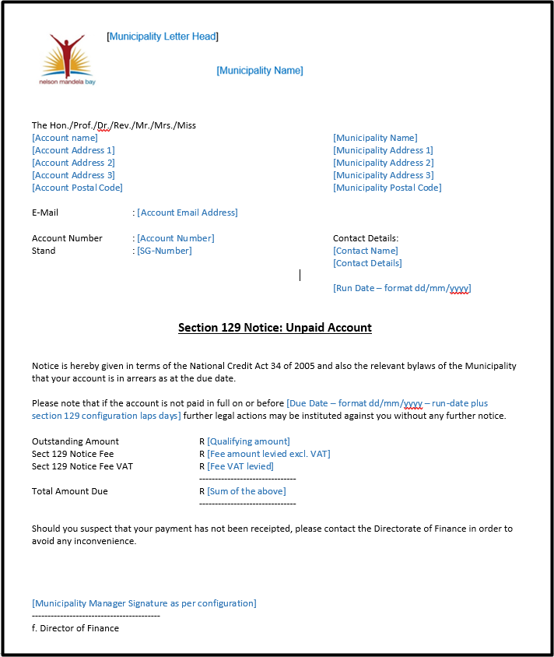

Field | Comments
Municipality Letter Head | Print the municipality logo here as per the Municipality Details configuration.
Municipality Name | Display the municipality name here – centered – in a font 50% larger than used in the rest of the document.
Account Name | Display the account holder’s name.
Account Address 1  Account Address 2  Account Address 3  Account Postal Code | Display the account holder’s delivery address as per Account Management.
Municipality Name | Display the municipality name.
Municipality Address1  Municipality Address2  Municipality Address3  Municipality Postal  Code | Display the municipality address details as per the municipality Details configuration.
Account Email Address | If the account has a valid email address registered – display it here. Do not display garbage.
Account Number | The account number.
Stand | The SG-number belonging to the account.
Contact Name | The contact’s name as per the Final Run.
Contact Details | The contact details as per the Final Run.
Contact Email Address | The contact email address as per the Final Run.
Run Date | The date on which the note was created – format dd/mm/yyyy.
Due Date | This date must be calculated as follows:  - Take the run date  - Add the laps days as per the Section 129 configuration to the run date  - Take going into the next month in consideration.  Format is dd/mm/yyyy.
Qualifying Amount | The qualifying amount that was calculated during the run.
Fee Amount Levied | The fees that were levied on the account during the run – excl. VAT.
Fee VAT Levied | The VAT that was levied iro the fees.
Sum of the Above | The sum of:  - Qualifying Amount  - Fee Amount Levied  - Fee VAT levied
Municipality Manager Signature | If a signature has been registered as per the Municipality Details configuration – display it here.

A.2.2 – SMS Notice Standard Template – Template Definition
Billing >> Debt >> Section 129 Notices

- The below definition/format is for the “Section 129 Standard” template.
- This template must be used for SMS distribution types during the section 129 notices run.
- More site-specific templates may follow at a later stage.
Template:

Dear “Account holder”. The arrear balance of “BALANCE OF NOTICE” is outstanding on account nr “AccountID” and a Letter of Demand was issued. Please settle the amount or sign an acknowledgement of debt to avoid handover within 14 working days from date of issue.

Field | Comments
Account Name | Display the account holder’s name.
Qualifying Amount | The qualifying amount that was calculated during the run.
Account Number | The account number.

A.2.3 – SMS Log Report – Report Definition
Billing >> Report>> Miscellaneous Reports

- This same principle will be used as the Statement Email Log
- The below definition/format is for the “SMS Log” report.
- This template must be used for SMS distribution types during the section 129 notices run.
- This report may change at a later stage to list other SMS functionalities.
Field | Comments
Account Number | The account number.
Account Name | Display the account holder’s name.
Mobile Number | Display the valid mobile number that were used to send the SMS to.
Subject | Display “Section 129 – Letter of Demand Notice”
Date Send | Date of action
Success/Fail | Status for the SMS if delivered then display = Success, if not delivered then display = Fail
Error Message | If status = Success then defaults to “None”, if status = Fail then displays the reason why the SMS could not be delivered = “Invalid Mobile Number”

A.3 – Section 129 Notices Report
Billing >> Reports >> Debt Recovery >> Section 129 Report

- This is a new report.
- Apply all normal system standards to the report.
- The report has 3 sections as defined below:
  - The heading
  - The Detail
  - The summary
- The report detail must be in the following sequence:
  - Primary – Billing Cycle – Ascending by cycle number
  - Account Number - Ascending

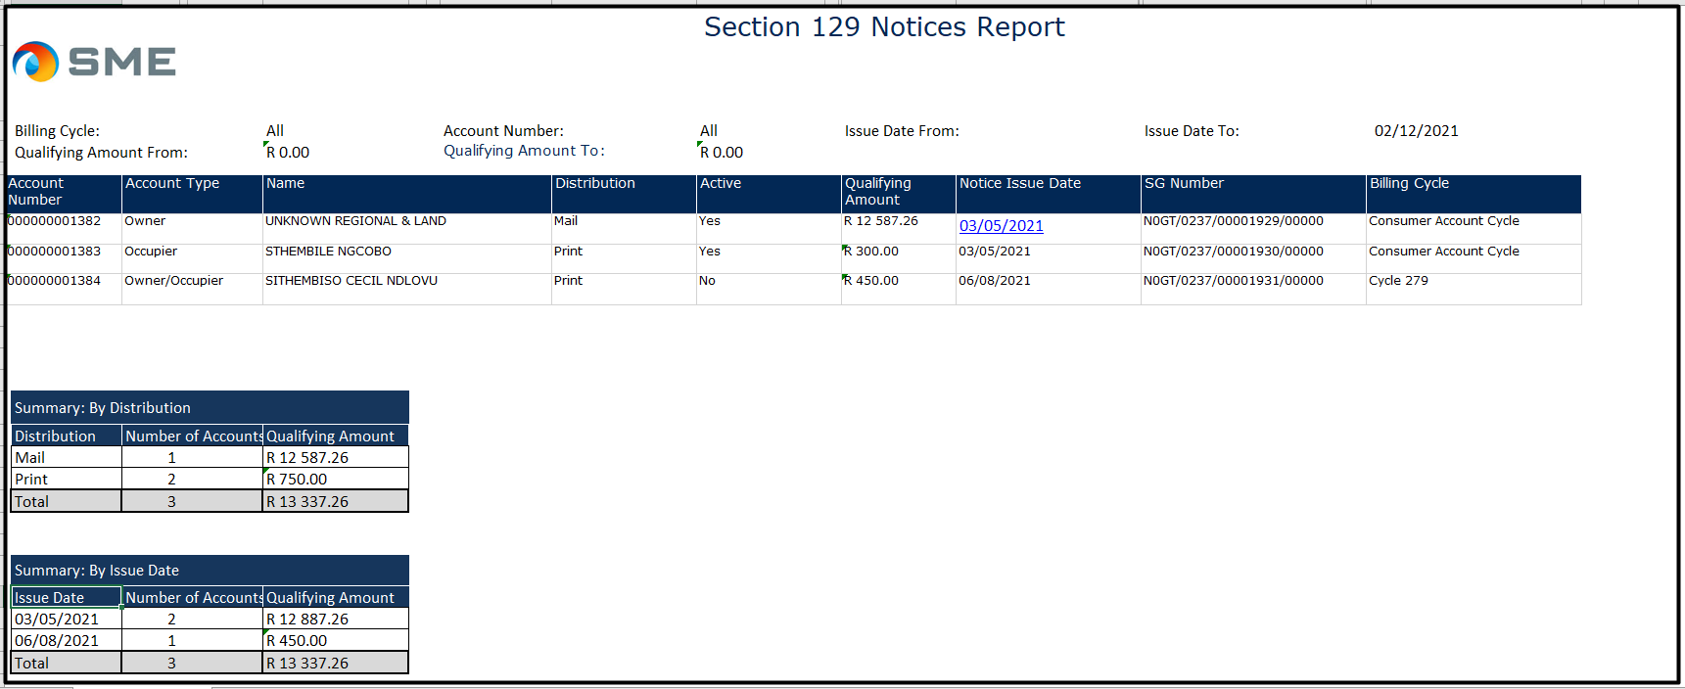

- Report heading
  - Display all the parameters as supplied on the front-end
  - Align the parameters and the parameter values

- Report detail

Field | Comments
Account No | The account number.
Account Type | The account’s account type e.g. Owner or Occupier.
Name | The account holder’s name.
Distribution | The distribution type – mail or print.
Active | The account status – active or inactive – yes or no.
Qualifying Amount | The qualifying amount when the notice was issued.
Notice Issue Date | The date on which the notice was issued.
SG Number | The SG-number linked to the account.
Billing Cycle | The billing-cycle linked to the child account.

- Report summaries
  - The report must have the following 2 summaries:

    - Per distribution type

Field | Comments
Distribution | The distribution types that was processed in the run – can be a combination of mail and print.
No of Accounts | The total number of accounts notices were issue to for the relevant distribution type.
Qualifying Amount | The total qualifying amount that notices were issued for per the relevant distribution type.
Column totals | Sum the following columns for a bottom-line total/amount:  - Number of accounts  - Qualifying amount

    - Per issue date

Field | Comments
Issue Date | There must be an entry in the grid for each issue-date processed during the creation of the report.
No of Accounts | The total number of accounts notices were issue to for the relevant issue date.
Qualifying Amount | The total qualifying amount that notices were issued for per the relevant issue date.
Column totals | Sum the following columns for a bottom-line total/amount:  - Number of accounts  - Qualifying amount

5.12 Proposed Screen Layout – Section 129 Notices – Landing Page – Section 129 Authorisation
- The same layout as all our other authorisation screens will apply (Journal Authorisation screen)
- Create a new screen as defined below.
Field Name | Dropdown / Input / Display | Mandatory | Notes
Review | Dropdown | Yes | 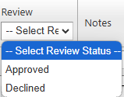
Notes | Varchar (250 char) | Yes | 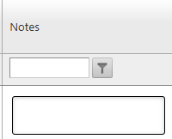
Run ID | Display | N/A | The Run-ID assigned to the trial run.
Status | Display | N/A | Notice Issued – Trial  This will be displayed from Const_Status  Only Run_ID’s with this status will be displayed in the authorisation grid
Distribution Type | Display | N/A | Display as “Trial Run Review”
Actioned by: | Display | N/A | User information of the user that did the process
Date Created | Display | N/A | The date on which the file was created (run-date). Date & time
Billing Cycle | Display | N/A | This column must be populated as follows:  - With the billing-cycle if a specific billing cycle was selected for the run.

Button | Description
Submit | Change the Status to “Notice Issued – Final”.  This will enable the Final Run on the Section 129 – Letter of Demand to display (Same as billing run authorisation)  Navigate back to the Dashboard.
Cancel | Close the page.  Navigate back to the Dashboard

