BILLING: Debt & Legal – Section 129 Notices – PART 5

TABLE OF CONTENTS
Contents
1. Glossary 3
2. Business requirement 3
2.1 Business Objectives 4
2.1.1 In scope 4
3. Detailed enhancement REQUIREMENTS – Menu’s & permissions – part 1 (spec) 4
4. Program Menu/Execution Path – Section 129 – Letter of Demand Configuration – Part 2 (Spec) 4
5. Program Menu/Execution Path – Billing Debt - Section 129 Letter of Demand – Actual Process – Trial Run 4
6. Program Menu/Execution Path – Billing Debt - Section 129 Letter of Demand – Actual Process – Final Run 4
7. Program Menu/Execution Path – Billing Debt - Section 129 Letter of Demand – Actual Process – Termination of handover 4
7.1 Proposed Screen Layout – Billing Debt - Handover – Terminate Handover - Landing Page - 5
7.2 Proposed Screen Layout – Billing Debt - Handover – Terminate Handover - Landing Page - Grid 6
7.3 Proposed Screen Layout – Billing Debt - Handover – Terminate Handover - Landing Page - Terminate 6
7.4 Proposed Screen Layout – Handover Process – Landing Page – Handover Terminate Authorisation 6
7.5 Handover Termination Authorised – Back-End Processing of Journals and Handover Account 7
7.6 Program Menu/Execution Path – General Enquiries 9
7.6.1 Proposed Screen Layout – General Enquiries – Detail Landing Page on Additional Account Details (Account Information) 9
7.7 Proposed Screen Layout – General Enquiries – Enquiry Button – Section 129 – Letter of Demand 9
7.1 Proposed Screen Layout – General Enquiries – Section 129 Notices Tab (Detail) 11
8. Proposed Screen Layout – General Enquiries – Handover Tab - Grid 13
9. Proposed Screen Layout – General Enquiries – Handover Tab – Grid – 2nd display (Cons_handovers_Transactions) 15
10. Program Menu/Execution Path – Section 129 Notices Report 16
10.1.1 Proposed Screen Layout – Section 129 Notices Report - Landing Page 16
10.1.2 Proposed Screen Layout – Handover Report - Landing Page 18
11. Annexure A 21
11.1 A.4 – Handover Report 21

Glossary

Term/Acronym | Description
SCOA | Standard Chart of Accounts.
Section 129 Notice | This is a final demand notice from the municipality send to the consumer in respective of outstanding amounts owed and not paid.
Handover | This is when an account remained unpaid, and the municipality decides to do a handover to an attorney to try and recover the amounts owed by means of legal processes. This process will make use of a “Handed Over Account”.
Handed Over Account | This is an account created by the Section 129 – Letter of Demand process and linked to the Master Account. There can be more than one Handed Over Account linked to a Master Account
Master Account | This is the original account where the arrears originated from.

Business requirement

The aim is to create functionality whereby a formal legal process can be actioned by the municipality to recover monies owed to the municipality.

To create and issue Section 129 notices (Letter of Demands) which will inform the Account Holder that legal actions will be started if outstanding arrears are not paid, or an acknowledgment of Debt is made within 14 workdays from Letter of Demand issued.

Number | Requirement description
1 | A configuration for legal action functionalities must be created to accommodate various settings required to use these functionalities.
2 | A new function must be created to qualify accounts for Section 129 notices and create these notices.
3 | The Section 129 notices on TRIAL RUN:  - Must be stored on General Enquiries for easy access.  - Must be able to mail them to the account holder.  - Must be able to SMS notification to the account holder  - Must be able to be printed/ mailed to a print house in bulk.
4 | An admin fee to raise during the FINAL RUN must be configurable.
5 | 3 options are required to execute this hand over process:  - Account  - Bulk  - Rotational

Business Objectives
To enable the client to apply credit control to accounts with unpaid balances with the use of formal legal action procedures.

In scope

No | Description
1 | Create a legal action configuration menu item to accommodate the relevant configuration settings.
2 | Create functionality to apply qualification based on parameters/filters for Section 129 notices and create the actual notices.
3 | Create the functionality to create the handover process
4 | Create the section 129 template used for email & print
5 | Create the SMS notification template
6 | Create Dashboard Notification under Debt for “Section 129 Letter of Demand – Process Handovers
7 | Add Status under Const_Status as indicated below

Detailed enhancement REQUIREMENTS – Menu’s & permissions – part 1 (spec)

Program Menu/Execution Path – Section 129 – Letter of Demand Configuration – Part 2 (Spec)

Program Menu/Execution Path – Billing Debt - Section 129 Letter of Demand – Actual Process – Trial Run

Program Menu/Execution Path – Billing Debt - Section 129 Letter of Demand – Actual Process – Final Run

Program Menu/Execution Path – Billing Debt - Section 129 Letter of Demand – Actual Process – Termination of handover

Proposed Screen Layout – Billing Debt - Handover – Terminate Handover - Landing Page -
- Create a new screen as defined below.
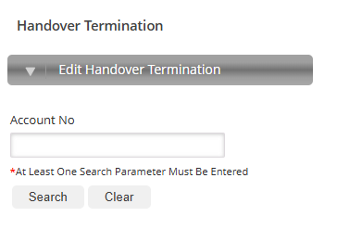
Field Name | Dropdown / Input / Display | Mandatory | Notes
Handed Over Account Number | Input | No | Default to “Empty”.  - Provide auto complete after the 3rd character has been supplied.  - This will only be the Handed Over Account numbers that will display here where the AccountTypeID = 5  - NO OTHER MASTER ACCOUNT WILL DISPLAY HERE

Button | Description
Search | Find the account number.  Populate the search grid.  Display the search grid.
Clear | Set all values in the “landing page” to its original values and re-display the page.

Proposed Screen Layout – Billing Debt - Handover – Terminate Handover - Landing Page - Grid
- By selecting the required account nr in the grid go to the termination landing page.

Field Name | Dropdown / Input / Display
Handed Over Account Number | Display
Handover Status | Display
Handover Amount | Display
Date Handed Over | Display
Attorney | Display
Name | Display
Location Address | Display
SG Number | Display

Proposed Screen Layout – Billing Debt - Handover – Terminate Handover - Landing Page - Terminate
- Display the normal account information label on top
- The user will only enter the comment and Submit
- On Submit the Dashboard Notification – Debt - Handover Termination Pending will show this notification
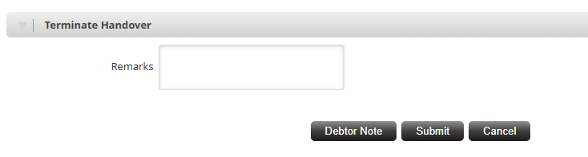
Field Name | Dropdown / Input / Display
Comment | Input

Proposed Screen Layout – Handover Process – Landing Page – Handover Terminate Authorisation
- The same layout as all our other authorisation screens will apply (Journal Authorisation screen)
- Create a new screen as defined below.

Field Name | Dropdown / Input / Display | Mandatory | Notes
Review | Dropdown | Yes | 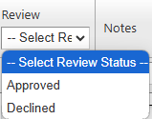
Notes | Varchar (250 char) | Yes | 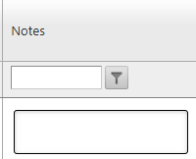
Account Nr | Display | N/A
Name
Location Address
SG Number
Status | Display | N/A
Captured by: | Display | N/A | User information of the user that did the process
Date Captured | Display | N/A | The date on which the file was created (run-date). Date & time

Button | Description
Submit | Change the Status to “Handover – Terminated”.  Navigate back to the Dashboard.
Cancel | Close the page.  Navigate back to the Dashboard

Handover Termination Authorised – Back-End Processing of Journals and Handover Account

- The back-end process must run on its own and not be an on-line process.
- Automated Journals that were done will be reversed (this is the same principal as the Billing_RepaymentPlan termination journals that is done) back to the master account
    - As per normal system rules used to do a transfer journal (63)
    - System must approve these journals (System Approved)
  - When the journals are processed the Master Account amount will increase with the hand over amount and the handover account (Child Account) will be 0 (Zero)
  - Set the handover account status to 2 – Inactive

- Make below process part of the handover termination when it is approved.

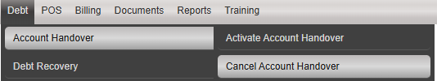

This is the script that I got from Eben - @Niren please see how we can change this to automatically run as part of the handover termination - approved.

UPDATE Billing_Handover
SET AccountId = @ACCOUNTID
,ActivateDate = @ACTIVATEDATE
,CancelDate = @CANCELDATE
,HandoverStatus = @HANDOVERSTATUS
WHERE Handover_Id = @HANDOVERID
END
ELSE
BEGIN
INSERT INTO Billing_Handover
(AccountId
,ActivateDate
,CancelDate
,HandoverStatus)
VALUES
(@ACCOUNTID
,@ACTIVATEDATE
,@CANCELDATE
,@HANDOVERSTATUS)
END";

This is how enquiries page is updated on the final run – NOW on termination “Account Handed Over” MUST NOT DISPLAY

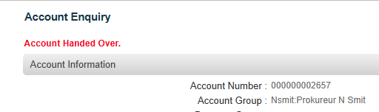

Program Menu/Execution Path – General Enquiries
Billing >> Enquiries >> General Enquiries

Proposed Screen Layout – General Enquiries – Detail Landing Page on Additional Account Details (Account Information)

Note that this layout is only for illustrative purposes.
Section 129 – Letter of Demand Status:
Handed Over:

Field Name | Dropdown / Input / Display | Mandatory | Notes
Section 129 Status | Display | N/A | Display the field value as follows:  - “Not Issued” – If the RUN_ID status is “Notice Issued – Trial Review”  Or  - “Notice Issued” – If the RUN_ID status is “Notice Issued – Trial Run” was processed
Handed Over | Display | N/A | If the Handover – Trial run was actioned:  - Display “Handover - Pending”.  If the Handover – Final run was actioned:  - Display “Handover - Active”.

Proposed Screen Layout – General Enquiries – Enquiry Button – Section 129 – Letter of Demand

- Add a new tab whereby the user can display the section 129 notices issued history for the relevant account.
- The user must also be able to search by financial year and month to print the notice again.

Below is the current enquiry tabs screen. It must be sorted by Ascending order to be more user-friendly – also including the addition of the new tab:
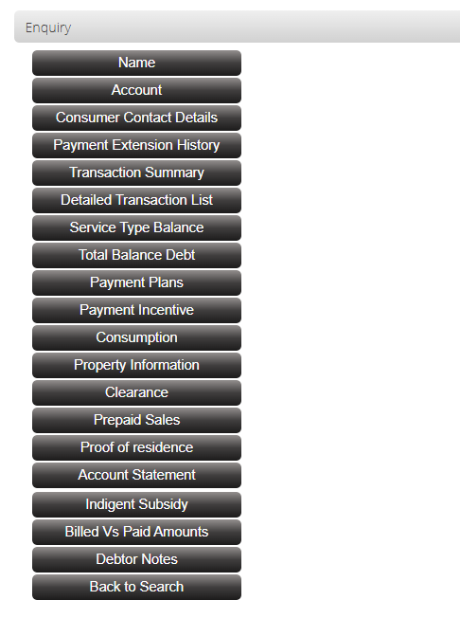
Add the following Button:

Field Name | Dropdown / Input / Display | Mandatory | Notes
Section 129 – Letter of Demand | Button | N/A | This is a new button and must be active for the user to use.  When this button is clicked it must open a new page displaying the section 129 – Letter of Demand detail page – where the user can search and display the relevant notices. If the user exit from this page control must return to the Enquiries Tabs page.  If the current enquiry-account does not have any notices issued yet and the button is clicked – display the relevant error message as per section 3.5.4.

Proposed Screen Layout – General Enquiries – Section 129 Notices Tab (Detail)

- This is a new page and will be displaying section 129 notice history. All notices issued to the account before.
- Also, with the Financial Year & Month selection.
- The Month must default to display all entries for the financial year, only when a actual month is selected it will display the relevant information.
- The display sequence in the grid must be:
  - Primary – Issue date and time descending – the most recent one at the top of the grid.
- Allow for 20 entries in the grid – and paging must be available.
- When this page is executed:
  - Find the latest 20 notices issued
  - Populate the grid in the display sequence
- From now on the user can use the dates to filter the notices – and much always do reload of the grid as the request can fall outside of the original 20 notices displayed.

Field Name | Dropdown / Input / Display | Mandatory | Notes
Financial Year | Dropdown | Yes | Financial Year functionality as per Detailed Transaction List
Month | Dropdown | Yes | Default to “ALL” so that all the financial years information displays, ONLY if the user select a certain Month, it will only display that month  Month functionality as per Detailed Transaction List  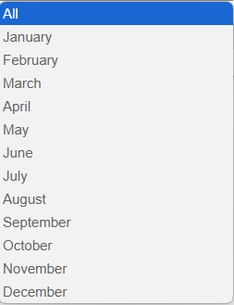
Final Run ID | Display | N/A | This will be the Run_ID recorded on the Section 129 – Letter of Demand Final Run
Grid – Distribution Type | Display | N/A | What the distribution type was for the notice at the time.  Can either be “Mail”, “SMS” or “Print”.
Grid – Issue Date | Display | N/A | The date on which the notice was issued – which will be the same as the run-date at time the notice run was done.
Grid – Qualifying Amount | Display | N/A | The qualifying amount at run-time which caused the notice to be issed.
Rotation Attorney | Check Box | N/A | Display “Yes” if enabled else display “No”.
Attorney | Display | N/A | Display the attorney’s name that it was handed over to
Proof of Delivery Date | Display | N/A | This will only apply for Email & SMS notifications sent & Delivered items  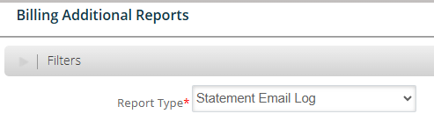  DateSen (Header name on report)
Proof of Delivery Status | Display | N/A | Success/Fail (Header name on report)
Proof of Delivery Message | Display | N/A | If status is = Success, then display “Delivered Successfully”  If status is = Fail, then display ErrorMessage
Download | Button | N/A | Display the standard Download icon here - .  The section 129 – Letter of Demand & SMS notice will be available here  The button must be live for the user to click.
Actioned by: | Display | N/A | User information of the user that did the process
Date Created | Display | N/A | The date on which the file was created (run-date). Date & time
Authorised by: | Display | N/A | User information of the user that did the process
Date Created | Display | N/A | The date on which the file was created (run-date). Date & time

Proposed Screen Layout – General Enquiries – Handover Tab - Grid

- This is a new page and will be displaying the Handover history.
- Also, with the Financial Year & Month selection.
- The Month must default to display all entries for the financial year, only when a actual month is selected it will display the relevant information.
- The display sequence in the grid must be:
  - Primary – Issue date and time descending – the most recent one at the top of the grid.
- Allow for 20 entries in the grid – and paging must be available.
- When this page is executed:
  - Find the latest 20 handovers
  - Populate the grid in the display sequence
- From now on the user can select the required item (Cons_Handovers) to open a display of the Cons_Handovers_Transactions to see the details of the journals – See point 9 below

Field Name | Dropdown / Input / Display | Mandatory | Notes
Financial Year | Dropdown | Yes | Financial Year functionality as per Detailed Transaction List
Month | Dropdown | Yes | Default to “ALL” so that all the financial years information displays, ONLY if the user select a certain Month, it will only display that month  Month functionality as per Detailed Transaction List  
Final Run ID | Display | N/A | This will be the Run_ID recorded on the Section 129 – Letter of Demand Final Run
Handover Account Nr | Display | N/A | This information can be obtained from the Cons_Handovers table  HandoverAccountID
Handover Amount | Display | N/A | This information can be obtained from the Cons_Handovers table  HandedOverAmount
Handed Over Date | Display | N/A | This information can be obtained from the Cons_Handovers table  HandoverDate
Outstanding Days Description | Display | N/A | This information can be obtained from the Cons_Handovers table  OustandingDaysDescription (Ageing bracket)
Outstanding Month | Display | N/A | This information can be obtained from the Cons_Handovers table  OutstandingPeriodID
Attorney | Display | N/A | This information can be obtained from the Cons_Handovers table  AttorneyID – lookup to Const_Attorney to display the Attorney Name here
Status | Display | N/A | Display as per process:  Final Run done - Notice Issued - Final  Handover Terminated - Handover – Termination Approved
Capturer | Display | N/A | This information can be obtained from the Cons_Handovers table  CapturerID
Date Captured | Display | N/A | This information can be obtained from the Cons_Handovers table  DateCaptured
Reviewed By | Display | N/A | Who approved the Trial Run
Termination Reason | Display | N/A
Termination Date | Display | N/A
Capturer | Display | N/A
Reviewed By | Display | N/A | Who approved the termination
Review Date | Display | N/A

Proposed Screen Layout – General Enquiries – Handover Tab – Grid – 2nd display (Cons_handovers_Transactions)

From now on the user can select the required item (Cons_Handovers) from the grid to open a display of the Cons_Handovers_Transactions to see the details of the journals

This is all the headers from the Cons_Handovers_Transactions table:
Field Name | Dropdown / Input / Display | Mandatory | Table header
Handover ID | Display | N/A | HandoverID
Service Type | Display | N/A | ServiceTypeID – show the description
Total | Display | N/A | Sum the following per service type to get the total:  - Amount  - VatAmount  - InterestAmount
Amount | Display | N/A
Vat Amount | Display | N/A
Interest Amount | Display | N/A
Additional Billing | Display | N/A | AdditionalBillingID – show the description
Total | Display | N/A | Sum the following per additional billing to get the total:  - AmountAdditionalBilling  - VatAmountAdditionalBilling  - InterestAmountAdditionalBilling
Amount | Display | N/A | AmountAdditionalBilling
Vat Amount | Display | N/A | VatAmountAdditionalBilling
Interest Amount | Display | N/A | InterestAmountAdditionalBilling
Transaction Date | Display | N/A
Journal ID | Display | N/A
Transaction ID | Display | N/A
Document Type | Display | N/A | Display Description
Document Number | Display | N/A

Program Menu/Execution Path – Section 129 Notices Report
Billing >> Reports >> Debt Recovery >> Section 129 Notices Report

Proposed Screen Layout – Section 129 Notices Report - Landing Page

- This is a new screen.
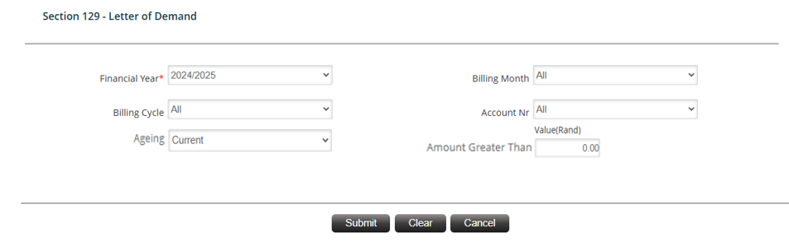
Field Name | Dropdown / Input / Display | Mandatory | Notes
Financial Year | Dropdown | Yes | Default to value to current financial year.  All financial years must be displayed as indicated, for example:  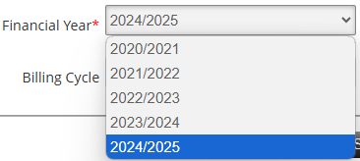
Billing Month | Dropdown |  | Default to value “All”.  All months must be displayed as indicated, for example:  
Billing Cycle | Dropdown | No | Default to value “All”.  The dropdown list must display:  - All  - All the cycles as registered in the Billing Cycle configuration with status “Enabled”.
Account Number | Input | No | Default to “Empty”.  Provide auto complete after the 3rd character has been supplied.
Ageing | Dropdown | Yes | Default to value “30 Days”.  Values to display in the dropdown:  - 30 Days  - 60 Days  - 90 Days  - 120 Days  - 150 Days  180 Days Plus
Amount Greater Than | Input | No | Default to value 0 (zero).  Decimals not allowed – must be integer.  Cannot be less than 0 (zero).

Button | Description
Submit | Validate all the parameters  Run the report in the standard manner – providing the user with all the relevant export options.  Set all landing page parameter values back to the defaults.  Redisplay the landing page.
Clear | Do not run the report.  Set all landing page parameter values back to the defaults.  Stay on the landing page.
Cancel | Do not run the report.  Close the landing page and re-direct to the billing dashboard.

Refer annexure A.3 for report sample and summary.

Proposed Screen Layout – Handover Report - Landing Page
Billing >> Reports >> Debt Recovery >> Handover Report

- This is a new screen.
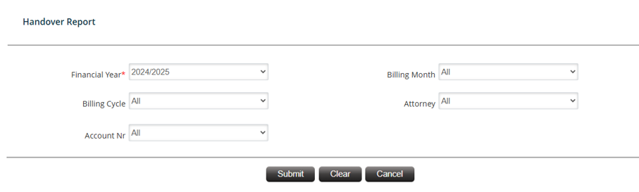

Field Name | Dropdown / Input / Display | Mandatory | Notes
Financial Year | Dropdown | Yes | Default to value to current financial year.  All financial years must be displayed as indicated, for example:  
Billing Month | Dropdown |  | Default to value “All”.  All months must be displayed as indicated, for example:  
Billing Cycle | Dropdown | No | Default to value “All”.  The dropdown list must display:  All the cycles as registered in the Billing Cycle configuration with status “Enabled”.
Attorney | Dropdown | No | Default to value “All”.  The dropdown list must display:  All the attorney as registered in the Attorney configuration with status “Enabled”.
Account Number | Input | No | Default to “Empty”.  Provide auto complete after the 3rd character has been supplied.

Button | Description
Submit | Validate all the parameters  Run the report in the standard manner – providing the user with all the relevant export options.  Set all landing page parameter values back to the defaults.  Redisplay the landing page.
Clear | Do not run the report.  Set all landing page parameter values back to the defaults.  Stay on the landing page.
Cancel | Do not run the report.  Close the landing page and re-direct to the billing dashboard.

Refer annexure A.4 for report sample and summary.

Annexure A

A.4 – Handover Report
Billing >> Reports >> Debt Recovery >> Handover Report

- This is a new report.
- Apply all normal system standards to the report.
- The report has 3 sections as defined below:
  - The heading
  - The Detail
  - The summary
- The report detail must be in the following sequence:
  - Primary – Billing Cycle – Ascending by cycle number
  - Account Number - Ascending

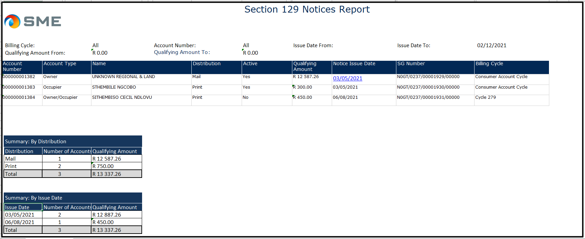

- Report heading
  - Display all the parameters as supplied on the front-end
  - Align the parameters and the parameter values

- Report detail

Field | Comments
Account No | The Master account number.
Account Type of Master | The account’s account type e.g. Owner or Occupier.
Status of Master | The account status – active or inactive – yes or no.
Handover Account Nr | This is the handed over account nr with AccoutTypeID = 5
Account Type of Handover | The account’s account type e.g. Owner or Occupier.
Status of Handover | The account status – active or inactive – yes or no.
Name | The account holder’s name.
SG Number | The SG-number linked to the account.
Location Address
Attorney | The distribution type – mail or print.
Property Category | Linked to Property Partition
Property Type of Use | Linked to Property Partition
Qualifying Amount | The qualifying amount when the notice was issued.
Notice Issue Date | The date on which the notice was issued.
Billing Cycle | The billing-cycle linked to the child account.

- Report summaries
  - The report must have the following 2 summaries:

    - Per Attorney

Field | Comments
Attorney | The rotation attorneys that were processed in the run
No of Accounts | The total number of accounts notices were issue to for the relevant attorney.
Qualifying Amount | The total qualifying amount that notices were issued for per the relevant distribution type.
Column totals | Sum the following columns for a bottom-line total/amount:  - Number of accounts  - Qualifying amount

    - Per issue date

Field | Comments
Handover Date | There must be an entry in the grid for each issue-date processed during the creation of the report.
No of Accounts | The total number of accounts notices were issue to for the relevant issue date.
Qualifying Amount | The total qualifying amount that notices were issued for per the relevant issue date.
Column totals | Sum the following columns for a bottom-line total/amount:  - Number of accounts  - Qualifying amount

