
Debt Management

Version 1
Prepared by
SAMRAS Team

Copyright Notice

© 2020 Solvem Consulting (Pty) Ltd. All rights reserved. This document is protected by copyright law.
No part of this document may be reproduced or used in any manner whatsoever without the prior written permission of Solvem Consulting (Pty) Ltd, Registration Number 2006/003138/07.

Warning: the unauthorised reproduction or distribution of this copyright work is illegal and constitutes criminal copyright infringement.

Confidentiality Notice

Any quotation or proposal information contained in this document is provided in strict confidence and may not be disclosed to any third party or used for any other purpose without the prior written permission of Solvem Consulting (Pty) Ltd.

CONTENTS

2.1 OVERVIEW 6
2.2 Debt Management process diagram 6
2.3 Individual workflow during disconnection process diagram 7
2.4 Account Maintenance 8
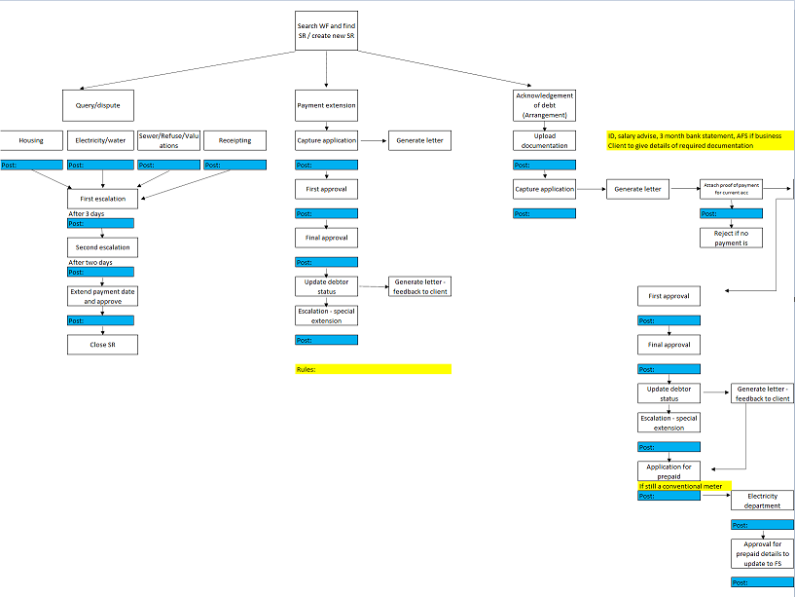 8
DETAIL SPECIFICATION 9
2.5 Global Data 9
2.6 Category (B029) 9
2.7 Sub-group (B512) Category 9
2.8 Discount category (B20) 10
2.9 Pay centre/region 10
2.10 Ward (B302) 10
2.11 Suburb (B02) 10
2.12 DEBT MANAGEMENT PROCESS 11
2.13 First reminder SMS 11
2.14 Second reminder SMS – 5 days after debit raising 11
2.15 Third reminder SMS (day before due date) 12
2.16 Selection of arrear debt 13
2.17 Arrear message – 1st arrear SMS 14
2.18 Arrear message – 2nd arrear SMS 14
2.19 14 Days’ notice 15
2.20 Apply for prepaid (only if option is selected) 21
2.21 Notice of disconnection 22
2.22 Meter audit 25
2.23 Section 129 Demand Workflow Item 25
2.24 Debt Management: Summons Workflow Item 27
2.25 Debt Management: Judgement and Warrant Workflow Item 31
2.26 New development for Stellenbosch debt management 32
2.27 Specification for disconnection of arrangement: 32
Extract 1: Arrangement disconnection - Prepaid: 33
Extract 2: Arrangement disconnection - Conventional: 36
Extract 3: Arrangement disconnection - KVA: 39
2.28 First notice – warning – normal and indigent 41
Extract 4: Normal first notice 41
Extract 5: Indigent first notice 43
2.29 Disconnection notices 49
Extract 6: Disconnection – Prepaid – normal accounts: 49
Extract 7: Disconnection – Prepaid – indigent accounts: 52
Extract 8: Disconnection – Conventional accounts 57
Extract 9: Disconnection – KVA accounts 60
2.30 New screens for Stellenbosch release January 2025 62
PRODUCT CHANGE APPROVAL 65
CLIENT ACCEPTANCE 66
TIMING 67
TECHNICAL DESIGN 68
2.31 Database changes 68
2.32 Programs impacted 68
2.33 Action Blocks to be re-used 68
TESTING 69
2.35 Testing Instructions 69
2.36 Regression Testing 69
2.37 Testing Documentation 69
2.38 Testing Signoff 69
DOCUMENTATION SIGNOFF 70

OVERVIEW

The system provides several MyWork Workflows that manages the creation SMS messages and letters to debtors in the correct sequence and at the required times.
The following diagram shows the process an account goes through from debit raising through to a Judgement against the debtor, should the debtor default on payment. At each step in the process the debtor is given the opportunity to settle the account which will end the workflow. The process illustrated below will be for a Municipality utilizing a debt collector or multiple debt collectors.

Debt Management process diagram
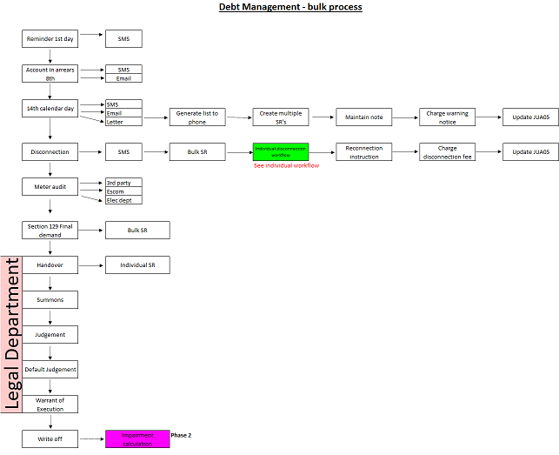

Individual workflow during disconnection process diagram

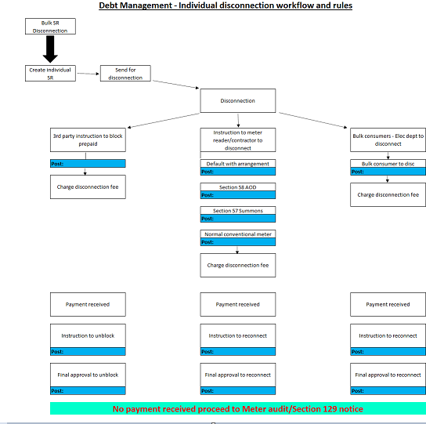

Account Maintenance



DETAIL SPECIFICATION

Global Data

Category (B029)
- Business and commercial
- Communal land
- Farm properties
- Formal and informal settlements
- Industrial properties
- Municipal properties
- National Monuments
- Privately owned towns
- Protected areas
- Public Benefit Organisations
- Public Service Infrastructure
- Residential
- Restitution
- Small holdings
- Special rating area
- State owned properties
- State trust land
- Mining
- Agricultural properties
- Multi purposes

Sub-group (B512) Category
- Business and commercial
- Farm Property
- Residential
- Small holdings
- Agricultural
- Industrial
- Residential Developed
- Residential Vacant
- Communal Property
- Restitution of land
- National Government
- Provincial Government
- Other
- Indigent

Discount category (B20)

- Indigent
- Discretionary
- Bona fide farmers
- Pensioners
- Social Grants
- Phase in reductions
- Municipal
- State
- Public Service Infrastructure

Pay centre/region

Ward (B302)

As defined by the regional indicator of the Local Authority

Suburb (B02)

B02 suburb file / GIS import of suburbs for the Local Authority

DEBT MANAGEMENT PROCESS

First reminder SMS
MY WORK:
Action: Create
Process: DEBT MNGMENT
Activity: FIRST REMINDER SMS

This is a message generated directly after debit raising containing the outstanding balance of the debtor. SMS to be sent or SMS to email. Automated message where the following fields will be extracted:
- MEMBER_NAME
- MEMB_REF_NO
- TOTAL_DUE

A document template (1298 DEV02) as per the example below must be created at each client:
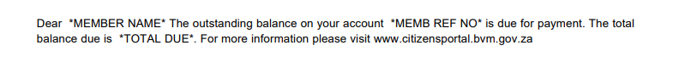
Click COMPLETE PROCESS, the activity will change to SECOND REMINDER SMS and the system will flow send SMS page.
The Workflow will be completed. If the account is paid at this point it will not generate further workflows for this debt.

Second reminder SMS – 5 days after debit raising

MY WORK:
Action: Create
Process: DEBT MNGMENT
Activity: SECOND REMINDER SMS

This is a message generated 5 days after debit raising containing the outstanding balance of the debtor. SMS to be sent or SMS to email. Automated message where the following fields will be extracted:
- MEMBER_NAME
- MEMB_REF_NO
- TOTAL_DUE

A document template (1298 DEV02) as per the example below must be created at each client:

Click COMPLETE PROCESS, the activity will change to THIRD REMINDER SMS and the system will flow send SMS page.
The Workflow will be completed. If the account is paid at this point it will not generate further workflows for this debt.

Third reminder SMS (day before due date)

MY WORK:
Action: Create
Process: DEBT MNGMENT
Activity: THIRD REMINDER SMS

The third reminder SMS is like the first two SMS messages. This is reminder SMS to be sent the day before the due date of the accounts. Normally the 7th of the month.
Automated message where the following fields will be extracted:
- MEMBER_NAME_1
- MEMB_SURNAME
- MEMB_REF_NO
- TOTAL_DUE

A document template (1229-1 DEV02) like the example below must be created at each client:
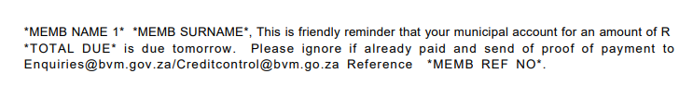
Click COMPLETE PROCESS, the activity will change to SELECTION OF ARREARD DEBT and the system will flow the selection of arrear debt page.
The Workflow will be completed. If the account is paid at this point it will not generate further workflows for this debt.

Selection of arrear debt

A selection screen making provision for the following fields must be created:
Selection of all arrear debt with the following exclusions

- List all SUBURBS default to select YES with the option to change the selected suburb to NO to exclude from the arrear file.
- List all WARDS default to select YES with the option to change the selected ward to NO to exclude from the arrear file.
- List all INCOME/EXPENSE types (Service/subservice). Default to YES with the option to change the selected income/expense type to NO to exclude from the arrear file.
- List all debtor CATEGORIES. Default to YES with the option to change the selected category to NO to exclude from the arrear file.
- List all SUB-CATEGORIES. Default to YES with the option to change the selected sub-category to No to exclude from the arrear file.
- Minimum last date of payment – this is the last date that the debt must be settled. Any debt not settled by this date is deemed to be arrears
- Minimum amount – allow the user to select a minimum amount due. This is normally not less than R50,00. It should however be determined by the user
- Automatically exclude any accounts with a valid arrangement, payment extension, account under query.

Field | Activity | Description | Comment | Identifier
Select
Suburbs, Wards, Income/expense type/categories/sub-categories | Select - YES/NO  YES = include in arrear file  NO = exclude from arrear file | Select between the various drop-down options | User must be able to set different options for the batch job to be generated
Last payment date | Capture date  dd/mm/YYYY | Insert last date of payment to consider as the due date of outstanding debt
Minimum amount | Capture | Allow user to specify minimum amount outstanding to be used in extract

Screen to be designed and inserted into the specification

Display an arrear listing for all accounts matching the selected criteria – list.

Click COMPLETE PROCESS, the activity will change to 1ST ARREAR SMS and the system will flow the create process page to create 1ST ARREAR SMS process.
The Workflow will be completed. If the account is paid at this point it will not generate further workflows for this debt.

Arrear message – 1st arrear SMS

MY WORK:
Action: Create
Process: DEBT MNGMENT
Activity: FIRST ARREAR SMS

An SMS message is generated from the arrear selection screen. Process is normally done around the 8th working day of the month. SMS is sent to defaulting debtor using document template 1390.
Automated message where the following fields will be extracted:
- MEMBER_NAME
- MEMB_REF_NO
- TOT_ARREARS
Click COMPLETE PROCESS, the activity will change to 2ND ARREAR SMS and the system will flow the create process page to create 2nd ARREAR SMS.
The Workflow will be completed. If the account is paid at this point it will not generate further workflows for this debt.

Arrear message – 2nd arrear SMS

MY WORK:
Action: Create
Process: DEBT MNGMENT
Activity: SECOND ARREAR SMS

An SMS message is generated from the arrear selection screen and only for accounts still matching the criteria set. A validation must be done to make provision for accounts which might have been paid or corrected and no longer meet the criteria set in the selection. Process is normally done around the 15th of the month. SMS is sent to defaulting debtor using document template 1391.
Automated message where the following fields will be extracted:
- MEMBER_NAME
- TOT_ARREARS
- MEMB_REF_NO
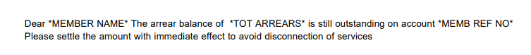
Click COMPLETE PROCESS, the activity will change to 14 DAYS NOTICE and the system will flow the create process page for the creation of the 14 DAYS NOTICE.
The Workflow will be completed. If the account is paid at this point it will not generate further workflows for this debt.

14 Days’ notice

Accounts that are in arrears after the payment date and which still meet the criteria set on the selection screen will be flagged by a batch job that generates a Workflow item with a process of DEBT MNGMNT and an activity of 14 DAY NOTICE.

MY WORK:
Action: Create
Process: DEBT MNGMENT
Activity: 14 DAYS NOTICE

NEW: A report with contact details of all the defaulting debtors must be available. The option to extract the phone list report should be added to this step.

The debtor can enter into an agreement which will be selected by the user via a drop down. The following selections will be available:
- Payment extension/partial settlement
- Arrangement
- Apply for prepaid
- None – no AOD and no debt will be appended

The process will flow to the acknowledgement of debt screen where the AOD can be printed and signed.

To display the account status for a Debtor, highlight the Debtor on the JU3MS List of Debtors screen and select Account Status from the menus on the left.

Maintain debtor account status
This process was in the initial specification document with the screens.
Debtor account status should update automatically as the debtor account moves through the various debt management steps.

The JU3MR Account Status List screen is displayed.

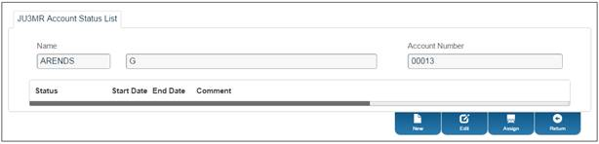

New
To add a new debt account status record for the Debtor, click NEW.

The JU3MR Account Status Maintain screen is displayed.

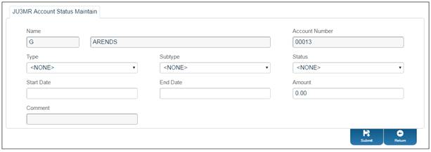

Capture details as follows:

Type | Select DEBT MANAGEMENT from the drop-down list.
Subtype | Select the terms of the debt from the drop-down list.  The following values may be selected:  120 days Plus  30 Days  60 Days  90 days  Balance C/O  Credit Amount
Status | Select the current Status of the debt from the drop-down list.  The following values may be selected:  14 Day Notice  Arrangement  Disconnection  Judgement  Partial Settlement  Pre-paid  Section 129  Summons
Start Date | Capture the start date of the debt status.
End Date | Capture the end date of the debt status.
Amount | Capture the amount of the debt
Description | Capture a text description of the debt.

Click SUBMIT.

Edit
To edit an existing debt account status record for the Debtor click EDIT.

The JU3MR Account Status Maintain screen is displayed.

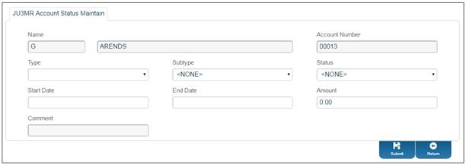

Edit the debt account status record details and click SUBMIT.

Assign
Assign to relevant user to complete processing. Approval is required.
Once approved an acknowledgement of debt agreement will be produced to be signed and stored in document management (scanned and uploaded). Template 1026(1)
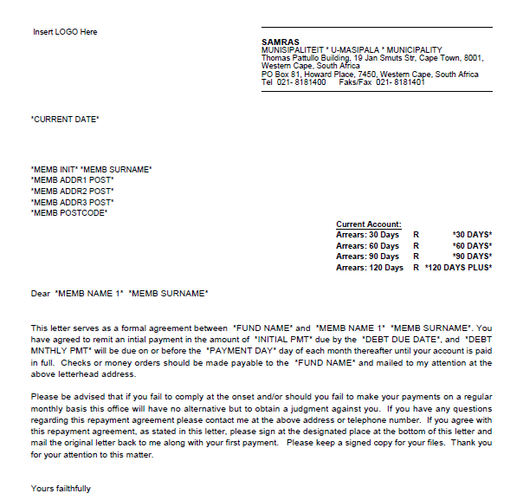

The debtor’s status will be updated with the acknowledgement of debt item approved.
The outstanding debt will append, with a termination date, once the AOD has been approved. All debtors without an AOD/agreement will flow to the 14 days’ notice action. A list must be provided. Add option to view/extract the list of debtors meeting the criteria to receive a 14 days’ notice
A new option to charge the 14 Day notice fee to the account for all defaulting debtors on the above list, should be added. The amount will be updated to the JUA05. Income/expense type to be added. This must be an automated process with the amount in a table and to be applied to all accounts that appears on the final 14 Days’ notice bulk file.

Click on the workflow item in the list.
Click PROCESS in the left-hand pane.

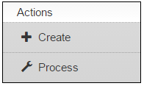

The system will flow to the JU4HL Letter Templates screen.

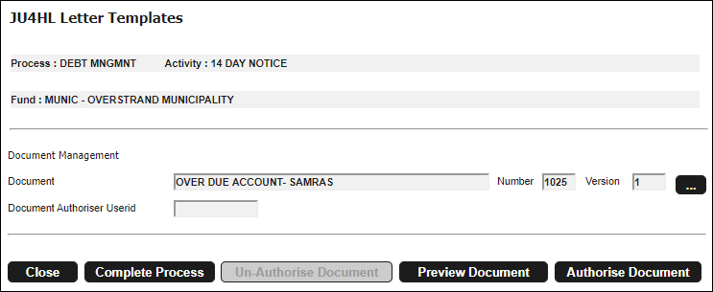

Click the LIST button to display the JU4HL Document template List screen.

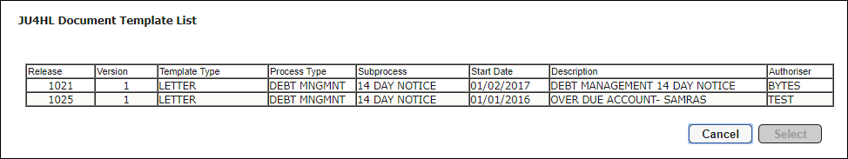

Click on the required letter template then click SELECT.

The JU4HL Letter Templates screen displays the template selected.



Click COMPLETE PROCESS, the activity will change to Bulk PDF and the system will flow to the Bulk printing screen.
Click PRINT.
14 days’ notice will now be printed to be delivered by the meter readers. Template not on DEV02
If apply for prepaid is selected the account will flow to the next activity AGREE TO PREPAYMENT. All other accounts without an acknowledgement of debt or an account status of NONE will flow to activity NOTICE OF DISCONNECTION.
The Workflow will be completed. If the account is paid at this point, then it will not generate further workflows for this debt.

Apply for prepaid (only if option is selected)

Step must be changed to only affect debtors where the option “apply for prepaid” was selected within the 14 days’ notice step.
Accounts that are still in arrears after receiving the 14 day notice, and the option apply for prepaid selected, will be flagged by a batch job that runs daily and generates a Workflow item with a process of DEBT MNGMNT and an activity of AGREE TO PRE-PAYMENT.

Click on the workflow item in the list.

Click PROCESS in the left-hand pane.



The system will flow to the JU4HL Letter Templates screen.



Click the LIST button to display the JU4HL Document template List screen.



Click on the required letter template 1024(1) then click SELECT. Error on the template in DEV02

The JU4HL Letter Templates screen displays the template selected.

Click PREVIEW DOCUMENT to view the template as a PDF in your browser.
Click COMPLETE PROCESS, the activity will change to Bulk PDF and the system will flow to the Bulk printing screen.
Click PRINT.
The Workflow will be completed. If the work order is accepted and subsequently the account is paid, then the system will not generate further workflows for this debt. Work order should route to the electricity department via workflow.
If it is not paid, then the system will generate a workflow with a process of DEBT MNGMNT and an activity of NOTICE OF DISCONNECTION.

Notice of disconnection
Accounts that are in arrears after failing to agree to a pre-payment or an approved acknowledgement of debt, will be flagged and an individual Workflow item with a process of DEBT MNGMNT and an activity of NOTICE OF DISCONNECTION will be created.
Full payment of account will stop the process on the account.
The debtor can also enter into an agreement and sign an acknowledgement of debt with the option to make an arrangement or pay extension. See 2.3.7 on page 10 for the specification. The exact same specification applies here. The debtor’s status will be updated.

The following acknowledgement of debt options must be available:

- Pay extension
- Arrangement
- Account under query
- None

The debt will append, with a termination date once the acknowledgement of debt has been approved.
Selecting none or no approval will move the debtor to the activity NOTICE OF DISCONNECTION.

Individual SR notice of disconnection

Click on the workflow item in the list.
Click PROCESS in the left-hand pane.



The system will flow to the JU4HL Letter Templates screen.



Click the LIST button to display the JU4HL Document template List screen.



Click on the required letter template then click SELECT.

The JU4HL Letter Templates screen displays the template selected.



Click COMPLETE PROCESS, the activity will change create an individual SR for each defaulting debtor and flow to the relevant department for disconnection.
The Workflow will be completed. If there is an agreement to convert to pre-payment and subsequently the account is paid, then the system will not generate further workflows for this debt.
If it is not paid, then the system will generate a workflow with a process of DEBT MNGMNT and an activity of DISCONNECTION OF SERVICE CONVENTIONAL/DISCONNECTION OF SERVICE BULK/BLOCK PREPAID depending on the type of meter. Decision must be taken how will these meters be identified.

Block prepaid
If the meter is prepaid flow to BLOCK PREPAID and create a third-party interface file which can be sent to the third party vendor to block prepaid.

Conventional metering – normal meter
Conventional metering should flow to DISCONNECTION OF SERVICE for normal conventional meters. A parameter selection should be available to enable the user to select which meters are normal conventional and which are bulk metering. The tariff linked to the meter normally indicates the type of meter. A normal conventional meter should flow to the meter reading department for disconnection. The disconnection will be carried out by the meter readers.

Bulk metering
Bulk metering should flow to the electricity department as an electrician must disconnect this meter. Normally meters more than 11KV, KVA and time of use meters.

Updating payment information
Payments are updated daily via various platforms within the billing module. An instruction to reconnect/unblock should be generated when the full outstanding amount on the SR is received. The relevant department should receive the instruction to reconnect/unblock the prepaid.

Charge disconnection notice
A new option to charge the NOTICE OF DISCONNECTION fee to the account should be added. The amount will be updated to the JUA05. This must be an automated process with the amount in a table and to be applied to all accounts that appears on the final NOTICE OF DISCONNECTION bulk file.
The Workflow will be completed. If there is an acknowledgement of debt or outstanding amount is paid in full, the system will not generate further workflows for this debt.
If it is not paid, then the system will generate a workflow with a process of DEBT MNGMNT and an activity of METER AUDIT.

Meter audit
This is a new process.
The user can decide to send the meter for an audit. A select YES/NO should be added to the SR. If YES is selected a workflow item should be sent to the electricity department. The audit is conducted, and a reply is sent back to the meter office. Electricity department should action if any meter tampering is found. This is however their own internal process. Electricity department can reply and send a report which will route back to the finance department. User can now select completed. A note must be updated to the debtor’s account which will generate a workflow with a process of DEBT MNGMNT and an activity of SECTION 129 DEMAND.
If meter audit NO is selected, the system will generate a workflow with a process of DEBT MNGMNT and an activity of SECTION 129 DEMAND.

NOTE: The legal department will deal with the defaulting accounts from process Section 129 Demand. Although templates have been created each client will have their own set of legal documentation. The terminology in these documents differ slightly from different magistrate courts. It’s therefore advisable to consult with the legal department during implementation to ensure the wording in the templates are correct.

Section 129 Demand Workflow Item
Accounts that continue to be in arrears after NOTICE OF DISCONNECTION and METER AUDIT will be flagged and flow to a Workflow item with a process of DEBT MNGMNT and an activity of SECTION 129 DEMAND.
Full payment of the account will terminate workflow on the account.
The debt collection type should be selected. The following options should be available:
Please confirm if we will give the option to select inhouse or outsources debt collection. Or will we only produce a handover file? Rotational handover between debt collectors is currently available in Classic an in use at some clients.
- In-house with rotation – municipality does own debt collection and the debt is split into several files – number of files is defined from 1 – 99. Option should be included to name the files according to responsible official – parameter.
- Debt collector with rotation – a bulk file will be sent to various debt collectors – number of files is defined from 1 – 99. Option should be included to name the files according to debt collector – parameter.
Selecting 1 in both cases will only produce 1 Section 129 (handover) file. A default name/debt collector will be assigned to the file

The option to append debt via an arrangement must be added to this step. No arrangement will move the debtor to the bulk file and create a Section 129 demand. The debt collection type should dictate the type of file as per the two bullet points above.

The debt within the SECTION 129 DEMAND bulk file
Click on the workflow item in the list.

Click PROCESS in the left-hand pane.



The system will flow to the JU4HL Letter Templates screen.



Click the LIST button to display the JU4HL Document template List screen.



Click on the required letter template then click SELECT.

The JU4HL Letter Templates screen displays the template selected.



Click COMPLETE PROCESS, the activity will change to Bulk PDF and the system will flow to the Bulk printing screen.

Click PRINT. Section 129 notices will now be printed.

The Workflow will be completed. If the account is paid at this point, then it will not generate further workflows for this debt.
If the debt collection type was selected as “debt collector with rotation” the process will stop here. Only a file will be produced which can be emailed to the debt collector. Debt collection type “In-house with rotation” will move all defaulting accounts to the next activity of SUMMONS in the process DEBT MNGMNT.

Debt Management: Summons Workflow Item
Accounts that are in arrears after receiving the Section 129 Demand will be flagged and generates a Workflow item with a process of DEBT MNGMNT and an activity of SUMMONS.
Click on the workflow item in the list.
Click PROCESS in the left-hand pane.



The system will flow to the JU4HL Letter Templates screen.



Click the LIST button to display the JU4HL Document template List screen.



Click on the required letter template then click SELECT.

The JU4HL Letter Templates screen displays the template selected.



Click PREVIEW DOCUMENT to view the template as a PDF in your browser.

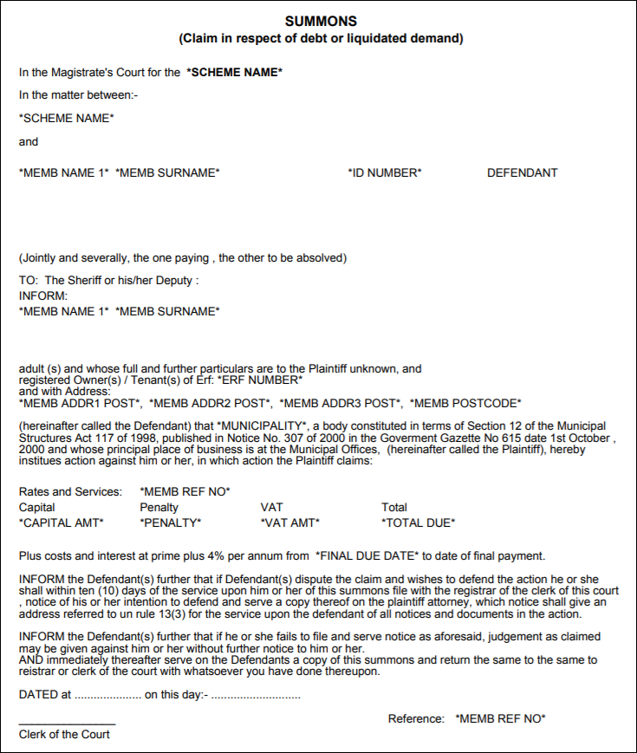

Click COMPLETE PROCESS, the activity will change to Bulk PDF and the system will flow to the Bulk printing screen.

Click PRINT.

The Workflow will be completed. If the account is paid at this point, then it will not generate further workflows for this debt.

If it is not paid, then the system will generate a workflow with a process of DEBT MNGMNT and an activity of JUDGEMENT AND WARRANT.

Debt Management: Judgement and Warrant Workflow Item
Accounts that are in arrears after the summons has been issued will be flagged and will generate a Workflow item with a process of DEBT MNGMNT and an activity of JUDGEMENT AND WARRANT.
Click on the workflow item in the list.
Click PROCESS in the left-hand pane.



The system will flow to the JU4HL Letter Templates screen.



Click the LIST button to display the JU4HL Document template List screen.



Click on the required letter template then click SELECT.

The JU4HL Letter Templates screen displays the template selected.



Click COMPLETE PROCESS, the activity will change to allow for re-assign to a new debt collector/write off debt or complete process

- Re-assign to new debt collector – new should allow debt to be transferred to new debt collector
- Write off debt – new process to be developed

New development for Stellenbosch debt management

Specification for disconnection of arrangement:
The due date for payment is the 7th of every month. The disconnection of arrangements will follow on the first working day.
A file must be prepared for:
- Prepaid
- Conventional
- KVA
A file is required for normal and indigent consumers on prepaid and conventional.
Please display all electricity meters found on the various extracts. Also display leading zero’s.

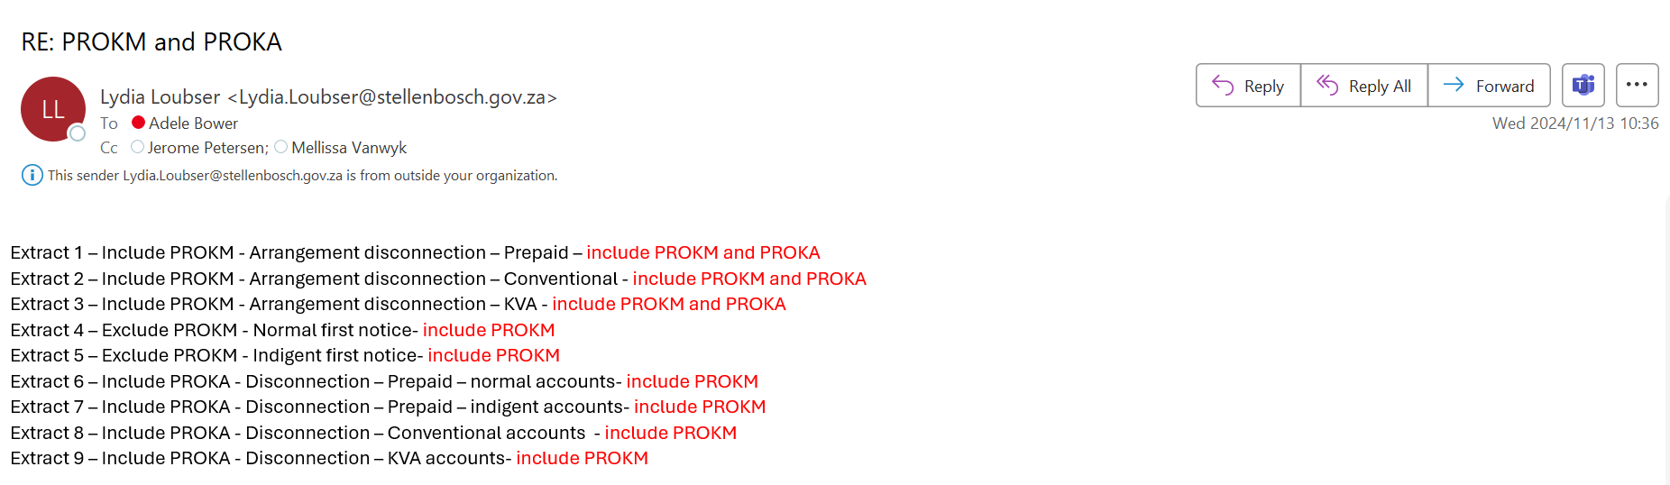

Extract 1: Arrangement disconnection - Prepaid:

- Scheme parameter: FACT or Age analysis
- Select account numbers: from 0 to Account number to 9999999999999
- Select H/O flag B10-HOFLAG = Y
- Select: B10-AUQ = N
- Select discount category B10-DISCCAT = selection (not currently in use)
- Select suburb: All (B10-SUBURB)
- Exclude sub-groups as per list below – The sub-groups in the example is SRES
- Exclude groups as per list below – The group in the example is NORM
- Exclude ward B03-WARD
- Exclude category B03-CATEGORY
- Select service: B40-SERV ELECT – only include accounts with an electricity meter
- Select subservice B40-SUBSID = CONS
- Select tariff B40-STARIFF = PREPD
- Select service open B40-MCLOSED = N
- Select service B13 for all outstanding services
- Select subservice IF B13-SUBSID = DEFER (for all services)
- Select defer type READ B17-DEFTYPE = Y
- Select total arrears amount (Sum B13-OSAMOUNT + B13-OSPENAL + B13-OSVAT)
for all services: R50,00 to R5 000 000,00
- Sum of all services must be = and > than R50,00
- Test for > or equals to R50,00.

- ARREARS_FLAG = Sum of total arrears all services
- Total balance and total due field = Sum of all total balances (all services)
- Ageing: must be on all services on B13debit record

Disconnection fee: R100,00
Link to template: 573

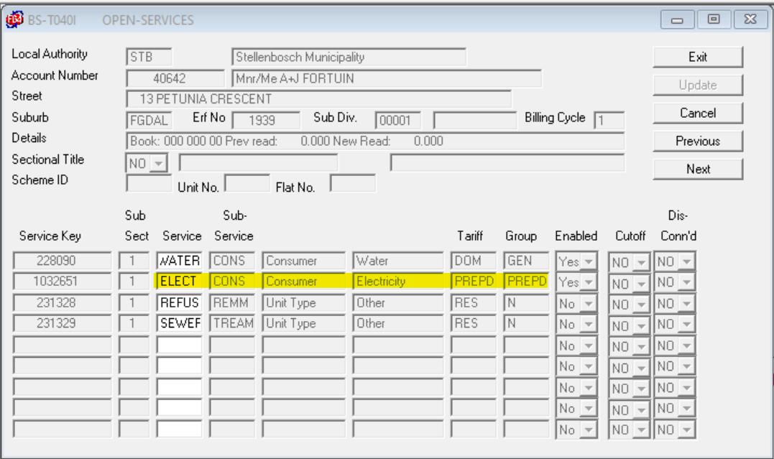

Groups to exclude from extract:
Group | Description | Include
ARIWO | ARRANGEMENT INDIGENT WRITE OFF | NO
BFWOF | BUSINESS & FARM WRITE OFF'S | NO
DISP | DISPUTE | NO
HOIWO | HAND OVER INDIGENT WRITE OFF | NO
HOWO1 | HAND OVER WRITE OFFS 1 | NO
ILU22 | INDIG EST LATE UNEMPLO | NO
ILU23 | INDIG EST LATE UNEMPLO | NO
ILU24 | INDIG EST LATE UNEMPLO | NO
INDLU | INDIGENT LOAN & RENT UNEMPLD | NO
INU22 | INDIG UNEMPLOYED APPL 2022 | NO
INU23 | INDIG UNEMPLOYED APPL 2023 | NO
INU24 | INDIG UNEMPLOYED APPL 2024 | NO
INW02 | Indigent write-offs: Febr 2006 | NO
INW03 | Indigent write-offs round 3 | NO
LEGWO | PRELIMINARY WRITE OFF | NO
MASWO | MASAKHANE WRITE-OFFS | NO
MAW02 | Msakhane write-offs: Febr 2006 | NO
MAW03 | Masakhane write-offs round 3 | NO
MUN | Municipality | NO
MUNXF | Municipality Transfers | NO
PREWO | PRELIMINARY WRITE OFF | NO
PROKF | HANDOVER FINAL WRITE OFF | NO
PROKT | HANDOVER TRACING | NO
PROKW | HANDOVER PRELIM WRITE OFF | NO
RTURN | UNRESOLVED RETURNED MA | NO
SALAR | SALARY DEDUCTIONS: SERVICES | NO
SFWOF | SUNDRY & FINAL WRITE OFF'S | NO
W0FF2 | WRITE OFF | NO
WOFF1 | GENERAL WRITE-OFFS ROUND 1 | NO
WOVVM | WRITE OFF VVM | NO
WR110 | WRITE OFF MAY 2010 | NO
WR111 | WRITE OFF DEC 2011 CFO | NO
WR210 | WRITE OFF MAY 2010 ANNEKS 2 | NO
WR310 | WRITE OFF JUNE 2010 - CFO | NO
WR410 | WRITE OFF MAY 2010 FINAL | NO

Sub-groups to excluded from extract:
Sub-group | Description | Include
INFRA | MUNICIPAL INFRASTRUCTURE | NO
PROPM | MUNICIPAL PROPERTY | NO

ADDITIONAL REQUIREMENT TO EXTRACT 1:
Read B10ACCS - (Child account)
If B10-GROUPNO = PROKA
And B10-HOFLAG = ‘N’
---------------------------------------------
Get Mother account to see if it has electricity services on B40SXREF
Read B111HOS - Alternate key 3 – B111-HOTO (Move child account into B111-HOTO)
Then Read B10ACCS to get mother account = B111-DACCOUN(Mother account)
Then Read B40SXREF for mother account by moving the B10-SUBURB/B10-ERFNO/B10SUBDIV of mother account(B111-DACCOUN)
Check if mother account has Elect prepd services
Select B40-SERVID = ELECT – only include accounts with an electricity meter
Select B40-SUBSERV = CONS
Select B40-STARIFF = PREPD
------------------------------------------
Get outstanding DEFER amounts for Child account
Read B13DEBIT for B111-HOTO(Child account)
- Select total arrears amount (Sum B13-OSAMOUNT + B13-OSPENAL + B13-OSVAT)
for all services: R50,00 to R5 000 000,00
- Sum of all services must be = and > than R50,00
- Test for > or equals to R50,00.
- Select service B13 for all outstanding services
- Select subservice IF B13-SUBSID = DEFER (for all services)
- Select defer type READ B17-DEFTYPE = Y

List child accounts in extract 1.

Extract 2: Arrangement disconnection - Conventional:
- Scheme parameter: FACT or Age analysis
- Select account numbers: from 0 to Account number to 9999999999999
- Select suburb: All
- Select: B10-HOFLAG = Y
- Select: B10-AUQ = N
- Select discount category B10-DISCCAT = selection (not currently in use)
- Select suburb: All (B10-SUBURB)
- Exclude groups as per list below
- Exclude sub-groups as per list below
- Exclude ward B03-WARD
- Exclude category B03-CATEGORY
- If B10 – GROUP = PROKA – split criteria – to be finalized.
- Select service B40-SERVID ELECT
- Exclude B40-SUBSID DEM
- AND
- 2. Select service B40-SERVID ELECT
- Select B40-SUBSID CONS
- Exclude B40=STARIFF PREPD
- Select service open B40-MCLOSED = N
- Select service B13 for all outstanding services
- Select subservice IF B13-SUBSID = DEFER (for all services)
- Select defer type READ B17-DEFTYPE = Y

- Select total arrears amount (Sum B13-OSAMOUNT + B13-OSPENAL + B13-OSVAT)
for all services: R550,00 to R5 000 000,00
Sum of all services must be = AND > R550,00
Test for > or equals to R550,00.
- ARREARS_FLAG = Sum of total arrears all services
- Total balance and total due field = Sum of all total balances (all services)
- Ageing: must be on all services on B13debit record
Disconnection fee: R450,00
Link to template: 558

Groups to exclude from extract:

Group | Description | Include
ARIWO | ARRANGEMENT INDIGENT WRITE OFF | NO
BFWOF | BUSINESS & FARM WRITE OFF'S | NO
DISP | DISPUTE | NO
HOIWO | HAND OVER INDIGENT WRITE OFF | NO
HOWO1 | HAND OVER WRITE OFFS 1 | NO
ILU22 | INDIG EST LATE UNEMPLO | NO
ILU23 | INDIG EST LATE UNEMPLO | NO
ILU24 | INDIG EST LATE UNEMPLO | NO
INDLU | INDIGENT LOAN & RENT UNEMPLD | NO
INU22 | INDIG UNEMPLOYED APPL 2022 | NO
INU23 | INDIG UNEMPLOYED APPL 2023 | NO
INU24 | INDIG UNEMPLOYED APPL 2024 | NO
INW02 | Indigent write-offs: Febr 2006 | NO
INW03 | Indigent write-offs round 3 | NO
LEGWO | PRELIMINARY WRITE OFF | NO
MASWO | MASAKHANE WRITE-OFFS | NO
MAW02 | Msakhane write-offs: Febr 2006 | NO
MAW03 | Masakhane write-offs round 3 | NO
MUN | Municipality | NO
MUNXF | Municipality Transfers | NO
PREWO | PRELIMINARY WRITE OFF | NO
PROKF | HANDOVER FINAL WRITE OFF | NO
PROKT | HANDOVER TRACING | NO
PROKW | HANDOVER PRELIM WRITE OFF | NO
RTURN | UNRESOLVED RETURNED MA | NO
SALAR | SALARY DEDUCTIONS: SERVICES | NO
SFWOF | SUNDRY & FINAL WRITE OFF'S | NO
W0FF2 | WRITE OFF | NO
WOFF1 | GENERAL WRITE-OFFS ROUND 1 | NO
WOVVM | WRITE OFF VVM | NO
WR110 | WRITE OFF MAY 2010 | NO
WR111 | WRITE OFF DEC 2011 CFO | NO
WR210 | WRITE OFF MAY 2010 ANNEKS 2 | NO
WR310 | WRITE OFF JUNE 2010 - CFO | NO
WR410 | WRITE OFF MAY 2010 FINAL | NO
Sub-group to exclude:
Sub-group | Description | Include
INFRA | MUNICIPAL INFRASTRUCTURE | NO
PROPM | MUNICIPAL PROPERTY | NO

ADDITIONAL REQUIREMENT TO EXTRACT 2:
Read B10ACCS - (Child account)
If B10-GROUPNO = PROKA
And B10-HOFLAG = ‘Y’
---------------------------------------------
Get Mother account to see if it has electricity services on B40SXREF
Read B111HOS - Alternate key 3 – B111-HOTO (Move child account into B111-HOTO)
Then Read B10ACCS to get mother account = B111-DACCOUN(Mother account)
Then Read B40SXREF for mother account by moving the B10-SUBURB/B10-ERFNO/B10SUBDIV of mother account(B111-DACCOUN)
Check if mother account has Elect services
Select B40-SERVID = ELECT – only include accounts with an electricity meter
Select B40-SUBSERV = CONS
Exclude B40-STARIFF = PREPD
------------------------------------------
Get outstanding DEFER amounts for Child account
Read B13DEBIT for B111-HOTO(Child account)
- Select service B13 for all outstanding services
- Select subservice IF B13-SUBSID = DEFER (for all services)
- Select defer type READ B17-DEFTYPE = Y

Read B13DEBIT for B111-HOTO(Child account)
- Select total arrears amount (Sum B13-OSAMOUNT + B13-OSPENAL + B13-OSVAT)
for all services: R550,00 to R5 000 000,00
- Sum of all services must be = and > than R550,00
- Test for > or equals to R550,00.

List child accounts in extract 2.

Extract 3: Arrangement disconnection - KVA:
- Scheme parameter: FACT or Age analysis
- Select account numbers: from 0 to Account number to 9999999999999
- Select suburb: All
- Select: B10-HOFLAG = Y
- Select: B10-AUQ = N
- Select discount category B10-DISCCAT = selection (not currently in use)
- Select suburb: All (B10-SUBURB)
- Exclude groups as per list below
- Exclude sub-groups as per list below
- Exclude ward B03-WARD
- Exclude category B03-CATEGORY
- Select service B40-SERVID ELECT
- Select B40-SUBSID DEM
- Select service open B40-MCLOSED = N
- Select service B13 for all outstanding services
- Select subservice IF B13-SUBSID = DEFER (for all services)
- Select defer type READ B17-DEFTYPE = Y
- Select total arrears amount (Sum B13-OSAMOUNT + B13-OSPENAL + B13-OSVAT)
for all services: R4 000,00 to R5 000 000,00
Sum of all services must be = AND > R4 000,00
- Test for > or equals to R4 000,00.
- ARREARS_FLAG = Sum of total arrears all services
- Total balance and total due field = Sum of all total balances (all services)
- Ageing: must be on all services on B13debit record

Disconnection fee: R3 100,00
Link to template: 574

Groups to exclude from extract:
Group | Description | Include
ARIWO | ARRANGEMENT INDIGENT WRITE OFF | NO
BFWOF | BUSINESS & FARM WRITE OFF'S | NO
DISP | DISPUTE | NO
HOIWO | HAND OVER INDIGENT WRITE OFF | NO
HOWO1 | HAND OVER WRITE OFFS 1 | NO
ILU22 | INDIG EST LATE UNEMPLO | NO
ILU23 | INDIG EST LATE UNEMPLO | NO
ILU24 | INDIG EST LATE UNEMPLO | NO
INDLU | INDIGENT LOAN & RENT UNEMPLD | NO
INU22 | INDIG UNEMPLOYED APPL 2022 | NO
INU23 | INDIG UNEMPLOYED APPL 2023 | NO
INU24 | INDIG UNEMPLOYED APPL 2024 | NO
INW02 | Indigent write-offs: Febr 2006 | NO
INW03 | Indigent write-offs round 3 | NO
LEGWO | PRELIMINARY WRITE OFF | NO
MASWO | MASAKHANE WRITE-OFFS | NO
MAW02 | Msakhane write-offs: Febr 2006 | NO
MAW03 | Masakhane write-offs round 3 | NO
MUN | Municipality | NO
MUNXF | Municipality Transfers | NO
PREWO | PRELIMINARY WRITE OFF | NO
PROKF | HANDOVER FINAL WRITE OFF | NO
PROKT | HANDOVER TRACING | NO
PROKW | HANDOVER PRELIM WRITE OFF | NO
RTURN | UNRESOLVED RETURNED MA | NO
SALAR | SALARY DEDUCTIONS: SERVICES | NO
SFWOF | SUNDRY & FINAL WRITE OFF'S | NO
W0FF2 | WRITE OFF | NO
WOFF1 | GENERAL WRITE-OFFS ROUND 1 | NO
WOVVM | WRITE OFF VVM | NO
WR110 | WRITE OFF MAY 2010 | NO
WR111 | WRITE OFF DEC 2011 CFO | NO
WR210 | WRITE OFF MAY 2010 ANNEKS 2 | NO
WR310 | WRITE OFF JUNE 2010 - CFO | NO
WR410 | WRITE OFF MAY 2010 FINAL | NO
Sub-group to exclude:
Sub-group | Description | Include
INFRA | MUNICIPAL INFRASTRUCTURE | NO
PROPM | MUNICIPAL PROPERTY | NO

First notice – warning – normal and indigent
The files are expected 2 days after the due date.

Extract 4: Normal first notice

Billing period of notice:
Select account numbers: from 0 to Account number to 9999999999999
Select suburb: All
Select amount: R 200,00 to R5 000 000,00
Total due must be equal and > R200,00
Select all services The groups selected will define the file
Exclude: B10-AUQ = Y
Exclude: B17-DEFTYPE = Y
If B17-MAFLAG = A – do not include
Warning fee: R 10,00
Link to template: 561

Groups to exclude from extract: : Please exclude the PROKA accounts too. It was not part of the initial requirement.

Group | Description | Include
ARIWO | ARRANGEMENT INDIGENT WRITE OFF | NO
ARRAN | ARRANGEMENTS | NO
BFWOF | BUSINESS & FARM WRITE OFF'S | NO
DISP | DISPUTE | NO
HOWO1 | HAND OVER WRITE OFFS 1 | NO
ILI22 | INDIG EST LATE INCOME | NO
ILI23 | INDIG EST LATE INCOME | NO
ILI24 | INDIG EST LATE INCOME | NO
ILP22 | INDIG EST LATE PENSION | NO
ILP23 | INDIG EST LATE PENSION | NO
ILP24 | INDIG EST LATE PENSION | NO
ILU22 | INDIG EST LATE UNEMPLO | NO
ILU23 | INDIG EST LATE UNEMPLO | NO
ILU24 | INDIG EST LATE UNEMPLO | NO
INDIG | BEHOEFTIGE GEVALLE | NO
INDLR | INDIGENT LOAN & RENTAL | NO
INDLU | INDIGENT LOAN & RENT UNEMPLD | NO
INF | INFORMAL AREAS | NO
INI22 | INDIG INCOME APPL 2022 | NO
INI23 | INDIG INCOME APPL 2023 | NO
INI24 | INDIG INCOME APPL 2024 | NO
INP22 | INDIG PENSIONER APPL 222 | NO
INP23 | INDIG PENSIONER APPL 223 | NO
INP24 | INDIG PENSIONER APPL 224 | NO
INSOL | INSOLVENCY CASES | NO
INU22 | INDIG UNEMPLOYED APPL 2022 | NO
INU23 | INDIG UNEMPLOYED APPL 2023 | NO
INU24 | INDIG UNEMPLOYED APPL 2024 | NO
INW02 | Indigent write-offs: Febr 2006 | NO
INW03 | Indigent write-offs round 3 | NO
ISITE | INTERSITE | NO
LEGWO | PRELIMINARY WRITE OFF | NO
MASWO | MASAKHANE WRITE-OFFS | NO
MUN | Municipality | NO
MUNXF | Municipality Transfers | NO
PREWO | PRELIMINARY WRITE OFF | NO
PROKF | HANDOVER FINAL WRITE OFF | NO
PROKT | HANDOVER TRACING | NO
PROKW | HANDOVER PRELIM WRITE OFF | NO
RTURN | UNRESOLVED RETURNED MA | NO
SALAR | SALARY DEDUCTIONS: SERVICES | NO
SFWOF | SUNDRY & FINAL WRITE OFF'S | NO
W0FF2 | WRITE OFF | NO
WOFF1 | GENERAL WRITE-OFFS ROUND 1 | NO
WOVVM | WRITE OFF VVM | NO
WR110 | WRITE OFF MAY 2010 | NO
WR111 | WRITE OFF DEC 2011 CFO | NO
WR210 | WRITE OFF MAY 2010 ANNEKS 2 | NO
WR310 | WRITE OFF JUNE 2010 - CFO | NO
WR410 | WRITE OFF MAY 2010 FINAL | NO

Sub-groups to exclude from extract:

Sub-group | Description | Include
INFRA | MUNICIPAL INFRASTRUCTURE | NO
PROPM | MUNICIPAL PROPERTY | NO

ADDITIONAL REQUIREMENT TO EXTRACT 4:
Read B10ACCS - (Child account)
If B10-GROUPNO = PROKM
And B10-HOFLAG = ‘Y’
---------------------------------------------
Read B111HOS - Alternate key 3 – B111-HOTO (Move child account into B111-HOTO)
Then Read B10ACCS to get mother account = B111-DACCOUN(Mother account)
Then Read B40SXREF for mother account by moving the B10-SUBURB/B10-ERFNO/B10SUBDIV of mother account(B111-DACCOUN)
------------------------------------------
Get outstanding DEFER amounts for Child account
Read B13DEBIT for B111-HOTO(Child account)
- Select service B13 for all outstanding services
- Select subservice IF B13-SUBSID = DEFER (for all services)
- Select defer type READ B17-DEFTYPE = Y

Read B13DEBIT for B111-HOTO(Child account)
- Select total arrears amount (Sum B13-OSAMOUNT + B13-OSPENAL + B13-OSVAT)
for all services: R200,00 to R5 000 000,00
- Sum of all services must be = and > than R200,00
- Test for > or equals to R200,00.

List child accounts in extract 4.

Extract 5: Indigent first notice
Billing period of notice:
Select account numbers: from 0 to Account number to 9999999999999
Select suburb: All
Select amount: R 100,00 to R5 000 000,00
Total due must be equal and > R100,00
Select all service The groups selected will define the file
Exclude: B17-DEFTYPE = Y
Exclude: B10-AUQ = Y
If B17-MAFLAG = A – do not include
Warning fee: R 10,00
Link to template: 560

Groups to exclude from extract: Please exclude the PROKA accounts too.

Group | Description | Include
AAE | ANGLO AFRICAN ESTATES | NO
ABSA | ABSA PROP PTY LTD | NO
ADMIN | ADMINISTRATION ORDERS | NO
AFERS | ERSKINE AF | NO
AFRI | AFRI GROUP | NO
AFRIG | AFRIGROUP | NO
ALET | ALET BEKKER EIENDOMME | NO
ANDER | ANDERSON PROJECTS | NO
ANGLO | ANGLO AMERICAN FARMS | NO
APEE | APEE EIENDOMME EDMS BPk | NO
ARIWO | ARRANGEMENT INDIGENT WRITE OFF | NO
ARRAN | ARRANGEMENTS | NO
ATTAC | ATTACHMENT OF PROPERTY | NO
BANK | STELLENBOSCH MUN ABSA | NO
BERGS | BERGSIG OPLEIDINGSENTR | NO
BFWOF | BUSINESS & FARM WRITE OFF'S | NO
BLAAU | BLAAUWKLIPPEN ARGRI ESTATE | NO
BONTE | BONTEVLEI LANDGOED EDMS BPK | NO
BOSCH | BOSCHENDAL FARMS | NO
BRICK | KILLARNEY BRICKFIELDS | NO
BRIER | TPD BRIERS | NO
BUCWY | BUCWYN PROPERTIES PTY LTD | NO
CANHA | DE CANHA / COVA DA IRIA TRUST | NO
CELLC | CELL C (PTY) LTD | NO
CFAIR | COUNTRY FAIR | NO
CHAMX | CAPE CHAMONIX HOLDINGS PTY LTD | NO
CLOET | CLOETE A | NO
CLR | COUNCILLORS | NO
COOL | COOL IDEAS 1508 C C | NO
CREDO | CREDO DEVELOPMENT | NO
DBOIS | DU BOIS BOERDERY | NO
DEBTP | Debtpack | NO
DELTA | DELTA CREST COUNTRY ESTATES | NO
DEVON | DEVONMUST PTY LTD | NO
DEZAL | DE ZALZE DEV PROP PTY | NO
DFBEH | DEFERRED HOUSING ACCOUNTS | NO
DISP | DISPUTE | NO
DLGHS | DPT OF LOCAL GOVT & HOUSING | NO
DMOSS | DF & M MOSS | NO
DORM | DORMANT ACCOUNTS | NO
DORPH | DORPSHUIS | NO
DOW | DEPARTEMENT OPENBARE WERKE | NO
DSTIL | DISTILLERS KORPORASIE | NO
DTREF | DEBT REVUE & ADMIN | NO
DTREV | DEBT REVIEW NCA,34 OF | NO
DZT | DOUGLAS ZIMAN TRUST | NO
EETL | LINDERS EET | NO
EMALL | EIKESTAD MALL | NO
ERFTR | STELLENBOSCH MUSEUM | NO
ESLAT | ESTATE LATE CASES | NO
FAJA | FA JACOBS | NO
FARM | STELLENBOSCH & PAARL FARMS | NO
FARMR | FARM RENTALS: COUNCIL FARMS | NO
FARMS | LANDELIK EX BDM | NO
FARMT | SMALL FARMERS TENANTS | NO
FHKPS | FHK KOPERS SONDER LENININGS | NO
FHKRS | P/A L WALTERS | NO
FHKW | FRANSCHHOEK WINGERDE | NO
FHPER | FRANSCHHOEK PERSONEEL | NO
FINAL | KREDIETBEHEER AFDELING | NO
FRIED | K FRIEDLAENDER | NO
FRITZ | FRITZ WIRTH TRUST | NO
GCITY | GARDEN CITIES | NO
GHB | G H BUILDING SUPPLIES | NO
HCMYB | HC MYBURGH | NO
HIST | POSBUS 51 | NO
HKORT | HUURKORTINGREKENINGE | NO
HODES | HODES HUISE | NO
HODIS | HANDOVER ACCOUNTS IN DISPUTE | NO
HOFMR | HOFMEYR | NO
HOIWO | HAND OVER INDIGENT WRITE OFF | NO
HOSP | STELLENBOSCH HOSPITAAL | NO
HOWO1 | HAND OVER WRITE OFFS 1 | NO
HUGEN | HUGENOTE MUSEUM | NO
HUXT | HUSTER S | NO
IKMB | DISTELL HOSTELS KAYA MANDI | NO
ILU22 | INDIG EST LATE UNEMPLO | NO
ILU23 | INDIG EST LATE UNEMPLO | NO
ILU24 | INDIG EST LATE UNEMPLO | NO
INDLU | INDIGENT LOAN & RENT UNEMPLD | NO
INSOL | INSOLVENCY CASES | NO
INU22 | INDIG UNEMPLOYED APPL 2022 | NO
INU23 | INDIG UNEMPLOYED APPL 2023 | NO
INU24 | INDIG UNEMPLOYED APPL 2024 | NO
INW02 | Indigent write-offs: Febr 2006 | NO
INW03 | Indigent write-offs round 3 | NO
ISITE | INTERSITE | NO
JACOB | OORHANDIGINGS: JACOBS PROK | NO
JAKOB | DAWID JACOBS PROKUREURS | NO
JOHNM | D & C JOHNMAN EDUCATION | NO
JPS | JPS TRUST | NO
JTSWA | JT SWARTZ | NO
KWV | POSBUS 528 | NO
KZALZ | KLEINE ZALZE REALISATION | NO
LAMOT | LA MOTTE HOUSE OWNERS | NO
LANDB | LANDBOUNAVORSINGSRAAD | NO
LANGR | LANGRUG PRE-PAID | NO
LANQ | LANQUEDOC HOUSE OWNERS | NO
LDEV | LYNDOCH DEVELOPMENT | NO
LEGWO | PRELIMINARY WRITE OFF | NO
LEOPO | LEOPONT 225 PROP | NO
LICEN | DRIVERS LICENCE CAMPAIGN | NO
LIEFD | KYLEMORE LIEFDADIGHEID | NO
LORMA | L'ORMARINS | NO
MAGNO | MAGNOLIA HOUSING (PTY) LTD | NO
MAIN | MAINGARD LABOURER'S COTTAGE | NO
MASAK | MASAKHANE FAMILY ACCOUNTS | NO
MASWO | MASAKHANE WRITE-OFFS | NO
MAW02 | Msakhane write-offs: Febr 2006 | NO
MAW03 | Masakhane write-offs round 3 | NO
MEERL | MEERLAND SES (EDMS)BPK | NO
MONDI | MONDI TIMBER | NO
MUN | Municipality | NO
MUNXF | Municipality Transfers | NO
NBR | NASIONALE BEHUISINGSRAAD | NO
NDTPW | NAT.DEPT.TRANSPORT+PUB WORKS | NO
NEDBK | NEDBANK | NO
NEON | NEONBEL SEWE (EDMS) BPK | NO
NGFHK | NG KERK | NO
NGNRD | N G KERK-NOORD | NO
NGSNT | N G KERK SENTRAAL | NO
NGSTU | N G STUDENTEGEMEENTE | NO
NGWEL | N G KERK | NO
NIMRO | NIMRO PTY LTD | NO
NONE | NONE | NO
NORM | NORMAL ACCOUNTS | NO
OSPJ | OSPJ BULTERYS | NO
PAPE | PAPEGAAISBERG LANDGOED WYN | NO
PBEST | DEPT. PLAASLIKE BESTUUR | NO
PDKLF | PARADYSKLOOF BOERDERY EDMS BPK | NO
PDTPW | PROV. DEPT.TRANSPORT+PUB. WORKDS | NO
PENS | PENSIOEN KORTING | NO
PERS | PERSONEEL | NO
PFS | PFS KONSULTANTE | NO
PREWO | PRELIMINARY WRITE OFF | NO
PROKF | HANDOVER FINAL WRITE OFF | NO
PROKM | GEODEBT HAND OVERS WEF 201407 | NO
PROKT | HANDOVER TRACING | NO
PROKW | HANDOVER PRELIM WRITE OFF | NO
PROPP | PROP-PLUS 35 PTY LTD | NO
R3-2A | R3-2A PROJECTS BK | NO
RAPIP | RAPIPROP 88 PTY LTD | NO
RDISC | RENTAL DISCOUNTS | NO
REMBR | REMBRANDT | NO
ROOS | PAUL ROOS BOERDERY | NO
RTURN | UNRESOLVED RETURNED MA | NO
RUGBY | SA RUGBY INSTITUUT | NO
RYCLF | RYCLOF BELEGGINGS | NO
SALAR | SALARY DEDUCTIONS: SERVICES | NO
SAMMY | SC MYBURGH | NO
SAMS | E SAMSON | NO
SAPST | SA POLICE TENANTS | NO
SFORD | SELFORD MOTORS | NO
SFW | P O BOX 46 | NO
SFWOF | SUNDRY & FINAL WRITE OFF'S | NO
SHEER | SHEERPROPS 91 PTY LTD | NO
SIMON | SIMONSIG LANDGOED PTY LTD | NO
SKOOL | SKOOLRAAD | NO
SMARY | ST MARY'S CHURCH | NO
SPORT | SPORTKLUBS | NO
T | TEST | NO
TEMP | KREDIETBEHEERAFDELING | NO
TKOM | TELKOM S A BEPERK | NO
TRANS | TRANSNET LTD | NO
TROLC | TROLCO PTY LTD | NO
TYDLK | TYDELIK: NET VIR HUIDIGE | NO
US | REGISTRATEUR FINANSIES | NO
VSRIO | VELLISARIO & RICHMOND | NO
VVM | VAN DE VENTER,MOJAPELO | NO
VVMHB | HANDBACKS FROM VVM | NO
W0FF2 | WRITE OFF | NO
WELG | WELGEVONDEN DEVELOPMENT | NO
WEMHK | WEMMERSHOEK HOUSING ASSOCIATION | NO
WKOD | WES-KAAP ONDERWYSDEPARTEMENT | NO
WOFF1 | GENERAL WRITE-OFFS ROUND 1 | NO
WOVVM | WRITE OFF VVM | NO
WR110 | WRITE OFF MAY 2010 | NO
WR111 | WRITE OFF DEC 2011 CFO | NO
WR210 | WRITE OFF MAY 2010 ANNEKS 2 | NO
WR310 | WRITE OFF JUNE 2010 - CFO | NO
WR410 | WRITE OFF MAY 2010 FINAL | NO
WSMIT | W S SMIT FAMILIETRUST | NO
WYNLD | WYNLAND DISTRIKSRAAD | NO
ZETLE | SAMUEL ZETLER TRUST | NO

Sub-groups to exclude from extract:

Sub-group | Description | Include
INFRA | MUNICIPAL INFRASTRUCTURE | NO
PROPM | MUNICIPAL PROPERTY | NO

ADDITIONAL REQUIREMENT TO EXTRACT 5:
Read B10ACCS - (Child account)
If B10-GROUPNO = PROKM
And B10-HOFLAG = ‘Y’
---------------------------------------------
Read B111HOS - Alternate key 3 – B111-HOTO (Move child account into B111-HOTO)
Then Read B10ACCS to get mother account = B111-DACCOUN(Mother account)
Then Read B40SXREF for mother account by moving the B10-SUBURB/B10-ERFNO/B10SUBDIV of mother account(B111-DACCOUN)

------------------------------------------
Get outstanding DEFER amounts for Child account
Read B13DEBIT for B111-HOTO(Child account)
- Select service B13 for all outstanding services
- Select subservice IF B13-SUBSID = DEFER (for all services)
- Select defer type READ B17-DEFTYPE = Y

Read B13DEBIT for B111-HOTO(Child account)
- Select total arrears amount (Sum B13-OSAMOUNT + B13-OSPENAL + B13-OSVAT)
for all services: R100,00 to R5 000 000,00
- Sum of all services must be = and > than R100,00
- Test for > or equals to R100,00.

List child accounts in extract 5.

Disconnection notices

14 days after the first notice was issue the process will move to disconnection notices.

A file must be prepared for:
- Prepaid
- Conventional
- KVA

Extract 6: Disconnection – Prepaid – normal accounts:

Billing period of notice:
Select account numbers: from 0 to Account number to 9999999999999
Select suburb: All
Select amount: Equals and > than R 300,00 to R5 000 000,00
Select service: B40-SERV ELECT – only include accounts with an electricity meter
Select subservice B40-SUBSID = CONS
Select tariff B40-STARIFF = PREPD
Exclude if: B10-AUQ = YES
Exclude if: B13-SUBSID = DEFER
Exclude if: defer type B17-DEFTYPE = YES
- ARREARS_FLAG = Sum of total arrears all services
- Total balance and total due field = Sum of all total balances (all services)
- Ageing: must be on all services on B13debit record
Exclude groups as per list below
Exclude sub-groups as per list below
ADDITIONAL REQUIREMENT TO EXTRACT 6:
Read B10ACCS - (Child account)
If B10-GROUPNO = PROKM
And B10-HOFLAG = ‘Y’
---------------------------------------------
Get Mother account to see if it has electricity services on B40SXREF
Read B111HOS - Alternate key 3 – B111-HOTO (Move child account into B111-HOTO)
Then Read B10ACCS to get mother account = B111-DACCOUN(Mother account)
Then Read B40SXREF for mother account by moving the B10-SUBURB/B10-ERFNO/B10SUBDIV of mother account(B111-DACCOUN)
Check if mother account has Elect prepd services
The mother accountmust be in arrears!!
Select B40-SERVID = ELECT – only include accounts with an electricity meter
Select B40-SUBSERV = CONS
Select B40-STARIFF = PREPD
------------------------------------------
Read B13DEBIT for B111-HOTO(Child account) – only if mother account is in arrears
- Select total arrears amount (Sum B13-OSAMOUNT + B13-OSPENAL + B13-OSVAT)
for all services: R300,00 to R5 000 000,00
- Sum of all services must be = and > than R300,00
- Test for > or equals to R300,00.
- Select service B13 for all outstanding services

Disconnection fee: R 100,00
Link to template: 575

Groups to exclude from extract:
Exclude group INDLU (Unemployed, all IND groups ending on a U is unemployed)
Group | Description | Include
ARIWO | ARRANGEMENT INDIGENT WRITE OFF | NO
BFWOF | BUSINESS & FARM WRITE OFF'S | NO
DISP | DISPUTE | NO
HOIWO | HAND OVER INDIGENT WRITE OFF | NO
ILI22 | INDIG EST LATE INCOME | NO
ILI23 | INDIG EST LATE INCOME | NO
ILI24 | INDIG EST LATE INCOME | NO
ILP22 | INDIG EST LATE PENSION | NO
ILP23 | INDIG EST LATE PENSION | NO
ILP24 | INDIG EST LATE PENSION | NO
ILU22 | INDIG EST LATE UNEMPLO | NO
ILU23 | INDIG EST LATE UNEMPLO | NO
ILU24 | INDIG EST LATE UNEMPLO | NO
INDIG | BEHOEFTIGE GEVALLE | NO
INDLR | INDIGENT LOAN & RENTAL | NO
INDLU | INDIGENT LOAN & RENT UNEMPLD | NO
INF | INFORMAL AREAS | NO
INI22 | INDIG INCOME APPL 2022 | NO
INI23 | INDIG INCOME APPL 2023 | NO
INI24 | INDIG INCOME APPL 2024 | NO
INP22 | INDIG PENSIONER APPL 222 | NO
INP23 | INDIG PENSIONER APPL 223 | NO
INP24 | INDIG PENSIONER APPL 224 | NO
INSOL | INSOLVENCY CASES | NO
INU22 | INDIG UNEMPLOYED APPL 2022 | NO
INU23 | INDIG UNEMPLOYED APPL 2023 | NO
INU24 | INDIG UNEMPLOYED APPL 2024 | NO
INW02 | Indigent write-offs: Febr 2006 | NO
INW03 | Indigent write-offs round 3 | NO
LEGWO | PRELIMINARY WRITE OFF | NO
MASAK | MASAKHANE FAMILY ACCOUNTS | NO
MASWO | MASAKHANE WRITE-OFFS | NO
MAW02 | Msakhane write-offs: Febr 2006 | NO
MAW03 | Masakhane write-offs round 3 | NO
MUN | Municipality | NO
MUNXF | Municipality Transfers | NO
PREWO | PRELIMINARY WRITE OFF | NO
PROKF | HANDOVER FINAL WRITE OFF | NO
RTURN | UNRESOLVED RETURNED MA | NO
SALAR | SALARY DEDUCTIONS: SERVICES | NO
SFWOF | SUNDRY & FINAL WRITE OFF'S | NO
W0FF2 | WRITE OFF | NO
WOFF1 | GENERAL WRITE-OFFS ROUND 1 | NO
WOVVM | WRITE OFF VVM | NO
WR110 | WRITE OFF MAY 2010 | NO
WR111 | WRITE OFF DEC 2011 CFO | NO
WR210 | WRITE OFF MAY 2010 ANNEKS 2 | NO
WR310 | WRITE OFF JUNE 2010 - CFO | NO
WR410 | WRITE OFF MAY 2010 FINAL | NO

Sub-groups to exclude from extract:

Sub-group | Description | Include
INFRA | MUNICIPAL INFRASTRUCTURE | NO
PROPM | MUNICIPAL PROPERTY | NO

Extract 7: Disconnection – Prepaid – indigent accounts:

Billing period of notice:
Select account numbers: from 0 to Account number to 9999999999999
Select suburb: All
Select amount: Equals and > R 250,00 to R5 000 000,00
Select service B40-SERVID ELECT
Select B40-SUBSID CONS
Select B40-STARIFF PREPD
Exclude if: B10-AUQ = YES
Exclude if: B13-SUBSID = DEFER
Exclude if: defer type B17-DEFTYPE = YES

- ARREARS_FLAG = Sum of total arrears all services
- Total balance and total due field = Sum of all total balances (all services)
- Ageing: must be on all services on B13debit record

Exclude groups as per list below
Exclude sub-groups as per list below
ADDITIONAL REQUIREMENT TO EXTRACT 7:
Read B10ACCS - (Child account)
If B10-GROUPNO = PROKM
And B10-HOFLAG = ‘Y’
---------------------------------------------
Get Mother account to see if it has electricity services on B40SXREF
Read B111HOS - Alternate key 3 – B111-HOTO (Move child account into B111-HOTO)
Then Read B10ACCS to get mother account = B111-DACCOUN(Mother account)
Then Read B40SXREF for mother account by moving the B10-SUBURB/B10-ERFNO/B10SUBDIV of mother account(B111-DACCOUN)
Check if mother account has Elect prepd services
The mother account must be in arrears!!
Select B40-SERVID = ELECT – only include accounts with an electricity meter
Select B40-SUBSERV = CONS
Select B40-STARIFF = PREPD
------------------------------------------
Read B13DEBIT for B111-HOTO(Child account) – only if mother account is in arrears
• Select total arrears amount (Sum B13-OSAMOUNT + B13-OSPENAL + B13-OSVAT)
for all services: R250,00 to R5 000 000,00
• Sum of all services must be = and > than R250,00
• Test for > or equals to R250,00.
• Select service B13 for all outstanding services
Disconnection fee: R 100,00
Link to template: 576

Groups to exclude from extract:

Group |  | Description |  | Include
AAE |  | ANGLO AFRICAN ESTATES |  | NO
ABSA |  | ABSA PROP PTY LTD |  | NO
ADMIN |  | ADMINISTRATION ORDERS |  | NO
AFERS |  | ERSKINE AF |  | NO
AFRI |  | AFRI GROUP |  | NO
AFRIG |  | AFRIGROUP |  | NO
ALET |  | ALET BEKKER EIENDOMME |  | NO
ANDER |  | ANDERSON PROJECTS |  | NO
ANGLO |  | ANGLO AMERICAN FARMS |  | NO
APEE |  | APEE EIENDOMME EDMS BPk |  | NO
ARIWO |  | ARRANGEMENT INDIGENT WRITE OFF |  | NO
ARRAN |  | ARRANGEMENTS |  | NO
ATTAC |  | ATTACHMENT OF PROPERTY |  | NO
BANK |  | STELLENBOSCH MUN ABSA |  | NO
BERGS |  | BERGSIG OPLEIDINGSENTR |  | NO
BFWOF |  | BUSINESS & FARM WRITE OFF'S |  | NO
BLAAU |  | BLAAUWKLIPPEN ARGRI ESTATE |  | NO
BONTE |  | BONTEVLEI LANDGOED EDMS BPK |  | NO
BOSCH |  | BOSCHENDAL FARMS |  | NO
BRICK |  | KILLARNEY BRICKFIELDS |  | NO
BRIER |  | TPD BRIERS |  | NO
BUCWY |  | BUCWYN PROPERTIES PTY LTD |  | NO
CANHA |  | DE CANHA / COVA DA IRIA TRUST |  | NO
CELLC |  | CELL C (PTY) LTD |  | NO
CFAIR |  | COUNTRY FAIR |  | NO
CHAMX |  | CAPE CHAMONIX HOLDINGS PTY LTD |  | NO
CLOET |  | CLOETE A |  | NO
CLR |  | COUNCILLORS |  | NO
COOL |  | COOL IDEAS 1508 C C |  | NO
CREDO |  | CREDO DEVELOPMENT |  | NO
DBOIS |  | DU BOIS BOERDERY |  | NO
DEBTP |  | Debtpack |  | NO
DELTA |  | DELTA CREST COUNTRY ESTATES |  | NO
DEVON |  | DEVONMUST PTY LTD |  | NO
DEZAL |  | DE ZALZE DEV PROP PTY |  | NO
DFBEH |  | DEFERRED HOUSING ACCOUNTS |  | NO
DISP |  | DISPUTE |  | NO
DLGHS |  | DPT OF LOCAL GOVT & HOUSING |  | NO
DMOSS |  | DF & M MOSS |  | NO
DORM |  | DORMANT ACCOUNTS |  | NO
DORPH |  | DORPSHUIS |  | NO
DOW |  | DEPARTEMENT OPENBARE WERKE |  | NO
DSTIL |  | DISTILLERS KORPORASIE |  | NO
DTREF |  | DEBT REVUE & ADMIN |  | NO
DTREV |  | DEBT REVIEW NCA,34 OF |  | NO
DZT |  | DOUGLAS ZIMAN TRUST |  | NO
EETL |  | LINDERS EET |  | NO
EMALL |  | EIKESTAD MALL |  | NO
ERFTR |  | STELLENBOSCH MUSEUM |  | NO
ESLAT |  | ESTATE LATE CASES |  | NO
FAJA |  | FA JACOBS |  | NO
FARM |  | STELLENBOSCH & PAARL FARMS |  | NO
FARMR |  | FARM RENTALS: COUNCIL FARMS |  | NO
FARMS |  | LANDELIK EX BDM |  | NO
FARMT |  | SMALL FARMERS TENANTS |  | NO
FHKPS |  | FHK KOPERS SONDER LENININGS |  | NO
FHKRS |  | P/A L WALTERS |  | NO
FHKW |  | FRANSCHHOEK WINGERDE |  | NO
FHPER |  | FRANSCHHOEK PERSONEEL |  | NO
FINAL |  | KREDIETBEHEER AFDELING |  | NO
FRIED |  | K FRIEDLAENDER |  | NO
FRITZ |  | FRITZ WIRTH TRUST |  | NO
GCITY |  | GARDEN CITIES |  | NO
GHB |  | G H BUILDING SUPPLIES |  | NO
HCMYB |  | HC MYBURGH |  | NO
HIST |  | POSBUS 51 |  | NO
HKORT |  | HUURKORTINGREKENINGE |  | NO
HODES |  | HODES HUISE |  | NO
HODIS |  | HANDOVER ACCOUNTS IN DISPUTE |  | NO
HOFMR |  | HOFMEYR |  | NO
HOIWO |  | HAND OVER INDIGENT WRITE OFF |  | NO
HOSP |  | STELLENBOSCH HOSPITAAL |  | NO
HOWO1 |  | HAND OVER WRITE OFFS 1 |  | NO
HUGEN |  | HUGENOTE MUSEUM |  | NO
HUXT |  | HUSTER S |  | NO
IKMB |  | DISTELL HOSTELS KAYA MANDI |  | NO
ISITE |  | INTERSITE |  | NO
JACOB |  | OORHANDIGINGS: JACOBS PROK |  | NO
JAKOB |  | DAWID JACOBS PROKUREURS |  | NO
JOHNM |  | D & C JOHNMAN EDUCATION |  | NO
JPS |  | JPS TRUST |  | NO
JTSWA |  | JT SWARTZ |  | NO
KWV |  | POSBUS 528 |  | NO
KZALZ |  | KLEINE ZALZE REALISATION |  | NO
LAMOT |  | LA MOTTE HOUSE OWNERS |  | NO
LANDB |  | LANDBOUNAVORSINGSRAAD |  | NO
LANGR |  | LANGRUG PRE-PAID |  | NO
LANQ |  | LANQUEDOC HOUSE OWNERS |  | NO
LDEV |  | LYNDOCH DEVELOPMENT |  | NO
LEGWO |  | PRELIMINARY WRITE OFF |  | NO
LEOPO |  | LEOPONT 225 PROP |  | NO
LICEN |  | DRIVERS LICENCE CAMPAIGN |  | NO
LIEFD |  | KYLEMORE LIEFDADIGHEID |  | NO
LORMA |  | L'ORMARINS |  | NO
MAGNO |  | MAGNOLIA HOUSING (PTY) LTD |  | NO
MAIN |  | MAINGARD LABOURER'S COTTAGE |  | NO
MASAK |  | MASAKHANE FAMILY ACCOUNTS |  | NO
MASWO |  | MASAKHANE WRITE-OFFS |  | NO
MAW02 |  | Msakhane write-offs: Febr 2006 |  | NO
MAW03 |  | Masakhane write-offs round 3 |  | NO
MEERL |  | MEERLAND SES (EDMS)BPK |  | NO
MONDI |  | MONDI TIMBER |  | NO
MUN |  | Municipality |  | NO
MUNXF |  | Municipality Transfers |  | NO
NBR |  | NASIONALE BEHUISINGSRAAD |  | NO
NDTPW |  | NAT.DEPT.TRANSPORT+PUB WORKS |  | NO
NEDBK |  | NEDBANK |  | NO
NEON |  | NEONBEL SEWE (EDMS) BPK |  | NO
NGFHK |  | NG KERK |  | NO
NGNRD |  | N G KERK-NOORD |  | NO
NGSNT |  | N G KERK SENTRAAL |  | NO
NGSTU |  | N G STUDENTEGEMEENTE |  | NO
NGWEL |  | N G KERK |  | NO
NIMRO |  | NIMRO PTY LTD |  | NO
NONE |  | NONE |  | NO
NORM |  | NORMAL ACCOUNTS |  | NO
OSPJ |  | OSPJ BULTERYS |  | NO
PAPE |  | PAPEGAAISBERG LANDGOED WYN |  | NO
PBEST |  | DEPT. PLAASLIKE BESTUUR |  | NO
PDKLF |  | PARADYSKLOOF BOERDERY EDMS BPK |  | NO
PDTPW |  | PROV. DEPT.TRANSPORT+PUB. WORKDS |  | NO
PENS |  | PENSIOEN KORTING |  | NO
PERS |  | PERSONEEL |  | NO
PFS |  | PFS KONSULTANTE |  | NO
PREWO |  | PRELIMINARY WRITE OFF |  | NO
PROKF |  | HANDOVER FINAL WRITE OFF |  | NO
PROKM |  | GEODEBT HAND OVERS WEF 201407 |  | NO
PROKT |  | HANDOVER TRACING |  | NO
PROKW |  | HANDOVER PRELIM WRITE OFF |  | NO
PROPP |  | PROP-PLUS 35 PTY LTD |  | NO
R3-2A |  | R3-2A PROJECTS BK |  | NO
RAPIP |  | RAPIPROP 88 PTY LTD |  | NO
RDISC |  | RENTAL DISCOUNTS |  | NO
REMBR |  | REMBRANDT |  | NO
ROOS |  | PAUL ROOS BOERDERY |  | NO
RTURN |  | UNRESOLVED RETURNED MA |  | NO
RUGBY |  | SA RUGBY INSTITUUT |  | NO
RYCLF |  | RYCLOF BELEGGINGS |  | NO
SALAR |  | SALARY DEDUCTIONS: SERVICES |  | NO
SAMMY |  | SC MYBURGH |  | NO
SAMS |  | E SAMSON |  | NO
SAPST |  | SA POLICE TENANTS |  | NO
SFORD |  | SELFORD MOTORS |  | NO
SFW |  | P O BOX 46 |  | NO
SFWOF |  | SUNDRY & FINAL WRITE OFF'S |  | NO
SHEER |  | SHEERPROPS 91 PTY LTD |  | NO
SIMON |  | SIMONSIG LANDGOED PTY LTD |  | NO
SKOOL |  | SKOOLRAAD |  | NO
SMARY |  | ST MARY'S CHURCH |  | NO
SPORT |  | SPORTKLUBS |  | NO
T |  | TEST |  | NO
TEMP |  | KREDIETBEHEERAFDELING |  | NO
TKOM |  | TELKOM S A BEPERK |  | NO
TRANS |  | TRANSNET LTD |  | NO
TROLC |  | TROLCO PTY LTD |  | NO
TYDLK |  | TYDELIK: NET VIR HUIDIGE |  | NO
US |  | REGISTRATEUR FINANSIES |  | NO
VSRIO |  | VELLISARIO & RICHMOND |  | NO
VVM |  | VAN DE VENTER,MOJAPELO |  | NO
VVMHB |  | HANDBACKS FROM VVM |  | NO
W0FF2 |  | WRITE OFF |  | NO
WELG |  | WELGEVONDEN DEVELOPMENT |  | NO
WEMHK |  | WEMMERSHOEK HOUSING ASSOCIATION |  | NO
WKOD |  | WES-KAAP ONDERWYSDEPARTEMENT |  | NO
WOFF1 |  | GENERAL WRITE-OFFS ROUND 1 |  | NO
WOVVM |  | WRITE OFF VVM |  | NO
WR110 |  | WRITE OFF MAY 2010 |  | NO
WR111 |  | WRITE OFF DEC 2011 CFO |  | NO
WR210 |  | WRITE OFF MAY 2010 ANNEKS 2 |  | NO
WR310 |  | WRITE OFF JUNE 2010 - CFO |  | NO
WR410 |  | WRITE OFF MAY 2010 FINAL |  | NO
WSMIT |  | W S SMIT FAMILIETRUST |  | NO
WYNLD |  | WYNLAND DISTRIKSRAAD |  | NO
ZETLE |  | SAMUEL ZETLER TRUST |  | NO
ILU22 | INDIG EST LATE UNEMPLO |  | NO
ILU23 | INDIG EST LATE UNEMPLO |  | NO
ILU24 | INDIG EST LATE UNEMPLO |  | NO
INU22 | INDIG UNEMPLOYED APPL 2022 |  | NO
INU23 | INDIG UNEMPLOYED APPL 2023 |  | NO
INU24 | INDIG UNEMPLOYED APPL 2024 |  | NO

Sub-groups to exclude from extract:

Sub-group | Description | Include
INFRA | MUNICIPAL INFRASTRUCTURE | NO
PROPM | MUNICIPAL PROPERTY | NO

Extract 8: Disconnection – Conventional accounts

Billing period of notice:
Select account numbers: from 0 to Account number to 9999999999999
Select suburb: All
Select amount: Equals and > than R 550,00 to R5 000 000,00

Select service B40-SERVID ELECT
Exclude B40-SUBSID DEM
AND
Select service B40-SERVID ELECT
Select B40-SUBSID CONS
Exclude B40=STARIFF PREPD

Exclude if: B10-AUQ = YES
Exclude if: B13-SUBSID = DEFER
Exclude if: defer type B17-DEFTYPE = YES

- ARREARS_FLAG = Sum of total arrears all services
- Total balance and total due field = Sum of all total balances (all services)
- Ageing: must be on all services on B13debit record

Exclude groups as per list below
Exclude sub-groups as per list below

ADDITIONAL REQUIREMENT TO EXTRACT 8:
Read B10ACCS - (Child account)
If B10-GROUPNO = PROKM
And B10-HOFLAG = ‘Y’
---------------------------------------------
Get Mother account to see if it has electricity services on B40SXREF
Read B111HOS - Alternate key 3 – B111-HOTO (Move child account into B111-HOTO)
Then Read B10ACCS to get mother account = B111-DACCOUN(Mother account)
Then Read B40SXREF for mother account by moving the B10-SUBURB/B10-ERFNO/B10SUBDIV of mother account(B111-DACCOUN)
Check if mother account has Elect services – all services excluding PREPD.
The mother account must be in arrears!!
Select B40-SERVID = ELECT – only include accounts with an electricity meter
Select B40-SUBSERV = CONS
Select B40-STARIFF = all excluding PREPD.
------------------------------------------
Read B13DEBIT for B111-HOTO(Child account) – only if mother account is in arrears
• Select total arrears amount (Sum B13-OSAMOUNT + B13-OSPENAL + B13-OSVAT)
for all services: R550,00 to R5 000 000,00
• Sum of all services must be = and > than R550,00
• Test for > or equals to R550,00.
• Select service B13 for all outstanding services

Disconnection fee: R 450,00
Link to template: 577

Groups to exclude from extract:
Group | Description | Include
ARIWO | ARRANGEMENT INDIGENT WRITE OFF | NO
DISP | DISPUTE | NO
HOIWO | HAND OVER INDIGENT WRITE OFF | NO
INSOL | INSOLVENCY CASES | NO
INU22 | INDIG UNEMPLOYED APPL 2022 | NO
INU23 | INDIG UNEMPLOYED APPL 2023 | NO
INU24 | INDIG UNEMPLOYED APPL 2024 | NO
INW02 | Indigent write-offs: Febr 2006 | NO
INW03 | Indigent write-offs round 3 | NO
LEGWO | PRELIMINARY WRITE OFF | NO
MASAK | MASAKHANE FAMILY ACCOUNTS | NO
MASWO | MASAKHANE WRITE-OFFS | NO
MAW02 | Msakhane write-offs: Febr 2006 | NO
MAW03 | Masakhane write-offs round 3 | NO
PREWO | PRELIMINARY WRITE OFF | NO
PROKF | HANDOVER FINAL WRITE OFF | NO
RTURN | UNRESOLVED RETURNED MA | NO
SALAR | SALARY DEDUCTIONS: SERVICES | NO
SFWOF | SUNDRY & FINAL WRITE OFF'S | NO
W0FF2 | WRITE OFF | NO
WOFF1 | GENERAL WRITE-OFFS ROUND 1 | NO
WOVVM | WRITE OFF VVM | NO
WR110 | WRITE OFF MAY 2010 | NO
WR111 | WRITE OFF DEC 2011 CFO | NO
WR210 | WRITE OFF MAY 2010 ANNEKS 2 | NO
WR310 | WRITE OFF JUNE 2010 - CFO | NO
WR410 | WRITE OFF MAY 2010 FINAL | NO

Sub-groups to exclude from write-off:
Sub-group | Description | Include
INFRA | MUNICIPAL INFRASTRUCTURE | NO
PROPM | MUNICIPAL PROPERTY | NO

Extract 9: Disconnection – KVA accounts

Billing period of notice:
Select account numbers: from 0 to Account number to 9999999999999
Select suburb: All
Select amount: Equals and > than R 4 000,00 to R5 000 000,00
Select Service: B40-SERVID = ELECT
Select B40-SUBSID DEM
Exclude if: B10-AUQ = YES
Exclude if: B13-SUBSID = DEFER
Exclude if: defer type B17-DEFTYPE = YES
- ARREARS_FLAG = Sum of total arrears all services
- Total balance and total due field = Sum of all total balances (all services)
- Ageing: must be on all services on B13debit record

ADDITIONAL REQUIREMENT TO EXTRACT 9:
Read B10ACCS - (Child account)
If B10-GROUPNO = PROKM
And B10-HOFLAG = ‘Y’
---------------------------------------------
Get Mother account to see if it has electricity services on B40SXREF
Read B111HOS - Alternate key 3 – B111-HOTO (Move child account into B111-HOTO)
Then Read B10ACCS to get mother account = B111-DACCOUN(Mother account)
Then Read B40SXREF for mother account by moving the B10-SUBURB/B10-ERFNO/B10SUBDIV of mother account(B111-DACCOUN)
Check if mother account has Elect prepd services
The mother account must be in arrears!!
Select B40-SERVID = ELECT – only include accounts with an electricity meter
Select B40-SUBSERV = DEM
Select B40-STARIFF = ALL TARIFFS EXCEPT PREPD.
------------------------------------------
Read B13DEBIT for B111-HOTO(Child account) – only if mother account is in arrears
• Select total arrears amount (Sum B13-OSAMOUNT + B13-OSPENAL + B13-OSVAT)
for all services: R4000,00 to R5 000 000,00
• Sum of all services must be = and > than R4000,00
• Test for > or equals to R4000,00.
• Select service B13 for all outstanding services
Disconnection fee: R 3 100,00
Link to template: 578

Groups to exclude from extract:
Group |  | Description |  | Include
ARIWO |  | ARRANGEMENT INDIGENT WRITE OFF |  | NO
DISP |  | DISPUTE |  | NO
HOIWO |  | HAND OVER INDIGENT WRITE OFF |  | NO
ILU22 |  | INDIG EST LATE UNEMPLO |  | NO
ILU23 |  | INDIG EST LATE UNEMPLO |  | NO
ILU24 |  | INDIG EST LATE UNEMPLO |  | NO
INSOL |  | INSOLVENCY CASES |  | NO
INU22 |  | INDIG UNEMPLOYED APPL 2022 |  | NO
INU23 |  | INDIG UNEMPLOYED APPL 2023 |  | NO
INU24 |  | INDIG UNEMPLOYED APPL 2024 |  | NO
LEGWO |  | PRELIMINARY WRITE OFF |  | NO
MASAK |  | MASAKHANE FAMILY ACCOUNTS |  | NO
MASWO |  | MASAKHANE WRITE-OFFS |  | NO
MAW02 |  | Msakhane write-offs: Febr 2006 |  | NO
MAW03 |  | Masakhane write-offs round 3 |  | NO
MUN |  | Municipality |  | NO
MUNXF |  | Municipality Transfers |  | NO
PREWO |  | PRELIMINARY WRITE OFF |  | NO
PROKF |  | HANDOVER FINAL WRITE OFF |  | NO
RTURN |  | UNRESOLVED RETURNED MA |  | NO
RYCLF |  | RYCLOF BELEGGINGS |  | NO
SFWOF |  | SUNDRY & FINAL WRITE OFF'S |  | NO
W0FF2 |  | WRITE OFF |  | NO
WOFF1 |  | GENERAL WRITE-OFFS ROUND 1 |  | NO
WOVVM |  | WRITE OFF VVM |  | NO
WR110 |  | WRITE OFF MAY 2010 |  | NO
WR111 |  | WRITE OFF DEC 2011 CFO |  | NO
WR210 |  | WRITE OFF MAY 2010 ANNEKS 2 |  | NO
WR310 |  | WRITE OFF JUNE 2010 - CFO |  | NO
WR410 |  | WRITE OFF MAY 2010 FINAL |  | NO
SALAR | SALARY DEDUCTIONS: SERVICES |  | NO
Sub-groups to exclude from write-off:
Sub-group | Description | Include
INFRA | MUNICIPAL INFRASTRUCTURE | NO
PROPM | MUNICIPAL PROPERTY | NO

New screens for Stellenbosch release January 2025

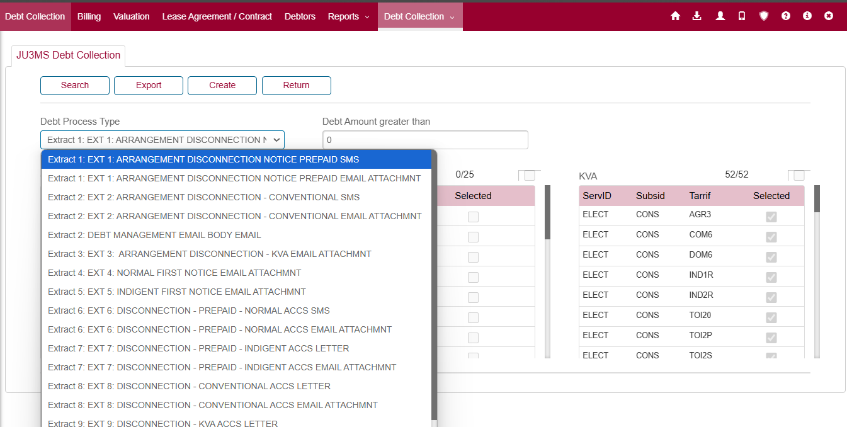

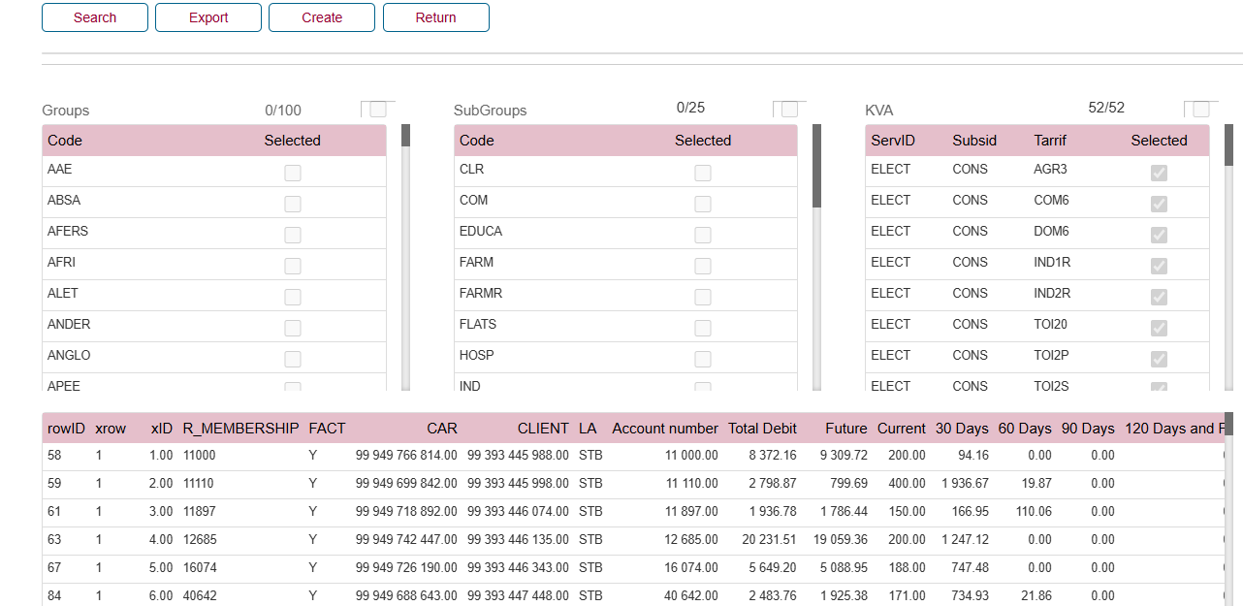

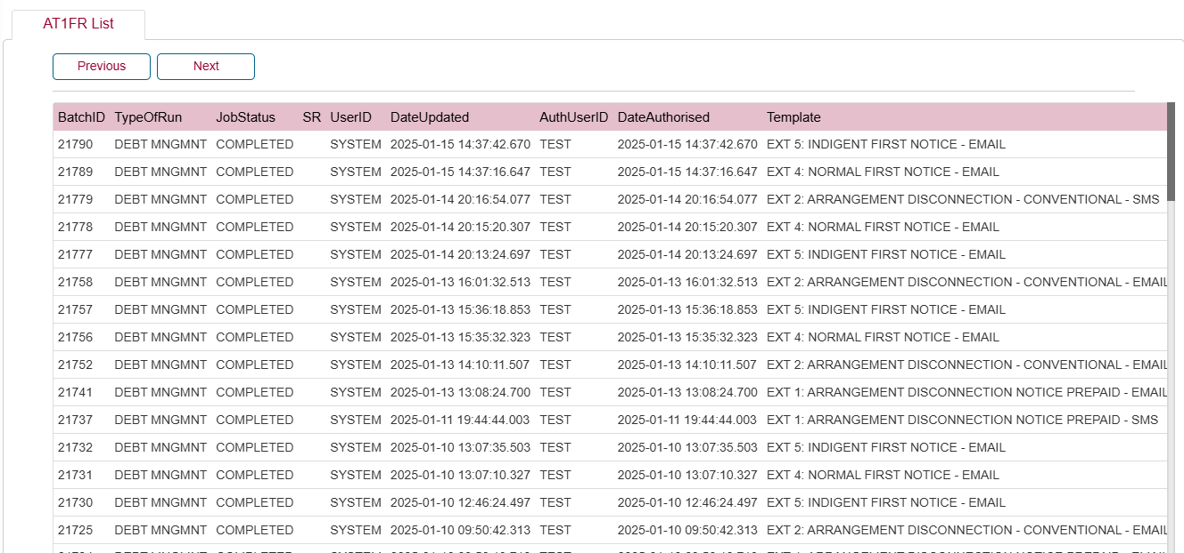

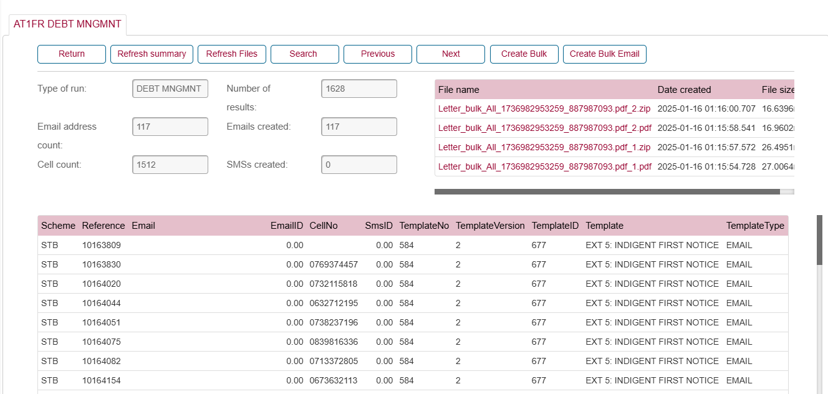

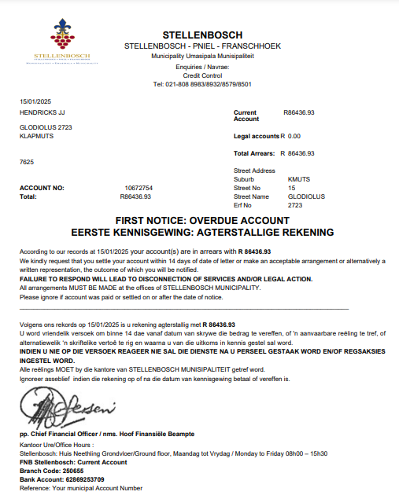

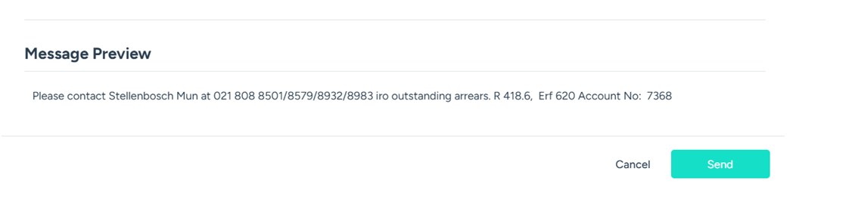

PRODUCT CHANGE APPROVAL
Name | Date | Signature

CLIENT ACCEPTANCE
Specification accepted by the duly authorised person.

-------------------------------------------------------------
Name

-------------------------------------------------------- -----------------------------------------
Signature Date

TIMING
Component | Mandays | Date | Signature
Project Management
Analysis
Design
Database
Development
Testing
System Testing
Documentation
Release / Deployment
User Acceptance Testing

TECHNICAL DESIGN
To be completed after client sign-off.

Database changes

Programs impacted

Action Blocks to be re-used

TESTING

Testing Instructions
Scenario | Test | Completed

Regression Testing
Scenario | Test | Completed

Testing Documentation
Directory:

Testing Signoff
Name of Analyst | Date | Signature

DOCUMENTATION SIGNOFF
Name | Date | Signature

