PLATINUM ASSET MANAGEMENT

Asset Verification
User Manual

Mnquma Local Municipality (EC122)
GRAP / MFMA / mSCOA Compliant
Date: 30 March 2026
Version 1.0

Overview
The Asset Verification module supports the physical verification of all municipal assets in compliance with GRAP 17 and MFMA requirements. Physical verification involves physically locating each asset, confirming its existence and condition, and updating the register accordingly. The module provides three sub-sections: Verification Register, Verification Planning, and Verification Reports.

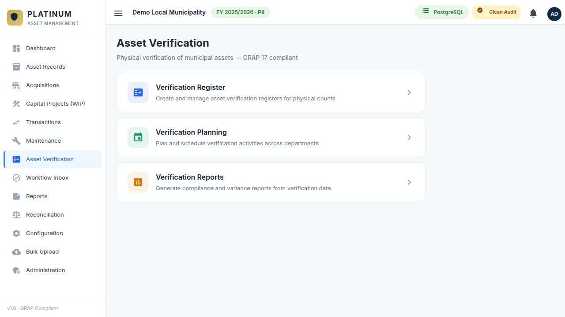
Figure 1 — Asset Verification landing page

Verification Register
The Verification Register records the results of physical asset verification exercises. Each register is linked to a specific financial year and can be filtered by department, location, or asset category.

Creating a New Verification Register
- Navigate to Asset Verification → Verification Register.
- Click + New Register.
- Complete the register header: Financial Year, Department, Location (Building/Floor/Room), and Verification Date.
- Assign a Verification Team Leader.
- Click Create Register to save the header.

Capturing Verification Results
Once a register is created, assets expected to be in the selected location are listed automatically (based on the asset register). For each asset:

Found | Tick if the asset was physically located at the specified address
Barcode Scanned | Indicate whether the barcode/tag was scanned or manually confirmed
Condition | Update the physical condition (Good / Fair / Poor / Very Poor / Not Assessed)
Location Verified | Confirm the physical location matches the register
Comments | Notes on any discrepancies or issues observed

TIP Assets listed in the register that are not found are flagged as Missing. Assets found but not in the register are captured as New/Unregistered and must be registered through the Asset Records module.

Submitting the Register
Once all assets in the scope have been checked, click Submit Register. The register is locked for editing and a summary is generated showing found, missing, and new/unregistered counts. The completed register is available in Verification Reports.

Verification Planning
Verification Planning allows supervisors to schedule and plan the annual asset verification exercise across all departments and locations.

Creating a Verification Plan
- Navigate to Asset Verification → Verification Planning.
- Click + New Plan.
- Set the Financial Year and the planned verification period (start and end dates).
- Add plan items — each item assigns a department or location to a specific team and scheduled date.

Department | The department whose assets will be verified
Location | Specific building, floor, or room scope (optional)
Planned Date | The scheduled date for that verification session
Assigned Team | The verification team or individual responsible
Status | Not Started / In Progress / Completed

- Save the plan. As verification registers are completed, the plan items are automatically marked as completed.

Verification Reports
Verification Reports generate compliance and variance reports from completed verification exercises.

Verification Summary | Overall count of assets found, missing, and new per department or location
Missing Assets Report | Full list of assets that could not be physically located during verification
Condition Report | Distribution of asset conditions as captured during verification vs prior assessment
Variance Report | Differences between the asset register and physical verification findings (location, condition, existence)
Completion Status | Progress of the verification exercise against the verification plan

NOTE Verification reports can be exported to Excel for submission to the Auditor-General as part of the annual financial statements support pack.

