PLATINUM ASSET MANAGEMENT

Capital Projects (WIP)
User Manual

Mnquma Local Municipality (EC122)
GRAP / MFMA / mSCOA Compliant
Date: 30 March 2026
Version 1.0

Overview
The Capital Projects module manages Work-in-Progress (WIP) assets — capital projects that have been budgeted and are under construction or procurement but have not yet been completed and transferred to the asset register. This module is GRAP 17 compliant. When a project is complete, the WIP balance is unbundled into individual assets and transferred to the live Asset Register.

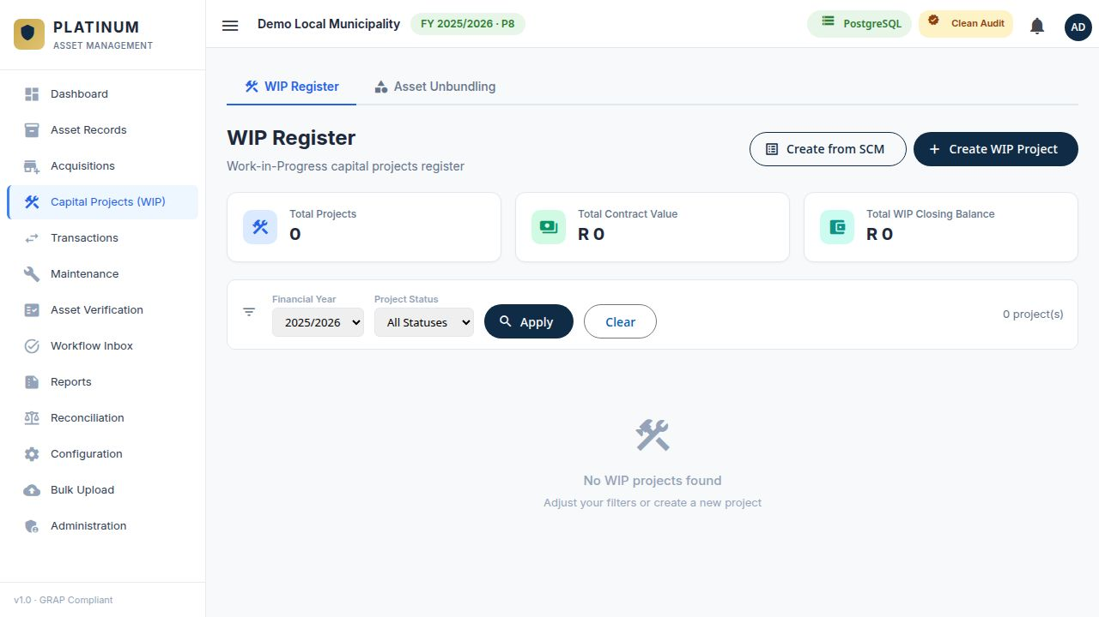
Figure 1 — WIP Register showing capital projects

Tab 1 — WIP Register

Understanding the WIP Register
The WIP Register shows all active and historical capital projects. Each project card shows:
Project Name | Descriptive name of the capital project
Project Status | Current status — Active, Completed, or Cancelled
Contract Value (R) | Total approved contract or budget value of the project
WIP Closing Balance (R) | Total expenditure capitalised to WIP to date
Financial Year | The financial year filter applied to the list

Creating a New WIP Project

Option 1 — Create from SCM
- Click Create from SCM to link the WIP project to an existing SCM contract.
- Select the relevant SCM contract from the list. The contract value and supplier details are pre-populated.
- Add the project name, department, and any additional details.
- Submit for approval.

Option 2 — Create WIP Project manually
- Click + Create WIP Project.
- Complete all required fields: Project Name, Financial Year, Department, Custodian, Contract Value, and Project Status.
- Attach supporting documents (e.g. council resolution, engineer's certificate).
- Submit for approval.

Viewing a WIP Project
Click on a project row to open the detail view. The WIP detail screen contains:
General Tab | Project name, description, department, custodian, status, dates, and CIDMS classification
Financial Tab | Contract value, expenditure per period, and WIP closing balance
Costs Tab | Itemised cost lines posted to this project
Documents Tab | Uploaded project documents
Assets Tab | Any assets already unbundled from this project

Posting Costs to a WIP Project
Use the Costs tab within a WIP project to capture expenditure as it is incurred. Each cost line records:
Financial Year | The year the cost relates to
Period | The month/period within the financial year
Amount (R) | The cost amount to be capitalised
Description | Description of the cost (e.g. progress payment 1)
Reference | Payment reference or invoice number

NOTE WIP costs are not depreciated. Depreciation only begins once the asset is unbundled from WIP and transferred to the Asset Register with an In-Service Date.

Tab 2 — Asset Unbundling
Asset Unbundling is the process of converting a completed WIP project into individual asset records in the Asset Register. This is done once a capital project is physically complete and the asset is ready for use.

Unbundling Process
- Navigate to Capital Projects (WIP) → Asset Unbundling.
- Select the completed WIP project to unbundle.
- The total WIP closing balance is displayed. You must allocate this balance across one or more individual assets.
- For each asset, capture: Description, Asset Category, Asset Type, In-Service Date, Useful Life, Department, Custodian, and CIDMS Classification.
- The sum of all asset values must equal the total WIP balance. A running total is shown to help balance the allocation.
- Once all assets are captured and the balance is fully allocated, click Submit Unbundling.
- The unbundling is routed to the Workflow Inbox for approval.
- On approval, the WIP project is marked as Completed and the new assets are added to the Asset Register.

TIP If a single WIP project produces multiple assets (e.g. a road project that creates road segments, drainage structures, and signage), add a separate row for each asset component in the unbundling form.

NOTE Depreciation on newly unbundled assets begins from the In-Service Date captured during unbundling, not from the date the WIP project was created.

