Prior Year Adjustments
The user must be able to execute on prior year adjustment which include the following:
- Cost Adjustment – Assets on Actual cost.
- Valuation Adjustment – Asset has been revalued.
- Acquisition Date Correction – Assets on actual cost.
- Newly identified asset – Deemed cost
- Residual Value Adjustment
- Impairment loss recognised or changed – Asset on actual cost.
- Impairment Loss recognised or changed – Asset has been revalued
- Impairment loss reversed or changed – Asset on actual cost.
- Impairment Loss reversed or changed – Asset has been revalued
- Asset disposed – Asset on actual cost
- Asset disposed – Asset has been revalued

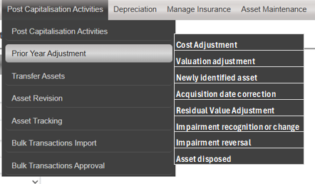

RESIDUAL VALUE ADJUSTMENT
When the user selects the Residual Value Correction option from the sub-sub menu, the following screen must display:
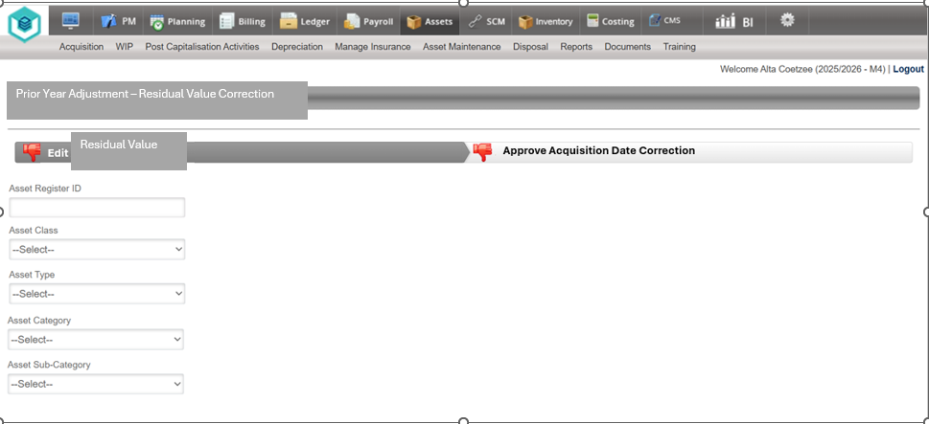

The User must be able to search for an Asset with the following Filter Criteria:
- Asset Register ID
- Asset Class
- Asset Type
- Asset Category
- Asset Sub-Category
The search results as per the filters applied must be displayed in a grid.
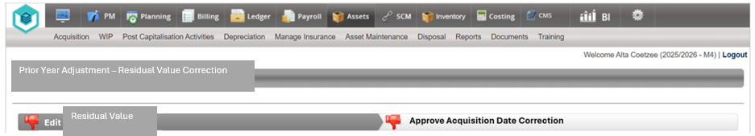
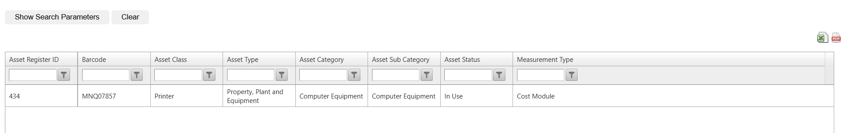

The user must be able to select a line item from the GRID by clicking on the line and the following Screen must be displayed:
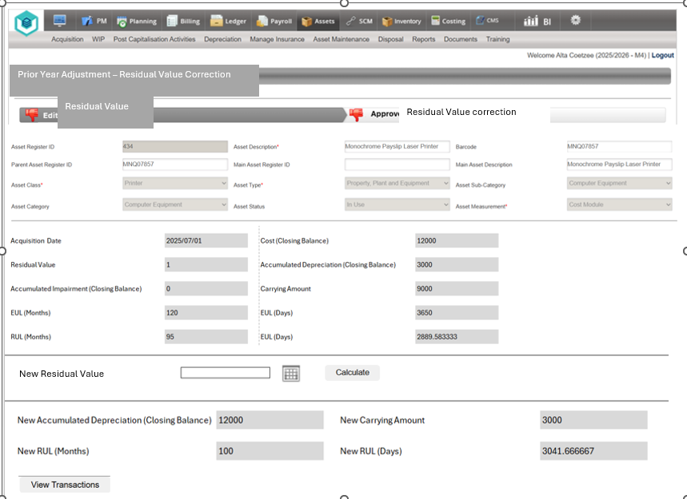
Take note: This asset has an impairment balance for the current year. Please correct the applicable Impairment transactions
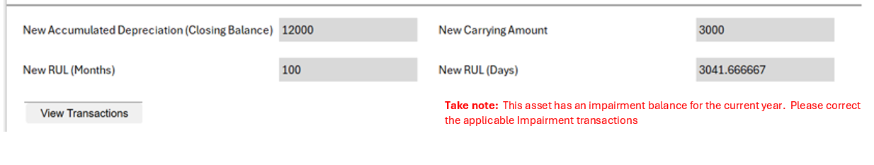

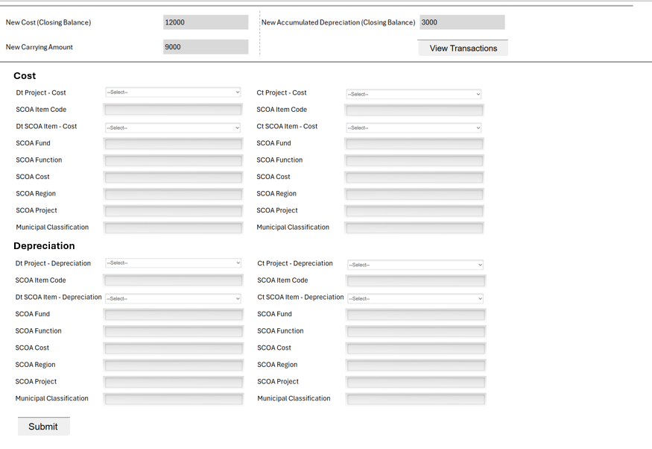

The System must display the current values as per the Asset register in the summary pane.
The user must be able to type in the new Residual Value.
When the User click on the Calculate button, the system must calculate the new values for deprecation and the new RUL as per the new date.
The new Residual Value and implementation date must be populated as this will be used for the calculation of depreciation
When the User click on the Calculate button, the system must calculate the new values. The new values must differentiate between the current financial period, the period before (Comparative period balances) as well as the periods before the (Comparative opening balance). This split must be recorded and stored because it will be required and must be disclosed when the financial statements are compiled.
When the user selects the Calculate button, the system must first do a check on impairment and impairment reversal. If there were any transactions for impairment and impairment reversal for the current year, the system must display a message for the user in red.
The User must be able to View the transactions before submitting by clicking on the view transactions. The transactions must open in a downloaded excel sheet (refer to depreciation View Transaction functionality).
The user must be able to upload supporting documentation. This must be compulsory.
When the user selects the Submit button, the Residual Value Correction transaction must be moved to the approval page
Adjust the Red thumbs down on the screen to a green thumbs up on the Edit Acquisition Date Tab
When the User selects the Approve Acquisition Date Tab, the system must display the transaction for the Date Correction in a grid
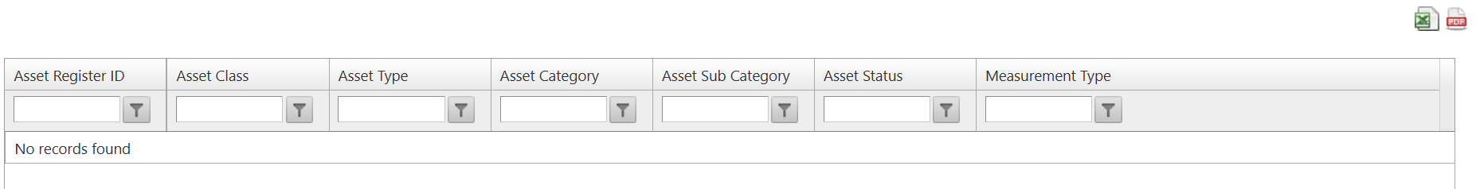
The user must be able to export the grid to an excel and pdf format
When the user selects the transaction from the grid, display the transaction as per the capturing page but all field must be greyed out.
The Approver must be able to view the transactions.
The user must be able to view the uploaded document.
All uploaded documents must be available in the Add/View Document Tab
The page must have a approve/Reject button.
If the User rejects the residual value correction, he/she must provide a reason
When the user clicks on approve, the Asset register must be updated with the new Residual value and effective date and depreciation values, and the system must do the postings to the ledger automatically.
Under the Transaction Type on the Ledger for “Prior Year Adjustments”, create a new document number on the ledger for “Residual Value Corrections”

The calculation for updating the Cost amount must be as follows:
- Residual Value adjustment can be up or down
- The system must be able to display decimals when the user type in the new cost amount.

Scenario 1

Residual value not captured - Should be R304,609.85

Refer to Attached Excel Sheet for detailed calculations (Prior Year Corrections Examples 20251021 v05.exl) Scenario 5.1

Scenario 2

Residual value captured as R500,100.00 instead of R304,610.00

Refer to Attached Excel Sheet for detailed calculations (Prior Year Corrections Examples 20251021 v05.exl) Scenario 5.2

