Prior Year Adjustments
The user must be able to execute on prior year adjustment which include the following:
- Cost Adjustment – Assets on Actual cost.
- Valuation Adjustment – Asset has been revalued.
- Acquisition Date Correction – Assets on actual cost.
- Newly identified asset – Deemed cost
- Residual Value Adjustment
- Impairment loss recognised or changed – Asset on actual cost.
- Impairment Loss recognised or changed – Asset has been revalued
- Impairment loss reversed or changed – Asset on actual cost.
- Impairment Loss reversed or changed – Asset has been revalued
- Asset disposed – Asset on actual cost
- Asset disposed – Asset has been revalued

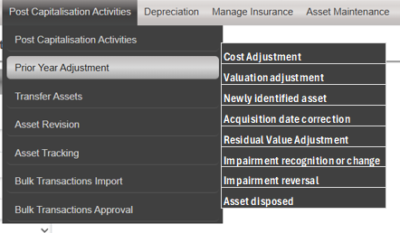

DISPOSAL ASSET ON VALUATION ADJUSTMENT
When the user selects the Disposal Adjustment option from the sub-sub menu, the following screen must display:

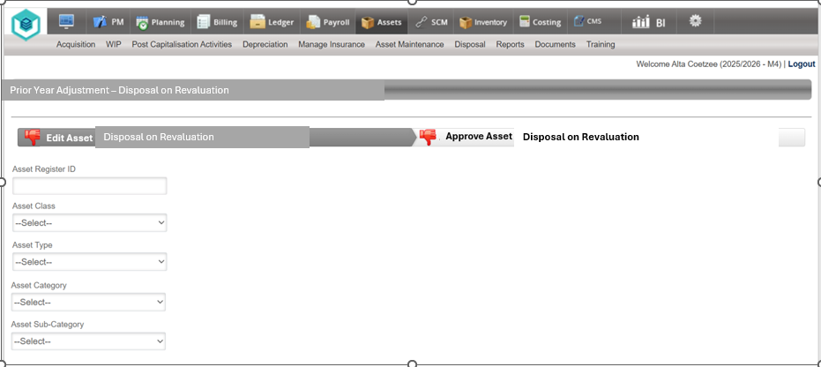

The User must be able to search for an Asset with the following Filter Criteria:
- Asset Register ID
- Asset Class
- Asset Type
- Asset Category
- Asset Sub-Category
The search results as per the filters applied must be displayed in a grid.
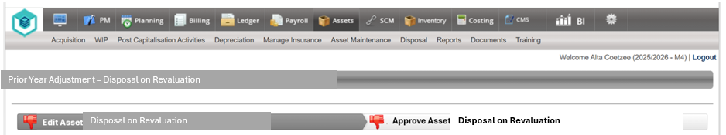
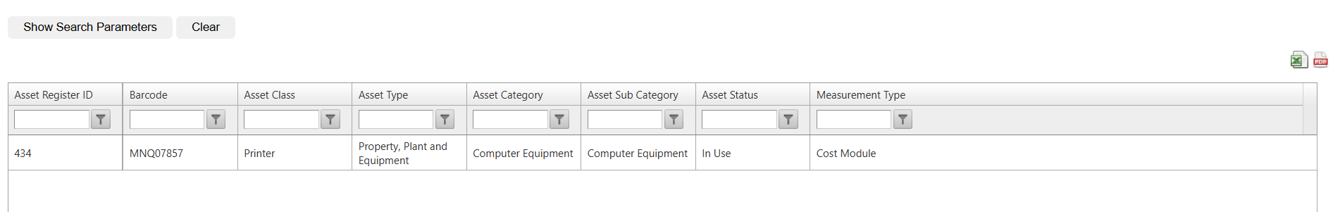

The user must be able to select a line item from the GRID by clicking on the line and the following Screen must be displayed:

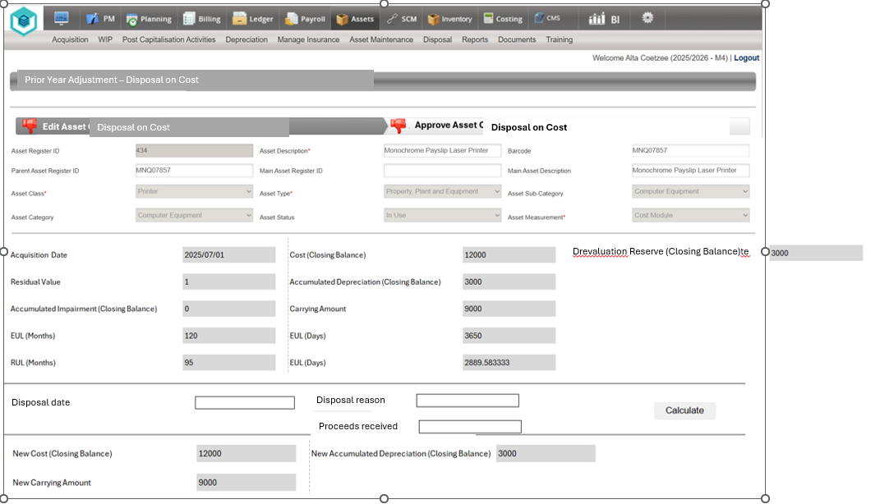

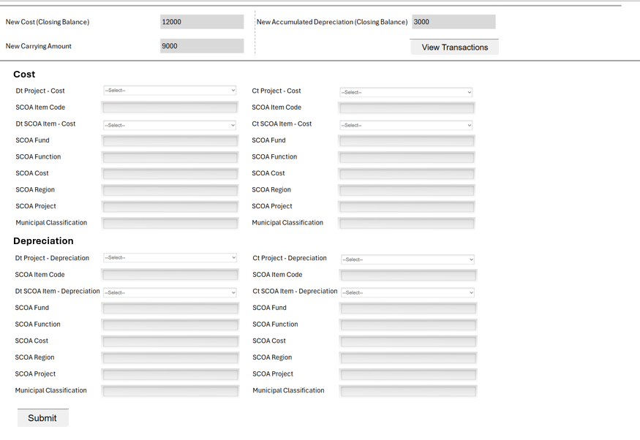
The balance in the Revaluation reserve must also be reflected here
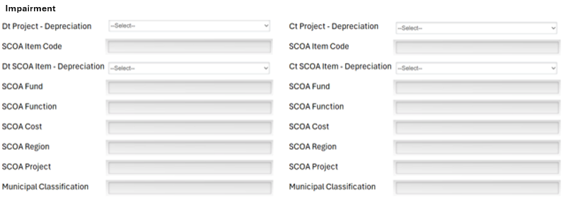
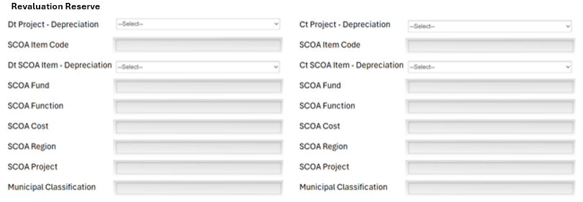

The System must display the current values as per the Asset register in the summary pane.
The user must be able to type in the disposal date, disposal reason, and proceeds if any.
When the User click on the Calculate button, the system must calculate the new values. The new values must differentiate between the current financial period, the period before (Comparative period balances) as well as the periods before the (Comparative opening balance). This split must be recorded and stored because it will be required and must be disclosed when the financial statements are compiled.
The system must first do a check on the impairment losses recognised on the asset, if there is an impairment loss, the system must display a message for the user in red. If there is no impairment, do not display the message.
The User must be able to View the transactions before submitting by clicking on the view transactions. The transactions must open in a downloaded excel sheet (refer to depreciation View Transaction functionality).
Make provision for the User to Upload Supporting Documentation – this is compulsory
The user must be able to select the Dt and Ct legs for ledger postings. The Dt and Ct legs for posting are not compulsory. The need for Dt and Ct legs will be determined by the type of error and if a correction transaction already exists or not. It will be the user’s responsibility/ discretion decide if it is needed or not. If no Dt and Ct projects is selected, it means that there are no postings to the ledger, but the asset register still needs to be updated with the new values. The new values must differentiate between the current financial period, the period before (Comparative period balances) as well as the periods before the (Comparative opening balance). This split must be recorded and stored because it will be required and must be disclosed when the financial statements are compiled. On some software packages used for example Caseware, separate journals are required for each of the periods (Current, prior, or before).

When the user selects the Submit button, the current year disposal adjustment transaction must be moved to the approval page
Adjust the Red thumbs down on the screen to a green thumbs up on the Edit Asset Cost Tab
When the User selects the Approve Asset Revaluation Adjustment Tab, the system must display the transaction for cost adjustment in a grid
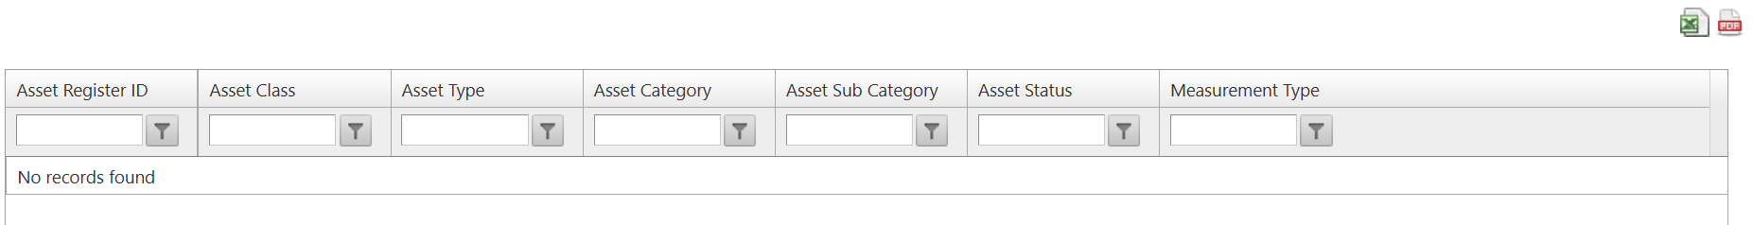
The user must be able to export the grid to an excel and pdf format
When the user selects the transaction from the grid, display the transaction as per the capturing page but all field must be greyed out.
The Approver must be able to view the transactions.
The user must be able to view the uploaded document.
All uploaded documents must be available in the Add/View Document Tab
The page must have an approve/Reject button.
If the User rejects the Revaluation amount Adjustment, he/she must provide a reason
When the user clicks on approve, the Asset register must be updated with the new values, and the system must do the postings to the ledger automatically if there was any Dt and CT projects selected.
Create a new Transaction Type on the Ledger for “Prior Year Adjustments”
Create a new document number on the ledger for “Disposal Adjustments”

The calculation for updating the Cost amount must be as follows:
- Revaluation amount adjustment can be up or down
- The system must be able to display decimals when the user type in the new cost amount.
- This is applicable to Revaluation Models.

Scenario 1

Asset was revalued on 30 June 2023. The balances at 30 June 2023 = Revaluation reserve = (5,660,048.60), Cost = 12,164,247.00, Acc Dep = (6,020,788.83), RUL = 5534, EUL = 10957.5, Value = 6,143,458.17 Asset should have been disposed on 20 June 2024 but the entries were not done

Description | Current balance | Corrected Balance | Journal - Debit/ (Credit)
Cost - Roads - Period before 2024
Cost - Roads - Period 2024 | 12,164,247.00 | 0.00 | (12,164,247.00)
Cost - Roads - Period 2025
Accumulated Depreciation - Roads - before 2024
Accumulated Depreciation - Roads - 2024 | 6,426,382.12 | 0.00 | 6,426,382.12
Accumulated Depreciation - Roads - 2025 | 405,247.74 | 0.00 | 405,247.74
Accumulated Surplus - Loss on disposal 2024 | 0.00 | 5,748,252.03 | 5,748,252.03
Accumulated Surplus - Deprecation Charges 2024 | 405,593.29 | 395,206.14 | (10,387.15)
Accumulated Surplus - Deprecation Charges 2025 | 405,247.74 | 0.00 | (405,247.74)
Revaluation reserve before 2024
Revaluation reserve 2024 | 5,285,712.17 | 0.00 | 5,285,712.17
Revaluation reserve 2025 | 373,313.65 | 0.00 | 373,313.65
Accumulated Surplus - RR Depreciation Offset 2024 | 374,336.43 | 364,108.66 | 10,227.77
Accumulated Surplus - RR Disposal 2024 | 0.00 | 5,295,939.94 | (5,295,939.94)
Accumulated Surplus - RR Depreciation Offset 2025 | 373,313.65 | 0.00 | (373,313.65)

Refer to Attached Excel Sheet for detailed calculations (Prior Year Corrections Examples 20251021 v05.exl) Scenario 2.1

Scenario 2

Asset was revalued on 30 June 2023. The balances at 30 June 2023 = Revaluation reserve = (5,660,048.60), Cost = 12,164,247.00, Acc Dep = (6,020,788.83), RUL = 5534, EUL = 10957.5, Value = 6,143,458.17
Asset was impaired on 20 June 2024. Asset was disposed on 25 June 2024 but the entries were not done

Description | Current balance | Corrected Balance | Journal - Debit/ (Credit)
Cost - Roads - Period before 2024
Cost - Roads - Period 2024 | 12,164,247.00 | 0.00 | (12,164,247.00)
Cost - Roads - Period 2025
Accumulated Depreciation - Roads - before 2024
Accumulated Depreciation - Roads - 2024 | 6,429,681.10 | 0.00 | 6,429,681.10
Accumulated Depreciation - Roads - 2025 | 499,543.63 | 0.00 | 499,543.63
Accumulated Impairment - Roads - before 2024
Accumulated Impairment - Roads - 2024 | 2,748,252.03 | 0.00 | 2,748,252.03
Accumulated Impairment - Roads - 2025
Accumulated Surplus - Loss on disposal 2024 | 0.00 | 2,991,788.32 | 2,991,788.32
Accumulated Surplus - Deprecation Charges 2024 | 408,892.27 | 403,417.82 | (5,474.45)
Accumulated Surplus - Deprecation Charges 2025 | 499,543.63 | 0.00 | (499,543.63)
Revaluation reserve before 2024
Revaluation reserve 2024 | 2,536,065.25 | 0.00 | 2,536,065.25
Revaluation reserve 2025 | 424,227.23 | 0.00 | 424,227.23
Accumulated Surplus - RR Depreciation Offset 2024 | 375,731.32 | 371,082.26 | 4,649.06
Accumulated Surplus - RR Disposal 2024 | 0.00 | 2,540,714.31 | (2,540,714.31)
Accumulated Surplus - RR Depreciation Offset 2025 | 424,227.23 | 0.00 | (424,227.23)

Refer to Attached Excel Sheet for detailed calculations (Prior Year Corrections Examples 20251021 v05.exl) Scenario 2.2

