Asset Verification Planning

Core Functionality
The core functionality relating to a Verification Plan contains the following:
- Schedule (Start and End Date)
- Associated Assets (Asset Type / Category)
- Scope of Work
- Location (Town / Area / Suburb / Building)
- Verification Team (Team Leader, Verification Officers, Support Staff, Administrative Staff)
- Linked Asset Verification Register (See Specifications for Asset Verification - Create Verification Register.doc)
- Progress Dashboard URL (Planet GIS linked Verification Progress Dashboard)
- Verification Plan Approval (User, Date, Approval Letter)
- Linked Documents (Approval Letters and other related documents)
- Role based Access Control (Defined in Asset Settings) on the following Functionality:
  - Create new Verification Plan
  - View / Export Verification Plan
  - Amend Verification Plan
  - Approve Verification Plan
  - Manage Verification Team
  - Upload of Documents to Verification Plan

New Menu Items in Assets Module
Create a new Menu item for the below functionality between Assets / Post Capitalisation Activities, and the New Asset Verification menu item.
Name: Verification Planning
- View Verification Plan
This window will serve as the “Administration” window of the created verification plans. Verification Plans should be able to carry the following verification statusses:
- Draft
- Approved
- Amended
- Amended (Approved)
The window should list all existing Verification plans with Filter capabilities listed at the top of each displayed field.
Each listed verification plan should have a select button (Radio Button) to allow the user to select which Verification plan to take action on.
Actions available should be:
- View (View of the Verification plan with actions available inside view: Approve / Amend / Export)
- Export (Save: Available to all Verification Plan Statusses)
- Export Template (An empty “Template” of the Verification Plan Structure must be exported when selected)
- Progress Dashboad (New Tab opens with the URL linked to the Planet Progress Dashboard linked to the Verification Plan when created)
A drop down should be available at the end of the listed fields that expans to the Audit Trail or History of the Verification plans when Amendments where made on the verification plan.
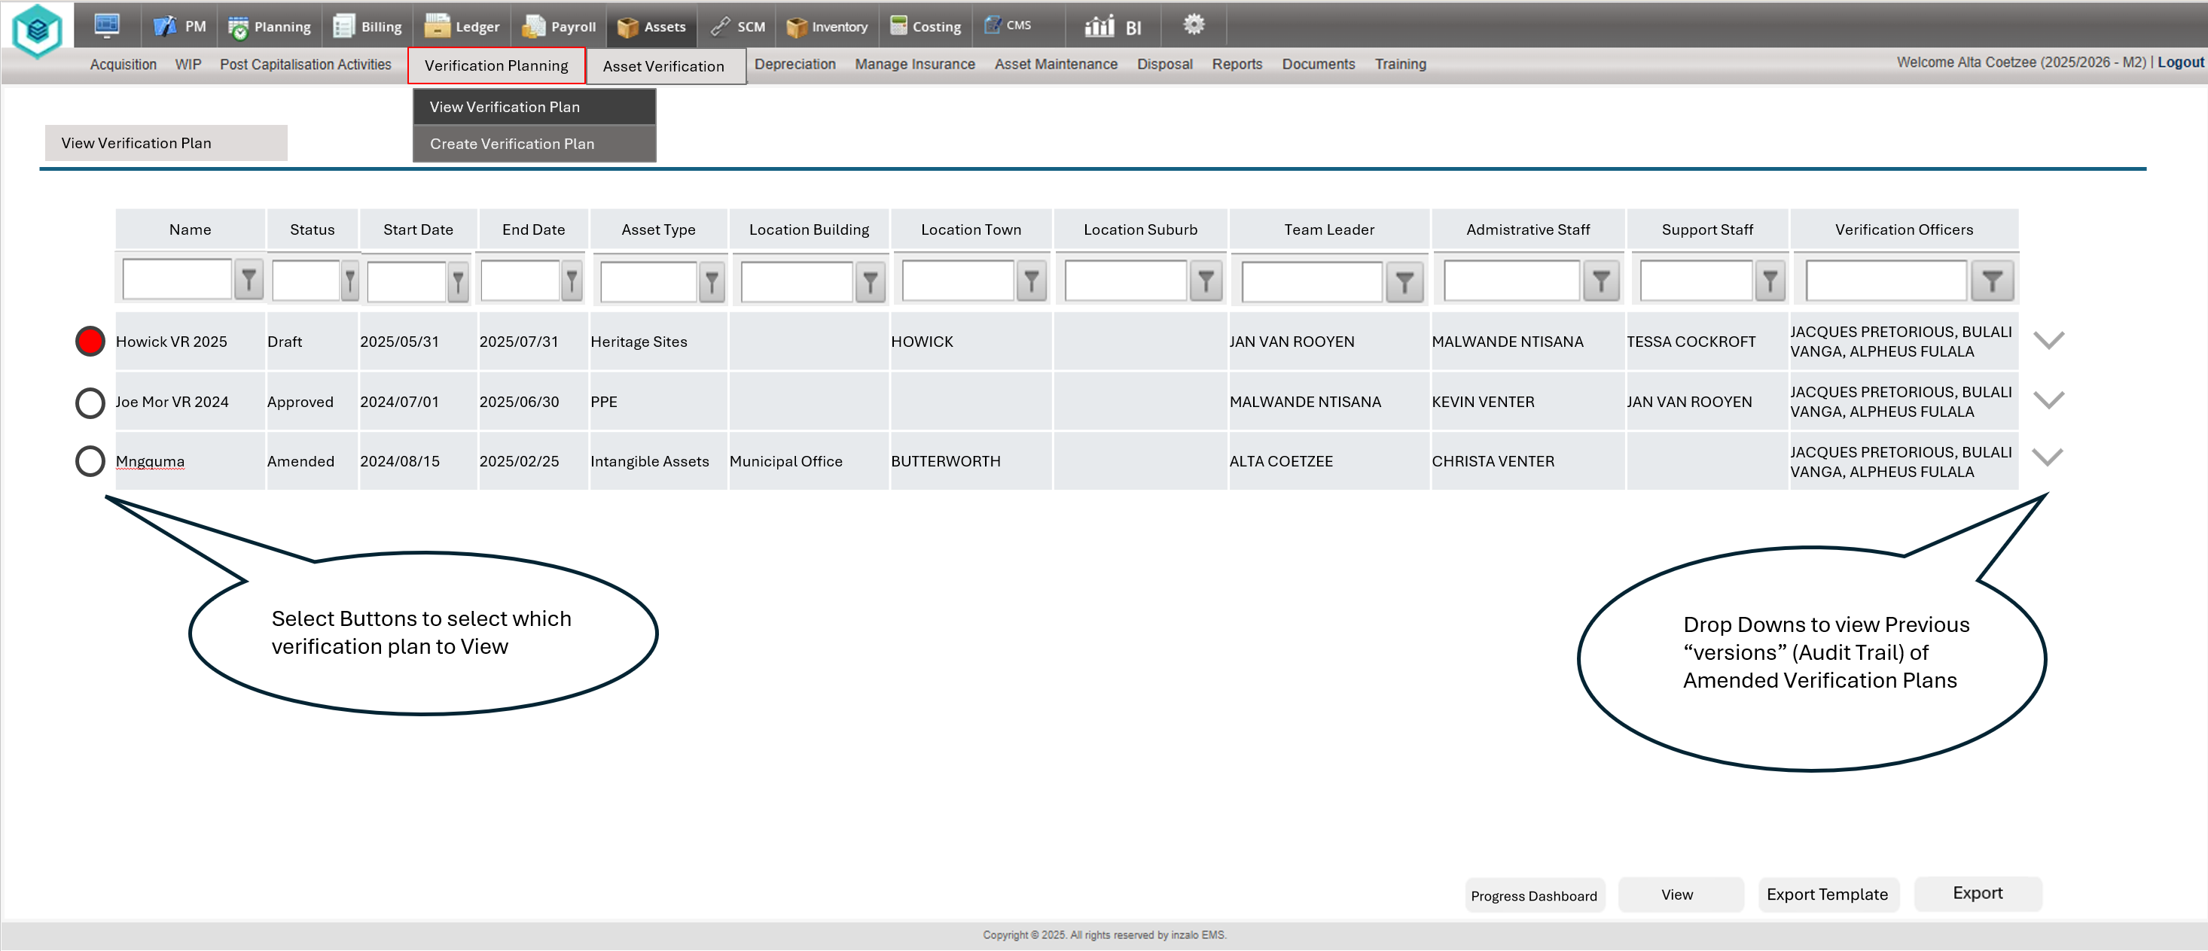

  - View Verification Plan
The purpose of the View Verification Plan is to to allow the user to View the details of the captured Verification Plan, Amend, Approve or Export all details of the selected verification register.
- Approve (Applicable to Draft and Amended Verification Plans)
- Amend (Applicable on All Verification Plan Statusses)
- Export (Report is generated with the Verification Plan Particulars)
When a user edits values captured on the existing verification plan, they should select the “Amend” button to save changes. If they navigate away from the page without selcting amend, a notification should be presented: “Would you like to Save the changes made to the verification Plan?” Yes / No. If Yes is selected, the plan should be amended (Saved), and an Audit Trail entry should be created containing the details of the edited information, with User Details and a Time Stamp. If No is selected, the changes should not be saved.
If an Approved Verification plan is Amended, the Status of the Verification Plan should change from Approved to Amended. The Verification Plan will then require Approval (Upload of a signed Approval document) to the verification plan, at which point the Status of the Verification Plan changes to Amended (Approved).
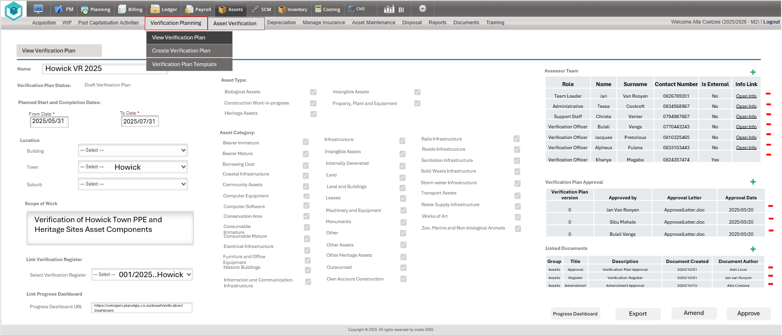
  - Amend Verification Plan

When a Verification Plan is selected from the View Verification Plan screen, and details captured in the plan is edited / Changed, and the “Amend” functionality is selected, the status of the Verification Plan should be updated:
  - Draft remains as Draft
  - Amended remains as Amended
  - Approved to Amended - (The Plan wil require the addition of Approval Person and uploaded signed Approval Document to move to Amended (Approved)
  - Amended (Approved) to Amended - (The Plan wil require the addition of Approval Person and uploaded signed Approval Document to move to Amended (Approved)

An audit trail should be kept on edits made on verification Plans to allow users to view previous versions of the Verification Plans with User information and Date Stamps assigned to each version of the Verification Registers.
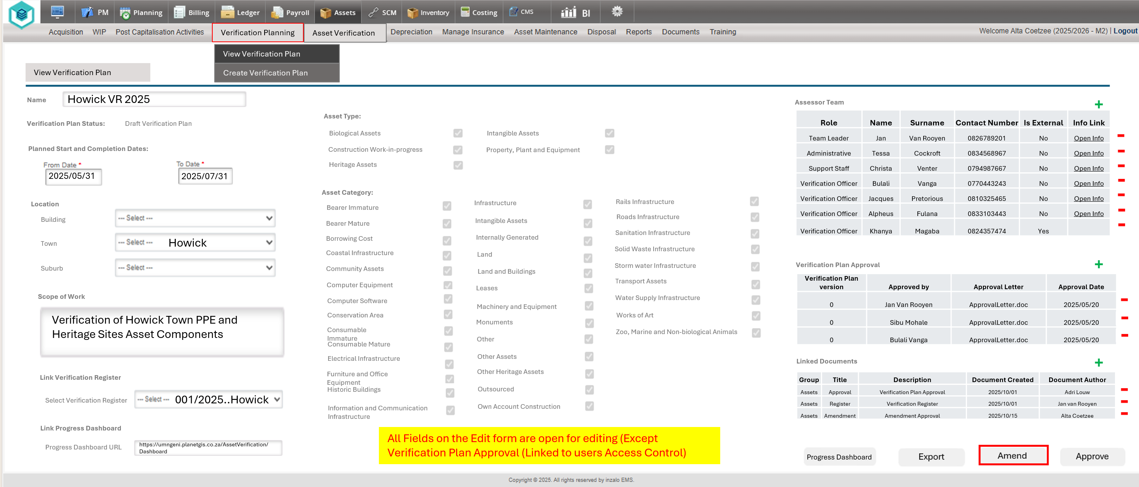
  - Approve Verification Plan
When the Verification Plan is Approved, the user should be required to select at least 1 Name (If Is External is No), or Type in a Name (If External is Yes) , as well as an Approval Date to the Form (Verification Plan), and a signed Approval Document should be uploaded to the Verification plan to Allow the “Approve” button to be excecuted. If the criteria mentioned was met, the Status of the Draft or Amended Verification Plan should be changed to either Approved (If a Draft Plan was selected), or Amended (Approved) if an Amended Verification Plan was selected.
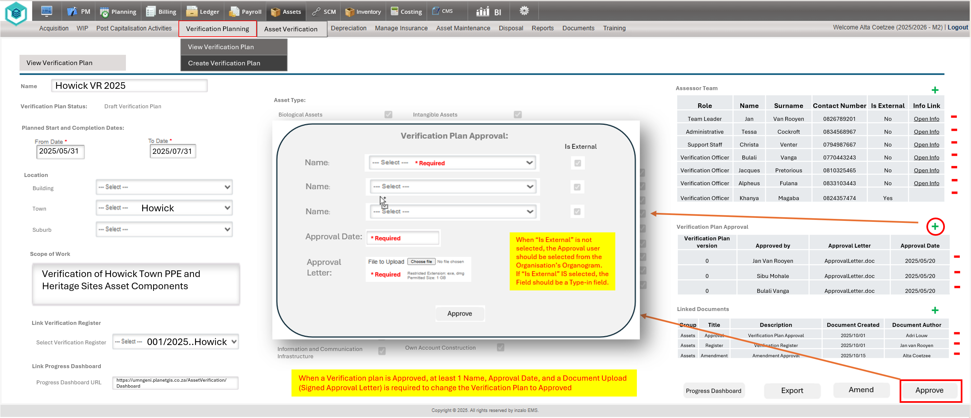

  - Export Verification Plan

When the Export Verification Plan Button is selected, the details of the Verification Plan as captured should be exported to an SSRS Report. All fields captured, along with the Verification Plan Approval (Done or Not Done) should be included in the Report. The export function should also also enable the exported document to be used to apply Approval Signatures to the verification plan, which in turn can be scanned and uploaded back into the verification plan as the Approval document (Containing the applied signatures.
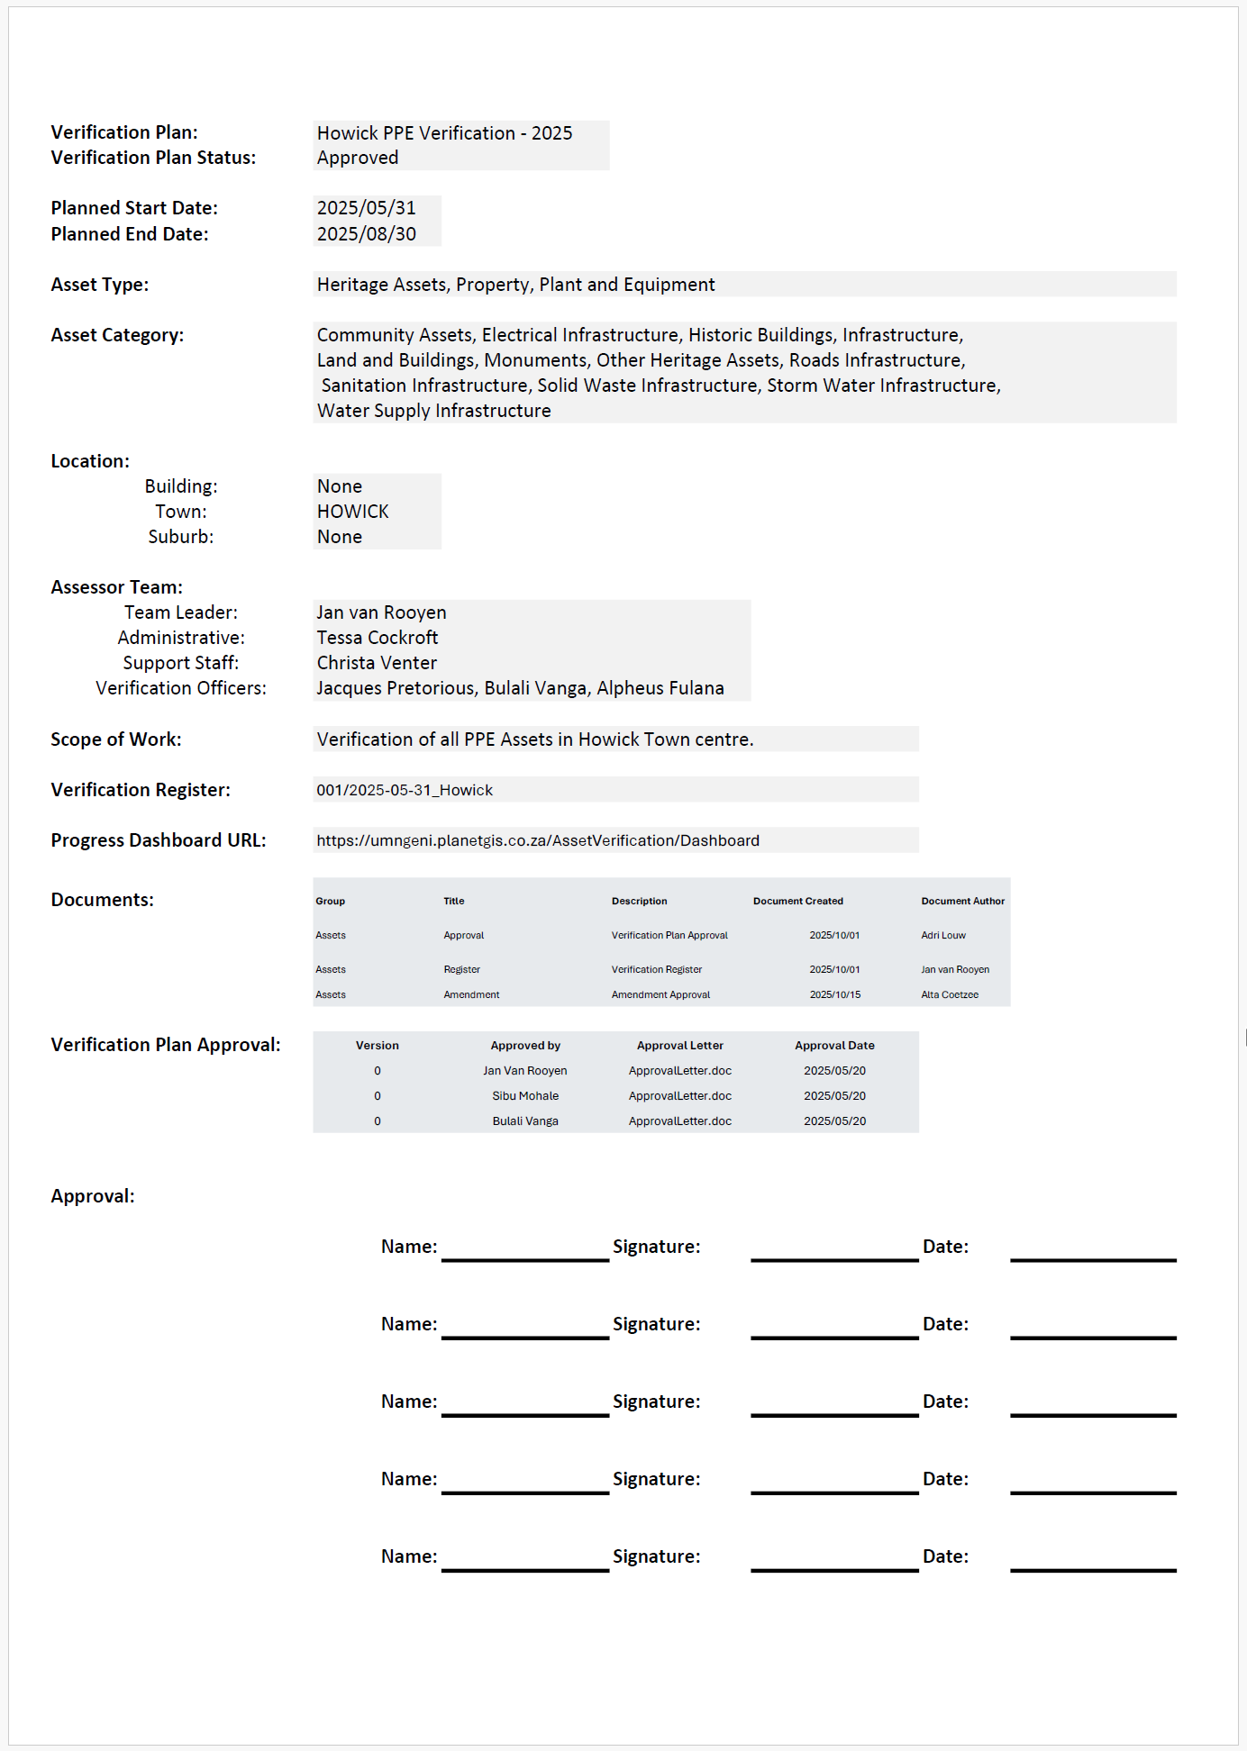
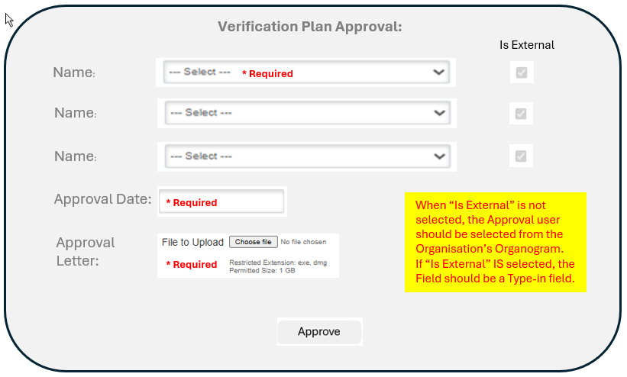
Pop-Up Windows for Addition of Information
- When members are added to the Assessor Team
- Approval is done on a Verification Plan
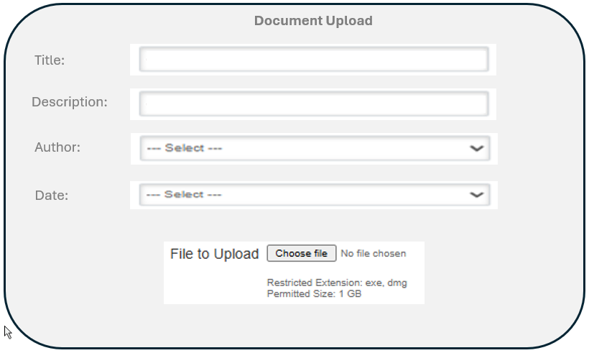
- Documentation is added to the Verification Plan

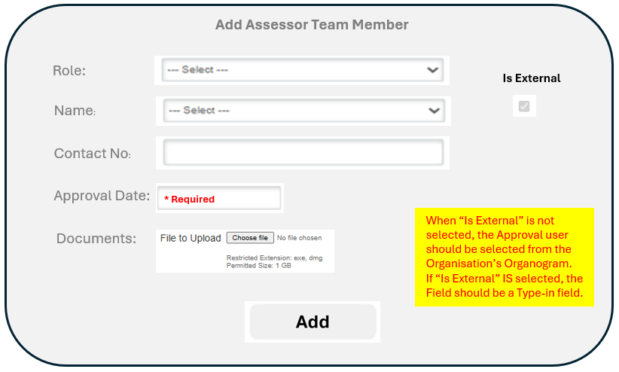

- Create Verification Plan
This functionality should enable the user to create a new Verification Plan, and populate all the data relating to the new verification plan.
The following Field data should be present on the form:
- Name (Name of the Verification Plan linked to a Unique ID for DB purposes containing a Version number for Audit Trail purposes)
- Planned Start From date and To Date
- Asset Type
- Asset Category (Linked to seleced Asset Types in Asset Setup)
- Location
  - Building (Drop down displaying Unique Values of Building Names captured in the EMS Asset Register / Setup)
  - Town (Drop down displaying Unique Values of Towns in the the EMS Asset Register / Setup)
  - Suburb (Drop down displaying Unique Values of Suburbs in the EMS Asset Register / Setup)
- Assessor Team (Distinction is required if a Team member is Internal or External to the Organisation. Internal (Drop Down from Orgranogram), External (Type in Field)
  - Team Leader (1 User)
  - Administrative (Multiple Users)
  - Support Staff (Multiple Users)
  - Verification Officers (Multiple Users)
- Scope of Work (Description field of the scope of work to be completed: 250 Characters)
- Select Verification Register (See Specifications: Asset Verification - Create Verification Register.docx)
- Progress Dashboard URL (URL link to External Planet GIS Progress dashboard to be used for display of the Dashboard in the EMS)

Linked User and Document Information:
- Assessor Team (Displays the linked member information relating to the Assessor Team)
  - Role
  - Name
  - Surname
  - Contact Number
  - Is External
  - Link Info (When the link is clicked, a new tab is opened with the Users Orgranogram information in a view only state)
- Veification Plan Approval (Displays the details of the persons/s who provided approval of the verification plan per Version of the Verification Plan)
  - Version (Version of the Verification Plan that was Approved)
  - Approved by (User that Approved the Version of the Verification Plan)
  - Approval Letter (Document Name of the Approval Letter uploaded on Approval)
  - Date (Date the Approval was done)
- Linked Documents (Displays the particulars of all linked documents (Approval letters or other related documents)
  - Group (Assets)
  - Title (Document Name)
  - Description (Text Description added when document was uploaded)
  - Date (Date the Document was uploaded)
  - Author (User who uploaded the document)
- File Upload (Functionality to upload files linked to the Verification Plan)
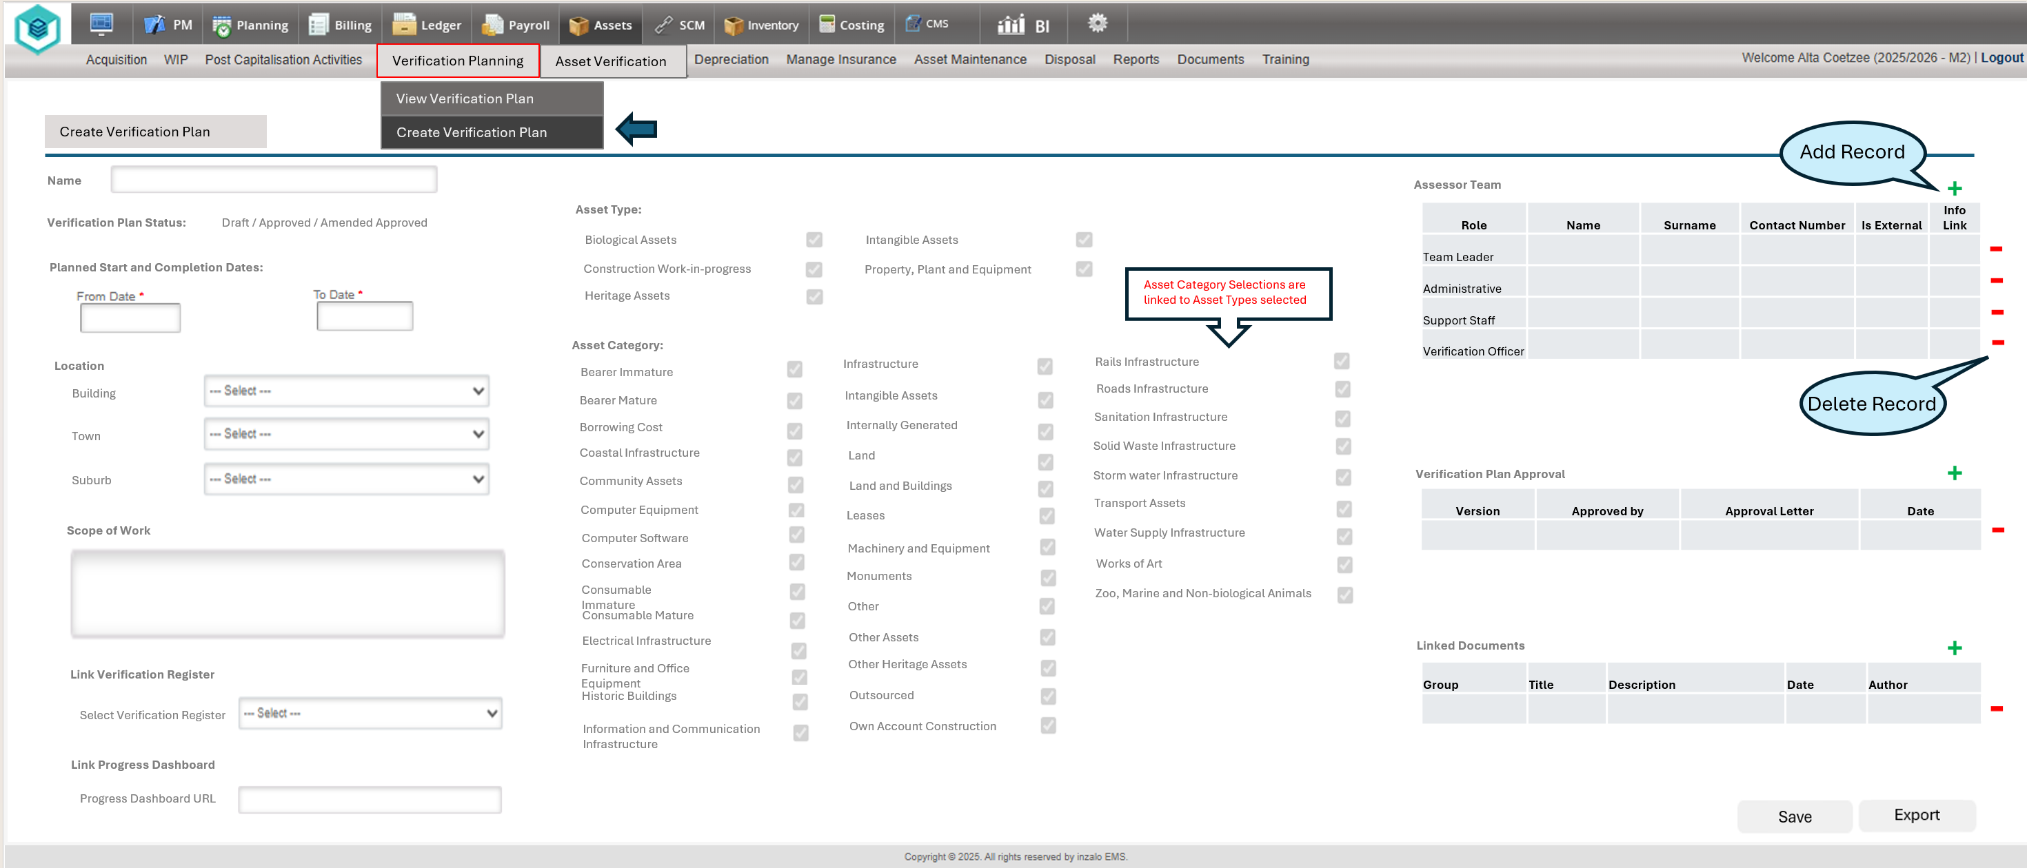

- Verification Plan Template
The Verification Plan Template Functionality should enable the user to view and Export (SSRS Report) a blank template of the Verification Plan Structure for Planning and Auditing Purposes. The SSRS Report created for the Export functionality can be used, only with no values entered for the variables.
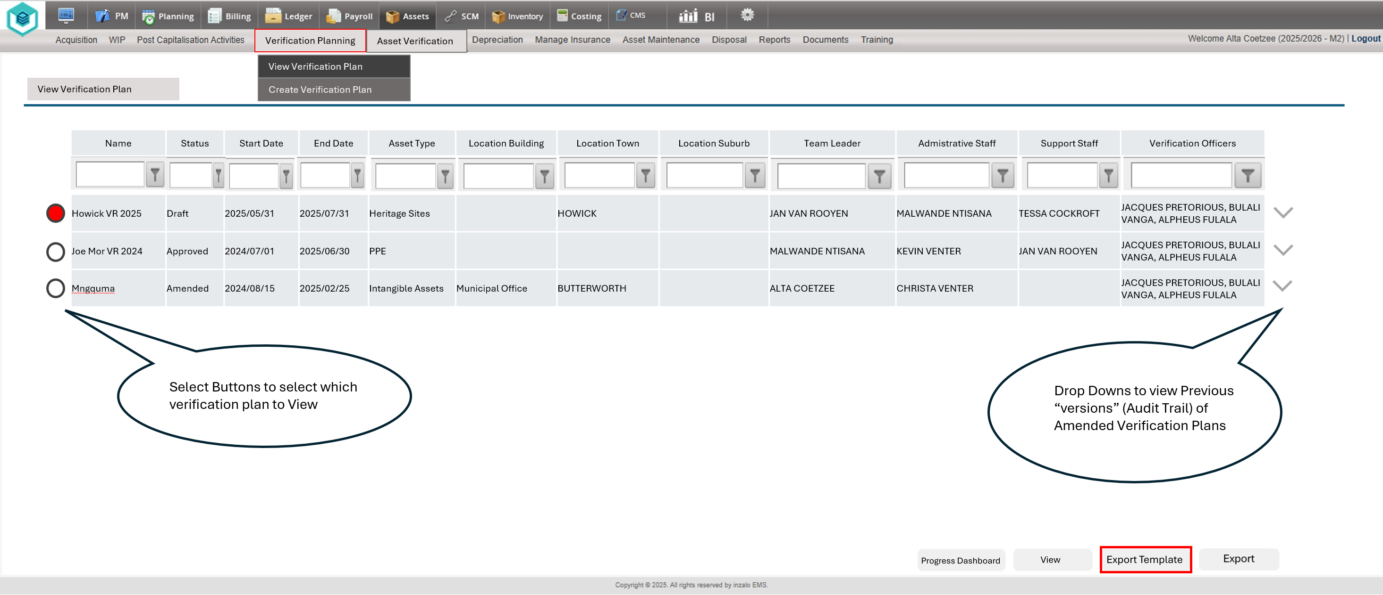
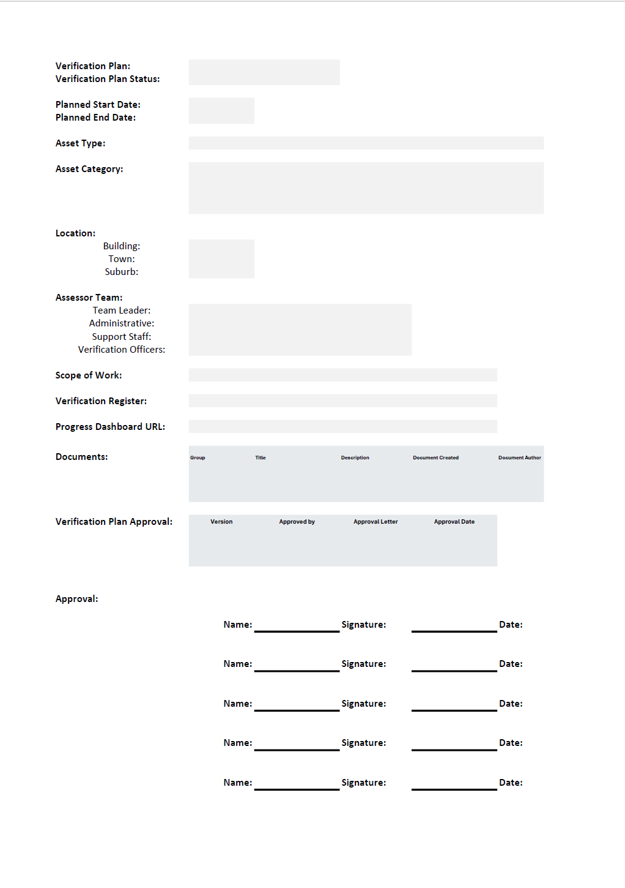
- Progress Dashboard
The user should be able to link a URL to a Planet Progress dashboard (Optional) that will open the URL in a new tab when the Progress Dashboard button is selected from either the select a Verification Plan screen, or from within the View Verification Plan (Edit) screen.
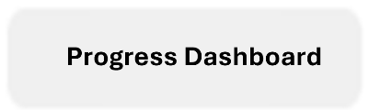
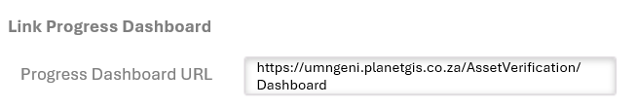
When the “Progress Dashboard” button is selected, a new tab must be opened in the user’s browser with the URL entered displaying on the new tab:
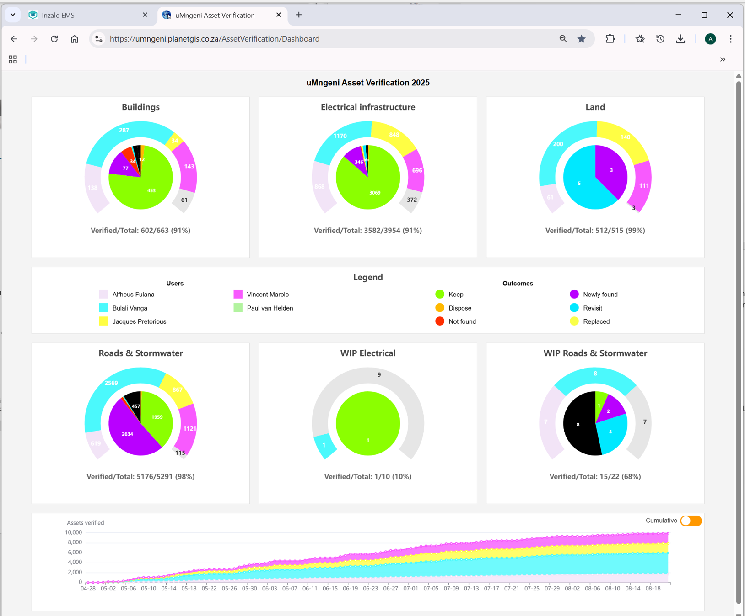
- Role based Access Control
Access Control is required on the individual functionalities listed above as per the requirements of National Treasury.
The following Actions from within the Asset Verification Planning module requires settings in the EMS to control who may access the functionality.
- Create new Verification Plan
- View / Export Verification Plan
- Amend Verification Plan
- Approve Verification Plan
- Manage Verification Team
- Upload of Documents to Verification Plan

A new “Item” should be added to Settings / Asset Settings for the new functionality and its access control with the ability to link roles that is allowed to Preform the actions listed:
