
+



Enterprise Management System 6.3
MODULE NAME: ASSETS
Functional System Specification – Enhancement
Unbundling of Asset (Part 2)
TP 91214
Author: Veronica Visser
Version 1

FUNCTIONAL SYSTEM SPECIFICATION OVERVIEW - Enhancement

The Functional System Specification specifies only what the business requirements are from a functional system requirements level. The detail of how the technical design will meet the business requirements will not be in this specification. This document is to be signed off by business, quality assurance and technology representatives.

REVISION AND APPROVAL

Revision Summary
Revision | Name | Date | Comments
0.1 | Veronica Visser | 19 August 2019 | Submitting First Draft

Document Review

Document Approval

Name | Designation \ Role | Date | Signature
Doré Snyman | Senior Manager Business and Support
 | Developer
Veronica Visser | Testing QA
Veronica Visser | Testing UAT

TABLE OF CONTENTS
Revision Summary 2
1. Glossary 5
2. Business requirement 5
2.1.1 Business Objectives 5
2.1.2 In scope 5
2.1.3 Out of Scope 5
2.1.4 Impacted Business Process 6
2.1.5 Dependencies 6
3. Detailed enhancement REQUIREMENTS 6
3.1 Program Menu/Execution Path 6
3.2 AS-IS Business Process Layout 6
3.3 TO-BE Business Process Layout – Acquire Assets – Assets UNBUNDLING 7
3.4 Business Rules – Unbundling of Assets 8
3.5 Use Case Narrative 15
3.6 Success Messages 25
3.7 Error Messages 25
3.8 Authorization 25
3.9 Proposed Screen Layout – mSCOA Settings – Transaction Type 25
3.10 Proposed Screen Layout – Acquisition – Unbundling 27
1. Performance 53
2. Design Constraints 53
3. Testing Requirements 53

Glossary

Term/Acronym | Description
EMS | Enterprise Management System
mSCOA | Municipal Standard Chart of Accounts
CIDMS | Cities Infrastructure Delivery and Management System

Business requirement

Build new business rules into the system for capturing transactions by providing functionality to unbundle “Completed Capital Contracts” into assets within the Asset Management System.

Number | Requirement description
1 | Ability to Unbundle Completed Capital Contracts initiated through SCM into Assets
2 | Ability to assign acquired assets to a Main Asset
3 | Ability to classify assets according to the CIDMS classification
4 | Ability to calculate the cost of the new assets based on the SCM information
5 | Add newly created assets to asset register

Business Objectives

WIP Assets must be registered and assigned to the “core asset” in the Asset Management System and where applicable, Assets must be assigned to Main Asset.

In scope

No | Description
1 | Creation of interfaces as per this FSS

Out of Scope

No | Description
1 | Manage Acquire Assets
2 | Take on
3 | Transfer of Assets
4 | Work-in-Progress Report
5 | Impairment of Work-in- Progress Project

Impacted Business Process

No | Description
1 | Acquisition

Dependencies

No | Type | Dependency Detail | Impact
1 | Configurations | Configurations | High
2 | Bill of Quantities | Tender process in SCM | High
3 | Purchase Items | Informal Tender | High
4 | Capital Contract | Approved Capital Contract in SCM | High
6 | Invoices | Approved | High
7 | Debit Notes | Approved Debit Notes | High
8 | Credit Notes | Approved Debit Notes | High
9 | Final Bill of Quantities | Final Bill of Quantities | High
10 | Completion Certificate | Completion Certificate | High

Detailed enhancement REQUIREMENTS

Program Menu/Execution Path

Assets>>Acquire Assets

AS-IS Business Process Layout

Currently the EMS does not cater for Asset Unbundling

TO-BE Business Process Layout – Acquire Assets – Assets UNBUNDLING

The authorised user needs to login to EMS, clicks on the Assets>> Acquire Assets>> Assets Unbundling

Business Rules – Assets Unbundling

Number | Business Rule
1 | Permission parameters only authorised user should have the ability to perform transactions such as Asset Unbundling
2 | Asset Unbundling Transaction Type is a Default Asset Transaction Type and must be preloaded in the system
3 | Initiated projects must be available for selection that exist in the selected financial year.
4 | Once the planning Project is selected only mSCOA Items linked to that project must be available for selection
5 | Once the mSCOA item is selected it must default the other 6 segments from planning
6 | - The following Mandatory fields must display in a grid from SCM (Contract Management) that was pushed to the Unbundling of Asset Table into the Capital Contract interface page:  - Contract Period Start Date  - Contract Period End Date  - Contract Registration No  - Contract Description  - Awarded Contract Value  - Actual Expenditure  - Project Complete indicator  - The above summary information displayed in the grid must be non-editable  - This grid must be downloadable in Excel/PDF
7 | The Project Complete indicator can only be Yes or No  The Project Complete indicator cannot be edited and only be updated by the system
8 | - Summary of Contract details displays from SCM (Contract Management) that was pushed to the Unbundling of Asset Table into the Capital Contract interface page:  - Capital Contract Details:  - Contract Registration Number  - Contract Description  - Awarded Contact Value  - Actual Expenditure  - % Completion Rate  - The System must continuously calculate the % completion rate (Formula: Actual Expenditure/ Contract Value)  - Project Complete indicator  - The System must update the status of the project to Yes only when the project is successfully unbundled.  - The following mandatory fields displays in a grid from SCM that was pushed to the Unbundling of Asset Table:  - Supplier Details  - Invoice Date  - Invoice Number  - Invoice Amount  - Debit/ Credit Note Number  - Debit/ Credit Note Amount  - Payment Certificate Number  - Purchase Item Description  - Only Approved Invoices must be transferred to the “Unbundling Assets” Process  - Only Approved Debit Notes must be transferred to the “Unbundling Assets” Process  - Only Approved Credit Notes must be transferred to the “Unbundling Assets” Process  - All the above fields are non-editable  - This grid must be downloadable in Excel/PDF  - Invoice, Debit/Credit Note can only be viewed
9 | - Upload of the following supporting documents are mandatory:  - Completion Certificates  - Bill of Quantities  - File upload format for the Completion Certificate must only be PDF  - File upload format for Bill of Quantities must only be PDF  - Ability to upload multiple documents must exist
10 | Completion Certificate and Bill of Quantities must be available to be downloaded and viewed by the Approver  The Completion Certificate and Bill of Quantities must be non-editable
11 | The following mandatory fields are pushed from SCM to the Unbundling of Asset Table (Back end):  - Goods/ Services Description  - Unit of Measure  - Quantity
12 | The Goods/ Services Description information derived from SCM is default and is non-editable
13 | Only an alphanumerical value can be entered for the Unit of Measure (UOM)
14 | Only a numerical value can be entered for the Quantity
15 | Only a decimal numerical value can be entered for the Rate
16 | The Rate field is mandatory
17 | The “Amount” field is automatically calculated by the System as soon as the Rate is captured. (Formula: Quantity x Rate)
18 | The “Amount” field cannot be edited
19 | CIDMS Sub Component limited to those CIDMS Sub Component configured in settings
20 | CIDMS Accounting Groups limited to those CIDMS Accounting Groups configured in settings
21 | CIDMS Accounting Sub Groups limited to those CIDMS Accounting Sub Groups configured in settings
22 | CIDMS Asset Class limited to those CIDMS Asset Classes configured in settings
23 | CIDMS Asset Group Type limited to those CIDMS Asset Group Type configured in settings
24 | CIDMS Asset Type limited to those CIDMS Asset Type configured in settings
25 | CIDMS Component Type limited to those CIDMS Component Type configured in settings
26 | The above fields will only be mandatory if:  - CIDMS Accounting Sub Group will be a mandatory field for those CIDMS Accounting Groups with an associated CIDMS Accounting Sub Group  - CIDMS Asset Class will be a mandatory field for those CIDMS Accounting Groups with an associated CIDMS Asset Class  - CIDMS Asset Group Type will be a mandatory field for those CIDMS Accounting Groups with an associated CIDMS Asset Group Type  - CIDMS Asset Type will be a mandatory field for those CIDMS Accounting Groups with an associated CIDMS Asset Type  - CIDMS Component Type will be a mandatory field for those CIDMS Accounting Groups with an associated CIDMS Component Type
27 | The dropdown box for CIDMS Asset Class not linked to a CIDMS Accounting Group will be greyed out;
28 | The dropdown box for CIDMS Asset Group Type not linked to a CIDMS Accounting Group will be greyed out;
29 | The dropdown box for CIDMS Asset Type not linked to a CIDMS Accounting Group will be greyed out;
30 | The dropdown box for CIDMS Component Type not linked to a CIDMS Accounting Group will be greyed out;
31 | Asset Type limited to those Asset types configured in settings
32 | Asset Category limited to those Asset Categories configured in settings.
33 | Asset Sub-Category limited to those Asset Sub-Categories configured in settings.
34 | Measurement Type limited to those Measurement Types configured in settings
35 | Asset Status limited to those Asset Statuses configured in settings
36 | The above fields will only be mandatory if:  - Asset Categories will be a mandatory field for those Asset types with an associated Asset Category  - Asset Sub Categories will be a mandatory field for those Asset types with an associated Asset Sub Category;  - Asset Measurement will be a mandatory field for those Asset types with an associated Asset Measurement Type;  - Asset Status will be a mandatory field for those Asset types with an associated Asset Status
37 | The dropdown box for the Asset Category not linked to an Asset Type will be greyed out;  The dropdown box for the Asset Sub Category not linked to an Asset Type will be greyed out;
38 | - Only 2 options available to indicate that the Goods/ Services Description is an Asset Item:  - Yes  - No  - This field is mandatory
39 | The following fields will be mandatory if the ‘Asset Item is set to “Yes” and must be completed:  - CIDMS Sub Component Type  - Asset Description  - Asset Type  - Asset Category  - Asset Sub Category  - Measurement Type  - Asset Status  - The following fields will display based on the configured CIDMS Sub Component Type selected:  - CIDMS Accounting Group  - CIDMS Accounting Sub-Group  - CIDMS Asset Class  - CIDMS Asset Group Type  - CIDMS Asset Type  - CIDMS Component Type  - The following fields must be selected:  - Asset Type  - Asset Category  - Asset Sub Category  - Measurement Type  - Asset Status
40 | Ability to save changes on the Asset Classification page must exist
41 | Only a numerical value can be entered for the Actual Survey on the Cost Distribution interface page
42 | The following is cost calculated by the system:  - Total General Cost (Formula: Preliminary Cost + General Cost)  (The System displays the Total General Cost calculated from the Asset Classification page and is based on the sum of all the Non-Asset Item costs, items marked as no.)  - General Cost Distribution per CIDMS Sub Component Type (Formula: Cost per Individual CIDMS Sub Component Type / {Total Cost per CIDMS Sub Component Type} x Total General Cost)  - The system automatically distributes the General cost per CIDMS Sub Component Type  - Total Bill of Quantities Cost (Formula: Total Cost per CIDMS Sub Component Type + General Cost Distribution per CIDMS Sub Component Type)  - Unit Cost Unit Cost per individual Asset within the CIDMS Sub Component Type (Formula: [{Cost per CIDMS Sub Component Type + General Cost Distribution per CIDMS Sub Component Type}/ Actual Survey]  - Total Project Cost (Formula:(Total General Cost + Total Cost for all CIDMS Sub Component Types)
43 | Total amount of the Actual expenditure display from the Capital Contract page into Cost Distribution table in the Cost Distribution interface page
44 | Actual Expenditure is non-editable
45 | The System calculating the Difference (Formula: Total Project Cost - Actual Expenditure)
46 | A reason for the difference is mandatory before the Cost Distribution table can be approved
47 | A reason for the declining the Cost Distribution is mandatory
48 | Asset list is system generated and push to the Unbundling of Asset Table (Back End)
49 | Budget (Actual expenditure Amount) will be committed when the Asset list is generated.
49 | The System calculates the Asset Count and display in the Commissioning interface page
50 | On Approval of the Commissioning the System will update the Asset Register with the new Additions and Post the entries to the General Ledger.
51 | On Approval of the Commissioning the budget will be consumed
52 | Asset Register Validations: For upload of the new asset list from manage asset  - No duplicate Asset Register ID should exist.  - Asset Register ID is a Mandatory Field  - Validate that Asset Register ID is a numerical value  - No duplicate Parent Asset Register ID should exist.  - Validate that Parent Asset Register ID is a numerical value  - Main Asset ID  - No duplicate Barcodes should exist.  - Validate that the Barcode is a numerical or Alphanumerical value  - Barcode is not a mandatory field  - No duplicate Old Barcodes should exist.  - Validate that the Old Barcode is an alpha-numerical value  - Old Barcode is not a mandatory field  - Validate if Image file reference exist  - Validate if the actual image is available  - Image Reference is not a mandatory field  - Financial Status field can only be  - Carrying Value zero  - Disposed  - Write-off  - Addition  - Existing Asset Register  - Donation  - Financial Status is not a mandatory field  - Validate that either the Asset Condition description or Asset Condition ID exists in the Asset Condition configuration  - Asset Condition is a Mandatory Field  - Infrastructure/ Non-Infrastructure field can only be  - Infrastructure  - Non-Infrastructure  - Nature of Addition can only be:  - New  - Existing - Replacement  - Existing - Upgrade  - Validate that Construction Material description is a character string  - Validate that "Verified Date” date format is "DD/MMM/YYYY"  - Verified Date is not a Mandatory Field  - Validate that "Verification Done by" is a character string (no numerical value)  - Validate that UOM is an alphanumerical value  - Validate that DIM1 is a numerical value  - Validate that DIM2 is a numerical value  - Validate that DIM3 is a numerical value  - Validate that Dimension Quantity is a numerical value  - Validate that Quantity is a numerical value  - Validate that the SG Key is an alphanumerical value  - Validate that the Deed Number is an alphanumerical value  - Validate that the Erf/ Farm Number is a numerical value  - Validate that Erf size M2 is an alphanumerical value  - Validate that Portion Number is a numerical value  - Validate that Unit Number is an alphanumerical value  - Validate that the Make description is a character string  - Validate that the Model description is a character string  - Validate that Registration Number is a character string  - Validate that the Serial Number is a character string  - Validate that Custodian Name is a character string (no numerical value)  - Custodian Name is a Mandatory Field  - Asset Ownership field can only be:  - Owned  - Leased  - Asset Ownership is a character string (no numerical value)  - Asset Ownership Name is a Mandatory Field  - Validate that either the Department description or Department ID exists in the General Settings  - Department is a Mandatory Field  - Validate that either the Division description or Division ID exists in the General Settings.  - Validate that the Division is linked to the Department  - Division is a Mandatory Field  - Validate that either the Town description or Town ID exists in General Settings  - Town is a Mandatory Field  - Validate that either the Street Address description or Street Address ID exists in the General Settings.  - Validate that either the Building description or Building ID exists in the Assets Settings.  - Validate that either the Ward description or Ward ID exists in the General Settings  - Validate that Zoning is either a numerical value or alphanumerical value  - Validate that either the Floor Area description or Floor Area ID exists in the Assets Settings.  - Validate that either the Room Number description or Room Number ID exists in the Assets Settings.  - Validate that either the Suburb description or Suburb ID exists in the General Settings  - Validate that the GIS Feature ID is a numerical value  - Validate if Residual Value is a numerical value  - Validate that the Current Replacement Cost (CRC) is a numerical value  - Depreciated Replacement Value (DRC)  - Validate that the Forecast Replacement Year  - Cash/ Non-Cash Generating field can only be  - Cash Generating  - Non-Cash Generating  - Annualised maintenance % CRC  - Validate that the Annual maintenance budget forecast amount is a numerical value  - Insurance cover field can only be:  - Yes  - No  - Validate that the Insurance Policy number is a character string  - Warranty field can only be:  - Yes  - No  - Validate that the Basic Municipality Service description or Basic Municipality Service ID exist in the Asset Settings.  - Validate that the Criticality Grade description or Criticality Grade ID exist in the Asset Settings.  - Validate that the Performance Grade description or Performance Grade ID exist in the Asset Settings.  - Validate that the Utilisation Grade description or Utilisation Grade ID exist in the Asset Settings.  - Validate that the Infrastructure Health Grade description or ID exist in the Asset Settings.
53 | Acquisition Date must auto-populate based on the date of Commissioning  Acquisition Date must not be editable  Acquisition Date is a mandatory field
54 | In Service Date must auto-populate based on the date of Commissioning  In Service Date must not be editable  In Service Date is a mandatory field
55 | Useful Life Year Component must be calculated by the system based on the Useful Life Month Component  Useful Life Year can be a decimal value  Useful Life Year Component is a mandatory field
56 | Useful Life Month Component can be a decimal value  Useful Life Month Component is a mandatory field
57 | Remaining Useful Life Year Component must be equal to the Useful Life Year Component  Remaining Useful Life Year can be a decimal value  Remaining Useful Life Year Component is a mandatory field
58 | Remaining Useful Life Month Component must be equal to the Useful Life Month Component  Remaining Useful Life Month Component can be a decimal value  Remaining Useful Life Month Component is a mandatory field
59 | Modified Date must auto-populate based on the System Date  Modified Date format is "DD/MMM/YYYY"
60 | Error message per row to display on the error log at the end
61 | The processing of the file doesn’t stop if an error is picked up in a row.  The file must load whatever records are error free.  The rows with errors must be displayed in the error log.
62 | Borders of omitted mandatory fields will turn red.

Use Case Narrative

Use Case Number: | Use Case 1
Description: | Acquisition – Unbundling Assets
Preconditions: | The following must have been configured:  - Settings for Asset Types, Asset Categories, Asset Sub Categories, Measurement Types, Asset Statuses, CIDMS Accounting Group, CIDMS Accounting Sub Group, CIDMS Asset Class, CIDMS Asset Group Type, CIDMS Asset Type, CIDMS Component Type, CIDMS Sub Component Type, mSCOA Setting, Asset Condition, Asset Locations.  Requirements to execute unbundling process:  - Approved Tender, Approved Informal Tender and Capital Contract from SCM;  - Approved Invoices charged against the Capital Contract;  - Approved Debit/ Credit Notes against the Invoice charged against the Capital Contract;  - Payment Certificate against the Capital Contract;  - Completion Certificate;  - Final Bill of Quantities;  - Complete Asset Register
Flow of Events: | Actor  - Navigate to the Asset module  - Select Acquisitions  - Select Unbundling Asset  - Select Contract from the Capital Contract grid  - Optional:  Click on the Invoice Number to View the Invoice details  - Optional:  Click on the Debtor or Credit Note Number to view the Debtor or Credit Note details  - Optional:  Click on the Payment Certificate Number to view the Payment Certificate Details  - Select Upload button to upload Completion Certificate, Bill of Quantities and associated supporting documents  - Click on Choose file button to upload Completion Certificate  - Select file to upload  - Click on Choose file button to upload Bill of Quantities  - Select file to upload  - Optional: Click on Attach another file to upload additional supporting documents  - Click on Cancel  - Click on Submit after all documents have been uploaded  - Capture Main Asset Description in the text box ‘Main Asset’  - Optional: Click on Add Button to capture additional Goods/ Services Description(s)  - Optional: Capture additional Goods/ Services Description on the grid  - Optional: Edit Unit of Measure  - Optional: Edit Quantity  - Capture the Rate per line item  - If the Item is not an Asset; select “No” from the dropdown box under Asset Item  - If the Item is an Asset; select “Yes” from the dropdown box under Asset Item  - Capture Asset Description  - Select from the dropdown box the CIDMS Sub Component Type  - Select from dropdown box the Asset Type  - Select from dropdown box the Asset Category  - Select from dropdown box the Asset Sub Category  - Select from dropdown box the Measurement Type  - Select from dropdown box the Asset Status  - Optional: Click on Save  - Optional: Click on View documents  - Click on Calculate Project Cost  - Click on Cancel  - Cost Distribution  - Capture Actual Survey  - Capture Comment  - Select Approved  - Select Approver from the dropdown box  - Select Decline  - Capture Comment  - Optional: Click on View documents  - Click on Generate Asset list  - Click on Submit  - Click on Cancel  - Commissioning  - Click the tick box of each Asset Type to be submitted for approval  - Select Approved  - Select Approver from the dropdown box  - Select Decline  - Capture a comment  - Click on Submit  - Click on Cancel  Manage Assets  - Click “Download Asset List”  - User corrects incomplete/omitted information in the CSV file and save the file  - On interface: User click on “Select file to upload”  - User can select to save the Asset List Upload Log  - Click Yes  - Click No | System  1.1The system must open the Asset Module Interface Page displaying menu options.  - The system must open Unbundling interface page.  3.1 Displaying: Capital Contract, Asset Classification, Cost Distribution, Commissioning and Manage Assets  3.2 The system displays the Grid listing all Capital Contracts from SCM (Contract Management) that was pushed to the Unbundling of Asset Table. The following information in the grid must populate from SCM:  - Contract Period Start Date  - Contract Period End Date  - Contract Registration No  - Contract Description  - Awarded Contract Value  - Actual Expenditure  - Complete indicator (Yes/No)  3.3The above summary information displayed in the grid is non-editable  3.4 This grid must be downloadable in Excel/PDF  4.1 The System opens a summary in the Capital Contract Interface page and displays the following fields based on the selected Contract:  - Capital Contract Details:  - Contract Registration Number  - Contract Description  - Awarded Contact Value  - Actual Expenditure  - % Completion Rate  - Project Complete indicator  4.2 The above summary information is non-editable (greyed out)  4.3 % Completion Rate: The System must continuously calculate the % completion rate by dividing the Actual Expenditure through the Contract Value  4.4 Project Complete indicator: The System must update the status of the project to Yes only when the project is successfully unbundled.  4.5 The System displays a grid (below the above summary) with the Approved Invoice or Debit/Credit note and Payment Certificate details from SCM that was pushed to the Unbundling of Asset Table  - Supplier Details  - Transaction Date  - Invoice Number  - Invoice Amount  - Debit/ Credit Note Number  - Debit/ Credit Note Amount  - Payment Certificate Number  4.6 All the above fields are not editable  4.7 This grid must be downloadable in Excel/PDF  5.1 Display the selected Invoice  5.2 Can only be viewed and non-editable.  6.1 Display the selected Debit or Credit Note  6.2 Can only be viewed and non-editable.  7.1 Display the selected Payment Certificate  7.2 Can only be viewed and non-editable.  8.1 The System opens the upload utility  10.1 The System uploads the file and links the file to the Contract Registration Number.  10.2 File format must be PDF  10.3 It is mandatory to upload the Completion Certificate  12.1 The System uploads the file and links the file to the Contract Registration Number.  12.2 File format must be PDF  12.2 It is mandatory to upload the Bill of Quantities  13.1 The System uploads the file and links the file to the Contract Registration Number.  14.1 The System will cancel the upload and return to Capital Contract Interface page displaying the Summary of contract details and Invoices, Debit/ Credit Notes and Payment Certificates.  15.1 The System validates if the mandatory documents have been uploaded.  15.2 Error message will display if all mandatory documents have not been uploaded “Upload mandatory documents”  15.3 The System validates if the Upload File format is PDF  15.4 Error message will display if the Upload File format is Invalid “Invalid upload, incorrect file type”  15.5 The System will return to the upload utility  15.6 The system will only allow the user to continue if the all validation passed.  15.7 The Capital Contract indicator will turn green only after all the above validations passed.  15.8 The System will automatically open the Asset Classification (Next banner) interface page and displays a text box for the Main Asset;  15.9 The System must on creating the Capital Contract in SCM, push the Contract details into the Unbundling Asset Table (Back end).  15.10The System must display the above associated information in a grid on the Asset Classification interface page:  - Goods/ Services Description (Default and non-editable)  - Unit of Measure  - Quantity  17.1The System will add a line(s) on the grid  18.1 Only additional Goods/ Services descriptions added can be edited;  19.1 Only an alphanumerical value can be entered for the Unit of Measure (UOM)  20.1 Only a numerical value can be entered for the Quantity  21.1 Display text box per line on the grid to capture the Rate  21.2 The Rate must be a decimal number value  21.3 The Rate field is a mandatory  21.3 The ‘Amount’ field is automatically calculated by the System as soon as the Rate is captured and cannot be edited by the user (Formula: Quantity x Rate)  21.4 The System display the calculated amount in the “Amount Column”  21.5 This amount is not editable  22.1 The following fields will be greyed out:  - CIDMS Sub Component Type and associated fields  - Asset Description  - Asset Type  - Asset Category  - Asset Sub Category  - Measurement Type  - Asset Status  23.1 The following fields are mandatory and must be completed:  - CIDMS Sub Component Type  - Asset Description  - Asset Type  - Asset Category  - Asset Sub Category  - Measurement Type  - Asset Status  24.1 The system will display text box to capture the Asset Description  25.1 The system will display only the CIDMS Sub Component Type as set up from Asset Settings>> CIDMS Sub Component Type.  25.2 The system displays the following fields based on the CIDMS Sub Component Type selected:  - CIDMS Accounting Group  - CIDMS Accounting Sub Group  - CIDMS Asset Class  - CIDMS Asset Group Type  - CIDMS Asset Type  - CIDMS Component Type  26.1 The system will display only the Configured Asset Types  26.1 Asset Type is mandatory  27.1 The system will display the Asset Categories associated with the Asset Type Selected  27.2Asset Categories will be a mandatory field for those Asset types with an associated Asset Category  27.3 The dropdown box for the Asset Category not linked to an Asset Type will be greyed out;  28.1 The system will display the Asset Sub Categories associated with the Asset Type Selected  28.2 Asset Sub Categories will be a mandatory field for those Asset types with an associated Asset Sub Category;  28.3 The dropdown box for the Asset Sub Category not linked to an Asset Type will be greyed out;  29.1 Measurement will be a mandatory field for those Asset types with an associated Asset Measurement Type;  30.1 Asset Status will be a mandatory field for those Asset types with an associated Asset Status  31.1 The input on the page will be saved.  32.1 The System displays the uploaded documents in a grid at the bottom of the screen in the Asset Classification interface page.  33.1 The System validates if the mandatory fields have been completed.  33.2 Borders of omitted mandatory fields will turn red.  33.3 The Asset Classification indicator will turn green only after all mandatory fields have been completed.  33.4 The System will automatically assign a Main Asset ID and link the Main Asset ID to the Individual Assets within the associated CIDMS Sub Component  33.5 The system will open the “Cost Distribution” interface page  34.1 The System close the page and return to Asset Classification Interface Page  35.1 The System will display a table with a summary of the General Cost totals, CIDMS Sub Component cost totals, from Asset Classification page.  Example (against Column Headings):  - Item Description:  - General Cost  - CIDMS Sub Component Types for example:  - Plynth  - Mast  - Light  - Total General Cost  - Formula:(Preliminary Cost + General Cost + Retention)  The System displays the Total General Cost calculated from the Asset Classification page and is based on the sum total of all the Non-Asset Item costs)  - Total Cost per CIDMS Sub Component Type  - Formula: Sum of all the Asset Item costs  (Cost per CIDMS Sub Component Type from the Asset Classification page and is based on the Sum of all the Asset Item costs)  - General Cost Distribution per CIDMS Sub Component Type  - Formula: Cost per Individual CIDMS Sub Component Type / (Total Cost per CIDMS Sub Component) x Total General Cost  - Total Bill of Quantities  - Formula: Total Cost per CIDMS Sub Component Type + General Cost Distribution per CIDMS Sub Component Type  36.1 The System displays a text box to capture the Actual Survey  36.2 Only a numerical value can be entered for the Actual Survey  36.3The System automatically calculates the Unit Cost per CIDMS Sub Component Type per individual Asset within the CIDMS Sub Component as per Asset list.  - Unit Cost  - Formula: Cost per CIDMS Sub Component Type + General Cost Distribution per CIDMS Sub Component Type) / Actual Survey = Unit Cost per individual Asset within the CIDMS Sub Component Type  36.4 Total Project Cost  - Formula: Total General Cost + Total Cost per CIDMS Sub Component Type  36.5 The System must auto-populate the Actual Expenditure total from the Capital Contract interface page  36.6 The System must automatically calculate the difference:  - Formula: Total Project Cost - Actual Expenditure  36.7 The System Validate if the Total Project Cost and Actual Expenditure reconciled (equal)  36.8 If there is a difference, the system must display Pop up message “Total Project Cost and the Actual Expenditure does not reconcile” provide a reason for the difference.  37.1 The System displays a text box ‘Comments’ for capturing a reason for the difference  37.2 If there is a difference, the Comment field will be Mandatory to complete  38.1 The System captures approval date and time  39.1The System displays a dropdown box of authorised approvers  39.2 The system displays a Pop-up message: The Cost Distribution Calculation is Approved.  41.1If Declined the Comment field will be mandatory  41.2 Cost Distribution Page close and return to the Acquire Asset page only after the comment have been captured.  43.1 The System displays the uploaded documents in a grid at the bottom of the screen in the Asset Classification interface page.  43.1 The System must Generate an Asset List based on the Cost distribution Table, llisting the following:  - Individual Assets within the CIDMS Sub Component Type  - CIDMS Accounting Group linked to the CIDMS Sub Component  - CIDMS Accounting Sub Group linked to the CIDMS Sub Component  - CIDMS Asset Class linked to the CIDMS Sub Component  - CIDMS Asset Group Type linked to the CIDMS Sub Component  - CIDMS Asset Type linked to the CIDMS Sub Component  - CIDMS Component Type linked to the CIDMS Sub Component  - Asset Type  - Asset Category  - Asset Sub Category  - Measurement Type  - Unit cost per Asset  43.2 The System displays a pop-up message: ‘Asset List successfully generated’  44.1 The System will update the Asset Unbundling Table with the Asset List  44.2 The Cost Distribution indicator turns green;  45.1 All input will be Cancelled, the page will return the Cost Distribution Interface page to Assets  46.1 The System display in a Grid a summary of all the Assets to be commissioned from the systems generated Asset List:  - Asset Type  - Asset Category  - Asset Sub Category  - Commissioning date  - System captures the Commissioning date  46.3 Asset Count  - The System must automatically calculate the number of Assets within the CIDMS Sub Component and display the Asset Count  46.4 Total Asset Cost  - The System displays from the Cost Distribution Interface page the Total Asset Cost (Sum of all the Cost of the Assets)  46.5 Total Project Cost  - The System Display from the Cost Distribution  Interface page  46.6 The system must display the Planning Project (Dt & Ct) and SCOA item (Dt & Ct) as Configured for the Unbundling Asset Transaction Type in Settings>>mSCOA Settings for the relevant Asset as per the Asset Hierarchy:  - Asset Type  - Asset Category  - Asset Sub Category  - Measurement Type  - Asset Status  48.1 The System captures approval date and time  49.1The System displays a dropdown box of authorised approvers  51.1 If Declined the Comment field will be mandatory to be completed.  51.2 The system displays a Pop-up message: The Cost Distribution Calculation is Declined.  51.3 Cost Distribution Page close and return to the Acquire Asset page only after the comment have been captured.  52.1 The system displays a Pop-up message: Commissioning is Approved.  52.2 The System will update the Asset Register with the new Additions and Post the entries to the General Ledger. The system will display a Pop-up message: “Asset Register successfully updated and posting successfully to the General Ledger” and the Commissioning indicator turns green  53.1 The page will close and return to the Cost Distribution Page  54.1 System export the Asset List Information to a CSV file  54.1 System opens the Upload Interface  54.2 System opens the selected CSV file and processes each record  54.3 System runs validations for each entry in the Asset List CSV File, as per “Business Rules”.  - If validation errors encountered, these are written to the Upload Log and processing of error-record is aborted.  - If validation passes, the error-free entry is written to the Asset Database and indicated as ‘successful’ in the Upload Log.  - System processes next entry  55.1The System displays message “Upload Successful” and write the completed Record to the Asset Database  55.2 If errors encountered, System displays Asset List Upload Log with message that errors occurred  55.3Manage Assets indicator turns green only after the upload was successful; Pop up Message: Are you sure you want to update the Asset Register?  56.1 The Asset Register will be updated with changes; Pop up Message: Asset Register Successfully updated.  56.2 The Project Complete Status on the Capital Contract interface page change from ‘No’ to ‘Yes’ after successful upload of the Asset List.  57.1The Manage Asset Interface will close and return to Acquisition (Asset Dashboard)
Post Conditions: | Successfully Unbundle Assets

Success Messages

Number | Action | Description
1 | Update Asset Record | Asset Register have been successfully updated and posting successfully to the General Ledger.
2 | Upload of Updated Asset List | Upload Successful
3 | Update Asset Register | Asset Register have been successfully updated

Error Messages

Number |  | Description
1 | Complete Mandatory fields | Mandatory field can’t be empty
2 | Upload documents:  Completion Certificate | Invalid upload, file type must be PDF.
3 | Upload document:  Bill of Quantities | Invalid upload, file type must be PDF.
4 | Unit of Measure (UOM) can only be an alphanumerical value | UOM is not an alphanumerical value (Invalid value)
5 | Quantity can only be a numerical value | Quantity is not a numerical value (Invalid value)
6 | Rate can only a decimal value | Rate is not a decimal value (Invalid value)
7 | Asset Item must be Yes or No | Asset Item field can’t be empty
8 | Actual Survey can only be a numerical value | Actual Survey is not a numerical value (Invalid value
9 | On approval of Cost Distribution | You don't have enough budget available to processes the transaction. Please update the budget for your project in planning and re-submit the transaction.
10 | Upload File can only be CSV for asset list under manage assets | Invalid upload, file type must be CSV.
11 | Submit more than 100 segments (Columns)  ‘Upload File limited to 1100 segments (Columns)’ | Invalid upload, total records not within the specified parameters.
12 | Refer to Error log for examples of Upload errors per line validation

Authorization
Asset Unbundling to be added to permission list. Name: Acquisition>> Asset Unbundling
- Asset Unbundling Transaction and manage asset
- Approval of the Cost Distribution
- Approval of the Commissioning of Assets
(To ensure segregation of duties these functions must be divided, and permission parameters should be set up)

Proposed Screen Layout – mSCOA Settings – Transaction Type

- Asset Settings>>Transaction Type
Add Transaction Type: Asset Unbundling as a Default Transactioin Type (refer to Business Rules)

- mSCOA Settings>> Transaction Type:
Add banner for Asset Unbundling (refer to Business Rules)

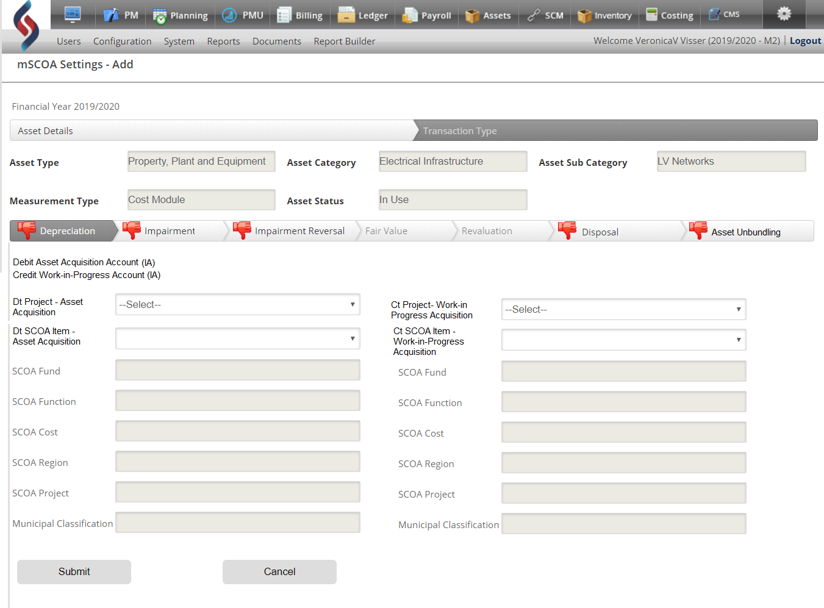

Screen Field Name | Dropdown / Input / Display | Mandatory | Notes
Transaction Type | Panel | Yes | If Transaction Type is selected; the system will open the Transaction Type lookup utility.
Asset Unbundling | Panel | Yes | The System display header configure Transaction Type: Asset Unbundling
Journal Entries | Display | Yes | The System displays the specific journal entries for the Asset Unbundling
Planning Project | Dropdown | Yes | The System must display only initiated Planning Projects.
SCOA Item | Dropdown | Yes | The System must display only SCOA Items linked to the selected Planning Project.
SCOA Segments | Display | Yes | The System will auto-populate the SCOA Segments based on the SCOA Item selected.
Submit | Button | Yes | - The System must Add the Transaction Type configuration to the Asset Configuration in the mSCOA Setting table.  - The System will display a message: Configuration Successfully Completed (refer to below pop-up message)
Cancel | Button | Yes | The System returns to the Asset Settings

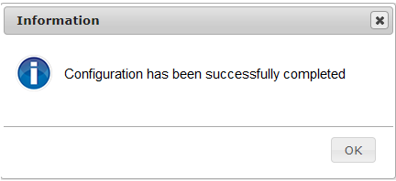

Proposed Screen Layout – Acquisition – Asset Unbundling

- Assets>>Acquisition >> Asset Unbundling Menu

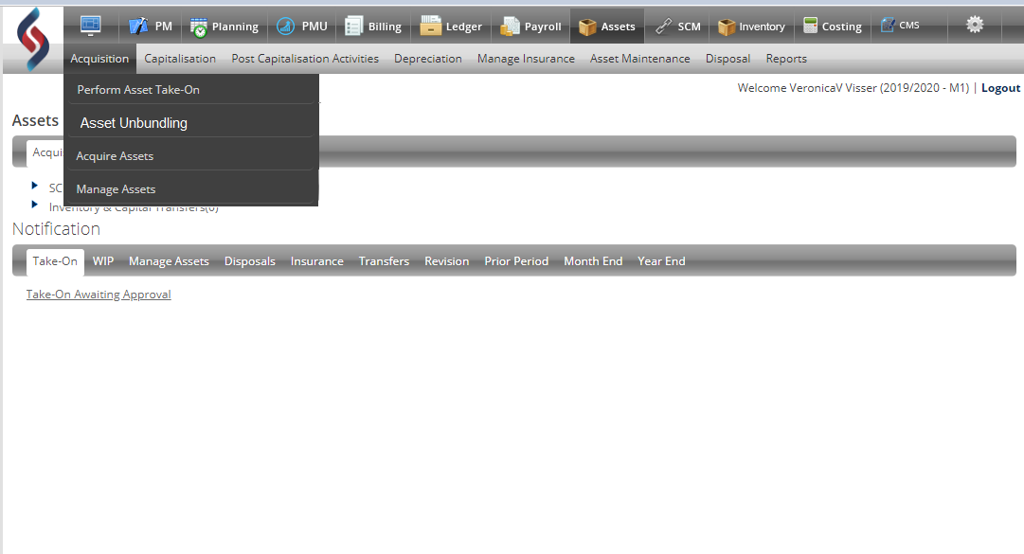

Screen Field Name | Dropdown / Input / Display | Mandatory | Notes
Acquisition Main menu option on Asset Dashboard | Display | No | Acquisition menu option
Asset Unbundling menu option | Display | No | Asset Unbundling menu option

- Assets>>Acquisition >> Asset Unbundling>> Capital Contract

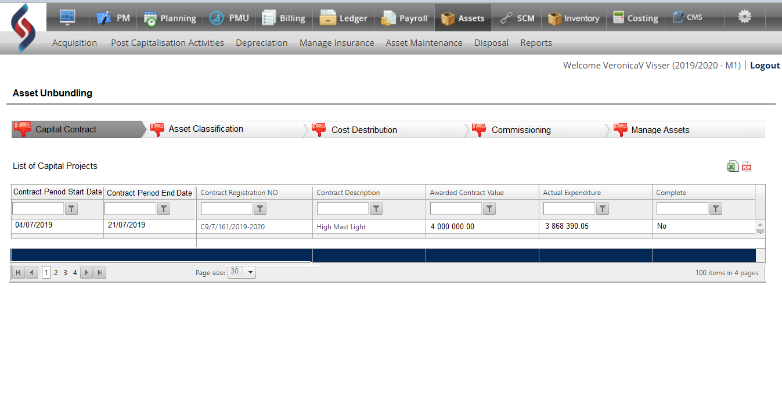

Screen Field Name | Dropdown / Input / Display | Mandatory | Notes
Configure Asset Unbundling header | Panel | No | Display header Configure Asset Unbundling
Capital Contract | Panel | No | Display Capital Contract banner  The system will automatically open the ‘Capital Contract’ interface page
Asset Classification | Panel | No | Display Asset Classification banner
Cost Distribution | Panel | No | Display Cost Distribution banner
Commissioning | Panel | No | Display Commissioning banner
Manage Assets | Panel | No | Display Manage Assets banner
List of Capital Contracts header | Panel | No | Display header List of Capital Contracts
Contract Period Start Date | Display | No | The System displays the Period Start Date for Capital Contract that was pushed from SCM ‘Contract Management’ to the Asset Unbundling table
Contract Period End Date | Display | No | The System displays the Period End Date for Capital Contract that was pushed from SCM ‘Contract Management’ to the Asset Unbundling table
Contract Registration No | Display | No | The System displays Contract Registration Number for Capital Contract that was pushed from SCM ‘Contract Management’ to the Asset Unbundling table
Actual Contract Value | Display | No | The System displays the Actual Contract Value for Capital Contract that was pushed from SCM ‘Contract Management’ to the Asset Unbundling table
Actual Expenditure | Display | No | The System displays the Actual Expenditure for Capital Contract that was pushed from SCM ‘Contract Management’ to the Asset Unbundling table
Project Complete indicator | Display | No | - Project complete indicator can only be Yes or No  - The Project Complete indicator cannot be edited and only be updated by the system.  - The System must update the status of the project to Yes only when the project is successfully unbundled.
Download format | Icon | No | The information in the Grid must be downloadable in Excel/ PDF

- Assets>>Acquisition >> Asset Unbundling>> Displaying invoices from SCM and Upload mandatory documents.

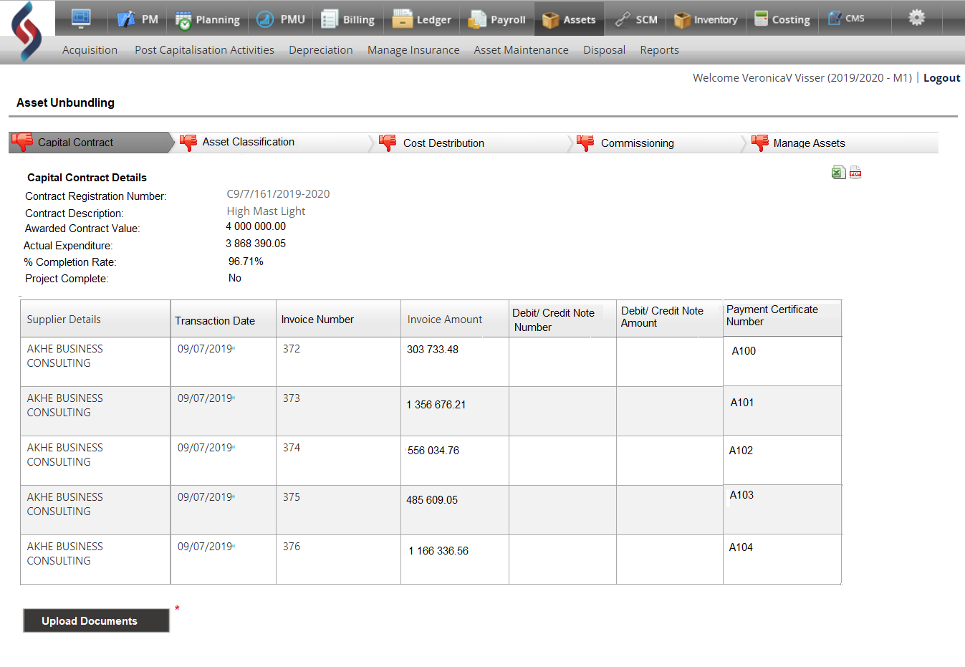

Screen Field Name | Dropdown / Input / Display | Mandatory | Notes
Configure Asset Unbundling header | Panel | No | Display header Configure Asset Unbundling
Capital Contract Details | Display | No | Display header Capital Contract Details
Actual Contract Value | Display | Yes | The System auto-populate the Actual Contract Value for the Capital Contracts generated from SCM
Contract Registration No | Display | No | The System displays Contract Registration Number for Capital Contract that was pushed from SCM ‘Contract Management’ to the Asset Unbundling table
Actual Contract Value | Display | No | The System displays the Actual Contract Value for Capital Contract that was pushed from SCM ‘Contract Management’ to the Asset Unbundling table
Actual Expenditure | Display | No | The System displays the Actual Expenditure for Capital Contract that was pushed from SCM ‘Contract Management’ to the Asset Unbundling table
% Completion Complete Rate | Display | No | The System must continuously calculate the % completion rate by dividing the Actual Expenditure through the Contract Value
Project Complete indicator | Display | No | - Project complete indicator can only be Yes or No  - The Project Complete indicator cannot be edited and only be updated by the system.  - The System must update the status of the project to Yes only when the project is successfully unbundled.
Supplier Details | Display | No | The System displays the Supplier Details for the Invoice charged against the Capital Contract that was pushed from SCM
Transaction Date | Display | No | The System displays the Transaction date of the Invoice or the Debit/ Credit note that was charged against the Capital Contract that was pushed from SCM
Invoice Number | Display | No | The System displays the Invoice Number for the Invoice charged against the Capital Contract that was pushed from SCM
Invoice Amount | Display | No | The System displays the Invoice Amount for the Invoice charged against the Capital Contract that was pushed from SCM
Debit/ Credit Note Number | Display | No | The System displays the Debit/ Credit Note Number for the Debit/ Credit Note linked to the Invoice charged against the Capital Contract that was pushed from SCM
Debit/ Credit Note Amount | Display | No | The System displays the Debit/ Credit Note Amount for the Debit/ Credit Note linked to the Invoice charged against the Capital Contract that was pushed from SCM
Payment Certificate Number | Display | No | The System displays the Payment Certificate Number for Capital Contract that was pushed from SCM ‘Contract
Upload Documents | Button | No | The system must open the Upload Utility. Refer to the Upload utility page.

- Assets>>Acquisition >> Asset Unbundling>> Upload utility

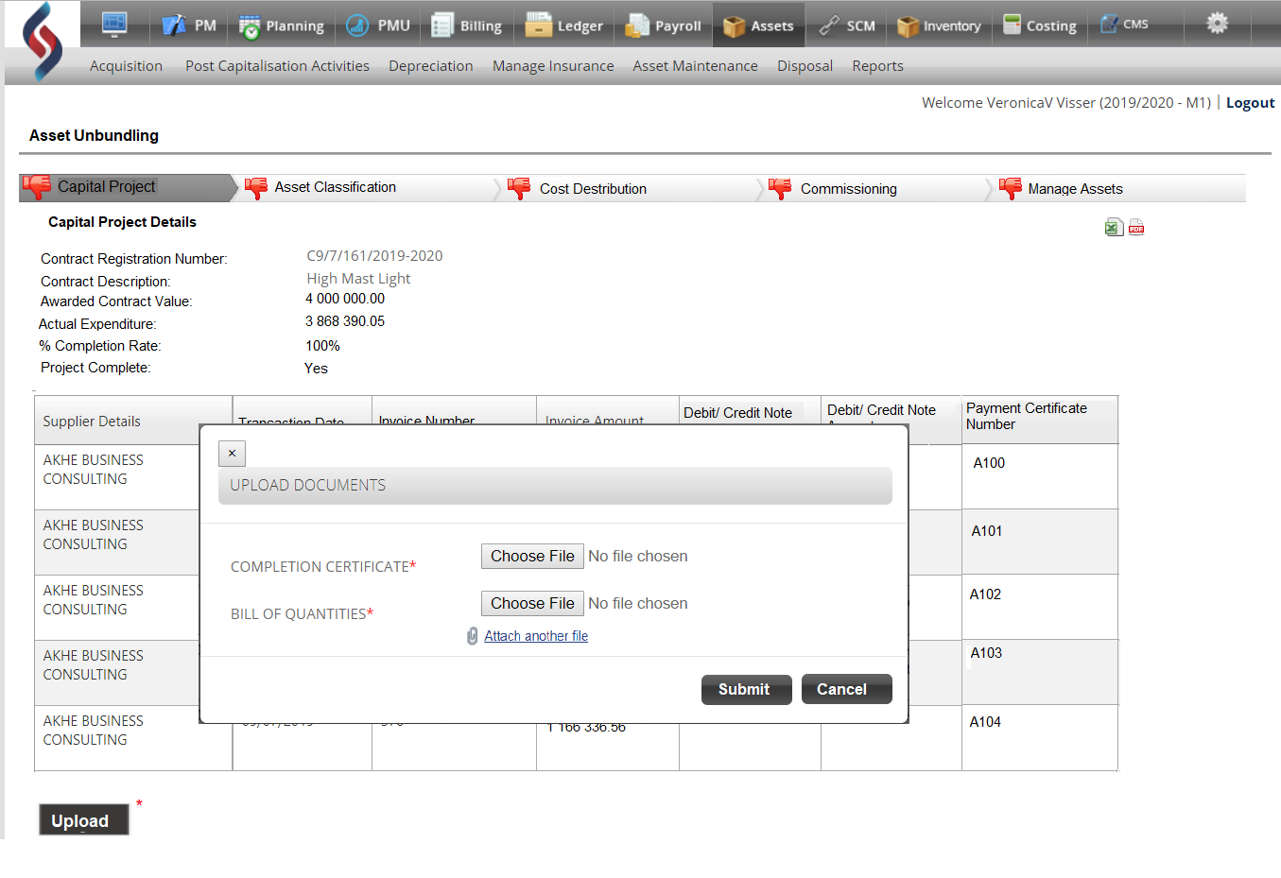

Screen Field Name | Dropdown / Input / Display | Mandatory | Notes
Configure Upload Documents | Display | No | Display header configure Upload Documents
Completion Certificate | Display | Yes | Display Completion Certificate  This is Mandatory
Choose File | Button | Yes | The System open the file selection interface;
Select file to upload | Panel | Yes | Select the File to be uploaded  File Format can only be PDF; the System validates the file to ensure that it is in the correct format;
Bill of Quantities | Display | Yes | Display Bill of Quantities  This is Mandatory
Choose File | Button | Yes | The System open the file selection interface;
Select file to upload | Panel | Yes | Select the File to be uploaded  (File Format can only be PDF; the System validates the file to ensure that it is in the correct format;
Attach another File | Button | No | The System open the file selection interface;
Select file to upload | Panel | No | Select the File to be uploaded
Submit | Button | No | - The System validates if the mandatory documents have been uploaded.  - Error message will display if all mandatory documents have not been uploaded “Upload mandatory documents”  - Error message will display if the Upload files are not in the correct file format.
Cancel | Button | No | The System will cancel the upload and return to Upload Utility.
Download format | Icon | No | The information in the Grid must be downloadable in Excel/ PDF

- Asset Unbundling>>Asset Classification

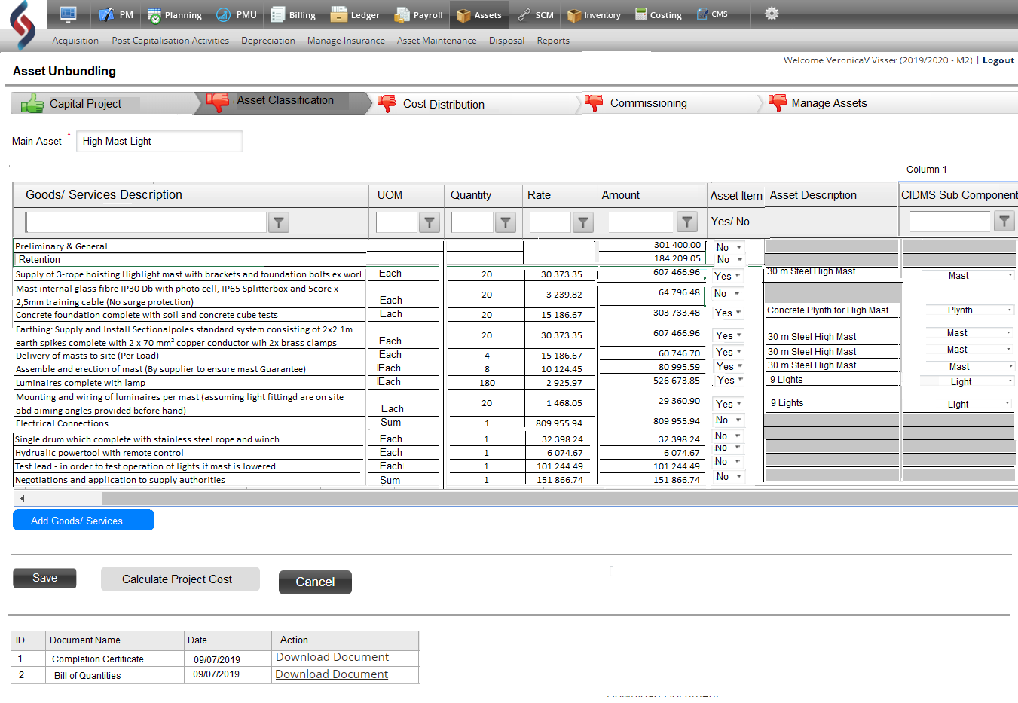

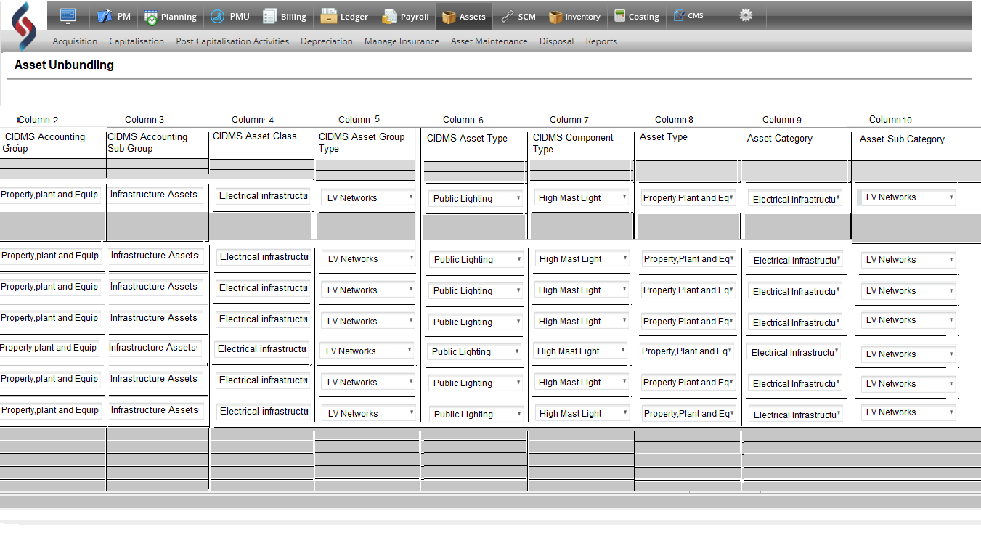

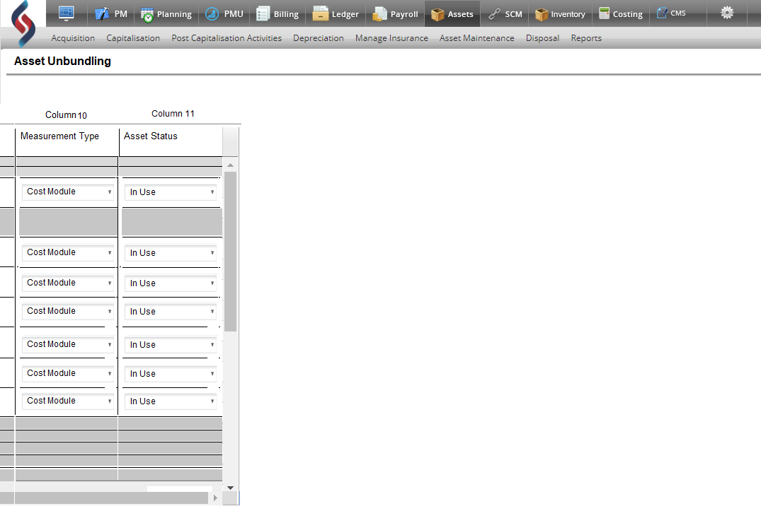

Screen Field Name | Dropdown / Input / Display | Mandatory | Notes
Main Asset | Input | Yes | Capture Main Asset
Goods/ Services Description | Display | Yes | The System displays the Goods/Services Description fields that is pushed from SCM to the Unbundling of Asset Table (Back end)  These information from SCM is not editable.
UOM | Display | Yes | The System displays the UOM fields that is pushed from SCM to the Unbundling of Asset Table (Back end)  The UOM can be edited  Validate as per Business Rules
Quantity | Display | Yes | The System displays the Quantity fields that is pushed from SCM to the Unbundling of Asset Table (Back end)  The UOM can be edited  Validate as per Business Rules
Rate | Input | Yes | The Rate is captured in every line and must only be a decimal value.  The Rate is mandatory  Validate as per Business Rules
Amount | Display | Yes | The “Amount” field is automatically calculated by the System as soon as the Rate is captured. (Formula: Quantity x Rate)  The amount is not editable
Asset Item | Dropdown | Yes | The System display a dropdown box with only 2 options:  - Yes  - No  This field is mandatory
Asset Description | Input | Yes | Capture the Asset Description
CIDMS Sub Component Type | Dropdown | Yes | - The System display all configured ‘CIDMS Sub Component Types’  - The user selects CIDMS Sub Component Type from the dropdown box
CIDMS Accounting Group | Display | No | Auto populate the CIDMS Accounting Group  based on the linked Sub Component Type
CIDMS Accounting Sub Group | Display | No | Auto populate the CIDMS Accounting Sub-Group  based on the linked CIDMS Sub Component Type
CIDMS Asset Class | Display | No | Auto populate the CIDMS Asset Class based on the linked CIDMS Sub Component Type
CIDMS Asset Group Type | Display | No | Auto populate the CIDMS Asset Group Type based on the linked CIDMS Sub Component Type
CIDMS Asset Type | Display | No | Auto populate the CIDMS Asset Type  based on the linked CIDMS Sub Component Type
CIDMS Component Type | Display | No | Auto populate the CIDMS Component Type based on the linked CIDMS Sub Component Type
Asset Type | Dropdown | Yes | The System display all configured Asset Types
Asset Category | Dropdown | No | The System display Asset Categories based on the Asset Type selected;  Asset Categories will be a mandatory field for those Asset types with an associated Asset Category
Asset Sub Category | Dropdown | No | The System display Asset Sub Categories based on the Asset Type selected  Asset Sub Categories will be a mandatory field for those Asset types with an associated Asset Sub Category;
Measurement Type | Dropdown | No | Measurement Type limited to those Measurement Types configured in settings  Asset Measurement will be a mandatory field for those Asset types with an associated Asset Measurement Type;
Asset Status | Dropdown | No | Asset Status limited to those Asset Statuses configured in settings  Asset Status will be a mandatory field for those Asset types with an associated Asset Status
Add Goods/ Services Description | Button | No | The System adds additional line to the grid  The user can capture additional Goods/Services description(s)
Save | Button | No | The System will Saves all input on page.
Calculate Project Cost | Button | Yes | - The System will Calculate the Project Cost  - System assigns Main Asset ID to all assets in associated CIDMS Sub Component  - Validation rules as per Business rules
Cancel | Button | No | The input will be cancelled, if not saved and the page will close and return to Acquisition (Asset Dashboard)

- Asset Unbundling>>Cost Distribution

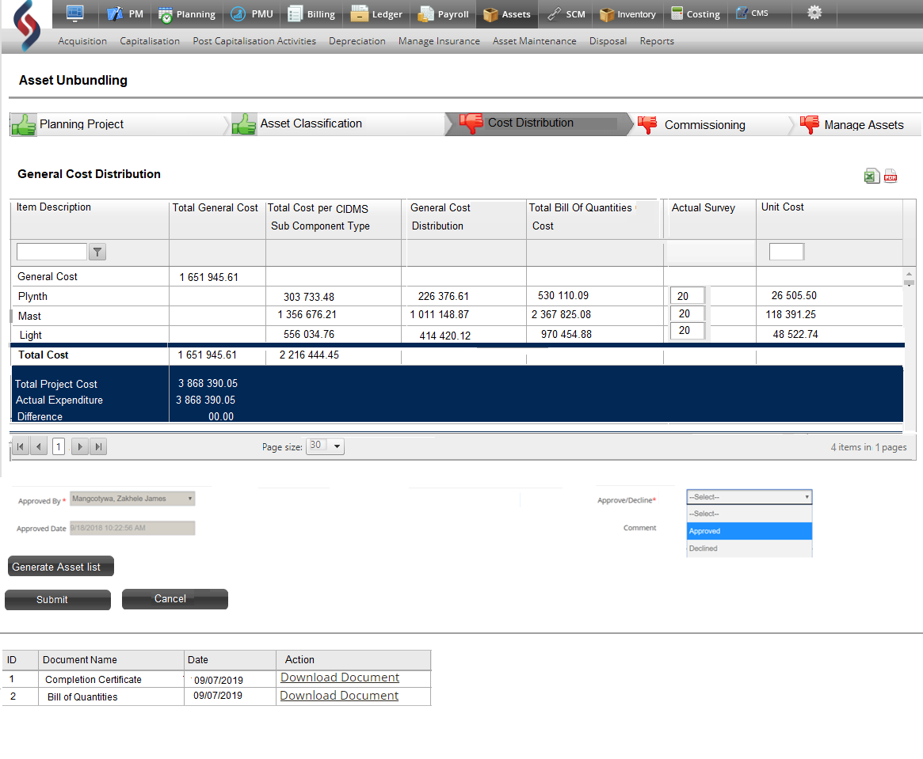

Screen Field Name | Dropdown / Input / Display | Mandatory | Notes
General Cost Distribution heading | Panel | No | General Cost Distribution heading on top of the table
Item Description | Display | No | The System Display a summary of the items from the Asset Classification interface page:  - General Cost  - CIDMS Sub Component Types for example:  - Plynth  - Mast  - Light
Total General Cost | Display | No | - Total General Cost  - Formula:(Preliminary Cost + General Cost + Retention)  The System displays the Total General Cost calculated from the Asset Classification page and is based on the sum total of all the Non-Asset Item costs)
Total Cost per CIDMS Sub Component Type | Display | No | - Total Cost per CIDMS Sub Component Type  - Formula: Sum of all the Asset Item costs  (Cost per CIDMS Sub Component Type from the Asset Classification page and is based on the Sum of all the Asset Item costs)
General Cost Distribution | Display | No | - General Cost Distribution per CIDMS Sub Component Type  - Formula: Cost per Individual CIDMS Sub Component Type / (Total Cost per CIDMS Sub Component Type) x Total General Cost
Total Bill of Quantities Cost | Display | No | - Total Bill of Quantities  - Formula: Total Cost per CIDMS Sub Component Type + General Cost Distribution per CIDMS Sub Component Type
Actual Survey | Input | Yes | The Actual Survey is Captured on the line of the CIDMS Sub Component Type in the Cost Distribution table
Unit Cost | Display | No | The System automatically calculates the Unit Cost per CIDMS Sub Component Type per individual Asset within the CIDMS Sub Component Type as per Asset list.  - Unit Cost  - Formula: Cost per CIDMS Sub Component Type + General Cost Distribution per CIDMS Sub Component Type) / Actual Survey = Unit Cost per individual Asset within the CIDMS Sub Component Type
Total Project Cost | Display | No | Total Project Cost  - Formula: Total General Cost + Total Cost per CIDMS Sub Component Type
Actual Expenditure | Display | No | The System must auto-populate the Actual Expenditure total from the Capital Contract interface page
Difference | Display | No | - The System must automatically calculate the difference:  - Formula: Total Project Cost - Actual Expenditure  - The System Validate if the Total Project Cost and Actual Expenditure reconciled  - If there is a difference, the system must display Pop up message “Total Project Cost and the Actual Expenditure does not reconcile” provide a reason for the difference.
Approved | Input | Yes | - The System displays a tick box  - The approver must tick the box to approve  - The System captures approval date and time
Comment/ Reason | Input | Yes | The System displays a text box for capturing a reason for the difference
Approved By | Dropdown | Yes | The System displays a dropdown box of authorised approvers
Decline | Dropdown | Yes | The transaction will be cancelled, and the page will close and return to Acquisitions (Asset Dashboard)
Download documents | Display | No | The System displays the uploaded documents in a grid at the bottom of the screen in the Asset Classification interface page.
Generate Asset List | Button | No | The System Generates an Asset list based on the information in the Cost Distribution Table
Cancel | Button | No | The page will close and return to Asset Classification Interface page
Submit |  |  | The Unbundling Asset Table will be updated with the Asset List
Download format | Icon | No | The information in the Grid must be downloadable in Excel/ PDF

- Pop-up message ‘Project Cost and Actual expenditure does not reconcile
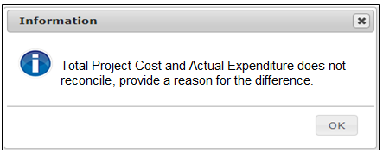

Screen Field Name | Dropdown / Input / Display | Mandatory | Notes
Pop up message: Total Project Cost and Actual Expenditure does not reconcile, provide a reason for the difference | Display | No | Total Project Cost and Actual Expenditure does not reconcile, provide a reason for the difference
Ok | Button | No | Close Pop-up message and return to the current page to capture a reason

- Approval of Cost Distribution Calculation

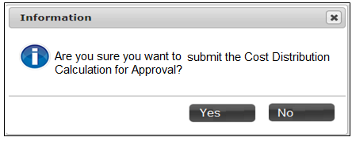

Screen Field Name | Dropdown / Input / Display | Mandatory | Notes
Pop up message: Are you sure you want to submit the Cost Distribution Calculation for Approval? | Display | No | Are you sure you want to submit the Cost Distribution Calculation for Approval?
Yes | Button | No | Approve the Cost Distribution Calculation and display a Pop-up message “The Cost Distribution is Approved” refer to Pop-up message below.
No | Button | No | The Cost distribution page will close and return to Acquisition (Asset Dashboard)

- Successful Approval Message for the Cost Distribution Calculation
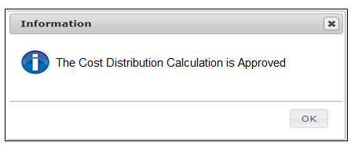

Screen Field Name | Dropdown / Input / Display | Mandatory | Notes
Pop up message: Cost Distribution Calculation is Approved | Panel | No | Cost Distribution Calculation is Approved
Ok | Button | No | Close page and return to Asset Dashboard

- Cost Distribution Calculation is Declined
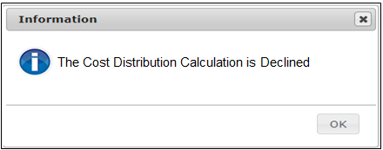
Screen Field Name | Dropdown / Input / Display | Mandatory | Notes
Pop up message: Cost Distribution Calculation is Declined | Panel | No | Cost Distribution Calculation is Declined
Ok | Button | No | Close page and return to Asset Dashboard

- Pop-up message: Asset List Successfully Generated
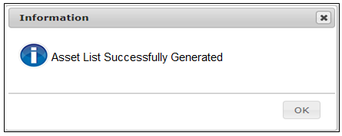
Example of an Asset List:
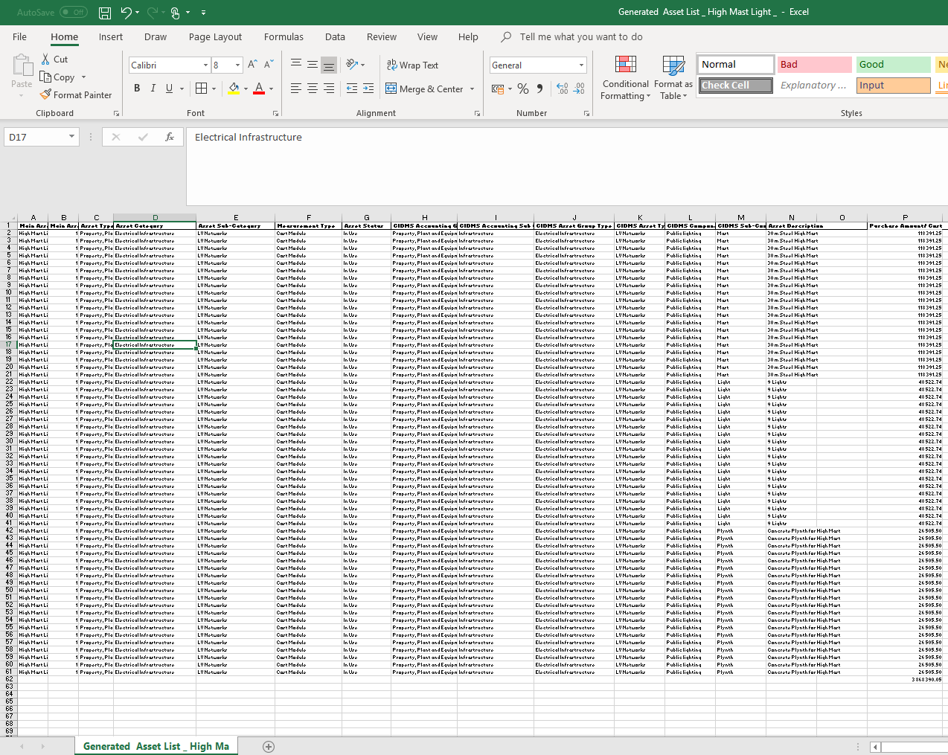

Screen Field Name | Dropdown / Input / Display | Mandatory | Notes
Pop up message: Asset List Successfully Generated | Panel | No | Asset List Successfully Generated
Ok | Button | No | Close page and open Commissioning Interface page

- Asset Unbundling>>Commissioning
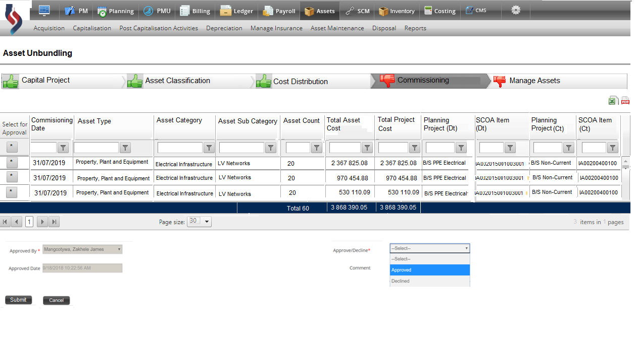

Screen Field Name | Dropdown / Input / Display | Mandatory | Notes
Select for Approval | Input | No | The System displays a tick box on each line of the grid to approve the commissioning of the CIDMS Sub Component Type
Commissioning Date | Display | No | The System displays Cost Distribution table approval Date generate by the System
Asset Type | Display | No | The System displays the Asset Type from the Asset List generated from the Cost Distribution interface page
Asset Category | Display | No | The System displays the Asset Category from the Asset List generated from the Cost Distribution interface page
Asset Sub Category | Display | No | The System displays the Asset Sub Category from the Asset List generated from the Cost Distribution interface page
Asset Count | Display | No | - The System automatically calculates the number of assets within the CIDMS Sub Component Type from the Asset List generated from the Cost Distribution interface page.  - The System displays the number of individual assets in the CIDMS Sub Component Type
Total Asset Cost | Display | No | The Total Asset Cost display from the Cost Distribution interface page
Total Project Cost | Display | No | The Total Project Cost display from the Cost Distribution interface page
Planning Project (Dt) | Display | No | The System must display the Planning Project (Dt) from settings as configured for Unbundling of Assets
SCOA Item (Dt) | Display | No | The System must display the SCOA Item (Dt) from settings as configured for Unbundling of Assets
Planning Project (Ct) | Display | No | The System must display the Planning Project (Ct) from settings as configured for Unbundling of Assets
SCOA Item (Ct) | Display | No | The System must display the SCOA Item (Ct) from settings as configured for Unbundling of Assets
Approved By | Display | Yes | The System will Display the Log in name of the Person
Approved Date | Display | No | The System will capture the Date and time
Approve | Dropdown | Yes | The User must select Submit (refer below)
Decline | Dropdown | No | The transaction will be cancelled, and the page will close and return to Acquisitions (Asset Dashboard)
Submit | Button |  | The System will update the Asset Register with the new additions and post the entries to the General Ledger.  The System display a Pop-up message: ‘Asset Register successfully updated and posting successfully to the General Ledger
Cancel | Button | No | The page will close and return to the Cost Distribution interface page
Download format | Icon | No | The information in the Grid must be downloadable in Excel/ PDF

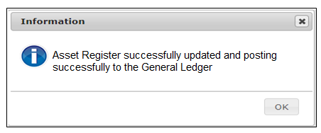
Screen Field Name | Dropdown / Input / Display | Mandatory | Notes
Pop up message: Asset Register successfully update and posting to the General Ledger | Panel | No | Asset Register successfully update and posting to the General Ledger
Ok | Button | No | Close page and return to Asset Dashboard.

- Asset Unbundling> Manage Assets

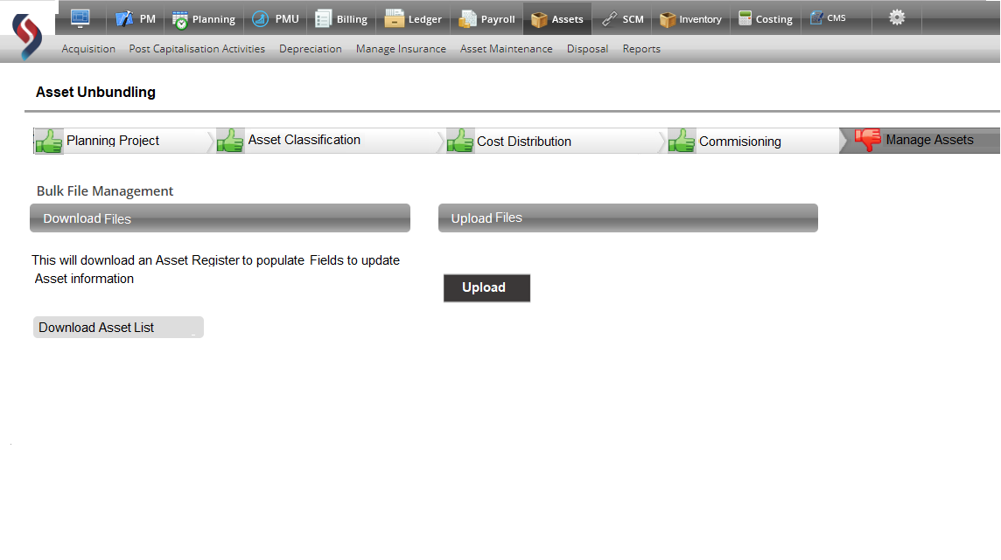

Screen Field Name | Dropdown / Input / Display | Mandatory | Notes
Manage Assets | Panel | No | Display panel Manage Assets
Asset Register ID From | Input | No | The System displays Asset Register ID’s and the user must select the Asset Register ID from where the download will start
Asset Register ID To | Input | No | The System displays Asset Register ID’s and the user must select the Asset Register ID from where the download must stop
Download Asset Register | Button | No | - System compiles and export the associated Asset Information to a CSV file  - User corrects incomplete/omitted information in the CSV file and save the file.
Upload Asset Register | Upload indicator | No | - System Opens the Upload interface  - User Selects the File to upload  - System opens the selected CSV file and processes each record  - System runs validations for each entry in the Asset Register CSV File, as per “Business Rules”.  - If validation errors encountered, these are written to the Bulk Upload Log and processing of error-record is aborted.  - If validation passes, the error-free entry is written to the Asset Database and indicated as ‘successful’ in the Bulk Upload Log.

- Asset Register Upload Log Example
Record No | Result | Error Description
1 | Successful
2 | Successful
3 | Error | Asset Ownership field invalid entry
4 | Successful
5 | Error | Basic Municipal Service does not exist
6 | Successful
7 | Error | Division does not exist
8 | Error | Invalid Financial Status
9 | Successful
10 | Successful | Department does not exist
11 | Error | Current Replacement Cost (CRC) is not a numerical value
12 | Error | Depreciated Replacement Value (DRC) must have a value
13 | Successful
14 | Successful
15 | Successful
16 | Successful
17 | Successful
18 | Successful
19 | Successful
20 | Successful

- Update Asset Register
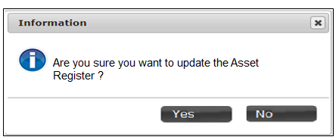
Screen Field Name | Dropdown / Input / Display | Mandatory | Notes
Pop up message: Are you sure you want to update the Asset Register? | Display | No | Are you sure you want to update the Asset Register?
Yes | Button | No | Update the Asset Register with the changes made to the Assets. Display a Pop-up message “The Asset Register is successfully updated.
No | Button | No | The Manage Asset Interface will close and return to Acquisition (Asset Dashboard)

- Successful message: Asset Register Successfully updated.
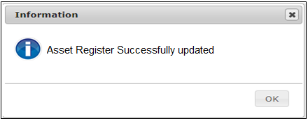

Screen Field Name | Dropdown / Input / Display | Mandatory | Notes
Pop-up Message: Asset Register Successfully updated | Display | No | Asset Register Successfully updated
Ok | Button | No | Close page and return to Asset Dashboard.

Example of upload file will be provided

Performance

- The system must allow the user to select the data and execute the transaction as per the permission associated to the user’s system profile.
- System must be User friend, allowing the User to easily navigate.

Design Constraints

None.

Testing Requirements

Number | Test Condition | Expected Results
1 | View Configuration | Confirming Configuration is complete
2 | Processing the Unbundling of Assets | Perform the Unbundling Transaction.
3 | Trace the new additions to the Asset Register | Traced and confirmed that Asset Register has been updated successfully.
4 | Trace the transactions to the Detail General Ledger | Traced and confirmed that the transactions posted accurately, correctly to the Detailed General ledger.

