# C:\Users\sec.registraracad\AppData\Local\Microsoft\Windows\Temporary Internet Files\Content.Outlook\H8M811DG\logo.jpg

# Faculty of Engineering Technology

# Mid-Term Examination Question Paper – B.Tech

**Department : Computer Science and Engineering**

**Programme : B.Tech in Computer Science and Engineering**

**Semester / Batch : 5th / 2019**

**Date of Test : 12th November 2021**

**Course Code : 19CSC303A**

**Course Title : Computer Networks**

**Mid-Term Exam**

**INSTRUCTIONS TO STUDENTS:**

1. **The first two questions (Questions 1 and Questions 2) are compulsory**
2. **Answer any two full questions from Question 3, Question 4 and Question 5**
3. Use of non-programmable scientific calculator is permitted
4. Use of data handbook permitted wherever applicable
5. Missing data may be appropriately assumed
6. Notations used have usual meaning

**Maximum Duration: 2 hours Maximum Marks: 50**

|  |  |  |  |
| --- | --- | --- | --- |
| **Q. No.** | **Question** | **Marks** | **CO\*** |
| **1.** | 1. In case of congestion, _________ packets are used to reduce the transmission rate.    1. Jamming    2. Choke    3. Jitter    4. Error 2. _____ is NOT carried out by the Network Layer.    1. Internetworking    2. Host to host delivery of packets    3. Routing    4. Access control 3. Protocol characterized by least number of collisions is ______.    1. CSMA-CA    2. CSMA    3. Pure ALOHA    4. Slotted ALOHA 4. The number of transceivers used in Fiber to Kerb method for N users is ____.    1. 2N    2. 2N+2    3. 2    4. 2N+1 5. Bridge is present in ______ layer of the OSI Model.    1. Physical    2. Data Link    3. Network    4. Transport | **05** | **1,2** |
| **2** | Discuss the classification of network based on scale and transmission technology. | **05** | **2** |
| **3** | 1. Differentiate between OSI and TCP/IP Network Software Architecture models. | **06** | **4** |
| 1. Discuss any two guided media transmissions in computer networks. | **06** | **2** |
| 1. Compute the Cyclic Redundancy Check (CRC) for the data set {10010} and the Generator Polynomial x^3+x+1. Check for any error if the received data is {10010011}. | **08** | **2** |
| **4** | 1. Enumerate any two framing techniques in Data Link Layer. | **06** | **1** |
| 1. Discuss the Passive Optical Network (PON) solution with a neat diagram. | **06** | **2** |
| 1. Compare the operation of Leaky Bucket and Token Bucket traffic shaping algorithm. | **08** | **2** |
| **5** | 1. Discuss any two Collision Free protocols in Medium Access Control (MAC) Layer. | **06** | **4** |
| 1. Consider an application that prioritizes real-time transfer of data over reliability. 2. Identify the ideal network layer service for such an application. 3. Enumerate the characteristics of the identified service. | **06** | **3** |
| 1. Enumerate the importance of inter-frame spaces in CSMA-CA and explain the types of inter-frame spacing in IEEE 802.11. | **08** | **2** |

**\*CO –** Course Outcome

|  |  |
| --- | --- |
| Course Outcomes | |
| 1 | Describe the protocols that operate in the TCP/IP stack and wireless networks |
| 2 | Explain the principles of computer networks, their protocols and security considerations |
| 3 | Choose appropriate network protocols for given applications |
| 4 | Analyse and compare different wired and wireless network protocols |
| 5 | Design and synthesize client‐server based computer networks using the sockets API |
| 6 | Evaluate the performance of wired and wireless networks using appropriate tools and simulators |

**Scheme and Solution**

|  |  |  |  |  |
| --- | --- | --- | --- | --- |
| **Question**  **No.** | Tasks –Steps involved | **Marks Allotted** | **Expected solution** | **Total Allotted Marks for the question** |
| 1. | i) b – Choke  ii) d – Access Control  iii) a – CSMA-CA  iv) c – 2  v) b – Data Link | 5 (1 Mark Each) |  | 10 |
| 2. | Classification of Networks  Based on Scale  Based on Transmission Technology | 6 Marks (4+2) | Appendix - 1 | 20 |
| 3. | a. Differences between OSI and TCP/IP  b. Guided Media Transmission  Explanation of Working Principle and diagram  c. CRC Error Detection  Generation of CRC Code and Checking for errors at the receiver side | 6 Marks  6 Marks  (3 + 3 )  8 Marks  (4 + 4 ) | Appendix-2 | 20 |
| 4. | a. Framing Techniques – Working Principle and diagram  b. PON – Working Principle with diagram  c. Leaky Bucket and Token Bucket Algorithm | 6 Marks  (3 + 3)  6 Marks  (4 + 2)  8 Marks | Appendix - 3  Appendix – 4  Comparison along with diagrams | 20 |
| 5. | a. Collision Free Protocols  b. Connection-less Service  Characteristics of Datagram  c. Importance of Inter-frame Spacing  Types of Inter-frame Spacing | 6 Marks  (3 + 3)  6 Marks  (1 + 5 )  8 Marks  ( 2 + 6 ) | Appendix – 5  Appendix - 6 | 20 |

**Detailed Solution**

**Appendix – 1**

Based on Scale

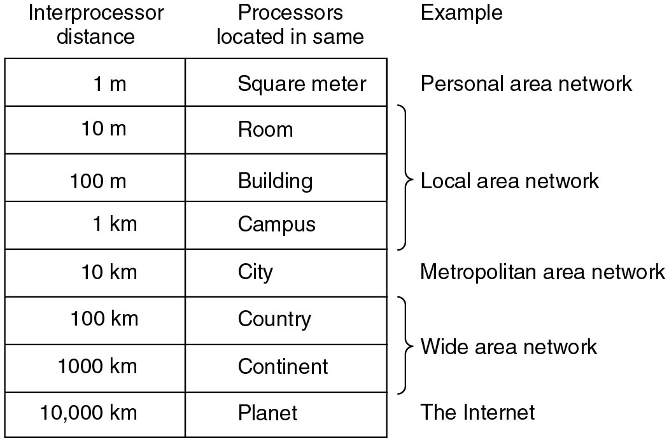

Based on Transmission Technology – Broadcast and Point to Point Links

**Appendix – 2**

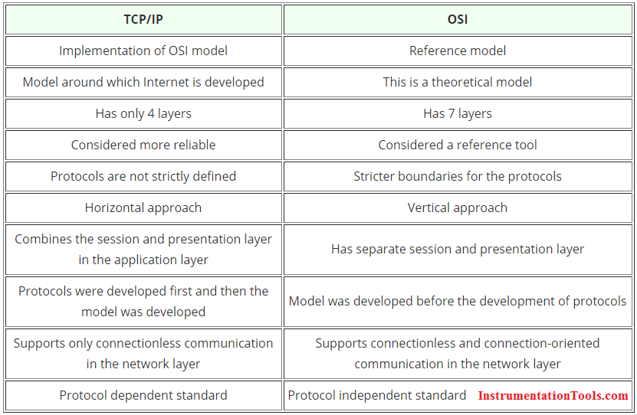

**Appendix – 3**

Framing Technique

Character Count

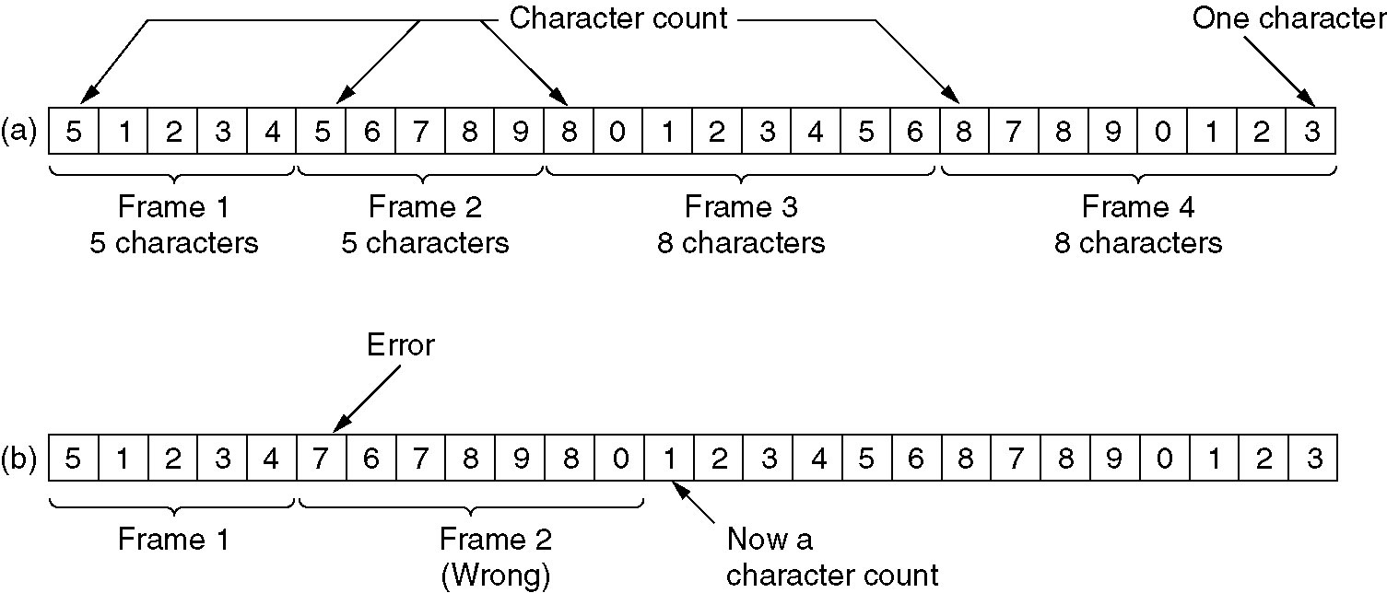

Byte Stuffing

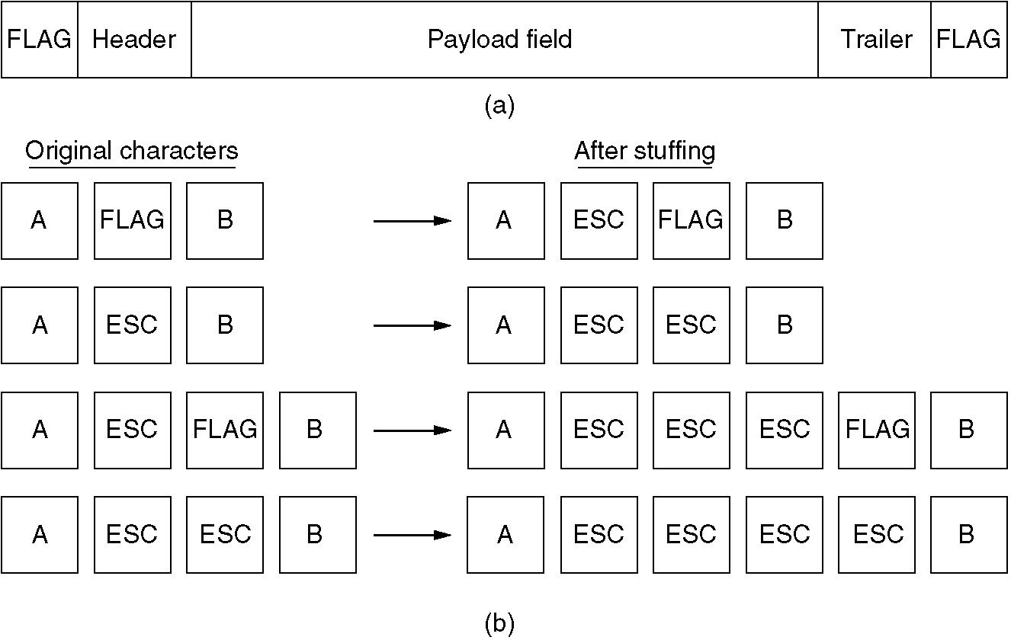

**Appendix – 4**

Passive Optical Networks

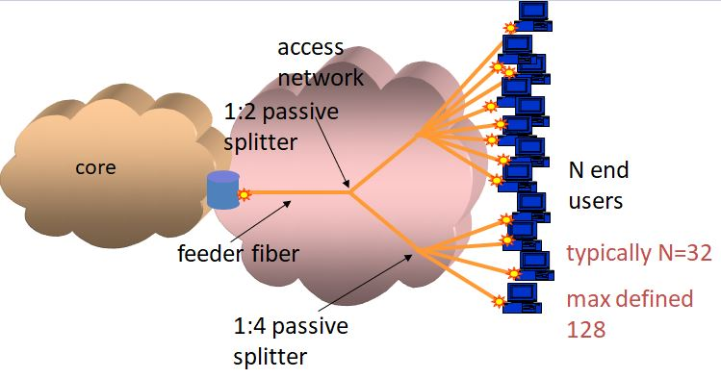

**Appendix – 5**

Basic Bit-Map Protocol

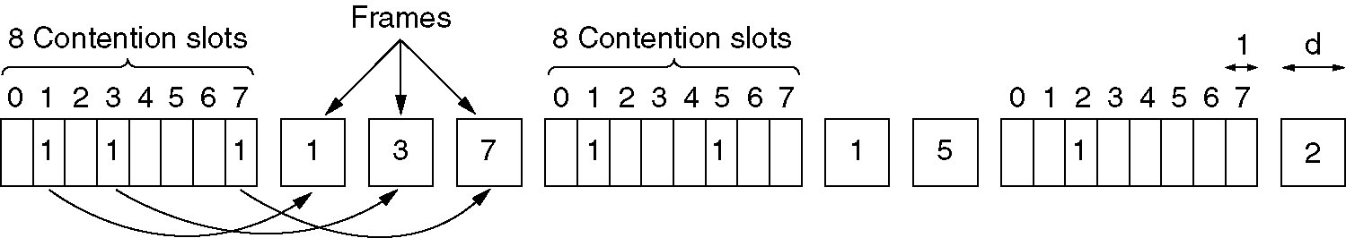

Binary Countdown Protocol

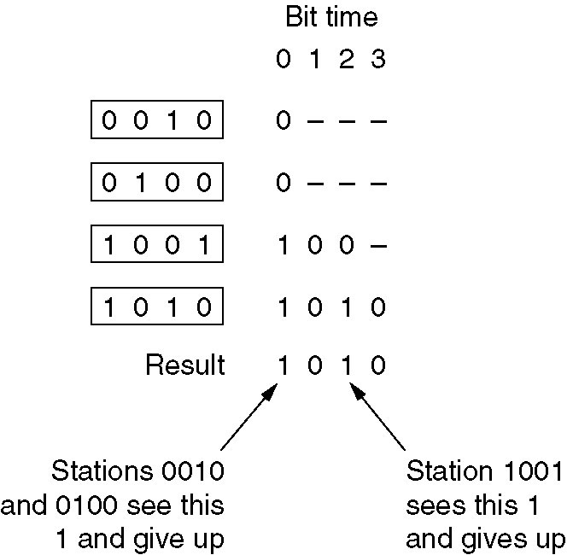

**Appendix – 6**

