**🔵 HALF-WAVE RECTIFIER (Second Image)**

**📌 Components:**

* 1 diode
* 1 resistor
* Function generator (AC supply)
* 2 oscilloscopes

**⚙️ How it works:**

1. **AC signal** comes from the function generator.
2. The **diode** allows only **positive half** of the AC wave to pass.
3. The **resistor** gets only the positive half.
4. **Oscilloscope 1** shows full AC signal (input).  
   **Oscilloscope 2** shows only **positive half** (output).

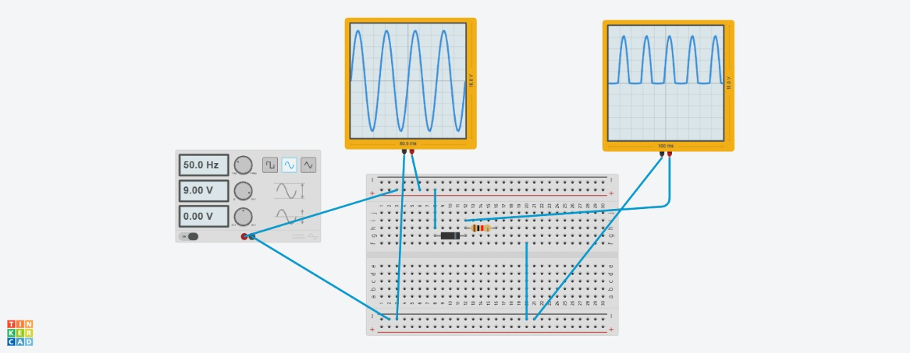

**✅ Result:**

You see **half waves** (positive part only) on the output side.

**🔴 FULL-WAVE RECTIFIER (First Image)**

**📌 Components:**

* 4 diodes (in bridge shape)
* 1 resistor
* Function generator
* 2 oscilloscopes

**⚙️ How it works:**

1. The 4 diodes are connected in a **bridge pattern**.
2. In each half of the AC cycle, **2 diodes conduct** and send **current in the same direction** through the resistor.
3. This makes both **positive and negative halves** of AC turn into **positive pulses**.
4. **Oscilloscope 1** shows input (AC).  
   **Oscilloscope 2** shows **both halves flipped positive** (output).

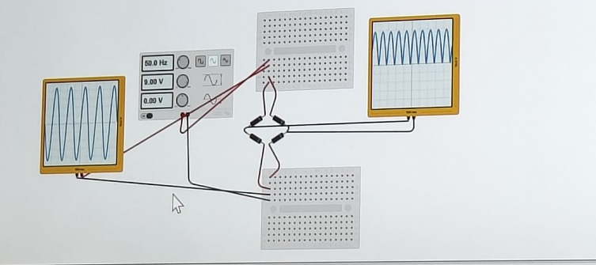

**✅ Result:**

You get **full waves** (all positive) at the output – smoother than half-wave.