# Description:-

First, we have chosen the payment problem because we noticed that the website doesn’t have a FAQ (problem and solutions page) that the user might have in payment page so we decided to make a FAQ page that contain problems that user might have and the solutions.

1. When the user opens the website, the first thing that will appear is Home page; the home page contains the game name, and link to log in page.

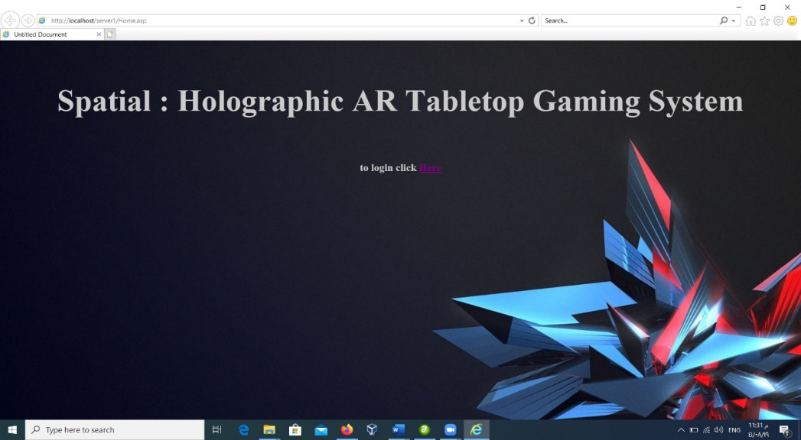

1. When the user presses on the Log in link she/he will be transferred to Log in page this is where the user inputs her/his information to enter the restricted area where only the users enter when they have a Username and Password. After typing the username and password the user must click on the Log in button to check if it is correct or not based on the database(picture down).

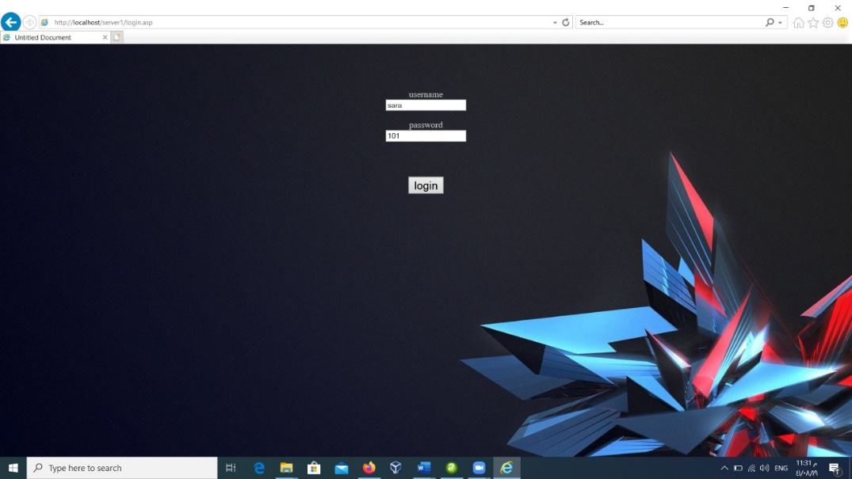

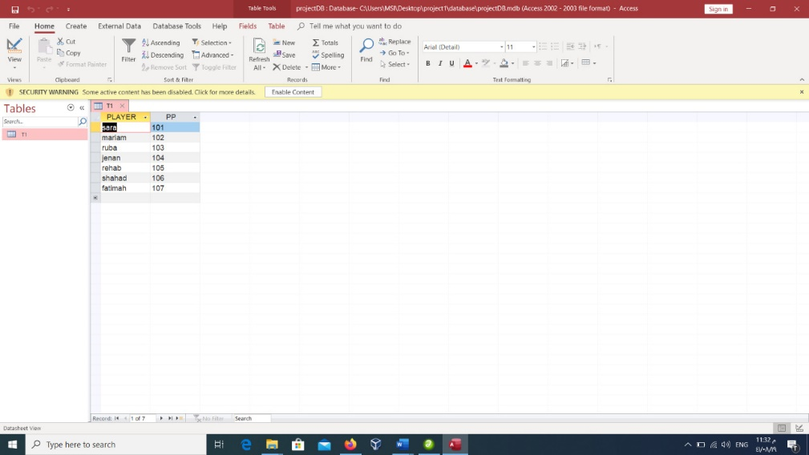

1. If the entered username and password are correct, the user will be transferred to the first page automatically, first page contains FAQ information and instruction about payments for the game. At the end of the page there is a link to another page where the user can pay in which is Second page, and another link if the user had any payment problem.

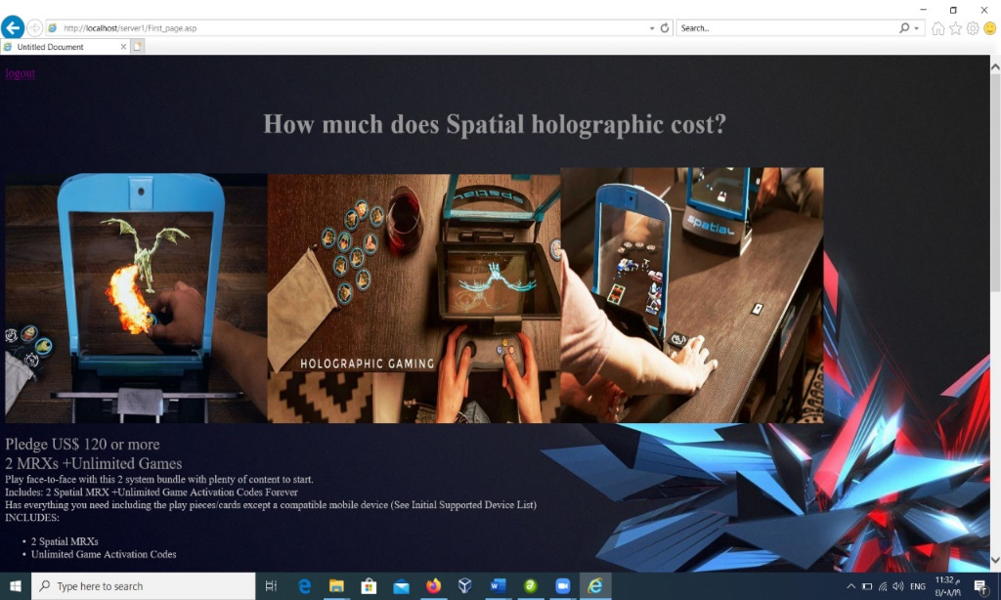

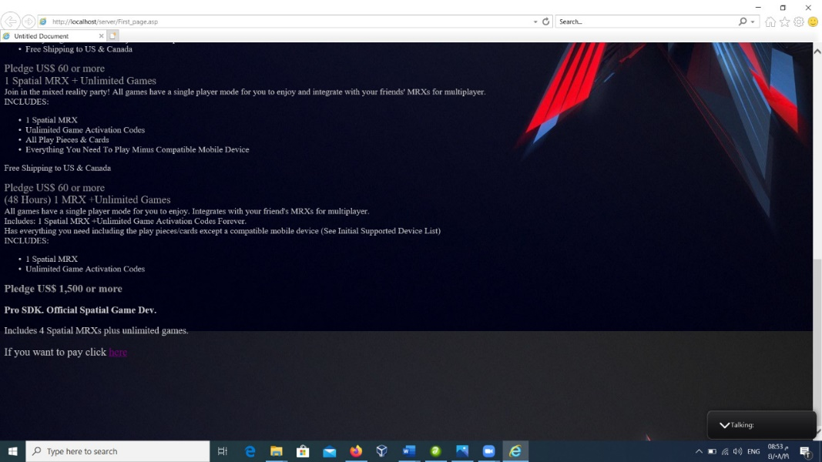

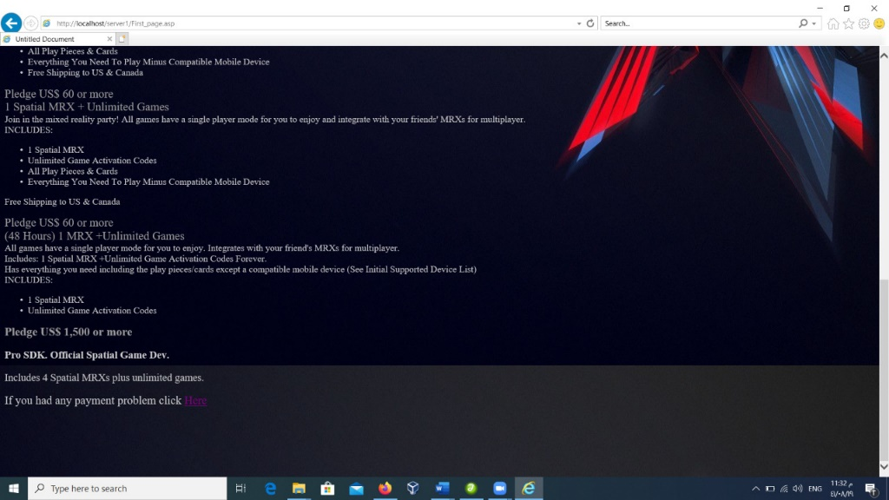

1. When the user enters the pay link, she/he will be transferred to the second page. The second page contains payment information and at the end of the page there is another page that transfers to log out page. (Picture down at point 5).
2. If logging in failed, the user will be transferred to Failed page which contain 2 links one transfer to Home page and the other to Log in page to try again.

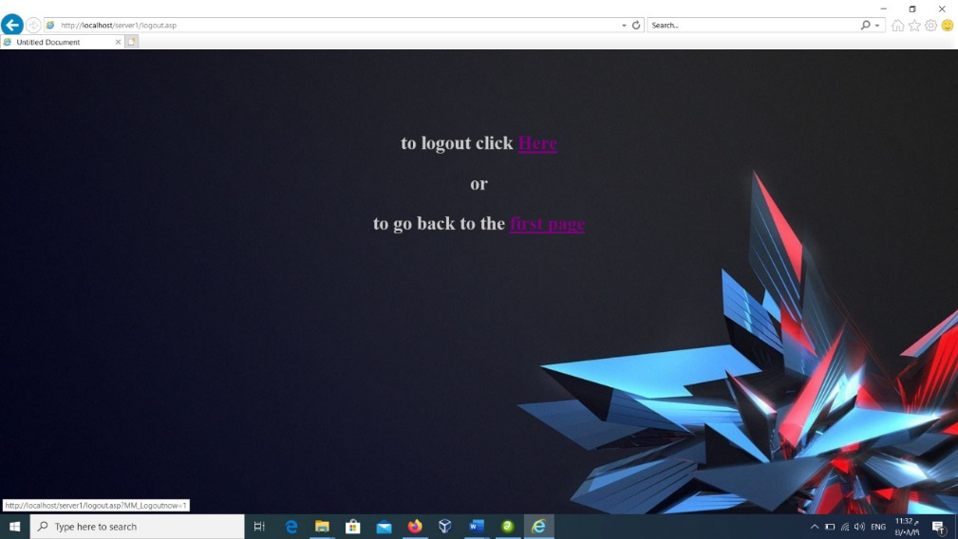

Ruba Al-Hilal