**Al Imam Mohammad Ibn Saud Islamic University**

**College of Computer and Information Sciences**

**Information Technology Department**

|  |  |
| --- | --- |
| **Course Title:** | Wireless & Mobile Computing |
| **Course Code:** | IT342 |
| **Assessment:** | Project |
| **Semester:** | Third |
| **Due Date:** | 4 Jun 2023 |
| **Duration:** | 9 weeks |
| **Marks:** | 20 |

|  |  |  |  |
| --- | --- | --- | --- |
| **Group ID** | **Student Name** | **Student ID** | **Section No** |
| 6 | Ruba Al Helal | 440022662 | 371 |
| Jood Alzeydan | 440021986 | 371 |
| Alhanouf Alhamied | 440022536 | 371 |

**Instructions:**

1. **Submission on 4 Jun 2023**.
2. You have to submit a soft copy via the Blackboard.

|  |  |  |
| --- | --- | --- |
| **Official Use Only** | | |
| **Question** | **Student Marks** | **Question Marks** |
| 1 |  | **20** |
| **Total** |  | **20** |

**Project description:**

In this project, You have to design an attractive Application that will present your beauty products: makeup, hair care, perfumes, personal care …etc. You will develop it using android studio and include several features which you can find bellow as deliverables.

1. Each web page contains:

1. A background image, “your logo”, at each page header that will create the basic “atmosphere” of the application.

2. An image-based menu system on the left (or the top) at each page in a separate frame that will cover all pages of the application.

1. Home page:

(Welcome page) including an audio sound or video and a small (2-3 paragraphs) description of your application and what the main services that your application provides.

1. About us page

with a short CV of the developers details( name, interests, degrees,...) presented in a paragraph.

1. Product Gallery page:

Display your beauty products to the visitors in a professional way. The presented products should be classified under different categories, like: makeup, hair care, perfumes, personal care...etc. Choose at least 5 kinds of products to do the following: When the user clicks on a product's photo, some information about it must be displayed, like: description of the product ant its price

1. Calculate Total Cost of Purchases:

Calculate and display the total cost of purchases based on the item that put in basket

1. Contact us page:

It should be able to present your contact details which giving to the user the chance to you anytime. Add many options of communication like twitter, Facebook and so on.

**Requirements:**

* develop a mobile application based on the requirement above.
* Develop a mobile application using a mobile development platform. The application should be usable and accessible. The application must connect to a database to store and retrieve data..
* Write a report using appropriate format. The report should include how the application can help people in the daily life. The report should be between 5 to 10 pages.
* Present your work at the end of the semester, the presentation should be in PowerPoint format with up to 15 slides. The duration is 10 minutes long for your presentation plus 5 minutes for demo. Each team member is expected to participate.

**Submission:**

1. The implementation files of the mobile application.
2. A report:
   * Students’ information (group number, name, id, and section number)
   * Overview about your mobile application, how it can help in improving the people life.
   * Similar mobile applications that are developed by other developers
   * An overview of your chosen development environment, this may include:
     + Reasons for choosing this platform
     + Operating system(s).
     + Supported platform(s).
     + In addition to any other information, you think it is important.
   * Environment Interface
     + A brief description for the main interface of the environment (The main windows and menu items)
   * You can add more sections as you need, the report is 10 pages maximum
   * Conclusions and future work to reflect on the project. Shortcomings of the applications i.e. some features you may improve in the future

**Submission on 4 Jun 2023**

The report should be submitted online via the blackboard. Responsibilities and Coordination:

|  |  |
| --- | --- |
| Group Member | Responsibilities |
| Alhanouf Alhamied | Writing report and working on the application |
| Jood Alzeydan | Writing report and working on the application |
| Ruba Al Hilal | Writing report and working on the application |

Contents

1. Overview 7

2. Similar Mobile Applications 7

3. Overview of the Development Environment 8

4. Environment Interface 8

5. Conclusions and Future Work 16

**Table of Figures**

Figure 1 Application Logo 7

Figure 2 Home Page 9

Figure 3 Video 9

Figure 4 Menu 10

Figure 5 Discover Page 11

Figure 6 Skincare Products 11

Figure 7 Makeup Products 12

Figure 8 Hair Products 12

Figure 9 Product Details Page 13

Figure 10 Cart Page 13

Figure 11 Delete Item Confirmation 14

Figure 12 Cart Page After Deleting Product 14

Figure 13 Notification of Products in Cart 15

Figure 14 About Us Page 15

Figure 15 Contact Us Page 16

# Overview

* **Application name:** BEAUTY
* **Application Logo:**



Figure 1 Application Logo

* **Application description:**

BEAUTY application is an android application developed to serve people interested in beauty products. Therefore, the products in the application are categorized into three categories: Skincare, Makeup, and Hair products. Each category will contain various types of products. Users can view each product’s details such as its name, image, description, and price with the ability to add the products to the shopping cart.

# Similar Mobile Applications

This section will provide a description of similar mobile applications.

* Beauty Bay

Beauty Bay is an iOS application developed in 1999 where it started as fragrance retails after that they expanded into skincare and cosmetics. The application affords a selection of high-quality and cruelty-free products. In 2018 they launched their own beauty brand “By Beauty Bay” to establish themselves as a key player in the beauty industry.

* Niceone

Is a Saudi Arabian company that developed an iOS application in 2016 that provides various types of beauty products such as perfumes, makeup, and lenses for users. It is considered to be one of the biggest Arabic applications in the beauty industry.

# Overview of the Development Environment

To develop the application, we used Android Studio and Firebase. Android studio is an open-source Integrated Development Environment (IDE) for android applications. It provides a lot of features such as a flexible Gradle-based build system, virtual emulator to test the application with, unified environment that gives the developer the ability to develop for all android devices, and the ability to design the interface in a flexible and creative ways. These features enhance productivity and save the developer’s time. In the project we used android studio to build the application and design the interfaces. We used this platform because the team members have previous knowledge of the platform.

Moreover, firebase is a Backend-as-Service (Baas) it provides developers with various serveries to help them in building high-quality applications. It is considered to be a NoSQL database program. Firebase has many features such as fast hosting for web applications, authentication where it provides a secure way for users to sign in their applications, and it provides different types of databases like Realtime database and cloud database. In this project we used Realtime database to build our application database and to extract the data in a fast way. Since firebase is supported by android studio, we used it to build our database.

# Environment Interface

We focused on making BEAUTY interface simple and easy to use to enhance user experience. The application has five pages on the menu-bar which are: home, discover, shopping cart, about us, and contacts us. Moreover, here is a description of each page with screenshots.

* **Home page**

The first page is the home page, it contains a video talking about how beauty is important in our lives. Also, a brief description about the BEAUTY app and the main services it provides.

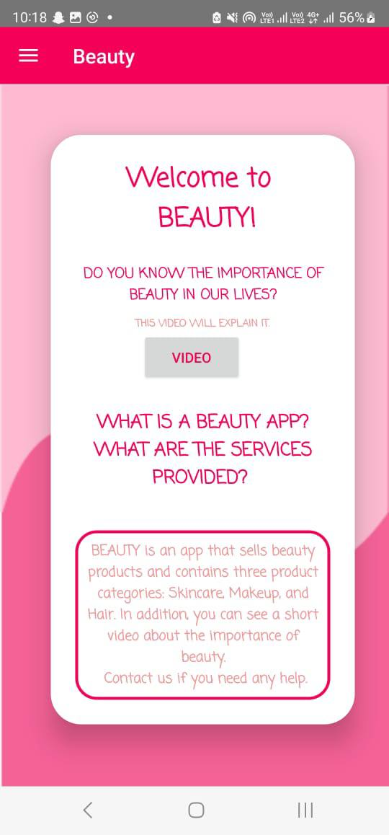

Figure 2 Home Page

Figure 3 Video

Figure 4 Menu

* **Discover Page**

Discover page will display three product categories for the user to choose from (Skincare, Makeup, and Hair). When the user clicks on a category, he/she will be forwarded to the products page of the chosen category. In this page the user can click on a product and a detailed description of it will appear with the ability to add it to the shopping cart.

Figure 5 Discover Page

Figure 6 Skincare Products

Figure 7 Makeup Products

Figure 8 Hair Products

Figure 9 Product Details Page

* **Shopping Cart Page**

This page will display what the user has added to the shopping cart, here they can change the quantity of each product or delete it. Moreover, the total price of the cart will be displayed.

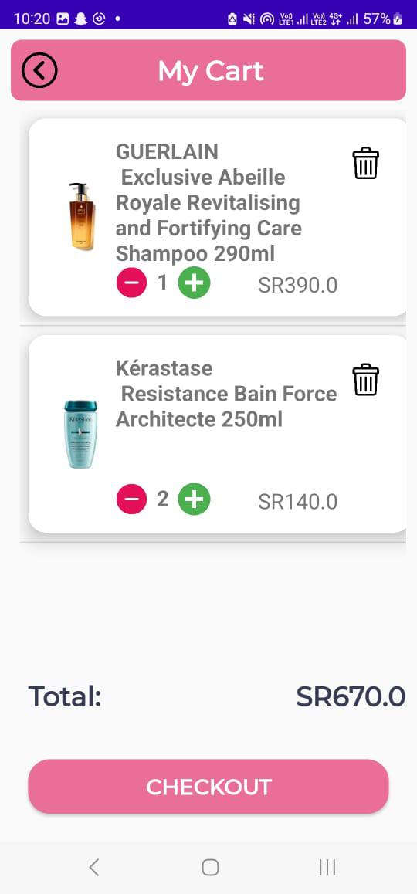

Figure 10 Cart Page

Figure 11 Delete Item Confirmation

Figure 12 Cart Page After Deleting Product

Figure 13 Notification of Products in Cart

* **About Us**

About us page, you can see a brief of the developers who worked on BEAUTY application such as their names, majors, university, experience, and interests.

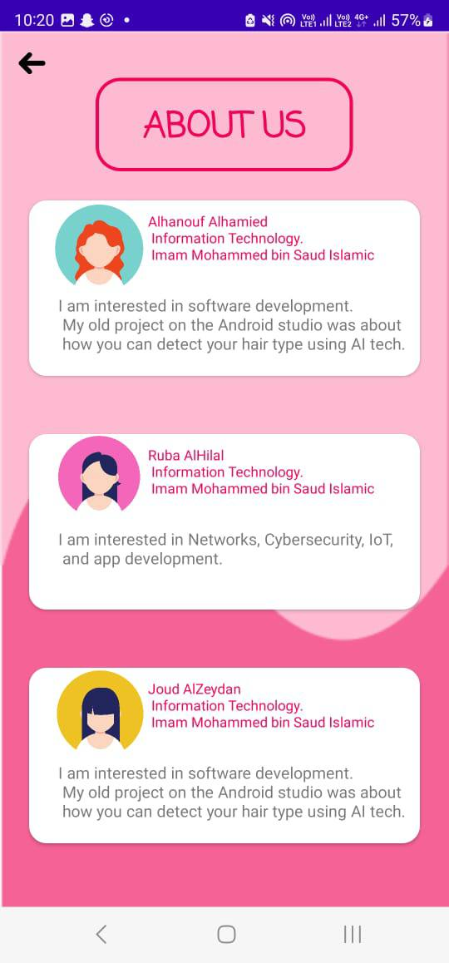

Figure 14 About Us Page

* **Contact Us**

For contact us page it will display the accounts for our application. If the user have suggestions or complaints or he/she need help with a problem they can contact us.

Figure 15 Contact Us Page

# Conclusions and Future Work

Finally, the main goal of the BEAUTY application is to help people to find what they need from beauty products easily. Many products appear in various categories such as skincare, makeup, and hair. In addition, users can add the wanted product into the shopping cart to buy. For related work, some features will be added such as each company has a special section for all its products, displaying other people's experiences on the product, trending products, and health products.