distinguish and explain agent-based modeling: Agent, environment, observer, behavior y 5 marks ka long tha 1 Short random variable tha 2 short agent ki properties the (Agent based modeling, stimulation, continuous, discrete) in topics mn sy thy

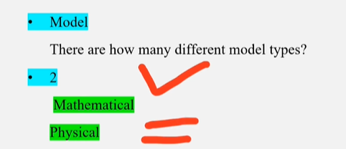

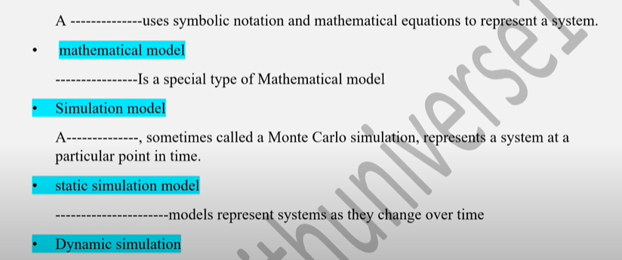

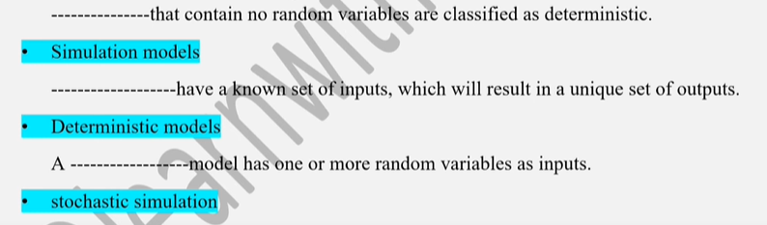

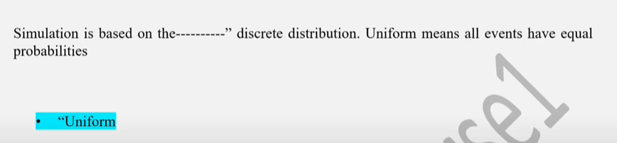

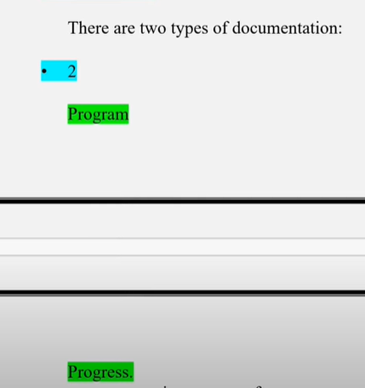

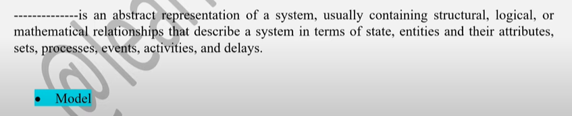

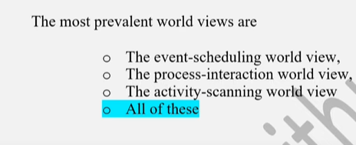

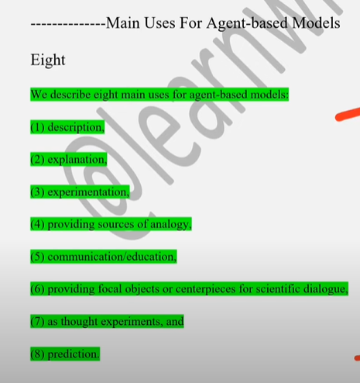

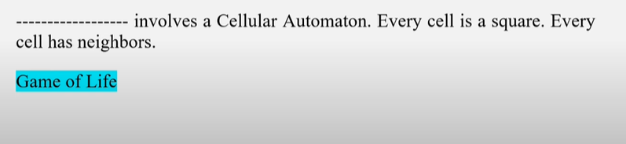

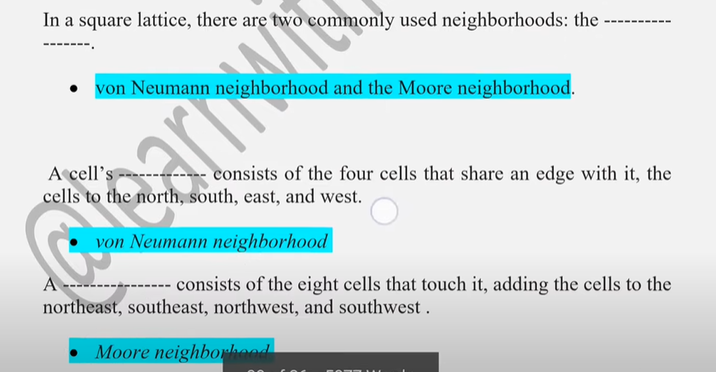

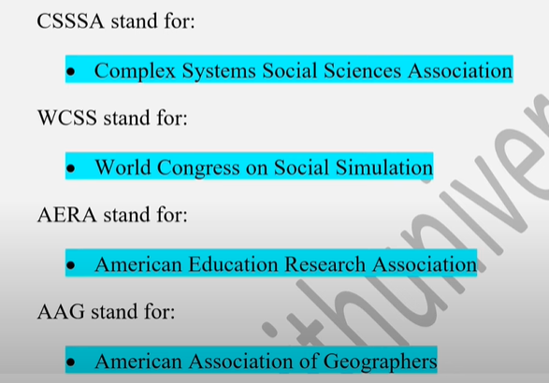

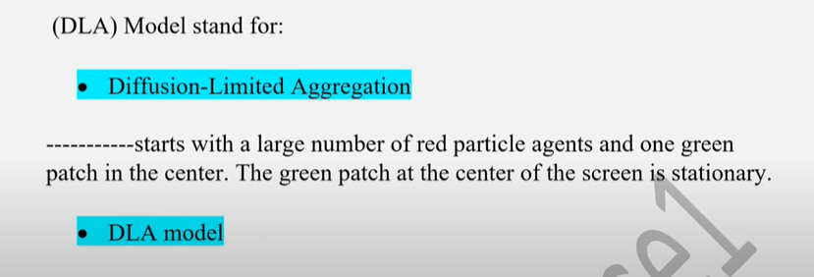

* **Generate a number between 0 and 1 – referred to as the “random number”**
* **“Random variable” is any randomly generated quantity with a specified statistical distribution.**
* **A method of generating a sequence of random numbers is called a Random Number Generator (RNG)**

**VBA in MS Excel**

* **We use the RAND formula = RAND()**
* **More complex formulas can be used e.g. IF(RAND() <= 0.5, 0.1)**
* **Here IF checks the first condition and if true, returns the second one**

**Simulation Clock**

* **Simulation clock is a key component in a dynamic discrete-event simulation.**
* **Clock times represent the time of occurrence of an event**
* **E.g. arrival, service beginning, completion etc.**

**Inputs**

* **Inputs are the exogenous variables that are (usually) defined independently of other system characteristics**
* **E.g. Probability of heads in a coin toss**
* **Service times**

**Output variables**

* **They compute measures of system performance (also known as model responses)**
* **E.g. an output could be:**
* **An individual customer’s waiting time (in a queue)**
* **The cost of an individual transaction in an inventory system**

**In Discrete-event Simulation,**

* + **A system is modeled in terms of-its state at each point in time; of the entities that pass through the system**
  + **And the entities that represent system resources; and of the activities and events that cause the system state to change.**

**lists are sometimes called sets, queues, or chains. Sets or lists are used to hold both entities and event notices**

Proponents claim that the activity scanning and three-phase approaches are particularly good at handling complex resource problems in which various combinations of resources are needed to accomplish different tasks.

**Emergent phenomena’s two levels**

* Emergent phenomena can be described as existing on
  + at least two levels: the level of the individual elements (cars, birds, people, etc.); and the
  + level of system or aggregate patterns (flocks, traffic jams, housing patterns, etc.).

**NetLogo:**

* ***NetLogo*** is both a modeling language and an integrated environment designed to make agent-based models easy to build.
* **Some of the most used constructs (data structures) in NetLogo are:**

1. **Agentsets**
2. **Lists**

* An agentset is a set of agents.
* Agentsets can have turtles, patches, or links, but they cannot mix agent types.
* You can ask an agentset to perform some commands.
* NetLogo comes with three special agentsets built in: “turtles,” “patches,” and “links”
* What makes agentsets so powerful is that you can create your own agentsets

• Lists are ordered collections of data.

• We can have a list of numbers

• A list of words, even a list of lists, also even a list of agents.

• Since they are in a list, these agents will have a particular order, so you can use the list to execute their commands in any order you might like.

**There are four characteristic features of agent-based modeling:**

1. Simple rules can be used to generate complex phenomena
2. Randomness in individual behavior can result in consistent patterns of population behavior
3. Complex patterns can “self-organize” without any leader orchestrating the behavior
4. Different models emphasize different aspects of the world

**We consider two major categories of modeling:**

1. **Phenomena-based modeling** and exploratory modeling

* In phenomena-based modeling, you begin with a known target phenomenon
* Typically, that phenomenon has a characteristic pattern,
* A *characteristic pattern*, known as a *reference pattern.*
* The goal of phenomena-based modeling is to create a model that will somehow capture the reference pattern

1. The second core modeling form is **exploratory modeling**.

* This form is perhaps less common in equational contexts than it is in ABM
* In exploratory modeling with ABM, you create a set of agents, define their behavior, and explore the patterns that emerge

**Top-down design**

In a top-down design, the model designer will have worked out the types of agents in the model, the environment they reside in, and their rules of interaction before writing a single line of code.

**Bottom-up Design**

In bottom-up design, you choose a domain or phenomenon of interest with or without specifying a formal question.

Using this approach, you would then start writing code relevant to that domain, building the conceptual model

**ABM design principle:**

Start simple and build toward the question you want to answer.

There are two main components of this principle

* The first is to begin with the simplest set of agents and rules of behavior that can be used to explore the system you want to model.
* Second, always have your question in mind, which means not adding anything to your model that does not help you in answering your question

**The natural progression seems to be:**

* *First* choose a question,
* *Second* build a model to answer that question.

**The main components of any ABM are**

* Agents
* Environment
* Interactions

**Some special types of agents:**

* Proto-agents, which are not fully specified agents;
* Meta-agents, composed of other agents.

**Subjective Questions Preparation for Modeling & Simulation Midterm**

**Short Questions (3 Marks Each)**

**1. Random Variable**

A random variable is a variable whose value is determined by the outcome of a random experiment. There are two types:

* **Discrete Random Variable**: Takes countable values (e.g., number of customers).
* **Continuous Random Variable**: Takes infinite values in a range (e.g., temperature).

**2. Agent Properties**

Agents in Agent-Based Modeling have the following properties:

* **Autonomy**: Act independently.
* **Reactivity**: Respond to the environment.
* **Proactiveness**: Take initiative.
* **Social ability**: Interact with other agents.

**3. Simulation Clock**

The simulation clock keeps track of the simulated time. It advances according to the time of the next scheduled event and helps maintain the flow of events in discrete event simulation.

**4. Discrete vs. Continuous Simulation**

* **Discrete**: State changes at specific times (e.g., bank queue).
* **Continuous**: Changes continuously over time (e.g., water level in a tank).

**5. Future Event List (FEL)**

FEL is a list that stores all the scheduled future events with their respective event times. It is ordered by event time and is essential in discrete event simulation.

**6. Model vs. Simulation**

* **Model**: A representation of a system.
* **Simulation**: The execution of the model over time to study behavior.

**7. System and Environment**

* **System**: The part of the world being studied (e.g., a hospital).
* **Environment**: The surroundings that interact with the system but are not part of it.

**8. Emergent Phenomenon**

An emergent phenomenon is a complex pattern or behavior that arises from simple rules followed by individual agents (e.g., flocking behavior in birds).

**Long Questions (5 Marks Each)**

**1. Agent-Based Modeling (ABM)**

ABM is a modeling technique where individual entities (agents) operate based on a set of rules. These agents interact with each other and their environment, leading to complex system behavior.

**Components:**

* **Agent**: Autonomous, goal-directed entities with specific behaviors.
* **Environment**: The space in which agents operate.
* **Observer**: Monitors the system and collects data.
* **Behavior**: Rules that govern how agents act and interact.

**Emergence**: Complex behavior arises from simple agent rules.

**Examples**: Predator-prey model, forest fire simulation in NetLogo.

**Conclusion**: ABM is useful for studying systems with decentralized control and local interactions.

**2. Discrete Event Simulation (DES)**

DES is a simulation where the state of the system changes at discrete points in time due to the occurrence of events.

**Key Concepts:**

* **System**: The model being simulated.
* **System State**: Variables that describe the system at any time.
* **Event List (FEL)**: A list of scheduled events.
* **Event**: An occurrence that may change the system state.
* **Attributes**: Properties of entities.
* **Clock**: Keeps track of simulation time.
* **Activity and Delay**: Represent actions or waiting periods.

**Application**: Queuing systems, manufacturing, customer service.

**3. Steps in Modeling and Simulation Study**

1. **Problem Formulation**: Define the problem clearly.
2. **Objective Setting**: Determine goals of the simulation.
3. **Model Building**: Develop a conceptual model.
4. **Data Collection**: Gather necessary data.
5. **Model Translation**: Convert model into simulation software.
6. **Verification & Validation**: Ensure accuracy of model.
7. **Experimentation**: Run simulations and analyze results.
8. **Documentation & Reporting**: Record findings and conclusions.

**4. Types of Models**

* **Physical/Iconic Models**: Physical representation (e.g., architectural model).
* **Mathematical Models**: Use equations to describe systems.
* **Simulation Models**: Model behavior over time using software.
* **Deterministic Models**: No randomness (fixed outcome).
* **Stochastic Models**: Include random variables.
* **Static Models**: Represent system at a specific time.
* **Dynamic Models**: Represent changes over time.

**5. Advantages and Disadvantages of Simulation**

**Advantages:**

* Helps in studying complex systems.
* Allows "what-if" analysis.
* Safer and cheaper than real-life testing.
* Allows time compression (study future now).

**Disadvantages:**

* Time-consuming to develop.
* Requires accurate data.
* Results depend on model accuracy.
* Cannot give exact answers, only approximations.

**6. Event Scheduling / Time Advance Algorithm**

This algorithm manages the execution of future events based on time.

**Steps:**

1. **Maintain FEL**: Schedule all future events.
2. **Find Imminent Event**: Choose event with the smallest time.
3. **Advance Clock**: Move simulation time to event time.
4. **Execute Event**: Change system state as per event.
5. **Update FEL**: Remove executed event, add new events.

**Types of Events:**

* **Endogenous**: Generated by the system.
* **Exogenous**: Triggered from outside.

**Uses:**

* Useful in bank, hospital, traffic simulations.

**7. Spreadsheet Simulation**

Spreadsheet simulation uses tools like MS Excel to simulate processes.

**Features:**

* Use RAND() or RANDBETWEEN() for randomness.
* Simulate scenarios like coin toss or service times.

**Example - Coin Toss:**

* If RAND() < 0.5 then Heads, else Tails.

**Framework Includes:**

* Input Variables
* Random Number Generation
* Model Logic in spreadsheet rows
* Output Analysis

**Uses:**

* Simple modeling of queues, service systems, and experiments.

**✅ 1. ABM's Benefits and Tradeoffs**

**✔ Benefits of Agent-Based Modeling (ABM):**

1. **Captures individual behavior**  
   – Each agent can behave differently based on its rules and state.
2. **Models’ emergent phenomena**  
   – Complex system-level patterns (like crowd behavior) emerge from simple agent rules.
3. **Flexible and realistic**  
   – Agents can be autonomous, adaptive, mobile, or reactive, which mirrors real-life systems.
4. **Supports heterogeneous entities**  
   – Agents can have different characteristics, goals, and roles.
5. **Exploratory and visual**  
   – Easy to visualize and experiment with real-time changes in agent behavior and interactions.

**❌ Tradeoffs of ABM:**

1. **Computational cost**  
   – Simulating many agents can be slow and memory-intensive.
2. **Model complexity**  
   – Designing and validating realistic agent rules is difficult.
3. **Data availability**  
   – Requires detailed data on individual behaviors and interactions.
4. **Difficult to validate**  
   – Emergent results can be hard to verify against real-world data.

✅ **2. Differences Between Agent-Based Modeling (ABM) and Equation-Based Modeling (EBM)**

| **Aspect** | **ABM (Agent-Based Modeling)** | **EBM (Equation-Based Modeling)** |
| --- | --- | --- |
| **A**ppr**oach** | Bottom-up | Top-down |
| **Entities** | Multiple agents with individual behaviors | System as a whole with averaged behavior |
| **Interactions** | Local interactions between agents | Global equations governing entire system |
| **Emergence** | Can model emergent phenomena | Cannot show emergent behavior |
| **Heterogeneity** | Can model heterogeneous agents | Usually assumes homogeneity |
| **Examples** | Predator-prey model, crowd simulation | Population growth, fluid dynamics |
| **Modeling Style** | Rule-based, behavioral | Mathematical, equation-based |

**Modeling & Simulation - One Page Cheat Sheet**

**✅ Key Definitions:**

* **Simulation**: Imitation of a real-world system over time.
* **Model**: A simplified representation of a system.
* **System**: A collection of entities interacting to accomplish a goal.
* **Environment**: Everything outside the system that affects it.
* **Discrete Simulation**: State changes at specific time points.
* **Continuous Simulation**: State changes continuously over time.

**🔁 Simulation Process:**

1. Problem Formulation
2. Objectives
3. Model Building
4. Data Collection
5. Model Translation
6. Verification & Validation
7. Experimentation
8. Documentation

**📊 Types of Models:**

* Physical (Iconic)
* Mathematical (Equations)
* Simulation (Dynamic)
* Static vs Dynamic
* Deterministic vs Stochastic

**🕒 Simulation Clock:**

* Keeps track of simulated time.
* Advances to the next event time.

**📋 Future Event List (FEL):**

* Ordered by time
* Contains all upcoming events

**⚙️ Discrete Event Simulation Terms:**

* **Entity**: Object (e.g., customer)
* **Attributes**: Properties of entities
* **Event**: Instantaneous occurrence (e.g., arrival)
* **Activity**: Takes time (e.g., service)
* **Delay**: Waiting period
* **Clock**: Simulation time
* **FEL**: Future event list

**📉 Randomness:**

* **Random Variable**: Value based on random outcome
  + Discrete (e.g., coin toss)
  + Continuous (e.g., temperature)
* **CDF (Cumulative Distribution Function)**: P(X ≤ x)

**🎲 Excel Simulation:**

* =RAND() → Uniform [0,1]
* =RANDBETWEEN(a, b) → Random integer
* Coin Toss: =IF(RAND()<0.5, "Heads", "Tails")

**🤖 Agent-Based Modeling (ABM):**

* **Agent**: Autonomous entity
* **Environment**: Agent lives/interacts here
* **Observer**: Monitors simulation
* **Behavior**: Rules followed by agents

**ABM Uses**: Predator-prey, crowd behavior, social modeling

**ABM vs EBM**:

* ABM: Bottom-up, local interactions
* EBM: Top-down, equations

**🧠 Tips for Exam:**

* Focus on event scheduling steps
* Understand ABM components
* Remember system vs environment
* Practice one Excel simulation
* Revise types of random variables & simulation types