|  |  |  |
| --- | --- | --- |
| **ID** | **Name** | **Student Sign** |
|  |  |  |

**1st Week 🡪(CT6)**

**Schema Diagram**

***\*login as system***

1. Create the tables according to the schema provided below. Arrows point from foreign key to corresponding primary key. Also insert 2 rows of data into each table created.

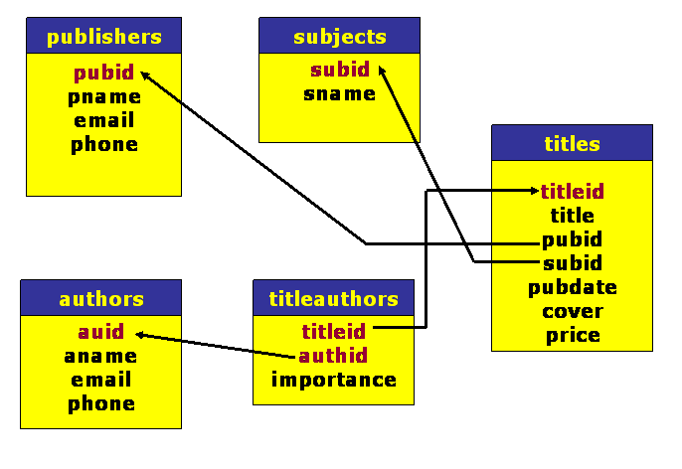

**Submission Process**

* **After solving the above question using Oracle 10g, write the SQLs (DDL+DML) on this page using pen or pencil. Make sure to write your Name, ID and Signature on the space provided above. If you require multiple papers to complete this work write your Name, ID and Signature on all of them.**
* **Click photos of your completed work from the papers and convert to pdf (you can use any tool/app of your choice).**
* **Submit pdf in link provided in your VUES Student Account.**
* **Name of pdf must be your ID.**