|  |  |  |
| --- | --- | --- |
| **Name** | **ID** | **STUDENT SIGN** |
| **Sheikh Rubaeid Sanjid** | **21-45844-3** |  |

**Class Test 01**

**Hogwarts** is a school of witchcraft and wizardry. To ensure proper management of their data the renowned school has decided to maintain a database system. Out of many bidders your company was hired to accomplish the task. Your job is to create a relational database for Hogwarts from the requirements specified below:

RDBMS- Oracle 10g

Language-SQL

Log in as User System and create a ***user*** Dumbledore who has ***password*** Phoenix. Dumbledore is granted ***unlimited tablespace***. He is also granted the permission to ***create*** tables. After logging in with his username and password Dumbledore creates ***two tables*** i.e. Student and House. ***Student*** table has five columns containing information about students ***Identification Number, Name, CGPA, Blood Status and House Number***. ***House*** table has three columns containing information about ***House Number, House Name and House Points***. Here S_Id, H_Id are the ***primary key columns*** of Student and House table respectively. Student table also has a ***foreign key*** column H_No. Constraint should be applied in such a way that CGPA cannot be greater than 4.00 and House name cannot be NULL. The two tables along with their inserted data are given below:

**Table: Student Table: House**

|  |  |  |  |  |
| --- | --- | --- | --- | --- |
| S_Id | S_Name | S_CGPA | S_BloodStatus | H_No |
| 2 | Harry | 3.45 | Halfblood | 11 |
| 7 | Ron | 3.01 | Pureblood | 11 |
| 12 | Hannah |  | Pureblood | 22 |
| 17 | Cedric | 3.78 | Pureblood | 22 |
| 22 | Cho | 3.55 | Muggleborn | 33 |
| 27 | Luna | 2.89 |  | 33 |
| 32 | Draco | 3.88 | Pureblood | 44 |
| 37 | Goyle | 2.10 | Pureblood | 44 |

|  |  |  |
| --- | --- | --- |
| H_Id | H_Name | H_Points |
| 11 | Gryffindor | 892 |
| 22 | Hufflepuf | 785 |
| 33 | Ravenclaw | 789 |
| 44 | Slytherin | 850 |

After creating the tables and inserting data based on provided requirements write Queries (Write down the question and also the answer. Give screenshot of the result of the query.You can add more Answer Box if required) according to the following specification:

-using **ARITHMETIC** operator

-using **CONCATENATION** operator

-using **COLUMN ALIAS**

-using **LIKE** operator

-using **IS NULL** operator

-using **ORDER BY** clause

-using **SUBSTR** function

-using **NVL** function

-using **MAX** function

-using **SUM** function

-using **GROUP BY** clause

-using **HAVING** clause

Answer:

CREATE TABLE House (

H_Id NUMBER PRIMARY KEY,

H_Name VARCHAR2(50) NOT NULL,

H_Points NUMBER

);

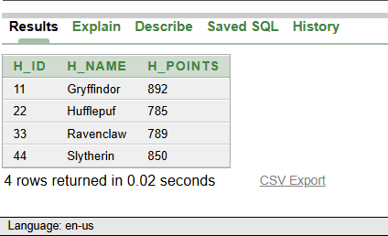

CREATE TABLE Student (

S_Id NUMBER PRIMARY KEY,

S_Name VARCHAR2(50),

S_CGPA NUMBER(3,2) CHECK (S_CGPA <= 4.00),

S_BloodStatus VARCHAR2(20),

H_No NUMBER,

CONSTRAINT fk_house FOREIGN KEY (H_No) REFERENCES House(H_Id)

);

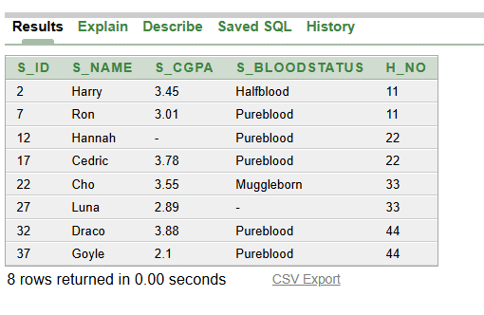

**1. Using ARITHMETIC Operator**

**Question:** Find the CGPA of each student after adding 0.10 bonus marks.

**Answer:** SELECT S_Name, S_CGPA, (S_CGPA + 0.10) AS CGPA_with_Bonus FROM Student;

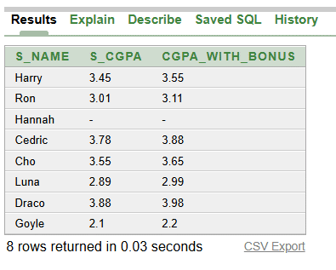

**2. Using CONCATENATION Operator**

**Question:** Display the full description like "Student Harry belongs to house 11".

**Answer:** SELECT 'Student ' || S_Name || ' belongs to house ' || H_No AS Student_Info FROM Student;

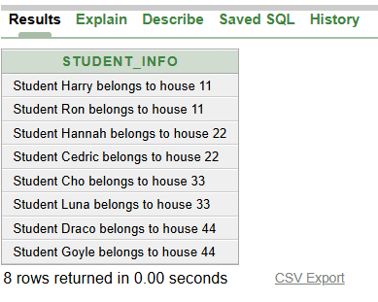

**3. Using COLUMN ALIAS**

**Question:** Display student names with CGPA, but rename CGPA as "Student CGPA".

**Answer:** SELECT S_Name, S_CGPA AS "Student CGPA" FROM Student;

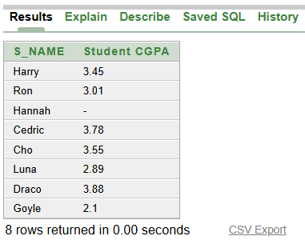

**4. Using LIKE Operator**

**Question:** Find all students whose names start with 'H'.

**Answer:** SELECT * FROM Student WHERE S_Name LIKE 'H%';

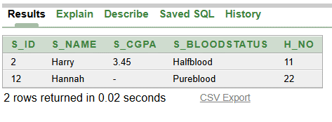

**5. Using IS NULL Operator**

**Question:** Find all students whose CGPA is not available (NULL).

**Answer:** SELECT * FROM Student WHERE S_CGPA IS NULL;

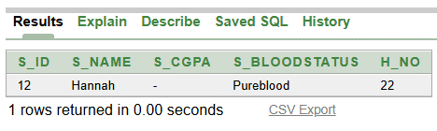

**6. Using ORDER BY Clause**

**Question:** Display all students ordered by CGPA in descending order.

**Answer:** SELECT * FROM Student ORDER BY S_CGPA DESC;

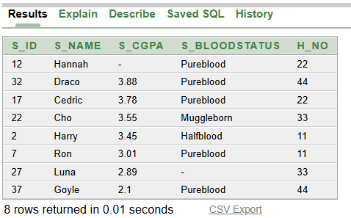

**7. Using SUBSTR function**

**Question:** Display the first 3 characters of student names.

**Answer:** SELECT S_Name, SUBSTR(S_Name, 1, 3) AS Name_Start FROM Student;

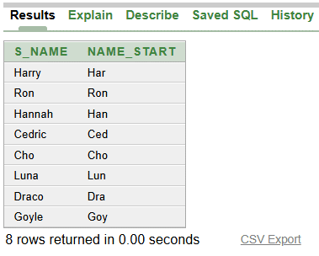

**8. Using NVL function**

**Question:** Display students' CGPA; if CGPA is NULL, show 0 instead.

**Answer:** SELECT S_Name, NVL(S_CGPA, 0) AS CGPA_or_Zero FROM Student;

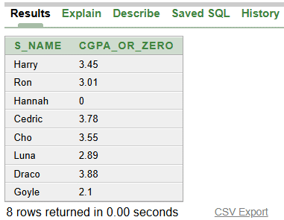

**9. Using MAX function**

**Question:** Find the maximum CGPA among all students.

**Answer:** SELECT MAX(S_CGPA) AS Max_CGPAFROM Student;

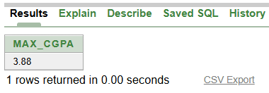

**10. Using SUM function**

**Question:** Find the total points of all houses.

**Answer:** SELECT SUM(H_Points) AS Total_House_Points FROM House;

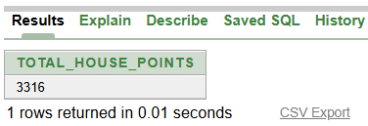

**11. Using GROUP BY Clause**

**Question:** Find the average CGPA of students grouped by their House Number.

**Answer:** SELECT H_No, AVG(S_CGPA) AS Average_CGPA FROM Student GROUP BY H_No;

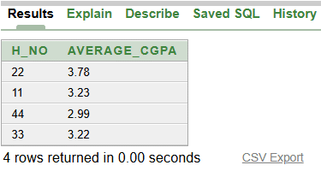

**12. Using HAVING Clause**

**Question:** Find the house numbers where the average CGPA is greater than 3.0.

**Answer:** SELECT H_No, AVG(S_CGPA) AS Average_CGPA FROM Student GROUP BY H_No HAVING AVG(S_CGPA) > 3.0;

