**Class Test 02**

**PL/SQL**

**Part 01:**

1. Write a query that displays **Hello ADBMS Section A** usingtheconcept of literal.

**Answer:** BEGIN

dbms_output.put_line('Hello ADBMS Section A');

END;

**Output:**

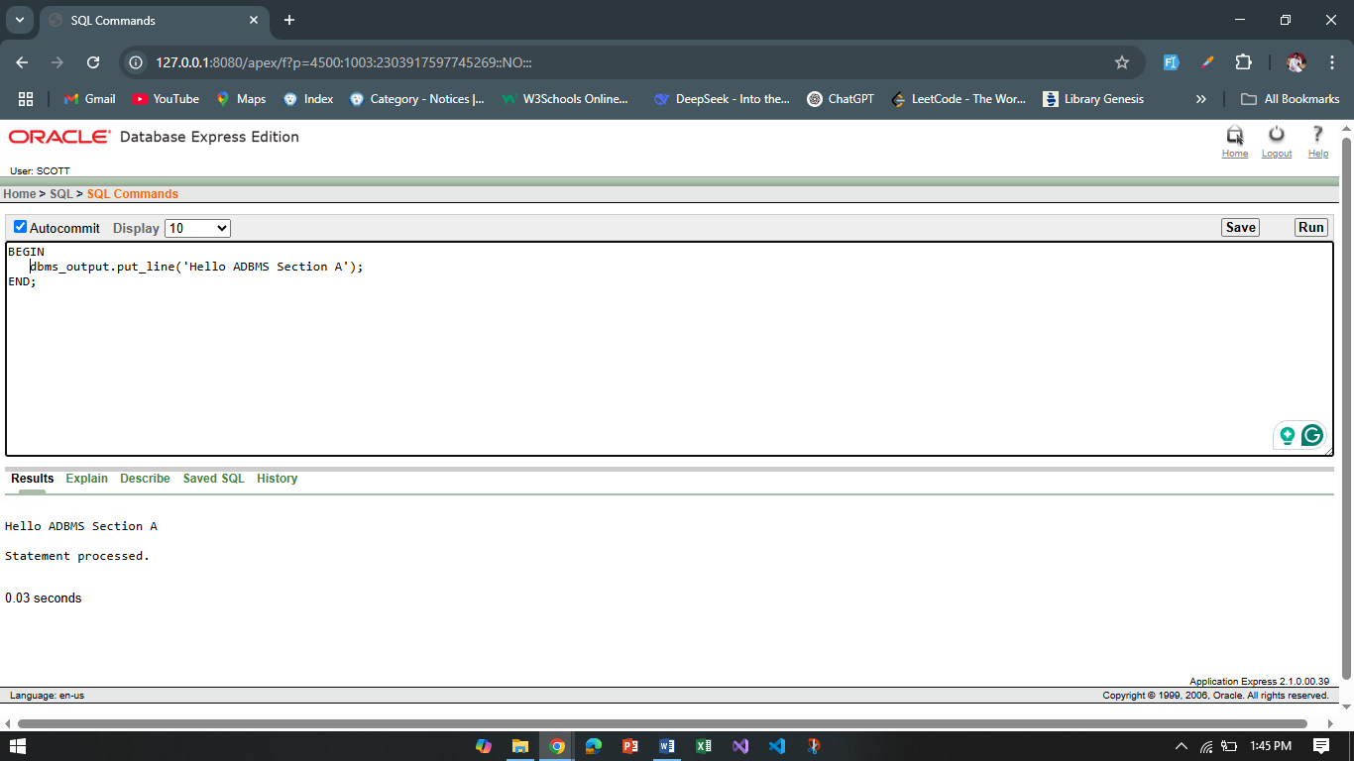

1. Write a query that can add two numbers using the concept of inner block and outer block.

**Answer:**

DECLARE

num1 NUMBER := 20;

num2 NUMBER := 20;

total NUMBER;

BEGIN

DECLARE

temp NUMBER;

BEGIN

temp := num1 + num2;

total:= temp;

END;

dbms_output.put_line('Total is: ' || total);

END;

**Output:**

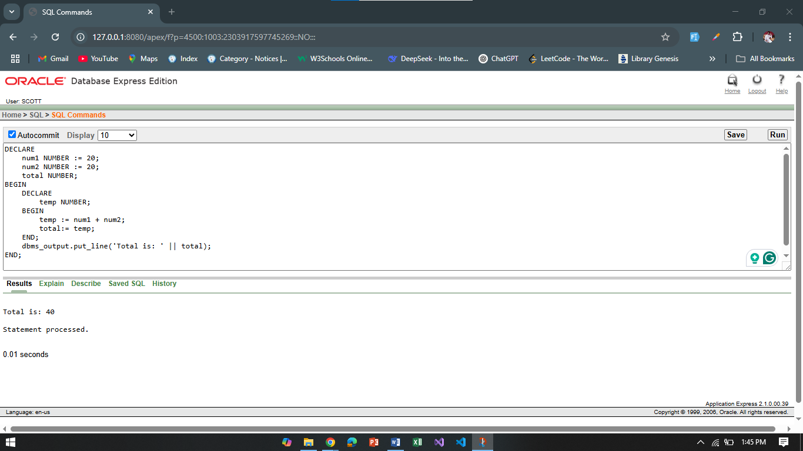

1. Write a query that can multiply three numbers using the concept of literal.

**Answer:**

BEGIN

dbms_output.put_line('Multiply of 3 numbers: ' || (4 * 3 * 2));

END;

**Output:**

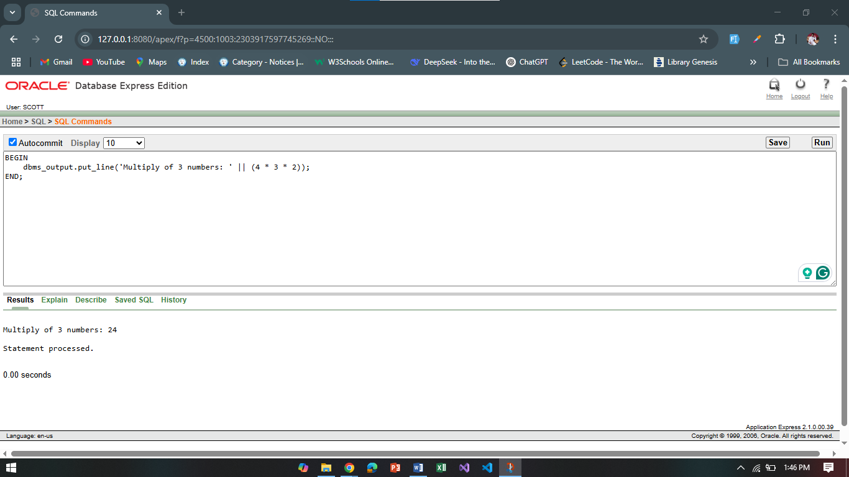

1. Write a query that stores **Hello World** in a variable and displays it in block letters.

**Answer:**

DECLARE

text VARCHAR2(50);

BEGIN

text := 'HELLO WORLD';

dbms_output.put_line(text);

END

**Output:**

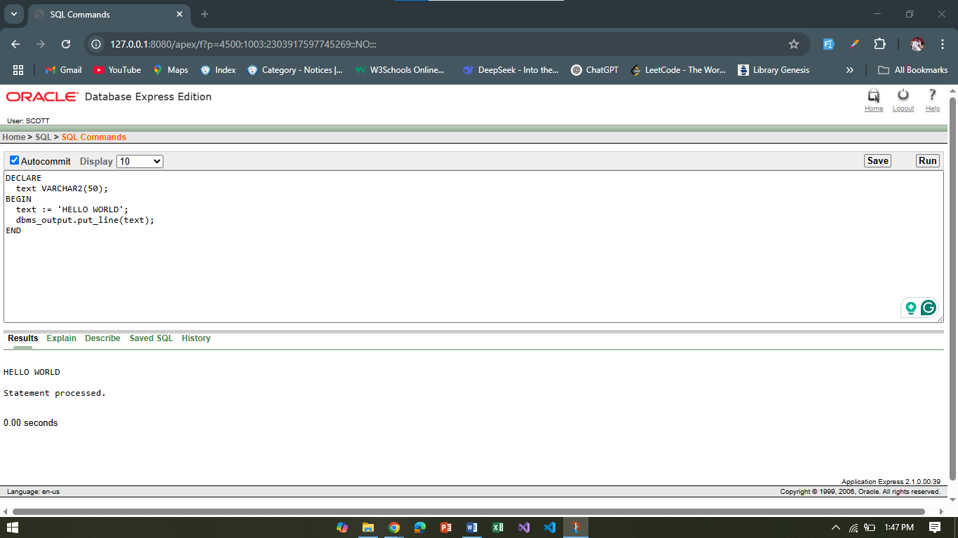

1. Write a query that can subtract a smaller number from a larger number and display the result using the concept of variable.

**Answer:**

DECLARE

num1 NUMBER := 40;

num2 NUMBER := 20;

result NUMBER;

BEGIN

result := num1 - num2;

dbms_output.put_line('Subtract result is: ' || result);

End

**Output:** 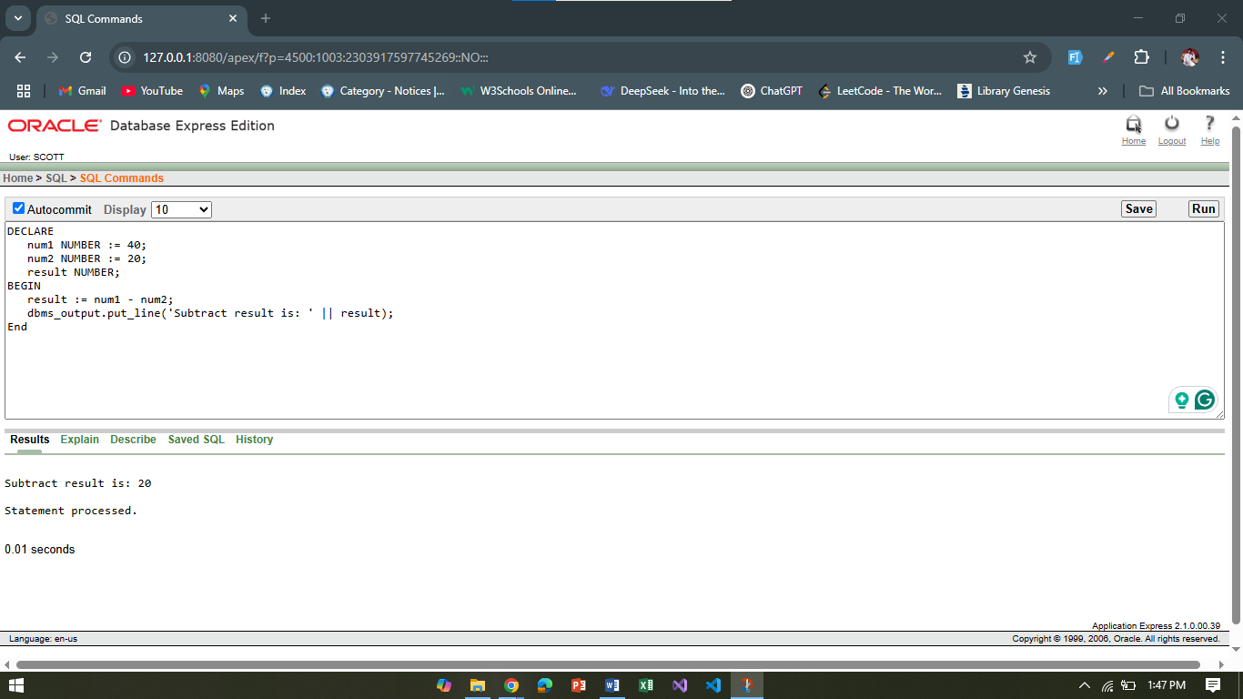

1. There are four numbers given i.e. 12,14,16,18. Find out the average.

**Answer:**

DECLARE

avg_num NUMBER;

BEGIN

avg_num := (12 + 14 + 16 + 18) / 4;

dbms_output.put_line('Average: ' || avg_num);

END;

**Output:**

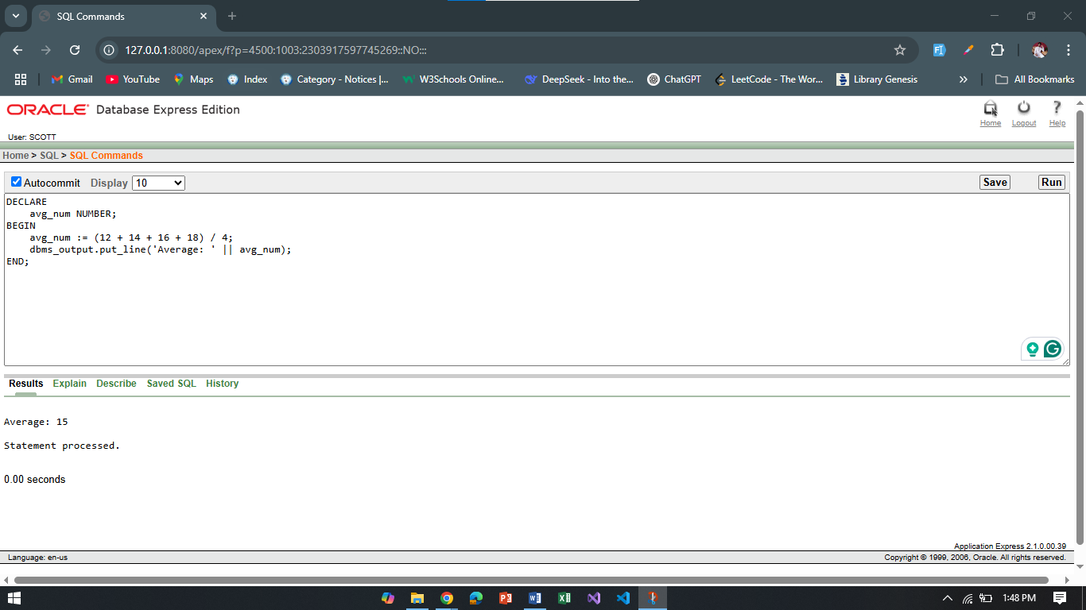

1. Write a query that displays the value of pi using the concept of constant.

**Answer:**

DECLARE

pi CONSTANT NUMBER := 3.14;

BEGIN

dbms_output.put_line('Value of Pi is: ' || pi);

END;

**Output:**

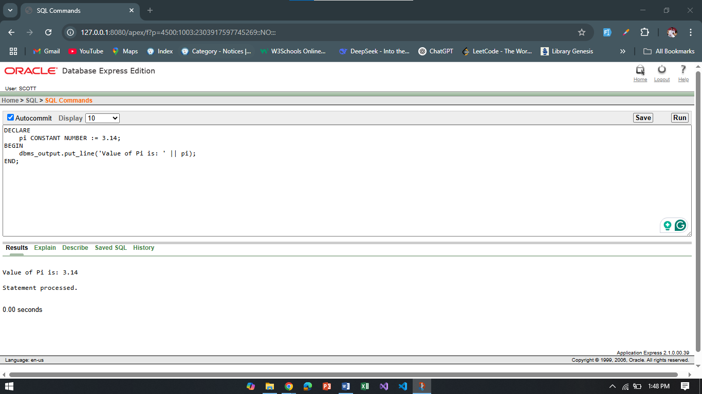

**Part 02:**

*To solve the following use the scott schema*

1. Write a query that can display the name of the department which has department number 10.

**Answer:** SELECT dname FROM dept WHERE deptno = 10;

**Output:**

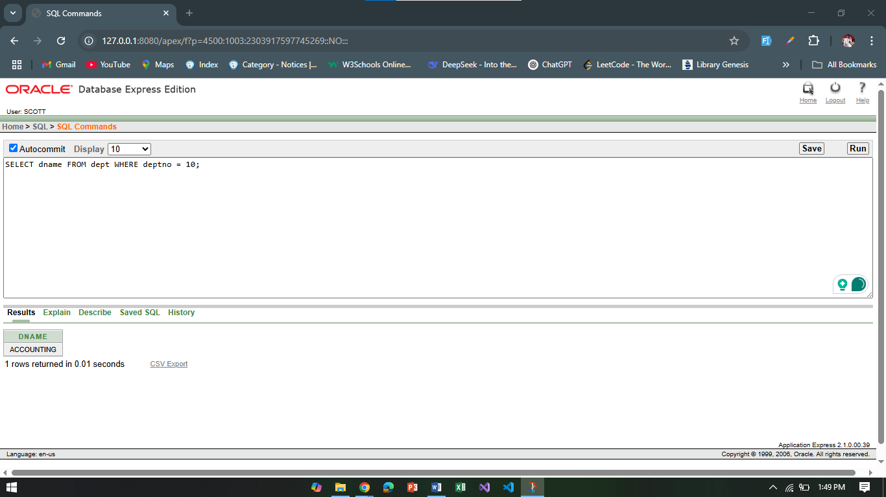

1. Write a query that can display the name of the department in lower case which has department number 20.

**Answer:** SELECT LOWER(dname) FROM dept WHERE deptno = 20;

**Output:**

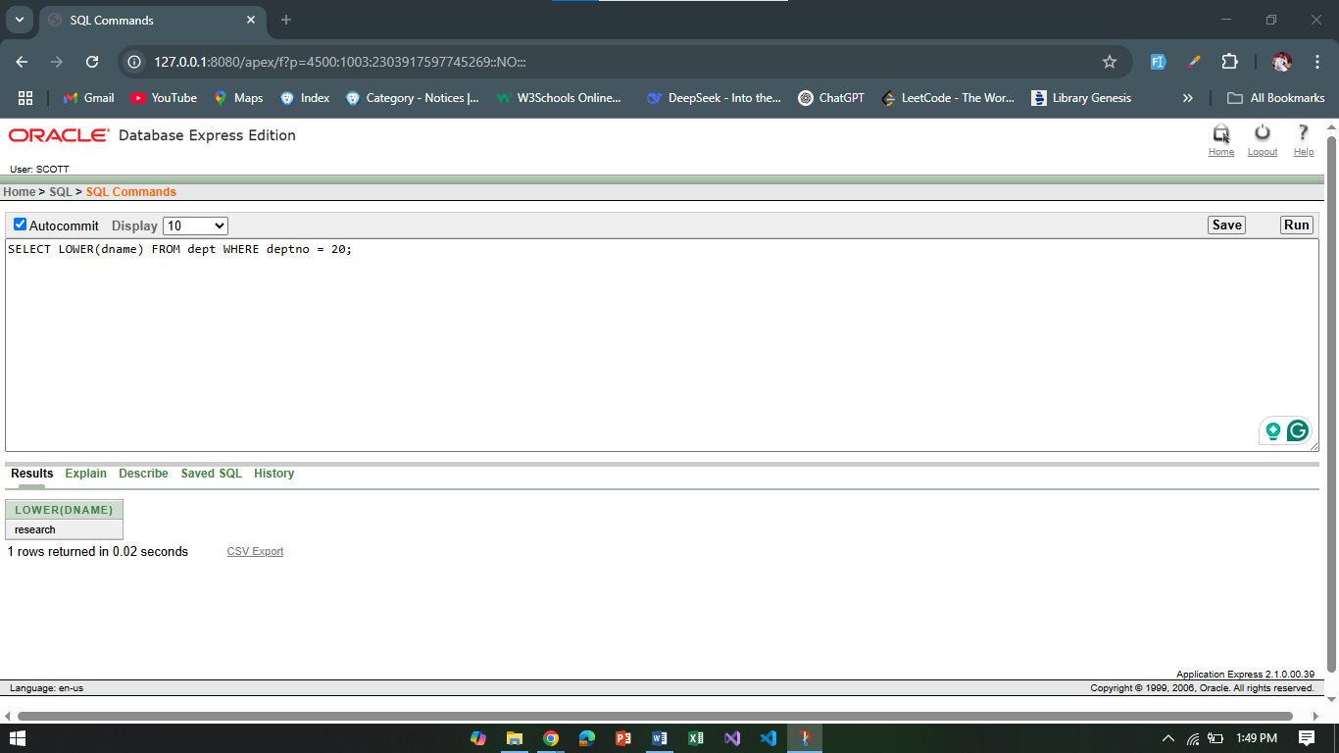

1. Write a query that displays the incremented salary (sal+250) of employee Smith.

**Answer:** SELECT ename, sal + 250 AS incremented_salary FROM emp WHERE ename = 'SMITH';

**Output:**

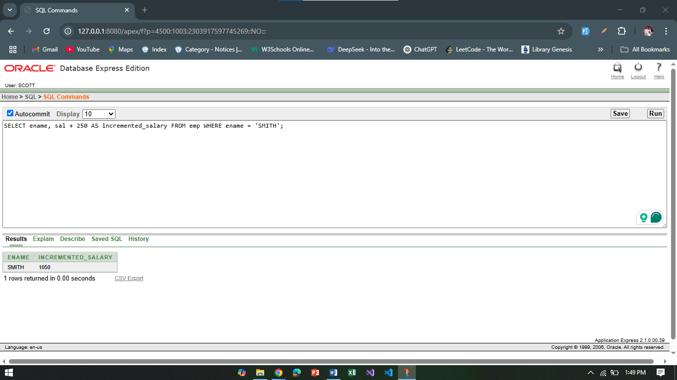

1. Write a query that displays the hiredate of employee KING.

**Answer:** SELECT hiredate FROM emp WHERE ename = 'KING';

**Output:**

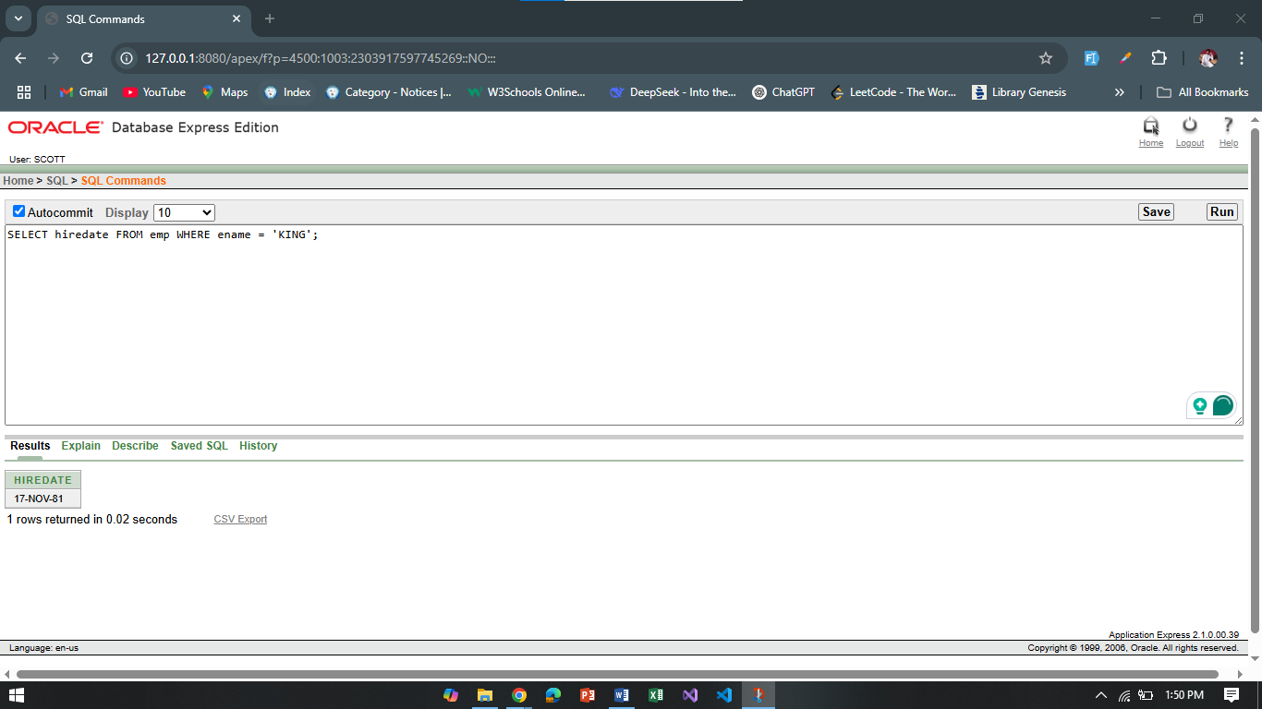

1. Write a query that displays the sum of salary of all the employees.

**Answer:** SELECT SUM(sal) AS total_salary FROM emp;

**Output:**

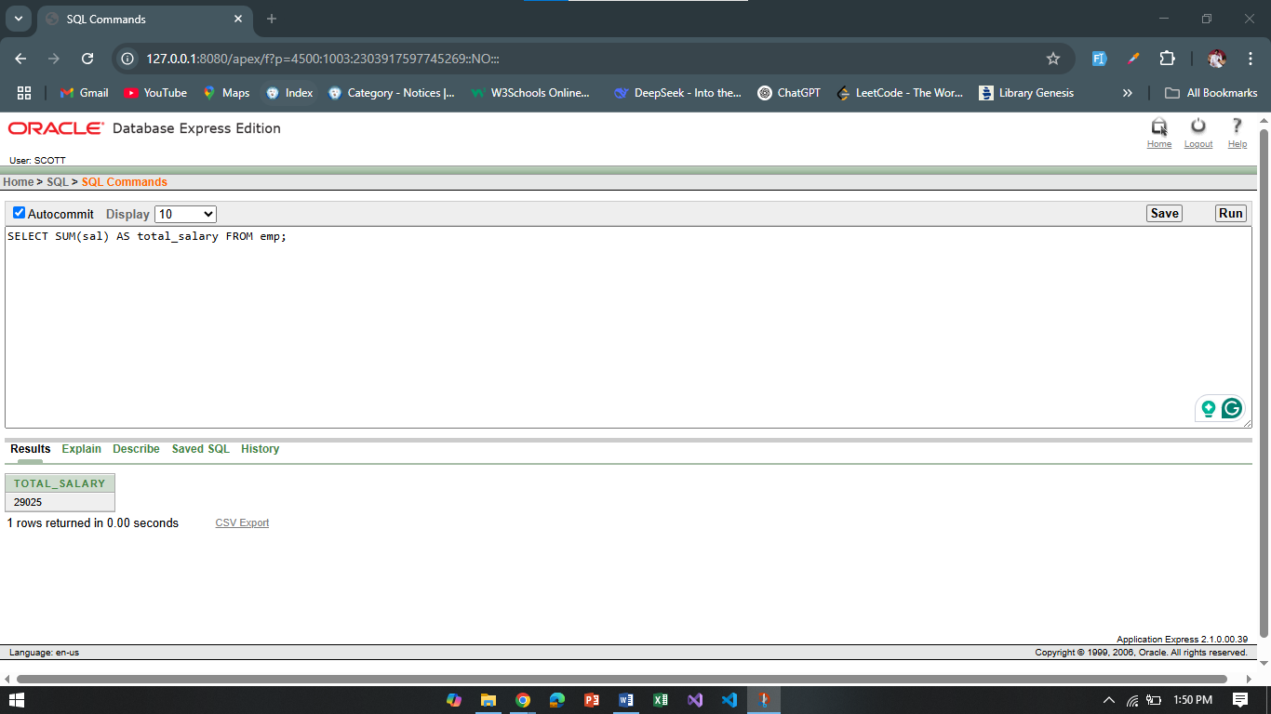

1. Write a query that displays the salary and commission of employee Allen.

**Answer:** SELECT sal, comm FROM emp WHERE ename = 'ALLEN';

**Output:**

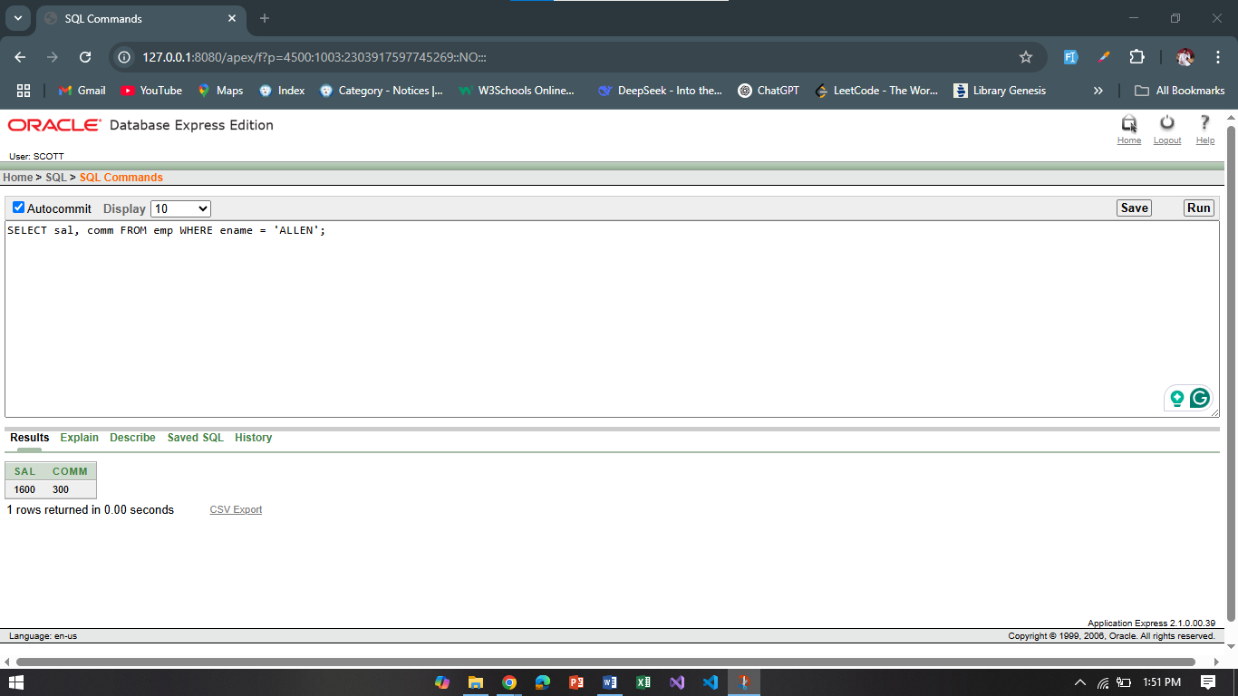

1. Write a query that displays only those employees who have *TT* (double T) in their name.

**Answer:** SELECT ename FROM emp WHERE ename LIKE '%TT%';

**Output:**

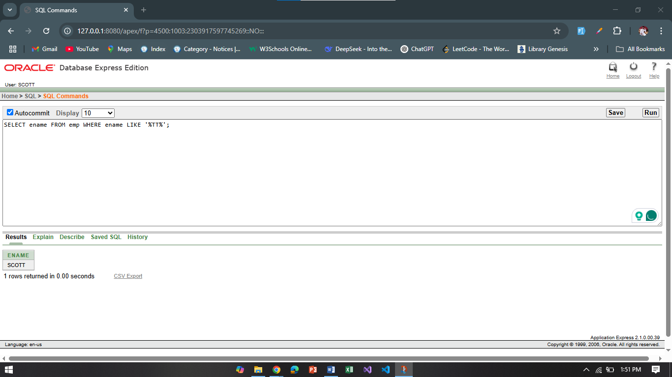

**\*\*After solving the above questions using Oracle 10g, write the PL/SQLs in a MS Word document (Write down the answer and give screenshot of the result of the query. The name of the document MUST be your ID and the PL/SQLs MUST be numbered accordingly) and upload it in the provided link in your VUES account**