**Class Test 04**

**Table: Student_info**

|  |  |  |  |  |  |
| --- | --- | --- | --- | --- | --- |
| S_Id | S_Name | S_CGPA | S_BloodStatus | S_BloodGroup | a_id |
| 1 | Mira | 3.59 | Halfblood | O+ | 11 |
| 2 | Rahman | 3.90 | Pureblood | A+ | 11 |
| 3 | Sharon |  | Pureblood | B+ | 22 |
| 4 | Caprio | 3.21 | Pureblood | AB+ | 22 |
| 5 | Winslet | 3.55 | Muggleborn | AB- | 33 |
| 6 | Khadija | 2.85 |  | O- | 33 |
| 7 | Shekhar | 2.30 | Pureblood | O+ | 44 |
| 8 | Florina | 3.10 | Pureblood | B+ | 44 |

**Table: Address**

|  |  |  |  |
| --- | --- | --- | --- |
| a_id | city | country | Country_code |
| 11 | Dhaka | Bangladesh | 101 |
| 22 | Doha | Qatar | 102 |
| 33 | Washington D.C | USA | 103 |
| 44 | London | UK | 104 |

Write down the queries of the following questions:

**SQL:**

1. Display the name, CGPA, (CGPA-0.5) of the students from the Student_info table.

**Answer:**

SELECT S_Name, S_CGPA, (S_CGPA - 0.5) AS Reduced_CGPA FROM Student_info;

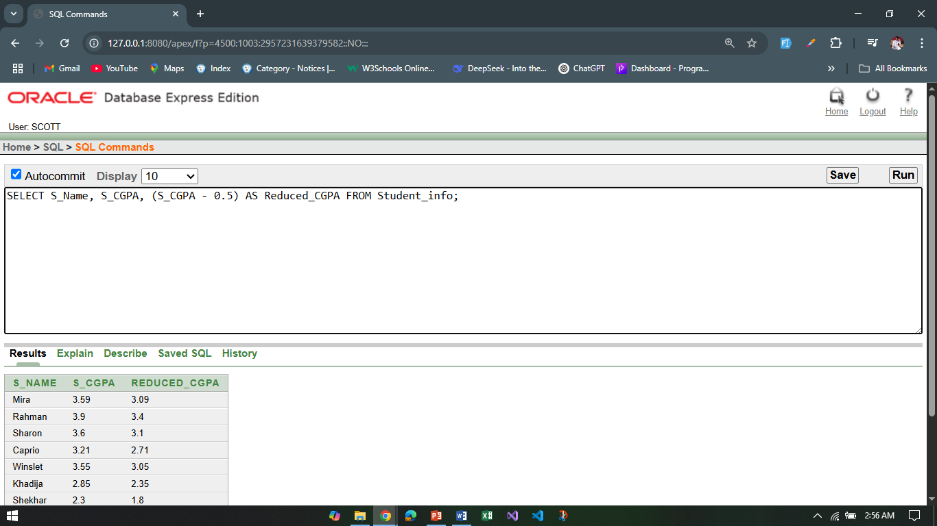

1. Display country and country code together as “Country_info” using concatenation function.

**Answer:**

SELECT country || ' - ' || Country_code AS Country_info FROM Address;

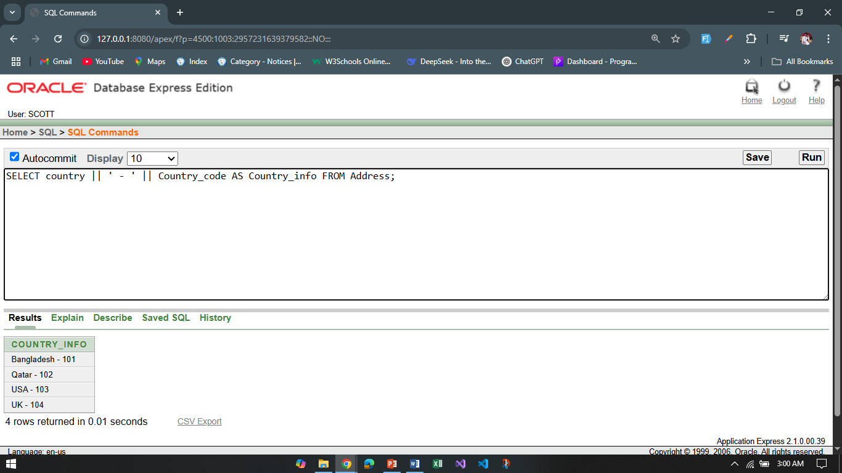

1. Display the student name and student blood status with the column name “Student Name” and “Student Blood Status” from Student_info.

**Answer:**

SELECT S_Name AS "Student Name", S_BloodStatus AS "Student Blood Status"

FROM Student_info;

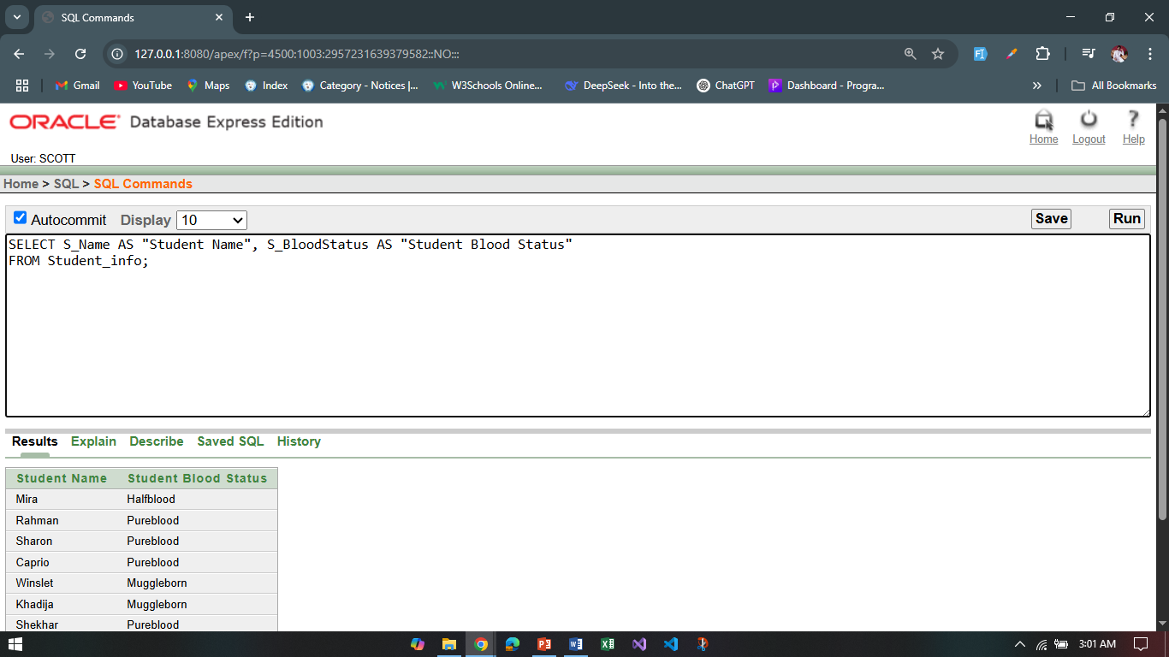

1. Display all students who have only one ‘o’ in their name.

**Answer:**

SELECT S_Name FROM Student_info WHERE LENGTH(LOWER(S_Name)) - LENGTH(REPLACE(LOWER(S_Name), 'o', '')) = 1;

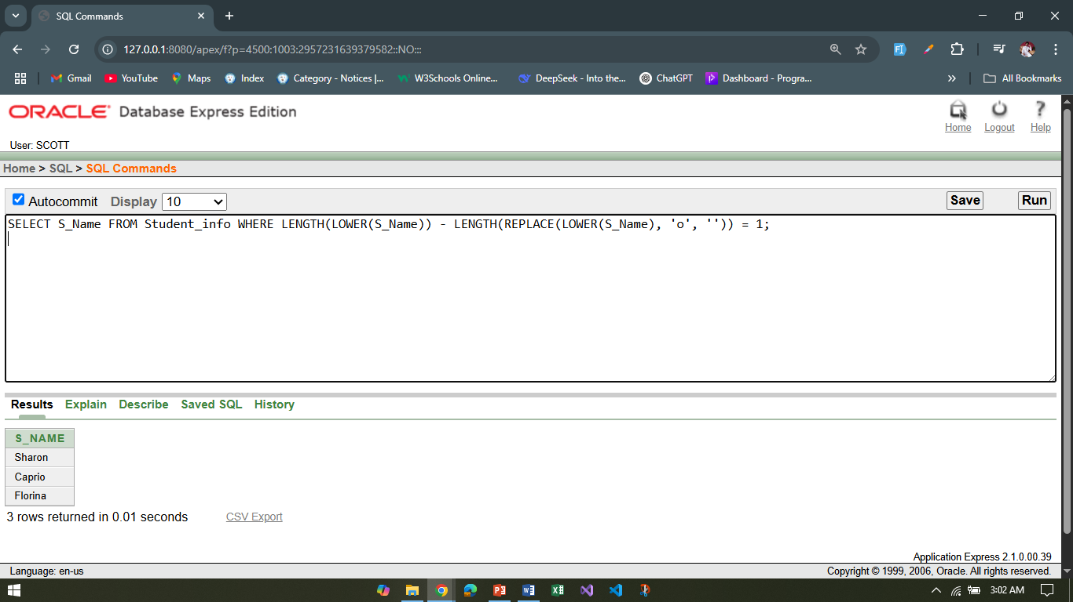

1. Display the student name , CGPA who have null value in their CGPA.

**Answer:**

SELECT S_Name, S_CGPA FROM Student_info WHERE S_CGPA IS NULL;

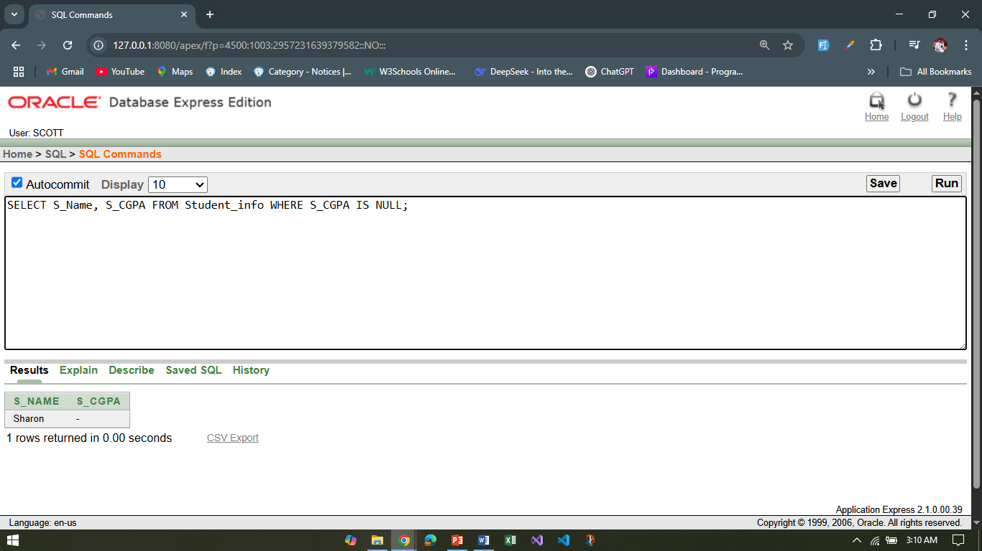

1. Display the city, country, country_code and those must be shown from highest numbered country code to lowest numbered country code.

**Answer:**

SELECT city, country, Country_code

FROM Address

ORDER BY Country_code DESC;

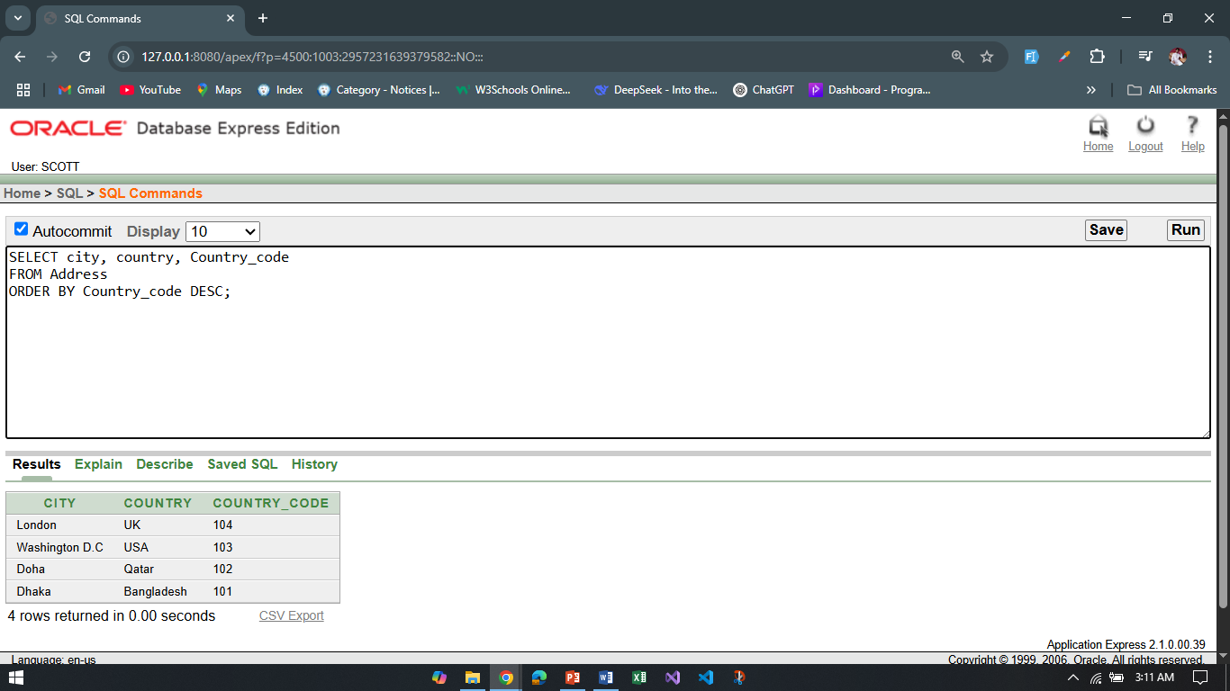

1. Display the student name, student CGPA and student blood status together where the blood status is pureblood using SUBSTR.

**Answer:**

SELECT S_Name, S_CGPA, SUBSTR(S_BloodStatus, 1, LENGTH(S_BloodStatus)) AS BloodStatus

FROM Student_info

WHERE S_BloodStatus = 'Pureblood';

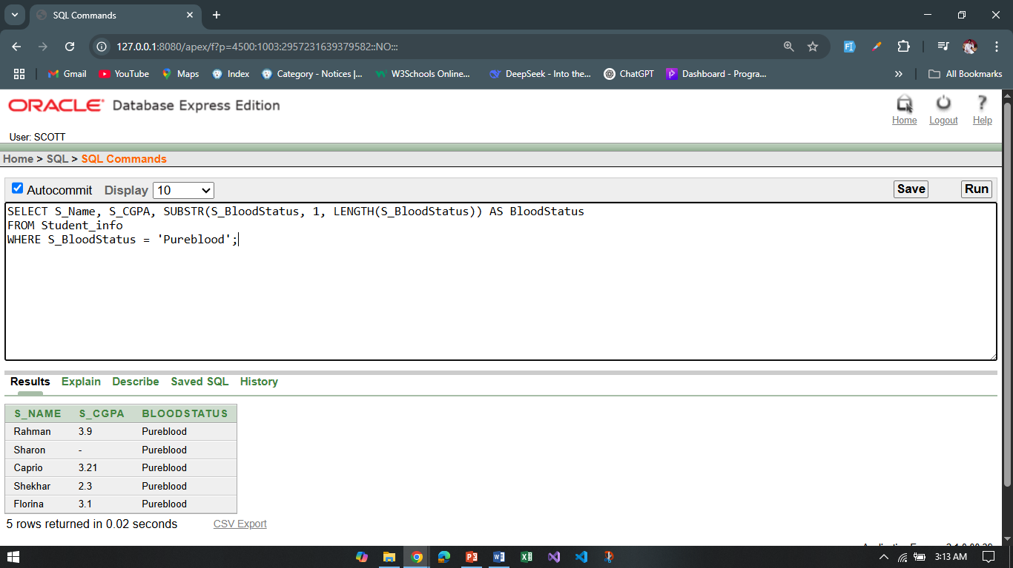

1. Show all the students with their CGPA and blood status. If there is any null value use NVL function.

**Answer:**

SELECT S_Name,

NVL(TO_CHAR(S_CGPA), 'Not Available') AS CGPA,

NVL(S_BloodStatus, 'Not Specified') AS Blood_Status

FROM Student_info;

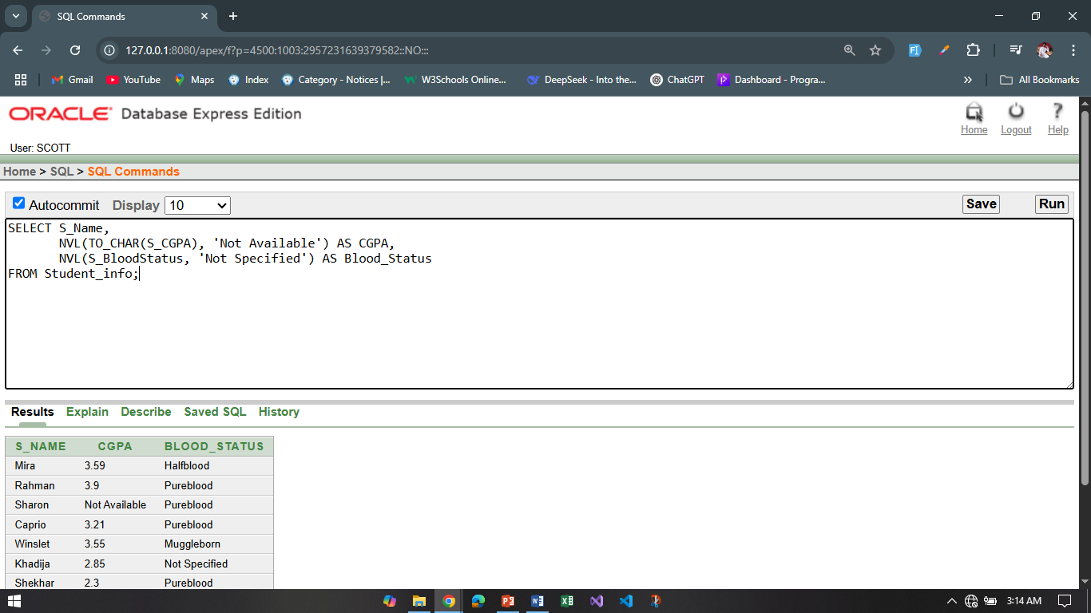

1. Find out the student who is holding maximum CGPA.

Answer:

SELECT S_Name, S_CGPA

FROM Student_info

WHERE S_CGPA = (SELECT MAX(S_CGPA) FROM Student_info);

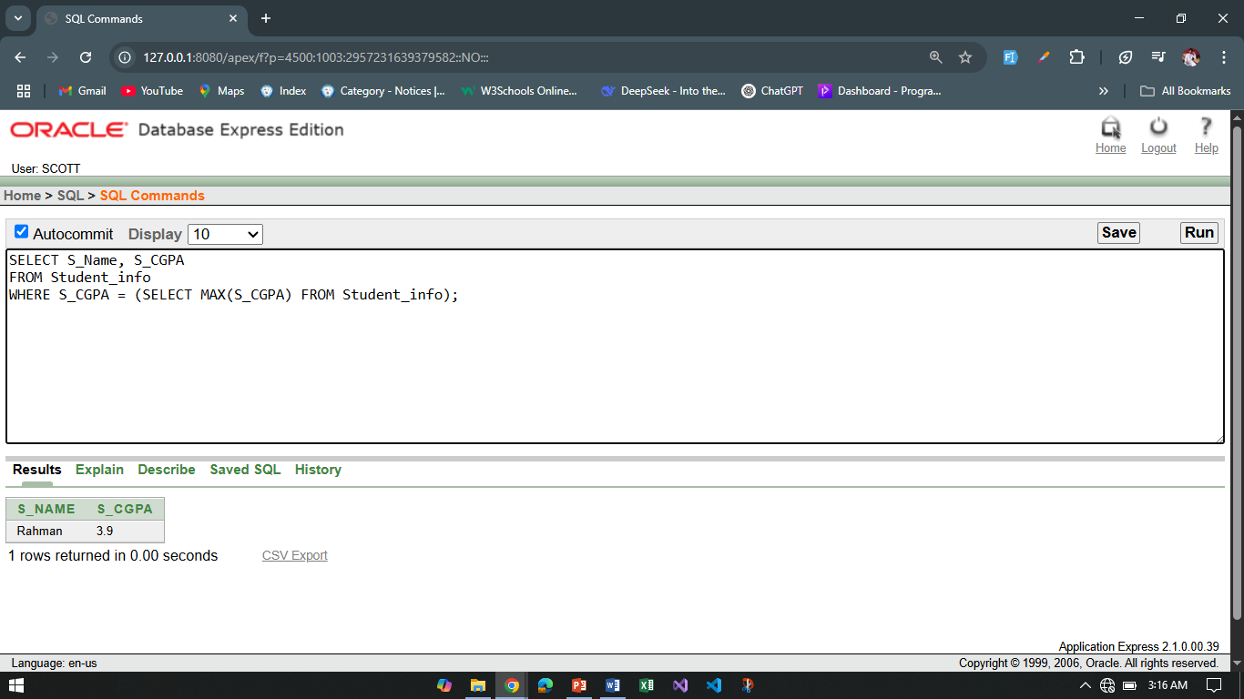

**PL SQL:**

1. Display the name, CGPA, (CGPA-0.5) of the students from the Student_info table.

**Answer:**

BEGIN

FOR stu IN (SELECT S_Name, S_CGPA FROM Student_info) LOOP

dbms_output.put_line('Name: ' || stu.S_Name);

dbms_output.put_line('CGPA: ' || stu.S_CGPA);

dbms_output.put_line('CGPA - 0.5: ' || (stu.S_CGPA - 0.5));

dbms_output.put_line('---------------------------');

END LOOP;

END;

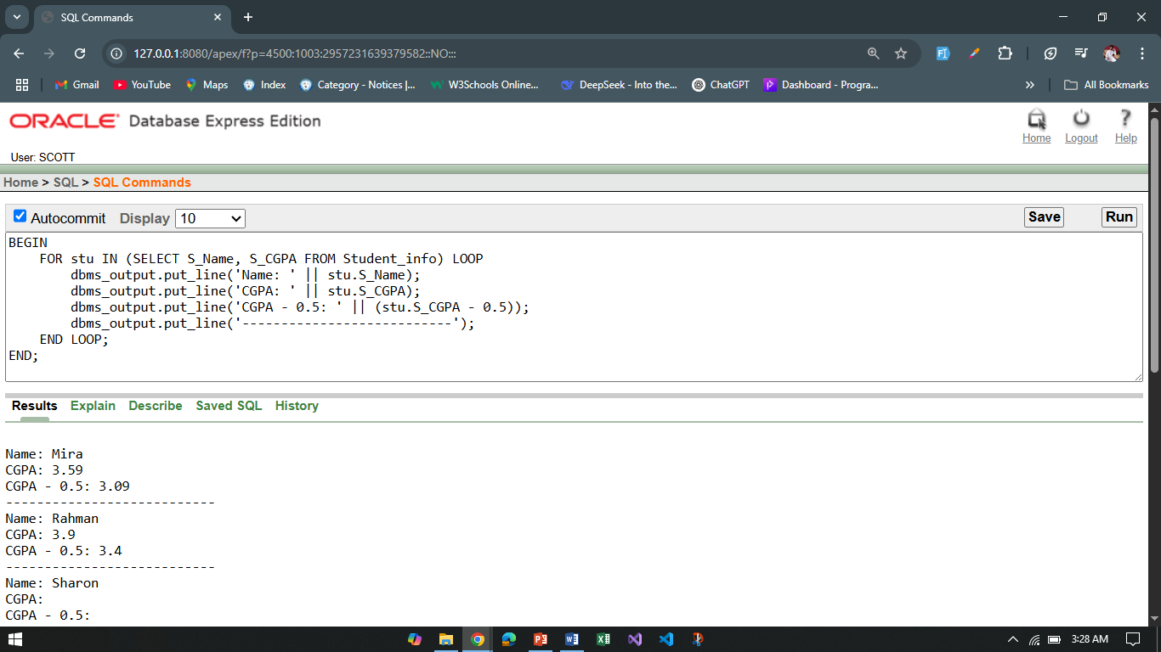

1. Display country and country code together as “Country_info” using concatenation function.

**Answer:**

BEGIN

FOR addr IN (SELECT country, country_code FROM Address) LOOP

dbms_output.put_line('Country_info: ' || addr.country || ' - ' || addr.country_code);

END LOOP;

END;

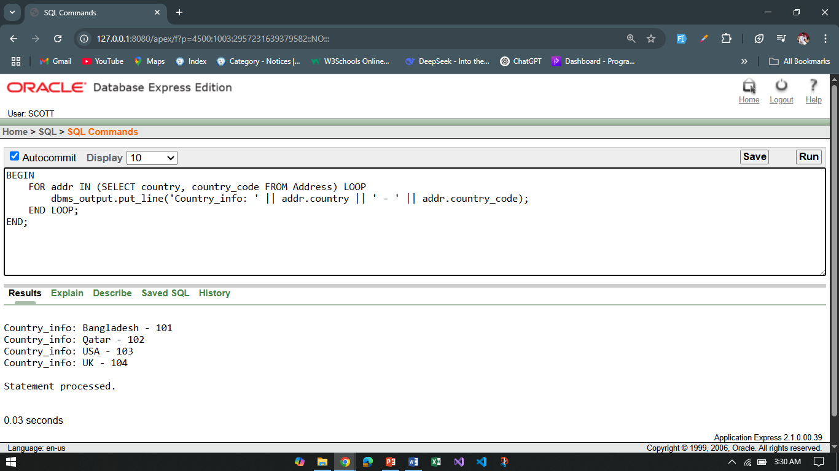

1. Display the student name and student blood status with the column name “Student Name” and “Student Blood Status” from Student_info.

**Answer:**

BEGIN

FOR stu IN (SELECT S_Name, S_BloodStatus FROM Student_info) LOOP

dbms_output.put_line('Student Name: ' || stu.S_Name);

dbms_output.put_line('Student Blood Status: ' || stu.S_BloodStatus);

dbms_output.put_line('--------------------------------');

END LOOP;

END;

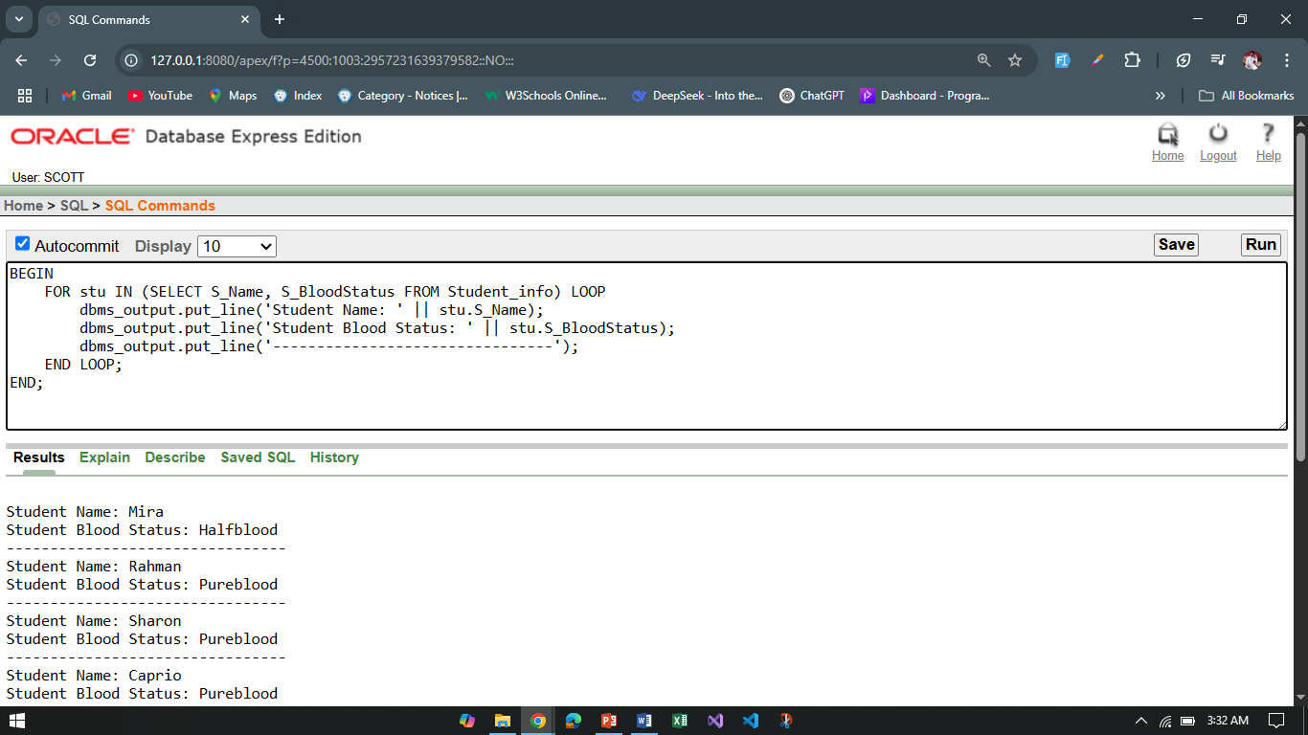

1. Display all students who have only one ‘o’ in their name.

**Answer:**

BEGIN

FOR stu IN (SELECT S_Name FROM Student_info) LOOP

IF LENGTH(stu.S_Name) - LENGTH(REPLACE(stu.S_Name, 'o', '')) = 1 THEN

dbms_output.put_line('Student with one "o": ' || stu.S_Name);

END IF;

END LOOP;

END;

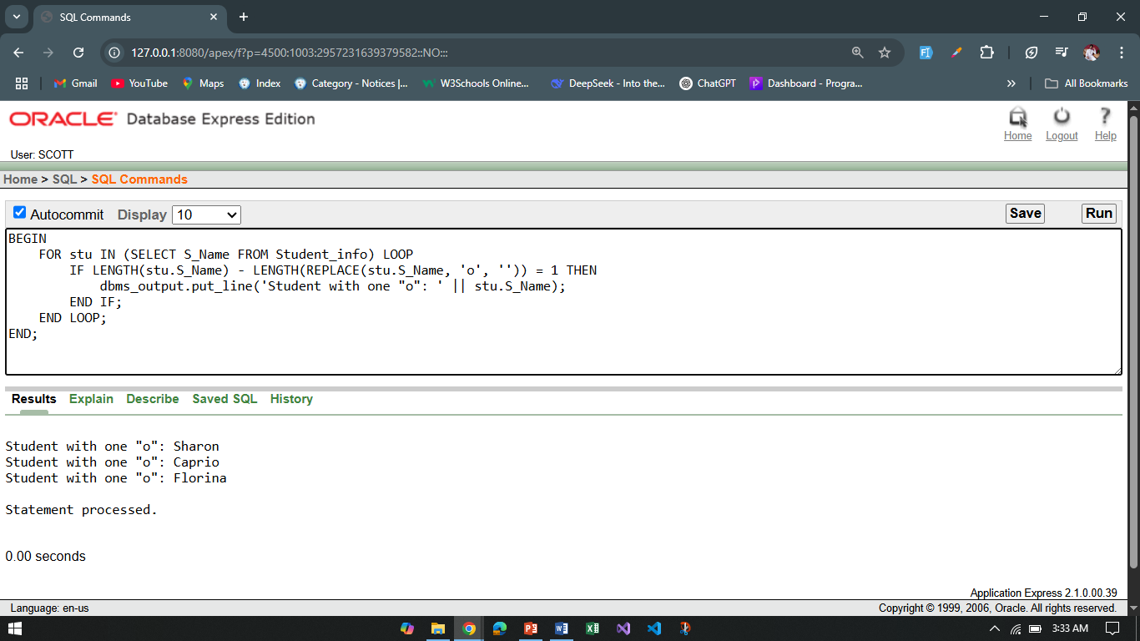

1. Display the student name , CGPA who have null value in their CGPA.

**Answer:**

BEGIN

FOR stu IN (SELECT S_Name, S_CGPA FROM Student_info) LOOP

IF stu.S_CGPA IS NULL THEN

dbms_output.put_line('Name: ' || stu.S_Name || ', CGPA is NULL');

END IF;

END LOOP;

END;

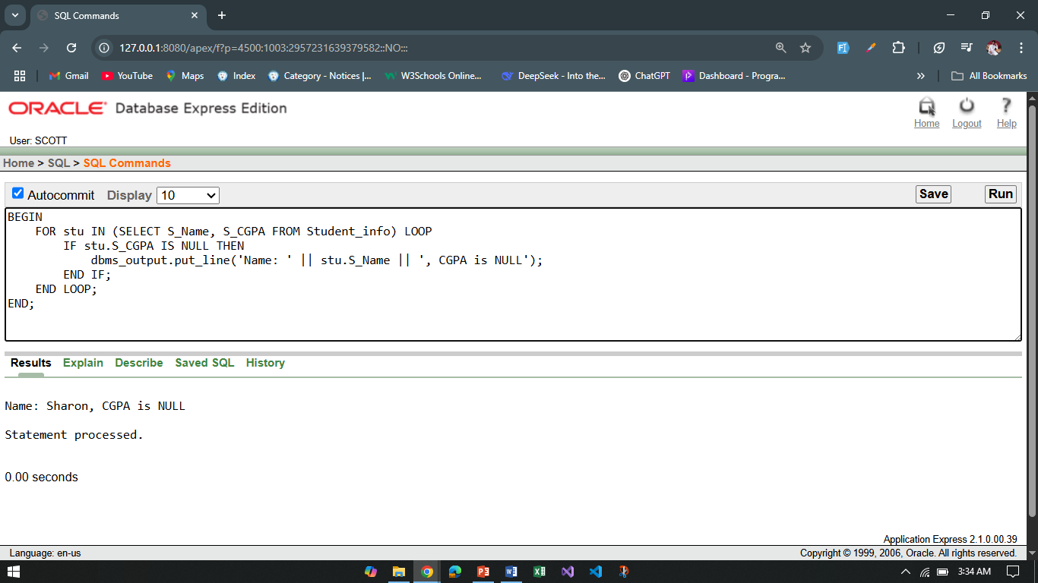

1. Display the city, country, country_code and those must be shown from highest numbered country code to lowest numbered country code.

**Answer:**

BEGIN

FOR addr IN (

SELECT city, country, country_code FROM Address ORDER BY country_code DESC

) LOOP

dbms_output.put_line('City: ' || addr.city || ', Country: ' || addr.country || ', Code: ' || addr.country_code);

END LOOP;

END;

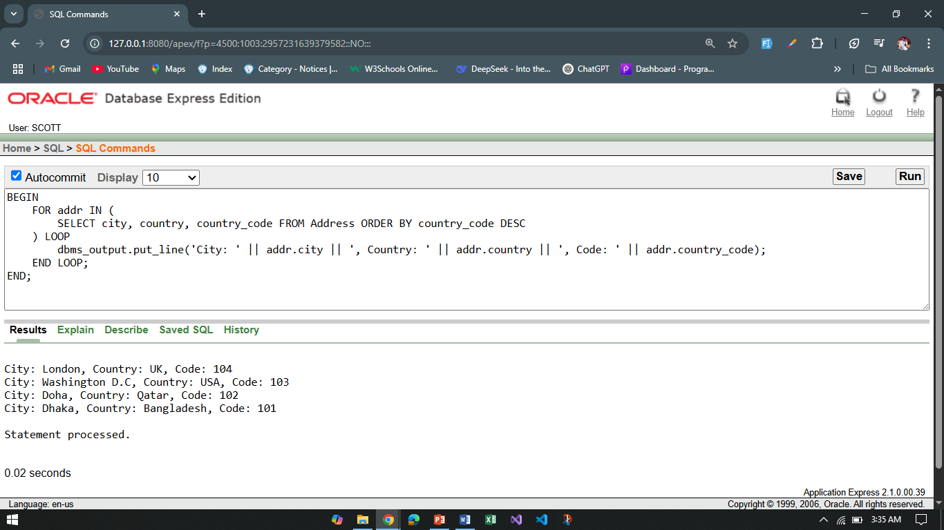

1. Display the student name, student CGPA and student blood status together where the blood status is pureblood using SUBSTR.

**Answer:**

BEGIN

FOR stu IN (

SELECT S_Name, S_CGPA, S_BloodStatus FROM Student_info WHERE S_BloodStatus = 'Pureblood'

) LOOP

dbms_output.put_line('Name: ' || SUBSTR(stu.S_Name, 1));

dbms_output.put_line('CGPA: ' || stu.S_CGPA);

dbms_output.put_line('Blood Status: ' || SUBSTR(stu.S_BloodStatus, 1));

dbms_output.put_line('--------------------------------');

END LOOP;

END;

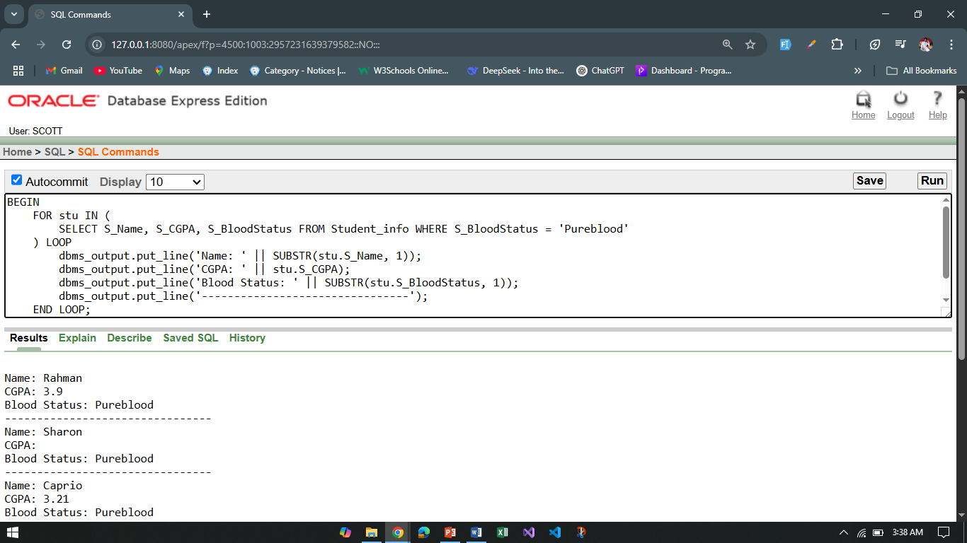

1. Show all the students with their CGPA and blood status. If there is any null value use NVL function.

**Answer:**

BEGIN

FOR stu IN (SELECT S_Name, NVL(S_CGPA, 0) AS CGPA, NVL(S_BloodStatus, 'Unknown') AS BloodStat FROM Student_info) LOOP

dbms_output.put_line('Name: ' || stu.S_Name || ', CGPA: ' || stu.CGPA || ', Blood Status: ' || stu.BloodStat);

END LOOP;

END;

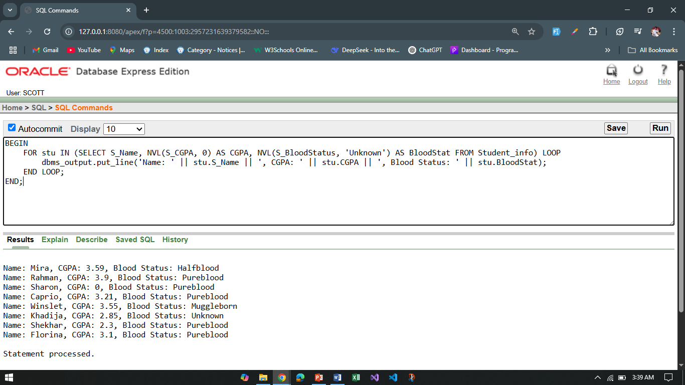

1. Find out the student who is holding maximum CGPA.

**Answer:**

DECLARE

max_cgpa NUMBER;

student_name VARCHAR2(50);

BEGIN

SELECT MAX(S_CGPA) INTO max_cgpa FROM Student_info;

SELECT S_Name INTO student_name

FROM Student_info

WHERE S_CGPA = max_cgpa;

dbms_output.put_line('Top Student: ' || student_name);

dbms_output.put_line('Maximum CGPA: ' || max_cgpa);

END;

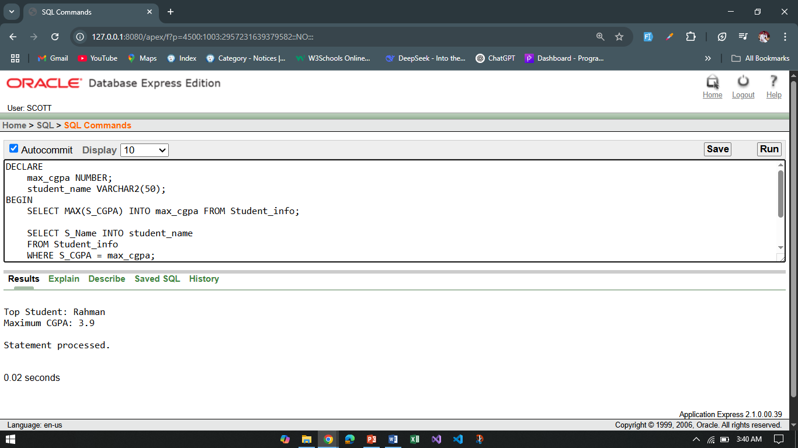

**\*\*Solve the above questions (1 to 9) with SQL. Afterwards solve the same questions with PL/SQL. Write down the answer and give screenshot of the results of the query in a MS Word document. You must use Oracle 10g.The name of the document MUST be your ID (solutions MUST be numbered accordingly) and upload it in the provided link in your VUES account**