**Class Test 05**

**PL/SQL**

*To solve the following use the scott schema*

1. Create a cursor that can output all the data from salgrade table.

**Answer:**

DECLARE

CURSOR sal_cursor IS

SELECT * FROM salgrade;

sal_record salgrade%ROWTYPE;

BEGIN

OPEN sal_cursor;

LOOP

FETCH sal_cursor INTO sal_record;

EXIT WHEN sal_cursor%NOTFOUND;

DBMS_OUTPUT.PUT_LINE('Grade: ' || sal_record.grade || ', LowSal: ' || sal_record.losal || ', HighSal: ' || sal_record.hisal);

END LOOP;

CLOSE sal_cursor;

END;

/

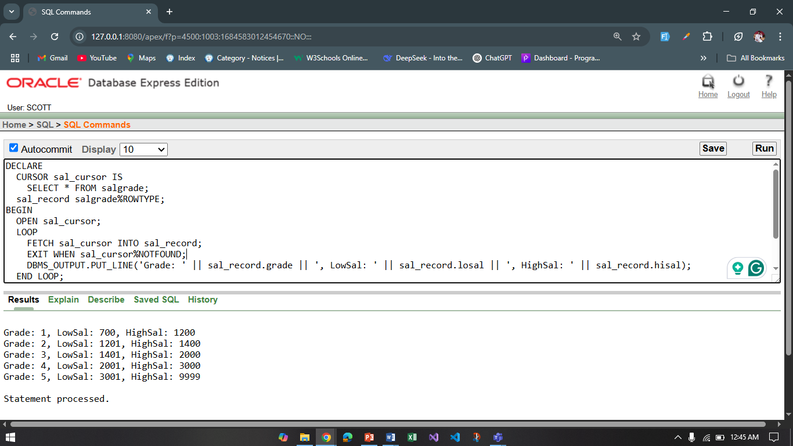

1. Create a record that can output the id, name, job, and hiredate of the employee whose Id is 7654.

**Answer:**

DECLARE

emp_record emp%ROWTYPE;

BEGIN

SELECT * INTO emp_record FROM emp WHERE empno = 7654;

DBMS_OUTPUT.PUT_LINE('ID: ' || emp_record.empno);

DBMS_OUTPUT.PUT_LINE('Name: ' || emp_record.ename);

DBMS_OUTPUT.PUT_LINE('Job: ' || emp_record.job);

DBMS_OUTPUT.PUT_LINE('Hiredate: ' || emp_record.hiredate);

END;

/

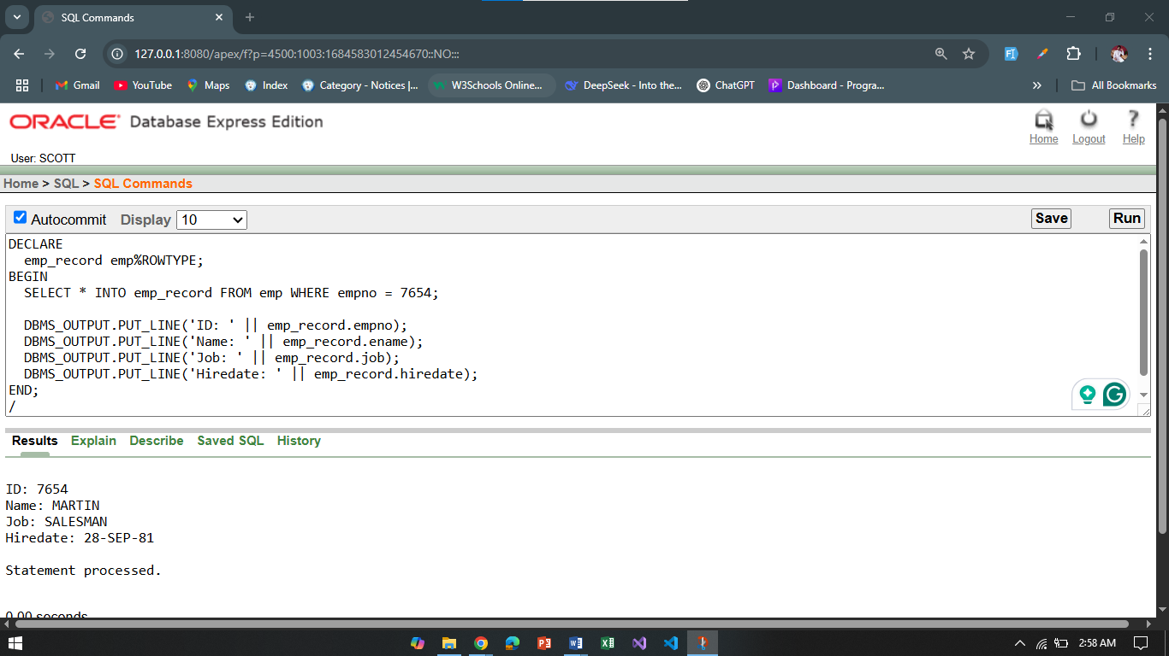

1. Create a trigger in such a way that whenever a new row is inserted into the salgrade table an output ‘New Row Added’ is generated.

**Answer:**

CREATE OR REPLACE TRIGGER trg_salgrade_insert

AFTER INSERT ON salgrade

FOR EACH ROW

BEGIN

DBMS_OUTPUT.PUT_LINE('New Row Added');

END;

/

INSERT INTO salgrade VALUES(6, 1500, 5000);

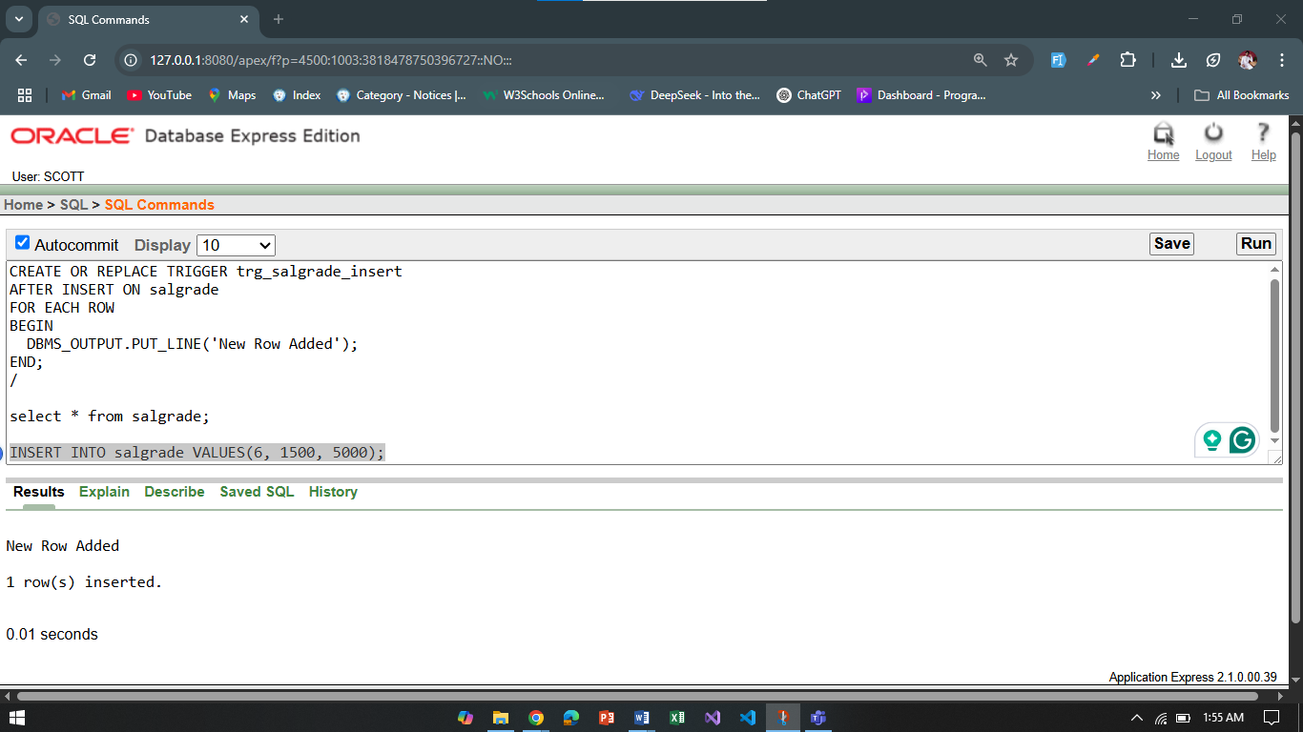

1. Create a package that contains a procedure which can display the grade whose losal and hisal is passed as its parameter.

**Answer:**

CREATE OR REPLACE PACKAGE salgrade_pkg AS

PROCEDURE display_grade(p_losal IN NUMBER, p_hisal IN NUMBER);

END salgrade_pkg;

/

CREATE OR REPLACE PACKAGE BODY salgrade_pkg AS

PROCEDURE display_grade(p_losal IN NUMBER, p_hisal IN NUMBER) IS

v_grade salgrade.grade%TYPE;

BEGIN

SELECT grade INTO v_grade

FROM salgrade

WHERE losal = p_losal AND hisal = p_hisal;

DBMS_OUTPUT.PUT_LINE('Grade: ' || v_grade);

EXCEPTION

WHEN NO_DATA_FOUND THEN

DBMS_OUTPUT.PUT_LINE('No grade found with given losal and hisal.');

END display_grade;

END salgrade_pkg;

/

BEGIN

salgrade_pkg.display_grade(700, 1200);

END;

/

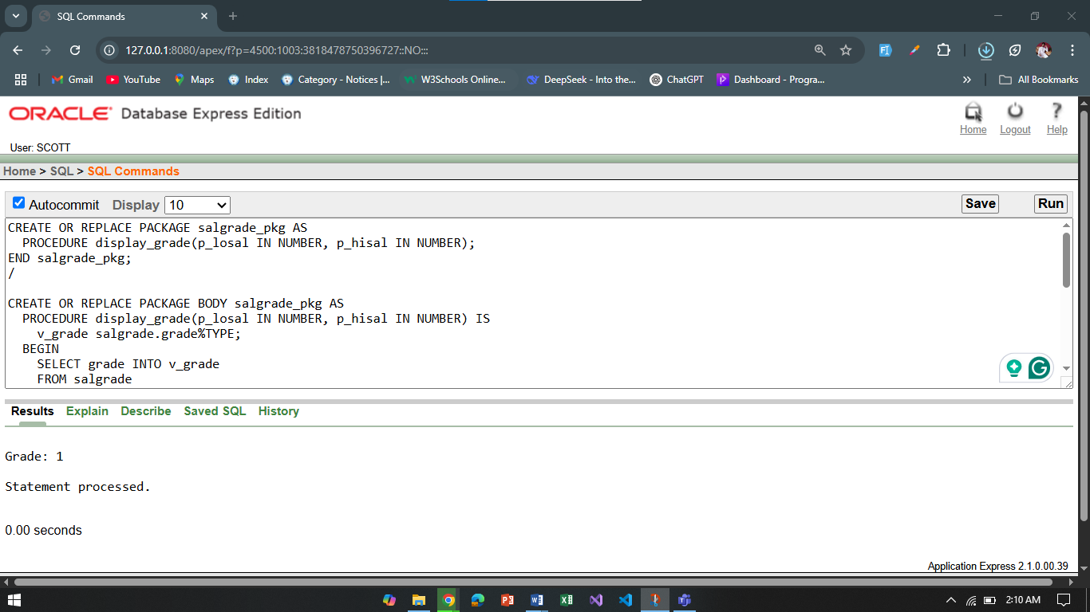

**\*\*After solving the above questions using Oracle 10g, write the PL/SQLs in a MS Word document (Write down the answer and give screenshot of the result of the query. The name of the document MUST be your ID and the PL/SQLs MUST be numbered accordingly) and upload it in the provided link in your VUES account**