SmartCare v0.3 - Domain Model Workbook
Name: Md Mainur Hasan Rubai Student ID: u3313159
Week 6 student resource

Requirement-to-Concept Trace
Requirement | Concept | State/behavior | Decision
FR-01 Book appointment | Appointment | State: patient, practitioner, date, time | Class that links a Patient and a Practitioner; created when booked
FR-02 Cancel appointment | Appointment | Behavior: cancel | Method that changes the status to Cancelled
FR-03 Block double booking | AppointmentManager | Behavior: check for clashes before booking | Needs all appointments to compare, so it goes in the manager, not one Appointment
FR-04 Status: Booked / Cancelled / Completed | Appointment | State: status | Attribute on Appointment, not its own class
FR-05 Keep cancelled appointments in history | Appointment | State: status stays Cancelled | Don't delete cancelled appointments, just change their status
FR-06 Add patient | Patient | State: id, name, DOB, phone, address | Class with attributes; created by the constructor
FR-07 Update patient phone/address | Patient | Behavior: update contact | Method that changes phone and address
FR-08 Find patient by ID or name | Patient list (not a class) | Behavior: search by ID or name | Simple function over the patient list, no manager class needed
FR-09 Show practitioner's appointments and free slots | Practitioner, Appointment | Behavior: list booked and free times | Simple function that filters appointments by practitioner
FR-10 Practitioner sees own appointments | Practitioner | Behavior: view own appointments | Filter appointments by the practitioner's id

CRC Cards

Patient
Responsibilities | Collaborators
Knows its own id, name, date of birth, phone and address (FR-06) | Appointment
Can update its phone and address (FR-07) | -

Practitioner
Responsibilities | Collaborators
Knows its own id and name (FR-11). | Appointment
Can see its own appointments (FR-10). | Appointment

Appointment
Responsibilities | Collaborators
Knows its patient, practitioner, date, time and status (FR-01, FR-04). | Patient, Practitioner
Can be cancelled and have its status changed, keeping cancelled ones in history (FR-02, FR-04, FR-05). | Patient, Practitioner

Optional class: AppointmentManager
Responsibilities | Collaborators
Holds all appointments so they can be compared (FR-01, FR-05). | Appointment
Checks for double bookings before booking and shows a practitioner's appointments and free slots (FR-03, FR-09). | Appointment, Practitioner

UML Class Diagram

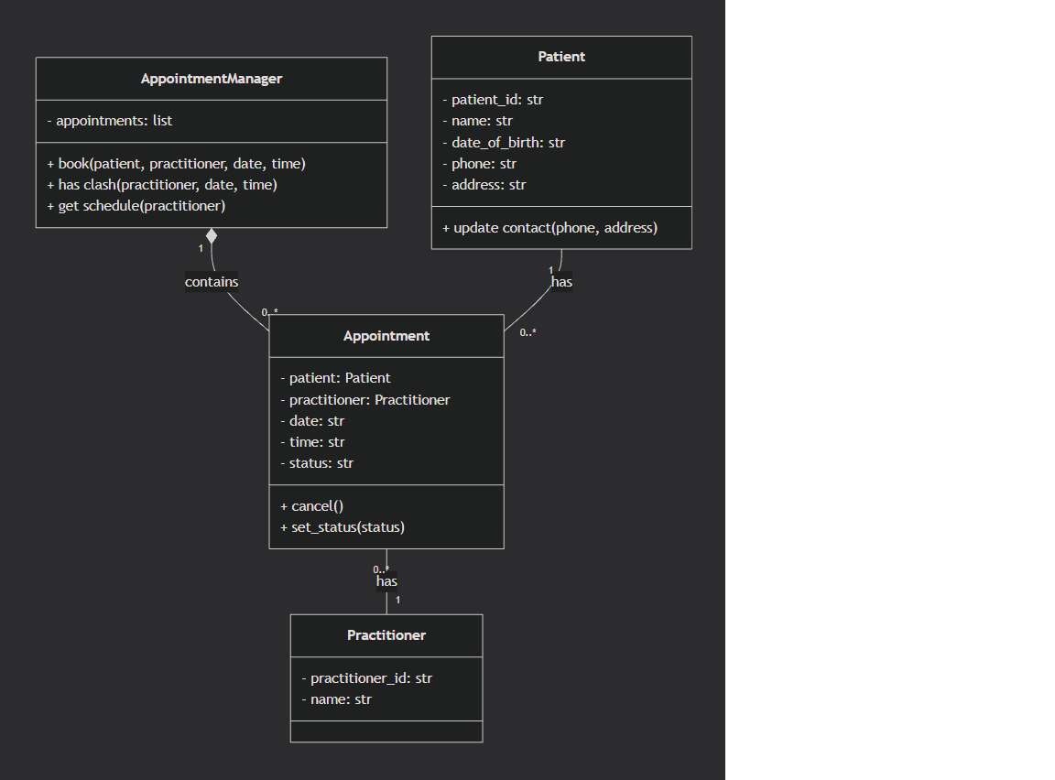

Design Rationale
Explain Class Selection
We decided to go with those four main classes, Patient, Practioner, Appointment and AppointmentManager. They really are the core pieces needed to make the system function. We intentionally did not design separate classes for elements such as Name, Status, Clinic, Database and Cancelation. The thing is that Name and Status are just simple things or properties that belong to other things, not separate things with their own behavior. The database is really just storage, an implementation detail that we don't have to model as a class. And Cancelation ? That’s just an action, something that happens to an appointment, so it makes much more sense as a method, not a class of its own.
Responsibility Allocation
We put has_clash() inside AppointmentManager because scheduling conflict checking is a big picture problem—you need to compare one slot against everything else that’s been booked. A single Appointment simply can't see the rest of the schedule, so it has no business trying to detect clashes. cancel() belongs to Appointment itself, because canceling is really just changing that specific appointment's own state, like flipping it from "Active" to "Cancelled." This is a classic case of giving the job to the person who actually has the information to do the job.
Key Relationships
The 1-to-0..* relationship between Patient/Practitioner and Appointment is just reality. A person can exist in the system with zero appointments, or they can have a whole bunch over time. We didn't use inheritance as an Appointment isn't a type of Patient or Practitioner, they are completely different things that are just connected to each other, not in the same family tree. The filled diamond means composition, i.e. the AppointmentManager really owns its Appointments and manages their lifecycle. They are not things in themselves, independent of the manager.

AI Design Review Record
AI suggestion | Evidence | Decision | Reason | Model change
Add a Receptionist class with operations like bookAppointment() | Copilot cited FR-01, FR-02, FR-06… but these only say a receptionist uses the system | Rejected | A receptionist is a user of the system, not something the clinic stores data about. Copilot gave it no attributes. | None
AppointmentStatus enumeration |  | Accepted | An enumeration only allows those three values, so a typo like "Canceled" can't be saved. | Changed status: str to status: AppointmentStatus and added an «enumeration» box
  FR-04 lists exactly three statuses: Booked, Cancelled, Completed
Practitioner has no attributes | FR-11 adds a practitioner and FR-12 lists them | Modified | FR-12 needs something to list, so Practitioner has to keep an id and a name. | Kept id and name, noted as assumptions (not stated in FR-11)
 |  | Rejected | One Practitioner can't see all the appointments, but AppointmentManager holds the full list. | None, get_schedule() stays on AppointmentManager
  Practitioner.viewTodayAppointments()
  FR-09 and FR-10 need a practitioner's appointments
Split update into updatePhoneNumber() / updateAddress() | FR-07 says update phone or address | Rejected | A single method already covers both, and splitting it adds methods without meeting any extra requirement. | None, kept update_contact(phone, address)

