**Answer to the question no: 01**

**Code:**

#include<stdio.h>

int main(){

int a,b,sum,sub,mul,add,mod;

char op;

printf("Enter an operator (+, -, *,/,%): ");

scanf("%c", &op);

printf("Enter two operands: ");

scanf("%d %d", &a, &b);

switch (op) {

case '+':

printf("%d + %d= %d", a,b, a+b);

break;

case '-':

printf("%d- %d = %d",a,b,a-b);

break;

case '*':

printf("%d*%d = %d",a,b, a*b);

break;

case '/':

printf("%d / %d= %d",a,b, a/b);

break;

default:

printf("mod = %d", a%b);

}

return 0;

}

**Output:**

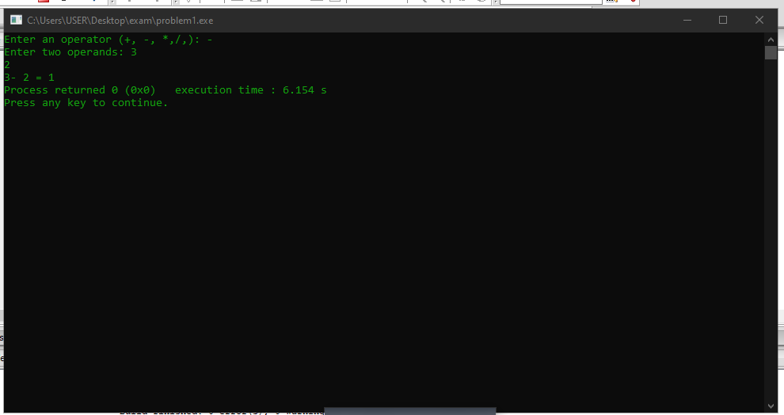

**Answer to the question no: 02**

**Code:**

#include <stdio.h>

int main()

{

int n,t,sum=0,rem;

printf("Enter an integer: ");

scanf("%d", &n);

t = n;

while(t!=0)

{

rem= t % 10;

sum = sum + rem;

t= t/10;

}

printf("Sum of digits = %d",sum);

return 0;

}

**Output:**

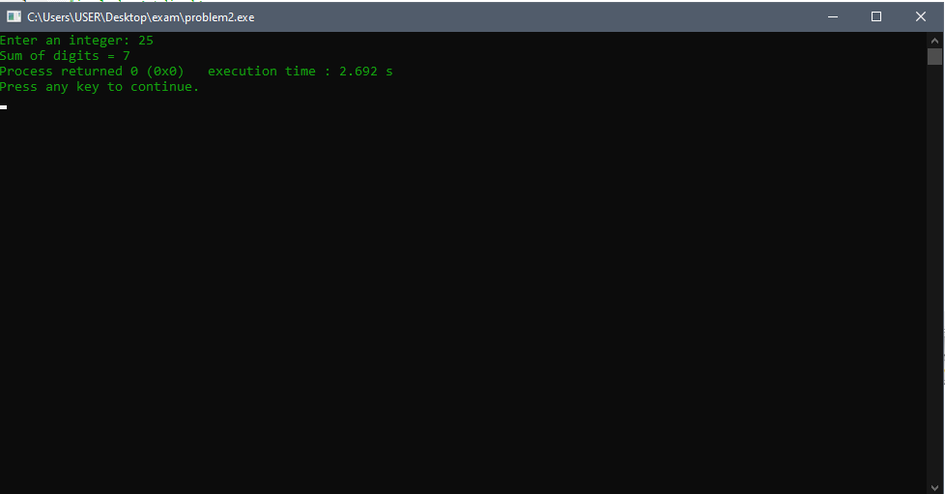

**Answer to the question no: 03**

**Code:**

#include<stdio.h>

int main()

{

int x,i=0,num=0;

printf("Enter a number: ");

scanf("%d",&x);

while(x>0 && x%2==0)

{

x/=2;

num++;

}

printf("Number of times the number is divisible by 2 is: %d" , num);

return 0;

}

**Output:**

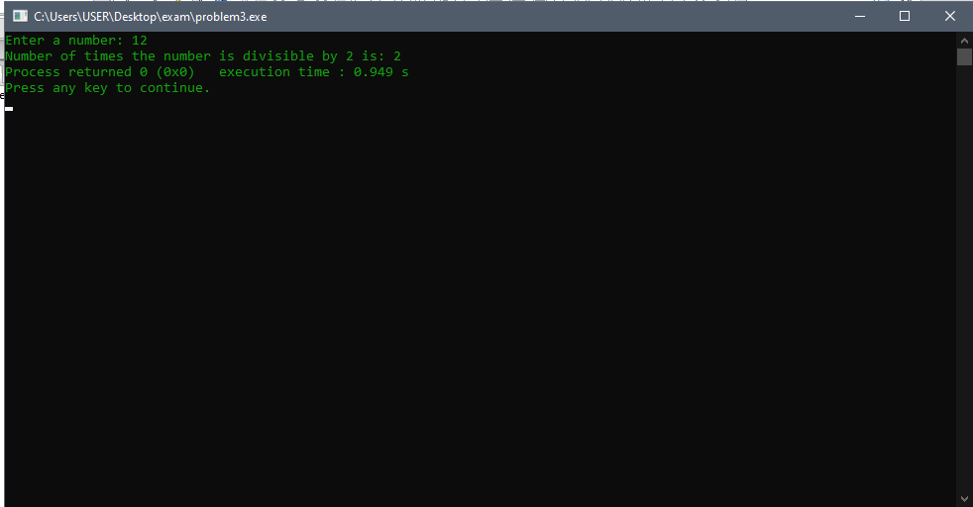

**Answer to the question no: 04**

**Code:**

#include <stdio.h>

#include <limits.h>

int main()

{

int x,

max_num = INT_MIN,

min_num = INT_MAX,

diff = 0;

printf(“Enter a number: ”);

while(1)

{

scanf("%d", &x);

if(x == -1)

break;

if(x > max_num)

max_num = x;

if(x < min_num)

min_num = x;

}

diff = max_num - min_num;

printf("Result: %d\n", diff);

return 0;

}

**Output:**

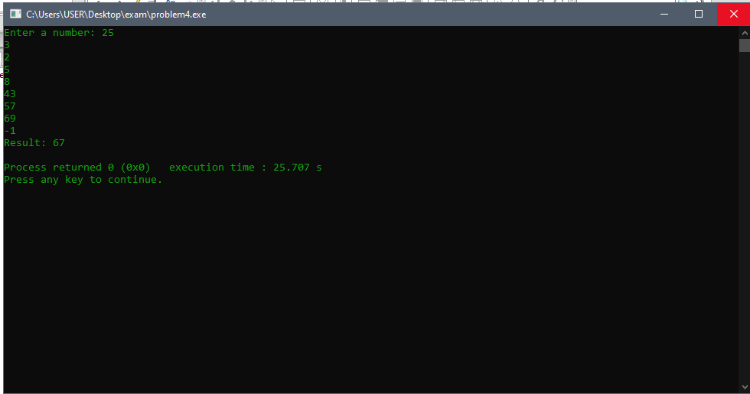

**Answer to the question no: 05**

**Code:**

#include<stdio.h>

int main()

{

int x, y, n;

scanf("%d", &n);

for(x=1; x<=n; x++)

{

for(y=1; y<=n; y++)

{

if(x==1 || x==n || y==1 || y==n)

{

printf("*");

}

else

{

printf(" ");

}

}

printf("\n");

}

return 0;

}

**Output:**

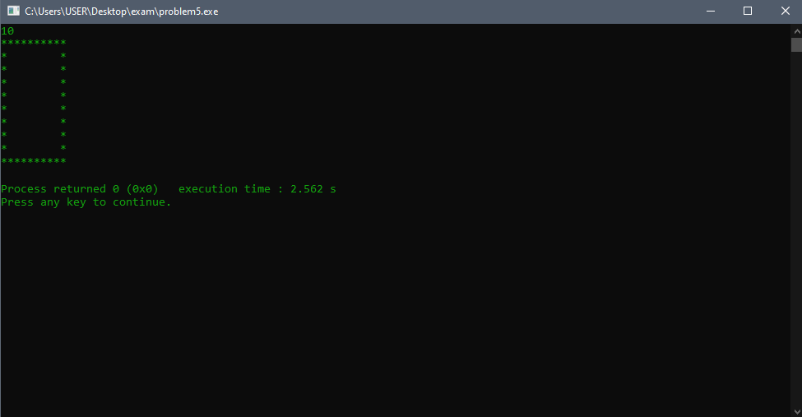

**Answer to the question no: 06**

**Code:**

#include <stdio.h>

int main()

{

while(1)

{

int x = 0, y = 0, res = 1;

printf("Enter base: ");

scanf("%d", &x);

printf("Enter exponent: ");

scanf("%d", &y);

while(y--)

{

res = x * res;

}

printf("Result: %d\n", res);

}

return 0;

}

**Output:**

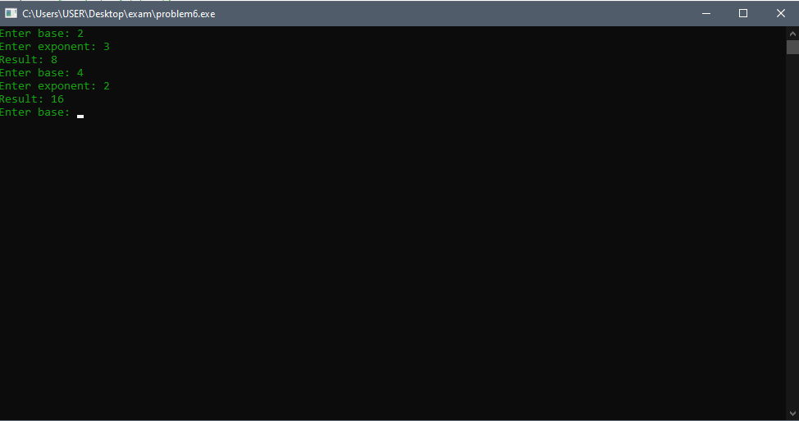

**Answer to the question no: 07**

**Code:**

#include <stdio.h>

int main()

{

int num,i,f;

i=f=1;

printf("Enter the number : ");

scanf("%d",&num);

while(i<=num)

{

f=f*i;

i++;

}

printf("It's Factorial: %d",f);

return 0;

}

**Output:**

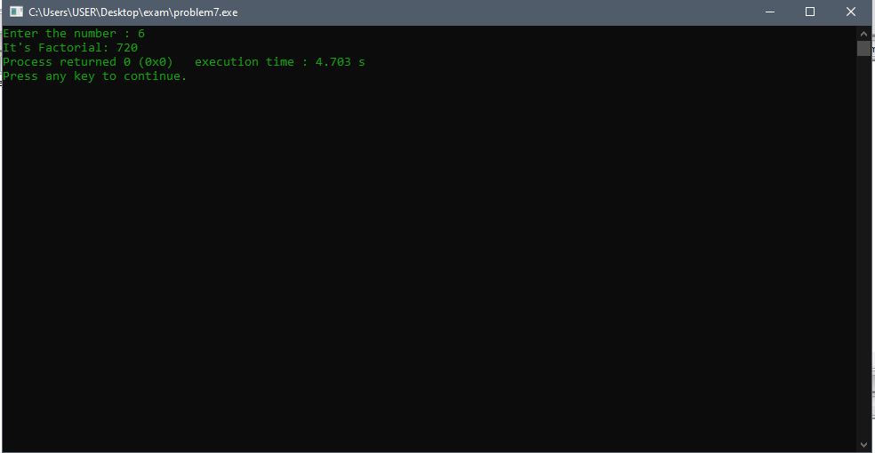

**Answer to the question no: 08**

**Code:**

#include<stdio.h>

int main()

{

int n, i, f = 1,j;

float e = 1.0;

start:

printf("Enter n value: ");

scanf("%d", &n);

if(n < 0)

{

printf("Please enter non-negetive value\n");

goto start;

}

for(i = 1; i <= n; i++)

{

for(j = 1; j <= i; j++)

{

f = f*j;

}

e = e + ((float)1/f);

f = 1;

}

printf("Result is: %f\n",(float)e);

return 0;

}

**Output:**

