This Documentation is for the Frontend Workshop and Hackathon conducted by Girlscript Bilaspur.

The theme I chose for the hackathon is creating a Bakery and Restaurant page

Name – Rubal Agrawal

Code- GSBSP-BR41

Assignment Given To me :

Problem Statements: “Bakery and Restaurant Page”

* Website must contain the following elements in minimum,

Nav Bar

Home Page/Landing Page

About Section

Footer

* 30 Dishes
* Website must have the following things/elements

A Menu Card

A contact us page/section

Company Logo

Business location

Completed my assignment as given above .This was first attempt to create a website in any Hackathon/Competition .

My Restaurant Name – **THE DISASTER RESTAURANT**

I have created my logo with the help of **canva**

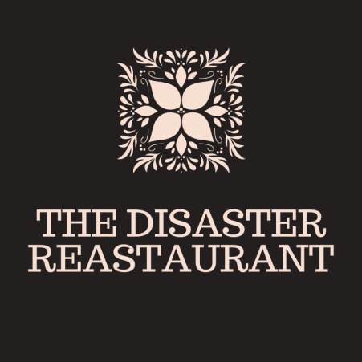

30 dishes which to be included in website is all created by **Canva** and in template mostly pictures are from canva inbuilt free images and some from **google**.

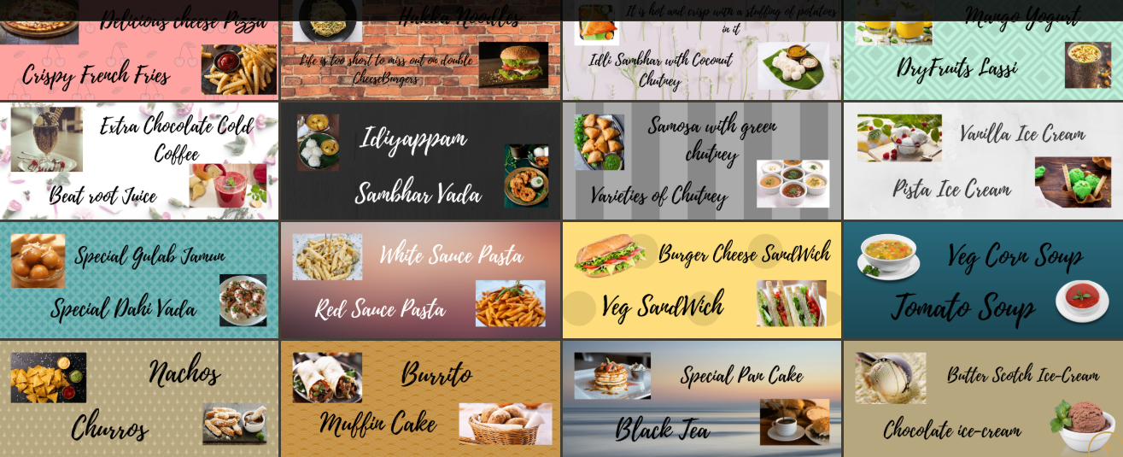

Template is downloaded by bootstrap.