AI-Based Occlusion Handling for AR/VR Using Monocular Depth Estimation and Segmentation Models
Dr. Surbhi Sharma, Rubalpreet Kaur
Department of Electronics and Communication, Thapar Institute of Engineering and Technology

Abstract
Accurate occlusion handling is essential in augmented reality and virtual reality systems because virtual content must obey the same visibility relationships as real-world objects. When occlusion is rendered incorrectly, virtual objects appear unrealistically in front of nearer real objects, which reduces immersion and visual consistency. Many existing occlusion-aware rendering systems address this problem using dedicated depth sensing hardware such as LiDAR, stereo cameras, and Time-of-Flight sensors. Although these approaches improve geometric reliability, they also increase device cost, power consumption, and hardware complexity. This paper presents a hardware-independent occlusion handling framework for AR/VR using monocular depth estimation and segmentation from standard RGB input. The proposed framework combines MiDaS for dense monocular depth prediction [1] with U²-Net for foreground object segmentation [2]. The resulting depth map and segmentation mask are fused in a pixel-wise occlusion reasoning module that determines whether virtual content should remain visible or be hidden behind real-world scene elements. The framework is implemented in Python using OpenCV and ONNX Runtime and evaluated on a CPU-only system with a standard laptop webcam.
Experimental observations show that the proposed pipeline can produce qualitatively plausible occlusion-aware compositing without dedicated depth sensors. The current implementation operates at approximately 0.5-1 frames per second, which indicates that the system is suitable as a proof of concept but still requires optimization for interactive deployment. The results support the feasibility of low-cost monocular RGB-based occlusion handling for future lightweight AR/VR platforms.
Keywords
Augmented Reality, Virtual Reality, Occlusion Handling, Monocular Depth Estimation, Semantic Segmentation, MiDaS, U²-Net

I. Introduction
Augmented reality and virtual reality technologies are increasingly used in education, healthcare, gaming, industrial training, and immersive visualization. A key requirement in these systems is correct visibility reasoning between real and virtual objects. If occlusion is handled incorrectly, virtual content may appear to pass through real objects or remain visible when it should be hidden. Such artifacts reduce spatial realism and weaken user immersion.
Traditional occlusion handling methods often rely on explicit geometric models, fiducial markers, background subtraction, or dedicated depth sensing hardware. These approaches can perform well in constrained settings, but they depend on prior scene knowledge, controlled capture conditions, or specialized sensors, which limits their suitability for low-cost and lightweight platforms [3]. Depth-sensing solutions can provide reliable geometric cues, but they also increase hardware cost, energy usage, and system complexity.
Recent progress in deep learning has made monocular depth estimation a viable alternative for sensor-free scene understanding. MiDaS demonstrated strong cross-dataset generalization for dense relative depth prediction from single
RGB images [1]. More recent methods such as ZoeDepth further improved depth estimation robustness [4]. However, monocular depth estimation alone is often insufficient for high-quality occlusion handling because it may produce unstable boundaries, errors on thin structures, and ambiguous depth discontinuities [1].

Segmentation provides a complementary signal by identifying object regions at the pixel level. U²-Net was designed to preserve both local detail and global context, making it effective for salient object extraction and boundary preservation [2]. When combined with depth estimation, segmentation can improve foreground localization and reduce false occlusion artifacts.
This paper presents a hardware-independent occlusion handling framework for AR/VR using monocular RGB input. The framework combines MiDaS-based depth estimation [1] with U²-Net-based segmentation [2] and fuses both outputs through a pixel-wise occlusion reasoning module. The work is positioned as a modular prototype and feasibility study rather than a new end-to-end occlusion foundation model.
In addition, adversarial refinement of occlusion masks is considered as a possible future extension for improving boundary quality and thin-structure preservation.

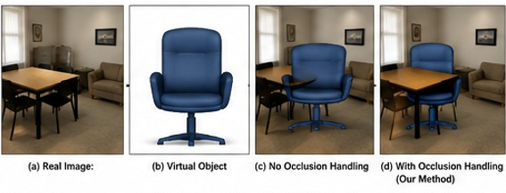
Fig. 1. Visual comparison between conventional rendering and the proposed occlusion-aware rendering. (a) Input RGB scene, (b) virtual object, (c) rendering without occlusion handling, and (d) rendering using the proposed occlusion-aware framework.
The main contributions of this work are as follows:
- A hardware-independent occlusion handling framework for AR/VR using only monocular RGB input.
- A fused depth-segmentation pipeline for pixel-wise visibility reasoning between real and virtual objects.
- A CPU-only prototype implemented using Python, OpenCV, and ONNX Runtime on commodity hardware.
- A proof-of-concept evaluation demonstrating feasible monocular occlusion-aware compositing without dedicated depth sensors.
The remainder of the paper is organized as follows. Section II reviews related literature. Section III presents the proposed methodology. Section IV describes the experimental setup and results. Section V discusses limitations and future work. Section VI concludes the paper.

II. Literature Review

A. Traditional Occlusion Handling Methods
Occlusion handling is a central problem in AR/VR because correct visibility relationships are necessary for believable scene composition. Earlier approaches commonly relied on explicit geometric scene models, fiducial markers, background subtraction, or predefined object models to determine whether virtual objects should appear in front of or behind real objects. These methods can be effective in controlled environments, but they depend on prior scene knowledge and adapt poorly to dynamic scenes with moving users or objects [3]. Their reliance on handcrafted representations limits scalability in practical deployment.

B. Depth-Based Occlusion Handling
Depth sensing substantially improved occlusion handling by enabling direct estimation of spatial relationships between real and virtual objects. Conventional systems have used stereo vision, RGB-D cameras, structured-light sensors, Time-of-Flight cameras, and LiDAR to generate depth maps for visibility reasoning. Although such methods often provide accurate geometry, they require specialized hardware and calibration, which increases system cost and complexity.
Monocular depth estimation addresses this limitation by predicting dense depth maps from a single RGB image. Ranftl et al. introduced MiDaS, which achieved strong zero-shot transfer across diverse indoor and outdoor datasets through mixed-dataset training and scale- and shift-invariant optimization [1]. This makes monocular depth estimation relevant to sensor-free occlusion handling. However, the same work also shows limitations that matter for compositing, including boundary blur, thin-structure failure, and ambiguous depth discontinuities [1]. ZoeDepth later improved generalization by combining relative and metric depth strategies [4].

C. Segmentation-Based Occlusion Handling
Depth prediction provides geometric ordering but does not always preserve precise object boundaries. This is especially problematic in AR/VR compositing because mask errors become visually obvious near silhouettes, fingers, cables, and hair. Segmentation methods help address this issue by identifying foreground regions at the pixel level.
U²-Net introduced a nested U-shaped architecture that preserves local detail while also modeling wider scene context [2]. This design is well suited for salient object extraction and fine-structure preservation. In occlusion-aware rendering, segmentation improves foreground-background separation and reduces false visibility artifacts at object edges. However, segmentation alone cannot determine relative depth ordering between real and virtual content because it does not encode which surfaces are closer to the camera [2].

D. Learning-Based Occlusion Reasoning
Recent work has moved beyond explicit depth-threshold pipelines toward learned visibility reasoning. Instead of first estimating full scene depth and then comparing it with virtual object depth, some approaches directly predict occlusion masks from image features and scene context.
Watson et al. proposed an implicit-depth method that predicts compositing masks directly from RGB features and known virtual geometry, thereby avoiding explicit intermediate depth regression [5]. This improves temporal stability and can reduce edge artifacts relative to hard depth-comparison pipelines. Related work has also explored hidden geometry reasoning. Dhamo et al. introduced layered depth prediction from a single image to recover both visible and occluded scene content [6]. More recently, occlusion-aware amodal depth estimation has extended this direction by estimating depth for partially hidden object regions, which improves reasoning in heavily occluded scenes [7]. These methods represent an advanced research direction, but they generally require more specialized architectures and more demanding supervision than lightweight deployment-oriented monocular systems.
Beyond direct depth and segmentation fusion, generative refinement strategies such as GAN-based mask enhancement may offer an additional pathway for improving occlusion boundary quality in visually complex scenes.

E. Research Gap
Despite substantial progress, several limitations remain. Sensor-based methods still depend on specialized hardware. Monocular depth estimation removes this dependency, but its predictions remain unreliable near boundaries and under strong occlusion [1]. Segmentation improves mask quality but lacks geometric ordering [2]. End-to-end learned occlusion systems and amodal depth methods provide stronger reasoning [5], [7], yet they are often more complex and less suitable for simple deployment on commodity hardware.
A practical gap therefore remains for a low-cost, hardware-independent framework that integrates monocular depth estimation and lightweight segmentation into a unified occlusion-aware compositing pipeline deployable on standard consumer hardware.

F. Motivation for the Proposed Work
Motivated by this gap, the present work develops a hardware-independent occlusion handling framework that combines MiDaS-based monocular depth estimation [1] with U²-Net-based foreground segmentation [2]. The depth map provides relative geometric ordering, while the segmentation mask improves foreground extraction and object boundary localization. By fusing these two signals through pixel-wise occlusion reasoning, the framework aims to generate more reliable visibility masks without requiring LiDAR, stereo cameras, or complex scene reconstruction.

III. Proposed Methodology

A. System Overview
The proposed framework performs occlusion-aware AR/VR rendering using only monocular RGB input. It eliminates the need for LiDAR, stereo cameras, and Time-of-Flight sensors by combining monocular depth estimation with foreground segmentation. The system consists of five stages:
- RGB frame acquisition
- Monocular depth estimation
- Foreground segmentation
- Pixel-wise occlusion reasoning
- Occlusion-aware rendering

The processing flow is:
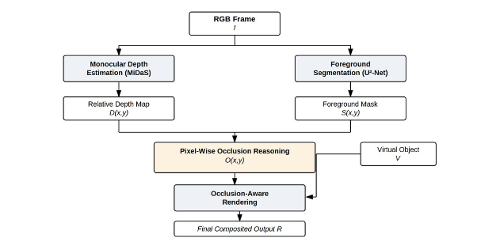
Fig. 2. Overall workflow of the proposed hardware-independent occlusion handling framework. The input RGB frame is processed through monocular depth estimation and semantic segmentation, followed by pixel-wise occlusion reasoning to generate the final occlusion-aware rendered output.The objective is to determine, for each pixel, whether the virtual object should remain visible or be hidden by a real-world foreground region.

B. RGB Frame Acquisition
The input scene is captured using a standard monocular RGB camera such as a laptop webcam. Let the input frame be denoted by
$$I∈R^{H×W×3}$$
where $H$ and $W$ denote image height and width, respectively, and the final dimension corresponds to RGB channels. The captured frame is provided to both the depth estimation and segmentation modules.

C. Monocular Depth Estimation
The framework employs MiDaS as the depth estimation backbone because of its strong cross-dataset generalization and ability to estimate dense relative depth from a single RGB image [1]. The depth estimation process is defined as
$$D=f_{\text{depth}}(I)$$
where $f_{\text{depth}}$ denotes the MiDaS model and $D$ is the estimated relative depth map. For each pixel $(x,y)$, the model outputs a relative depth value $D(x,y)$.
Because MiDaS predicts relative rather than metric depth, the output is used for ordinal visibility reasoning rather than absolute geometric reconstruction. This is sufficient for many AR/VR compositing tasks in which the primary goal is to decide which surface appears in front. However, monocular depth estimation can fail around thin structures and object boundaries [1], which motivates the addition of segmentation.

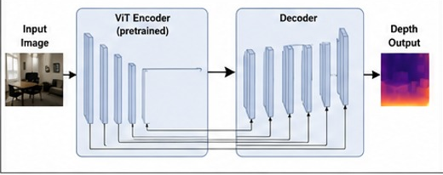
Fig. 3. Architecture of the MiDaS monocular depth estimation model used for predicting dense relative depth maps from a single RGB image.

D. Foreground Segmentation
To improve object boundary localization and isolate likely occluding regions, the framework uses U²-Net for salient object segmentation [2]. The segmentation process is defined as
$$S=f_{\text{seg}}(I)$$
where $f_{\text{seg}}$ denotes U²-Net and $S$ is a binary foreground mask. Each pixel is classified as
$$S(x,y)=\left\{\begin{matrix}1, & \text{foreground} \\ 0, & \text{background}\end{matrix}\right.$$
The segmentation mask identifies real-world scene elements that may occlude virtual content. Because U²-Net preserves fine structures and object contours effectively [2], it complements the depth map by refining boundary localization.

Fig. 4. Pixel-wise occlusion reasoning module illustrating the fusion of the estimated depth map, foreground segmentation mask, and virtual object depth to generate the final occlusion mask.

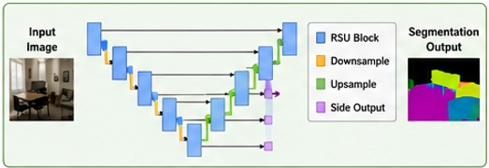
Fig. 5. Architecture of the U²-Net semantic segmentation network employed for foreground object extraction and accurate boundary localization.

E. Pixel-Wise Occlusion Reasoning
The core of the framework is the occlusion reasoning module, which combines relative depth and foreground segmentation to determine visibility. Let $D(x,y)$ denote the real-scene depth value at pixel $(x,y)$, and let $D_{v}$ denote the assigned virtual object depth expressed in the same relative ordering space. An occlusion event occurs when the real-world foreground object is closer than the virtual content.
The occlusion mask $O(x,y)$ is defined as
$$O(x,y)=\left\{\begin{matrix}1, & D(x,y)<D_{v}\text{ and }S(x,y)=1 \\ 0, & \text{otherwise}\end{matrix}\right.$$
where $O(x,y)=1$ indicates that the virtual object should be hidden at pixel $(x,y)$, and $O(x,y)=0$ indicates that the virtual object should remain visible.
This fused rule is more reliable than depth-only masking because it suppresses false occlusion decisions in background regions. The segmentation prior ensures that occlusion is applied only where a plausible real foreground object is present.

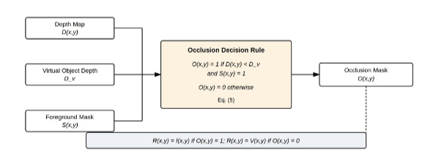
Fig. 5. Occlusion decision module illustrating the fusion of monocular depth estimation and semantic segmentation for pixel-wise occlusion mask generation.

F. Occlusion-Aware Rendering
The final compositing stage combines the real RGB frame, the virtual object, and the occlusion mask. Let $V$ denote the virtual object representation. The rendered output $R$ is defined as
$$R=f_{\text{render}}(I,V,O)$$
with the pixel-wise rendering rule
$$R(x,y)=\left\{\begin{matrix}I(x,y), & O(x,y)=1 \\ V(x,y), & O(x,y)=0\end{matrix}\right.$$
This rule preserves real foreground pixels where they lie in front of the virtual object and displays virtual content where no occlusion is detected.

G. Implementation Details
The prototype is implemented in Python and uses OpenCV for image handling and ONNX Runtime for model inference. MiDaS and U²-Net are deployed in ONNX format to support CPU-only execution.

Component | Implementation
Programming language | Python
Computer vision library | OpenCV
Inference engine | ONNX Runtime
Depth model | MiDaS
Segmentation model | U²-Net
Input device | Laptop webcam
Processing hardware | CPU-only

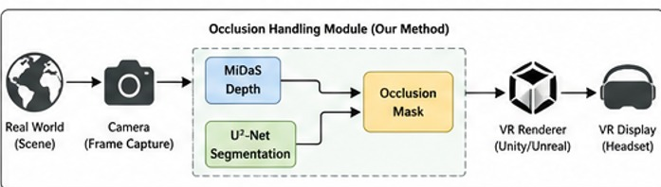
Fig. 6. Integration of the proposed occlusion handling module into a real-time VR rendering pipeline. The generated occlusion mask is supplied to the rendering engine to enable realistic interaction between real and virtual objects
The system does not use any dedicated depth hardware. This supports low-cost deployment, although the current implementation remains computationally limited.

IV. Experimental Setup and Results

A. Experimental Setup
The framework was evaluated using a standard laptop webcam as the real-scene input source. All experiments were conducted on a CPU-only setup without GPU acceleration and without dedicated depth sensing hardware. The purpose of the evaluation was to determine whether monocular depth estimation and segmentation could support practical occlusion-aware compositing in a hardware-independent setting.
The experimental configuration is summarized below.
Parameter | Configuration
Input source | Standard laptop webcam
Image type | RGB frames
Depth model | MiDaS
Segmentation model | U²-Net
Inference hardware | CPU-only
Software stack | Python, OpenCV, ONNX Runtime
Each frame was processed sequentially through depth estimation, segmentation, occlusion reasoning, and final compositing.

B. Qualitative Occlusion Performance
The prototype demonstrated qualitatively correct occlusion behavior in simple test scenes. When a real-world foreground object moved in front of the virtual object, the corresponding virtual pixels were partially or fully hidden. When the foreground object was absent from the relevant region, the virtual object remained visible.
Two representative cases were observed.
Case 1: Foreground object present
When a user’s face, hand, or body region appeared closer to the camera than the virtual content, the system occluded the corresponding virtual area and produced a plausible foreground-over-background relationship.
Case 2: Foreground object absent
When no occluding object was present, the system preserved full visibility of the virtual content.
These observations indicate that the combined depth-segmentation strategy can support basic sensor-free visibility reasoning. The present evaluation is qualitative and should be interpreted as proof-of-concept validation rather than benchmark-level quantitative assessment.

C. Runtime Performance
Although the framework produced plausible occlusion-aware compositing, runtime performance was limited by the computational cost of dense depth estimation and segmentation on CPU. The observed processing speed was approximately 0.5-1 frames per second.
Metric | Observed Value
Frame rate | 0.5-1 FPS
Hardware | CPU-only
GPU usage | None
Sensor dependency | None
The low frame rate is mainly due to the following factors:
- MiDaS inference is computationally expensive because it predicts dense per-pixel depth.
- U²-Net adds an additional deep segmentation stage for each frame.
- The pipeline executes these stages sequentially.
While this performance is insufficient for fully interactive AR/VR deployment, it is adequate for demonstrating the feasibility of hardware-independent monocular occlusion handling.

D. Advantages of the Proposed Framework
Despite its runtime limitations, the framework offers several practical advantages.
- It is hardware-independent and requires only a monocular RGB camera.
- It is cost-efficient because it avoids LiDAR, stereo rigs, and Time-of-Flight sensors.
- It is modular, allowing MiDaS and U²-Net to be replaced by lighter or more accurate alternatives.
- It uses widely available software tools, which supports portability and ease of implementation.

V. Discussion and Future Work
The present work demonstrates that monocular depth estimation and segmentation can be fused into a practical occlusion-aware compositing pipeline on commodity hardware. The results support the view that dense relative depth [1] and fine-grained foreground segmentation [2] provide complementary information for sensor-free AR/VR rendering.
At the same time, the framework has several limitations. The first is low throughput, which prevents real-time deployment in its current form. The second is boundary instability, particularly in scenes involving hair, fingers, cables, and other thin structures. This behavior is consistent with previously reported limitations of monocular depth estimation near fine scene geometry [1]. The third is depth ambiguity in visually complex environments, where reflective surfaces, cluttered backgrounds, or partial occlusions can degrade pixel-wise visibility reasoning.
Compared with more advanced learned occlusion reasoning systems [5] and amodal depth methods [7], the proposed pipeline is simpler and easier to deploy but less sophisticated in its handling of hidden geometry and temporal stability. This trade-off is acceptable for a feasibility study, but it also suggests clear directions for future improvement.
Promising future extensions include:
- replacing the current backbones with lighter models to improve throughput
- introducing temporal consistency to reduce frame-to-frame flicker, following the direction of learned occlusion reasoning [5]
- incorporating boundary-aware refinement for improved silhouette quality
- exploring amodal reasoning for heavily occluded regions, as suggested by layered and amodal depth approaches [6], [7]
A. GAN-Based Occlusion Refinement
Although the proposed framework can generate occlusion-aware compositing using monocular depth estimation and foreground segmentation, the current occlusion masks may still contain errors near object boundaries and thin structures. In particular, regions such as hair, fingers, cables, and partially occluded contours are difficult to represent accurately because monocular depth estimation may produce blurred depth discontinuities, while segmentation masks may contain boundary noise or small foreground-background misclassifications. These issues can reduce the visual quality of the final composite output.
A possible future extension is to introduce a GAN-based occlusion refinement module after the initial mask generation stage. In such a design, the preliminary occlusion mask produced by the depth-segmentation fusion pipeline would be passed to a generator network together with the RGB frame, estimated depth map, and segmentation mask. The generator would learn to produce a refined occlusion mask with improved boundary continuity, better preservation of thin structures, and fewer mask artifacts, while a discriminator would encourage the refined mask to remain visually realistic and structurally consistent.
The expected benefits of this refinement stage include improved boundary precision, reduced false occlusion regions, better handling of fine structures, and enhanced perceptual realism in AR/VR compositing. Such a module may also improve robustness in cluttered indoor scenes and under partial occlusion. However, this GAN-based refinement stage is not part of the current implementation and has not been experimentally evaluated in the present work. It is therefore proposed as a future research direction rather than as a contribution of the current system.

VI. Conclusion
This paper presented a hardware-independent framework for occlusion handling in AR/VR using monocular depth estimation and segmentation from standard RGB input. The system combines MiDaS [1] for dense relative depth estimation with U²-Net [2] for foreground segmentation and fuses both outputs through a pixel-wise occlusion reasoning module. The resulting pipeline enables occlusion-aware compositing without dedicated depth sensing hardware.
Experimental results show that the proposed approach can produce qualitatively plausible visibility relationships between real and virtual objects on a webcam-based CPU-only setup. Although the current implementation runs at only 0.5-1 FPS, it successfully demonstrates the feasibility of low-cost monocular occlusion handling as a proof of concept.
Future work should focus on model optimization, hardware acceleration, temporal stabilization, and boundary-aware refinement for interactive deployment. Another important direction is GAN-based occlusion mask refinement to improve boundary precision and thin-structure preservation in complex scenes. Overall, the work supports the potential of AI-driven monocular perception as a practical foundation for low-cost AR/VR occlusion handling.

References

[1] R. Ranftl, K. Lasinger, D. Hafner, K. Schindler, and V. Koltun, “Towards Robust Monocular Depth Estimation: Mixing Datasets for Zero-Shot Cross-Dataset Transfer,” IEEE Transactions on Pattern Analysis and Machine Intelligence, vol. 44, pp. 1623–1637, Jul. 2019, doi: 10.1109/TPAMI.2020.3019967.
[2] X. Qin, Z. Zhang, C. Huang, M. Dehghan, O. R. Zaiane, and M. Jägersand, “U2-Net: Going Deeper with Nested U-Structure for Salient Object Detection,” Pattern Recognit., vol. 106, p. 107404, May 2020, doi: 10.1016/j.patcog.2020.107404.
[3] J. Jorge, R. K. D. Anjos, and R. Silva, “Dynamic Occlusion Handling for Real-Time AR Applications,” Proceedings of the 17th ACM SIGGRAPH International Conference on Virtual-Reality Continuum and its Applications in Industry, Nov. 2019, doi: 10.1145/3359997.3365700.
[4] S. F. Bhat, R. Birkl, D. Wofk, P. Wonka, and M. Muller, “ZoeDepth: Zero-shot Transfer by Combining Relative and Metric Depth,” ArXiv, vol. abs/2302.12288, Feb. 2023, doi: 10.48550/arXiv.2302.12288.
[5] J. Watson et al., “Virtual Occlusions Through Implicit Depth,” 2023 IEEE/CVF Conference on Computer Vision and Pattern Recognition (CVPR), pp. 9053–9064, May 2023, doi: 10.1109/CVPR52729.2023.00874.
[6] H. Dhamo, K. Tateno, I. Laina, N. Navab, and F. Tombari, “Peeking Behind Objects: Layered Depth Prediction from a Single Image,” Pattern Recognit. Lett., vol. 125, pp. 333–340, Jul. 2018, doi: 10.1016/j.patrec.2019.05.007.
[7] S. Jo, D. Y. Lee, and C. E. Rhee, “Occlusion-Aware Amodal Depth Estimation for Enhancing 3D Reconstruction From a Single Image,” IEEE Access, vol. 12, pp. 106524–106536, 2024, doi: 10.1109/ACCESS.2024.3436570.

