Percentile

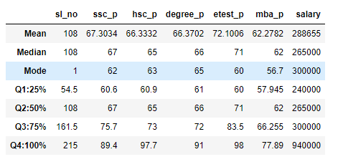

By reviewing percentile, I have observed the below

|  |  |  |  |  |  |  |
| --- | --- | --- | --- | --- | --- | --- |
| Percentile Data | | | | | | |
| Percentile | **ssc_p** | **hsc_p** | **degree_p** | **etest_p** | **mba_p** | **salary** |
| **Q1:25%** | 60.6 | 60.9 | 61 | 60 | 57.945 | 240000 |
| **Q2:50%** | 67 | 65 | 66 | 71 | 62 | 265000 |
| **Q3:75%** | 75.7 | 73 | 72 | 83.5 | 66.255 | 300000 |
| **Q4:100%** | 89.4 | 97.7 | 91 | 98 | 77.89 | 940000 |

|  |  |  |  |  |  |  |
| --- | --- | --- | --- | --- | --- | --- |
| Difference | | | | | | |
| Percentile | **ssc_p** | **hsc_p** | **degree_p** | **etest_p** | **mba_p** | **salary** |
| **Q1:25% -50%** | 6.4 | 4.1 | 5 | 11 | 4.055 | 25000 |
| **Q2:50% - 75%** | 8.7 | 8 | 6 | 12.5 | 4.255 | 35000 |
| **Q3:75% - 100 %** | 13.7 | 24.7 | 19 | 14.5 | 11.635 | 640000 |

On reviewing the above data, I could see there is a high difference in 75 th to 100th percentile on ssc_p, hsc, degree mba and salary.