Interquartile Range (IQR)

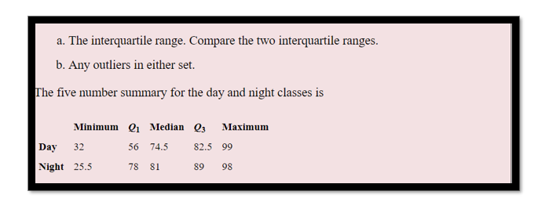

IQR = Q3-Q1

Lesser Outlier = Q1-1.5\*IQR

Greater Outlier = Q3+1.5\*IQR

Day - IQR = (82.5-56) = 26.5 Night – IQR = (89-78) = 11

The formula for outliers is:

• Lesser outlier: Q1 - 1.5 \* IQR

• Greater outlier: Q3 + 1.5 \* IQR

Using the values given in the question, we have:

• Lesser outlier for day class: 56 - 1.5 \* 26.5 = 16.25

• Greater outlier for day class: 82.5 + 1.5 \* 26.5 = 109.75

• No outliers in day class

• Lesser outlier for night class: 78 - 1.5 \* 11 = 61.5

• Greater outlier for night class: 89 + 1.5 \* 11= 105.5

• No greater outlier in night class

Therefore, there is one lesser outlier in the night class.