Skewness & Kurtosis

| **sl_no** | **ssc_p** | **hsc_p** | **degree_p** | **etest_p** | **mba_p** | **salary** |
| --- | --- | --- | --- | --- | --- | --- |



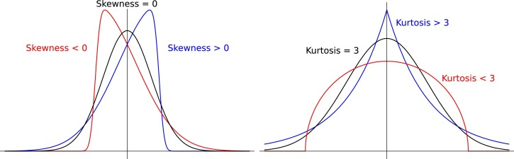

Kurtosis

sl_no: Negative kurtosis value indicates a relatively flat distribution with thinner tails.

ssc_p: Negative kurtosis value indicates a relatively flat distribution with thinner tails. Negative skewness indicates a left-skewed distribution, meaning more values towards the higher end of the scale.

hsc_p: Positive kurtosis value indicates a distribution with heavier tails and a sharper peak. Positive skewness indicates a right-skewed distribution, meaning more values towards the lower end of the scale.

degree_p: Negative kurtosis value indicates a relatively flat distribution with thinner tails. Negative skewness indicates a left-skewed distribution, meaning more values towards the higher end of the scale.

etest_p: Negative kurtosis value indicates a relatively flat distribution with thinner tails. Positive skewness indicates a right-skewed distribution, meaning more values towards the lower end of the scale.

mba_p: Negative kurtosis value indicates a relatively flat distribution with thinner tails. Positive skewness indicates a right-skewed distribution, meaning more values towards the lower end of the scale.

salary: Negative kurtosis value indicates a relatively flat distribution with thinner tails. Positive skewness indicates a right-skewed distribution, meaning more values towards the lower end of the scale.

Overall, the dataset seems to have relatively flat distributions with thinner tails

Skewness

sl_no: The skewness of this column is 0, indicating that the distribution is approximately symmetrical.

ssc_p: The skewness of this column is negative (-0.132649), indicating that the distribution is skewed to the left, with a longer tail on the left side.

hsc_p: The skewness of this column is positive (0.162611), indicating that the distribution is skewed to the right, with a longer tail on the right side.

degree_p: The skewness of this column is positive (0.204164), indicating that the distribution is skewed to the right, with a longer tail on the right side.

etest_p: The skewness of this column is positive (0.282308), indicating that the distribution is skewed to the right, with a longer tail on the right side.

mba_p: The skewness of this column is positive (0.313576), indicating that the distribution is skewed to the right, with a longer tail on the right side.

salary: The skewness of this column is positive (0.8067), indicating that the distribution is highly skewed to the right, with a very long tail on the right side.