Employee Management ER Daigram

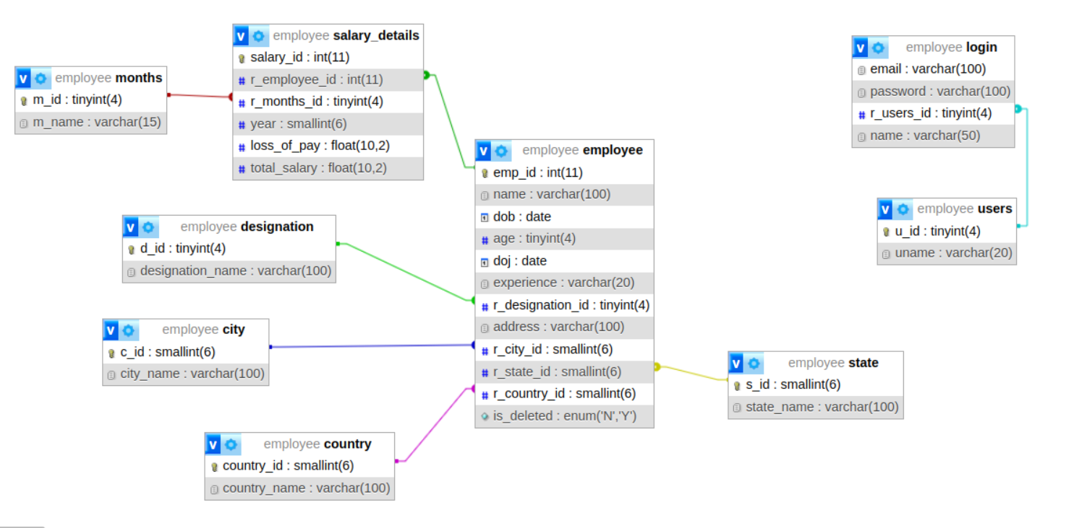

Employee Management workflow

Open Landing Page (Login Page):
- When the application is opened, the landing page is the login page where the user can enter their login details.
Enter Login Details:
- The user enters their login details (username and password).
Successful Login:
- If the login is successful, the user is redirected to the home page which displays the employee details table.
- If the login is not successful, the user is redirected back to the login page.
Home Page (Employee Details):
- The home page contains an employee details table with several functionalities:
  - Add Employee Button: Clicking this button navigates to a page where the user can add new employee details. Upon submission, the user is redirected back to the home page with the updated employee list.
  - Update Button (each row): Clicking this button navigates to a page where the user can update details for the selected employee. Upon submission, the user is redirected back to the home page with the updated employee list.
  - Delete Button (each row): Clicking this button prompts a confirmation for deleting the selected employee. Upon confirmation, the employee is deleted, and the updated employee list is shown on the home page.
  - Salary Button (each row): Clicking this button navigates to a salary page containing the salary details of the selected employee.
Salary Page:
- The salary page displays the salary details of the selected employee.
- Add Salary Button: Clicking this button allows the user to add salary details for the employee. Upon submission, the user is redirected back to the salary page with the updated salary details.

