|  |  |
| --- | --- |
| **Ex No: 10** | **GETTING CURRENT LOCATION USING GEOCODER** |
| **Date:** |  |

# AIM:

To develop an application that gets the current location with the help of geocoder using

Android Studio.

# DESCRIPTION:

The Getting Current Location Using Geocoder application in Android Studio employs the Geocoder class to efficiently retrieve and convert the device's geographic coordinates into human-readable location information. Leveraging the LocationManager and LocationListener, it continuously monitors and updates the device's location, while managing permissions to ensure compliance with Android's security standards. The resulting location data is seamlessly integrated into the application's user interface, enhancing the user experience for location-based services.

Key Components:

1. Geocoder Class: The Geocoder class is a fundamental component in this application, used to translate geographic coordinates into human-readable location data, such as the city, country, and address.
2. LocationManager: To access the device's current location, the LocationManager class is employed. It facilitates location updates and provides access to the device's GPS or network-based location data.
3. LocationListener: A LocationListener is used to monitor changes in the device's location. It triggers events when the location is updated, allowing the application to react dynamically to location changes.
4. Permissions: To access the device's location information, the application requests and manages the necessary permissions, ensuring that it adheres to Android's security protocols.
5. UI Integration: The application typically integrates this information into its user interface, displaying the current location details in a user-friendly format.

# PROGRAM:

Main Activity.java

package com.example.madex10;

import static android.Manifest.permission.ACCESS_FINE_LOCATION;

import androidx.annotation.NonNull;

import androidx.appcompat.app.AppCompatActivity; import androidx.core.app.ActivityCompat;

import androidx.core.content.ContextCompat; import android.content.Context;

import android.content.pm.PackageManager; import android.location.Address;

import android.location.Geocoder; import android.location.Location;

import android.location.LocationListener; import android.location.LocationManager; import android.os.Bundle;

import android.util.Log; import android.view.View; import android.widget.Button;

import android.widget.TextView; import android.widget.Toast; import java.util.List;

import java.util.Locale;

public class MainActivity extends AppCompatActivity implements LocationListener{ Button btnShowLocation;

LocationManager locationManager; private double latitude;

private double longitude;

TextView edit_Country,edit_State,edit_City,edit_Pincode; @Override

protected void onCreate(Bundle savedInstanceState) { super.onCreate(savedInstanceState); setContentView(R.layout.activity_main);

edit_Country = findViewById(R.id.editCountry); edit_State=findViewById(R.id.editState); edit_City=findViewById(R.id.editCity); edit_Pincode=findViewById(R.id.editPincode); btnShowLocation=findViewById(R.id.btnShowLocation); btnShowLocation.setOnClickListener(new View.OnClickListener() {

@Override

public void onClick(View v) {

if (ContextCompat.checkSelfPermission(MainActivity.this, ACCESS_FINE_LOCATION)!= PackageManager.PERMISSION_GRANTED){

ActivityCompat.requestPermissions(MainActivity.this,new String[]{ACCESS_FINE_LOCATION},1);

}else{

detectCurrentLocation();

}

}

});

}

private void detectCurrentLocation(){

Toast.makeText(this,"Getting your current location", Toast.LENGTH_SHORT).show(); locationManager=(LocationManager)

getSystemService(Context.LOCATION_SERVICE);

if (ActivityCompat.checkSelfPermission(this, ACCESS_FINE_LOCATION)

!=PackageManager.PERMISSION_GRANTED && ActivityCompat.checkSelfPermission()){

return;

}

locationManager.requestLocationUpdates(LocationManager.GPS_PROVIDER,0,0,this);

}

@Override

public void onLocationChanged(Location location){ latitude = location.getLatitude();

longitude = location.getLongitude(); findAddress();

}

private void findAddress(){ Geocoder geocoder; List<Address> addresses;

geocoder = new Geocoder(this, Locale.getDefault()); try{

addresses= geocoder.getFromLocation(latitude,longitude,1); String country = addresses.get(0).getCountryName();

String state = addresses.get(0).getAdminArea(); String city = addresses.get(0).getLocality();

String Pincode = addresses.get(0).getPostalCode(); edit_Country.setText(country); edit_State.setText(state);

edit_City.setText(city); edit_Pincode.setText(Pincode); Log.d("City",city);

Log.d("State",state); Log.d("Country",country); Log.d("Pincode",String.valueOf(Pincode));

}catch(Exception e){ Toast.makeText(this,""+e.getMessage(),Toast.LENGTH_SHORT).show();

}

}

@Override

public void onStatusChanged(String provider, int status, Bundle extras){

}

@Override

public void onProviderEnabled(String provider){

}

@Override

public void onProviderDisabled(String provider){

Toast.makeText(this,"Please turn on Location",Toast.LENGTH_SHORT).show();

}

@Override

public void onRequestPermissionsResult(int requestCode,@NonNull String[] permissions,@NonNull int[] grantResults){

super.onRequestPermissionsResult(requestCode,permissions,grantResults); if(requestCode == 1){

if(grantResults.length > 0 && grantResults[0] == PackageManager.PERMISSION_GRANTED){

detectCurrentLocation();

}else{

Toast.makeText(this,"Permission Denied",Toast.LENGTH_SHORT).show();

}

}

}

}

Main_activity.xml:

<?xml version="1.0" encoding="utf-8"?>

<RelativeLayout xmlns:andr[oid="htt](http://schemas.android.com/apk/res/android)p://[schemas.android.com/apk/res/android"](http://schemas.android.com/apk/res/android) xmlns:app=["http://sc](http://schemas.android.com/apk/res-auto)h[emas.android.com/apk/res-auto"](http://schemas.android.com/apk/res-auto) xmlns:t[ools="ht](http://schemas.android.com/tools)tp:/[/sc](http://schemas.android.com/tools)he[mas.android.com/tools"](http://schemas.android.com/tools) android:layout_width="match_parent" android:layout_height="match_parent" tools:context=".MainActivity">

<LinearLayout android:layout_width="match_parent" android:layout_height="wrap_content"

android:orientation="vertical">

<TextView android:layout_width="match_parent" android:layout_height="wrap_content" android:hint="Country" android:textColor="#000" android:textSize="20sp" android:id="@+id/editCountry"/>

<TextView android:layout_width="match_parent" android:layout_height="wrap_content" android:hint="State" android:textColor="#000" android:textSize="20sp" android:id="@+id/editState" />

<TextView android:layout_width="match_parent" android:layout_height="wrap_content" android:hint="City" android:textColor="#000" android:textSize="20sp" android:id="@+id/editCity"/>

<TextView android:layout_width="match_parent" android:layout_height="wrap_content" android:hint="Pincode"

android:textColor="#000" android:textSize="20sp" android:id="@+id/editPincode"/>

<Button

android:layout_width="match_parent" android:layout_height="wrap_content" android:text="Get Location" android:id="@+id/btnShowLocation"/>

</LinearLayout>

</RelativeLayout> Manifest.xml:

<?xml version="1.0" encoding="utf-8"?>

<manifest xmlns:android=["http://schemas.android.com/](http://schemas.android.com/apk/res/android)a[pk/res/android"](http://schemas.android.com/apk/res/android) package="com.example.ex10">

<uses-permission android:name="android.permission.INTERNET"/>

<uses-permission android:name="android.permission.ACCESS_FINE_LOCATION"/>

<uses-permission android:name="android.permission.ACCESS_COARSE_LOCATION"/>

<application android:allowBackup="true" android:icon="@mipmap/ic_launcher" android:label="ex10"

android:roundIcon="@mipmap/ic_launcher_round" android:supportsRtl="true" android:theme="@style/Theme.Ex10">

<activity android:name=".MainActivity" android:exported="true">

<intent-filter>

<action android:name="android.intent.action.MAIN" />

<category android:name="android.intent.category.LAUNCHER" />

</intent-filter>

</activity>

</application>

</manifest>

# OUTPUT:

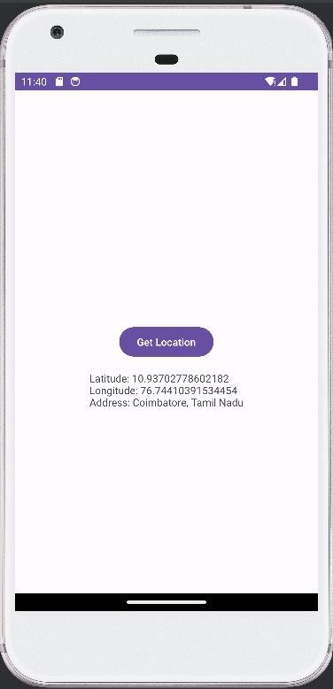

**RESULT:**

Thus, the application which gets the current location using geocoder with the help of Android studio has been executed successfully and the output has been verified.