|  |  |
| --- | --- |
| **Ex. No. 2** | **Student Information System** |
| **Date of Exercise** | **18/08/2023** |

**Aim**

To design a Student Information system using activity and intent concepts.

**Description**

Android activity lifecycle

In Android, an activity is referred to as one screen in an application. It is very similar to a single window of any desktop application. An Android app consists of one or more screens or activities.

Each activity goes through various stages or a lifecycle and is managed by activity stacks. So when a new activity starts, the previous one always remains below it. There are four stages of an activity.

* If an activity is in the foreground of the screen i.e at the top of the stack, then it is said to be active or running. This is usually the activity that the user is currently interacting with.
* If an activity has lost focus and a non-full-sized or transparent activity has focused on top of your activity. In such a case either another activity has a higher position in multi-window mode or the activity itself is not focusable in the current window mode. Such activity is completely alive.
* If an activity is completely hidden by another activity, it is stopped or hidden. It still retains all the information, and as its window is hidden thus it will often be killed by the system when memory is needed elsewhere.
* The system can destroy the activity from memory by either asking it to finish or simply killing its process. When it is displayed again to the user, it must be completely restarted and restored to its previous state.

Intents and types

This process of taking users from one application to another is achieved by passing the Intent to the system. Intents, in general, are used for navigating among various activities within the same application, but note, is not limited to one single application, i.e., they can be utilized from moving from one application to another as well.

Intents could be Implicit, for instance, calling intended actions, and explicit as well, such as opening another activity after some operations like onClick or anything else.

There are two types of intents in android

* Implicit Intent

Implicit Intent doesn’t specify the component. In such a case, intent provides information on available components provided by the system that is to be invoked. For example, you may write the following code to view the webpage.

* Explicit

Explicit Intent specifies the component. In such a case, intent provides the external class to be invoked.

**Program**

**XML code**

**(Main_activity)**

<?xml version="1.0" encoding="utf-8"?>

<androidx.constraintlayout.widget.ConstraintLayout xmlns:android="http://schemas.android.com/apk/res/android"

xmlns:app="http://schemas.android.com/apk/res-auto"

xmlns:tools="http://schemas.android.com/tools"

android:id="@+id/i1"

android:layout_width="match_parent"

android:layout_height="match_parent"

android:background="#FFFFFF"

tools:context=".MainActivity">

<ImageButton

android:id="@+id/examButton"

android:layout_width="84dp"

android:layout_height="75dp"

android:backgroundTint="#068DCA"

app:layout_constraintBottom_toBottomOf="parent"

app:layout_constraintEnd_toEndOf="parent"

app:layout_constraintHorizontal_bias="0.498"

app:layout_constraintStart_toStartOf="parent"

app:layout_constraintTop_toTopOf="parent"

app:layout_constraintVertical_bias="0.945"

app:srcCompat="@android:drawable/ic_menu_edit" />

<EditText

android:id="@+id/editTextText"

android:layout_width="wrap_content"

android:layout_height="wrap_content"

android:ems="10"

android:hint="Name"

android:inputType="text"

app:layout_constraintBottom_toBottomOf="parent"

app:layout_constraintEnd_toEndOf="parent"

app:layout_constraintHorizontal_bias="0.497"

app:layout_constraintStart_toStartOf="parent"

app:layout_constraintTop_toTopOf="parent"

app:layout_constraintVertical_bias="0.237" />

<TextView

android:id="@+id/textView3"

android:layout_width="wrap_content"

android:layout_height="wrap_content"

android:capitalize="sentences"

android:text="Student Information System"

android:textSize="24sp"

android:textStyle="bold"

app:layout_constraintBottom_toBottomOf="parent"

app:layout_constraintEnd_toEndOf="parent"

app:layout_constraintHorizontal_bias="0.495"

app:layout_constraintStart_toStartOf="parent"

app:layout_constraintTop_toTopOf="parent"

app:layout_constraintVertical_bias="0.062" />

<TextView

android:id="@+id/textView4"

android:layout_width="wrap_content"

android:layout_height="wrap_content"

android:text="Enter student information"

android:textSize="20sp"

android:textStyle="italic"

app:layout_constraintBottom_toBottomOf="parent"

app:layout_constraintEnd_toEndOf="parent"

app:layout_constraintHorizontal_bias="0.497"

app:layout_constraintStart_toStartOf="parent"

app:layout_constraintTop_toTopOf="parent"

app:layout_constraintVertical_bias="0.142" />

<EditText

android:id="@+id/editTextNumberDecimal"

android:layout_width="wrap_content"

android:layout_height="wrap_content"

android:ems="10"

android:hint="Register Number"

android:inputType="numberDecimal"

app:layout_constraintBottom_toBottomOf="parent"

app:layout_constraintEnd_toEndOf="parent"

app:layout_constraintHorizontal_bias="0.497"

app:layout_constraintStart_toStartOf="parent"

app:layout_constraintTop_toTopOf="parent"

app:layout_constraintVertical_bias="0.362" />

<EditText

android:id="@+id/editTextText2"

android:layout_width="wrap_content"

android:layout_height="wrap_content"

android:ems="10"

android:hint="Department"

android:inputType="text"

app:layout_constraintBottom_toBottomOf="parent"

app:layout_constraintEnd_toEndOf="parent"

app:layout_constraintHorizontal_bias="0.497"

app:layout_constraintStart_toStartOf="parent"

app:layout_constraintTop_toTopOf="parent"

app:layout_constraintVertical_bias="0.478" />

<EditText

android:id="@+id/editTextNumber"

android:layout_width="wrap_content"

android:layout_height="wrap_content"

android:ems="10"

android:hint="Sub 1 Marks"

android:inputType="number"

app:layout_constraintBottom_toBottomOf="parent"

app:layout_constraintEnd_toEndOf="parent"

app:layout_constraintHorizontal_bias="0.497"

app:layout_constraintStart_toStartOf="parent"

app:layout_constraintTop_toTopOf="parent"

app:layout_constraintVertical_bias="0.597" />

<EditText

android:id="@+id/editTextNumber2"

android:layout_width="wrap_content"

android:layout_height="wrap_content"

android:ems="10"

android:hint="Sub 2 Marks"

android:inputType="number"

app:layout_constraintBottom_toBottomOf="parent"

app:layout_constraintEnd_toEndOf="parent"

app:layout_constraintHorizontal_bias="0.492"

app:layout_constraintStart_toStartOf="parent"

app:layout_constraintTop_toTopOf="parent"

app:layout_constraintVertical_bias="0.698" />

<EditText

android:id="@+id/editTextNumber3"

android:layout_width="wrap_content"

android:layout_height="wrap_content"

android:ems="10"

android:hint="Sub 3 Marks"

android:inputType="number"

app:layout_constraintBottom_toBottomOf="parent"

app:layout_constraintEnd_toEndOf="parent"

app:layout_constraintHorizontal_bias="0.492"

app:layout_constraintStart_toStartOf="parent"

app:layout_constraintTop_toTopOf="parent"

app:layout_constraintVertical_bias="0.807" />

</androidx.constraintlayout.widget.ConstraintLayout>

**(activity_2)**

<?xml version="1.0" encoding="utf-8"?>

<androidx.constraintlayout.widget.ConstraintLayout xmlns:android="http://schemas.android.com/apk/res/android"

xmlns:app="http://schemas.android.com/apk/res-auto"

xmlns:tools="http://schemas.android.com/tools"

android:id="@+id/info"

android:layout_width="match_parent"

android:layout_height="match_parent"

tools:context=".Activity2">

<TextView

android:id="@+id/textView"

android:layout_width="wrap_content"

android:layout_height="wrap_content"

android:text="Exams"

android:textColor="#177AC8"

android:textSize="24sp"

android:textStyle="bold"

app:layout_constraintBottom_toBottomOf="parent"

app:layout_constraintEnd_toEndOf="parent"

app:layout_constraintHorizontal_bias="0.498"

app:layout_constraintStart_toStartOf="parent"

app:layout_constraintTop_toTopOf="parent"

app:layout_constraintVertical_bias="0.081"

tools:ignore="MissingConstraints" />

<TextView

android:id="@+id/textView2"

android:layout_width="wrap_content"

android:layout_height="wrap_content"

android:text="text"

android:textSize="20sp"

app:layout_constraintBottom_toBottomOf="parent"

app:layout_constraintEnd_toEndOf="parent"

app:layout_constraintHorizontal_bias="0.567"

app:layout_constraintStart_toStartOf="parent"

app:layout_constraintTop_toTopOf="parent"

app:layout_constraintVertical_bias="0.174"

tools:ignore="MissingConstraints" />

<TextView

android:id="@+id/textView5"

android:layout_width="wrap_content"

android:layout_height="wrap_content"

android:text="Name"

android:textSize="20sp"

android:textStyle="bold"

app:layout_constraintBottom_toBottomOf="parent"

app:layout_constraintEnd_toEndOf="parent"

app:layout_constraintHorizontal_bias="0.206"

app:layout_constraintStart_toStartOf="parent"

app:layout_constraintTop_toTopOf="parent"

app:layout_constraintVertical_bias="0.161" />

<TextView

android:id="@+id/Regno"

android:layout_width="wrap_content"

android:layout_height="wrap_content"

android:text="TextView"

android:textSize="20sp"

app:layout_constraintBottom_toBottomOf="parent"

app:layout_constraintEnd_toEndOf="parent"

app:layout_constraintHorizontal_bias="0.58"

app:layout_constraintStart_toStartOf="parent"

app:layout_constraintTop_toTopOf="parent"

app:layout_constraintVertical_bias="0.279" />

<TextView

android:id="@+id/textView7"

android:layout_width="62dp"

android:layout_height="16dp"

android:text="TextView"

android:textSize="16sp"

app:layout_constraintBottom_toBottomOf="parent"

app:layout_constraintEnd_toEndOf="parent"

app:layout_constraintHorizontal_bias="0.578"

app:layout_constraintStart_toStartOf="parent"

app:layout_constraintTop_toTopOf="parent"

app:layout_constraintVertical_bias="0.366" />

<TextView

android:id="@+id/textView8"

android:layout_width="wrap_content"

android:layout_height="wrap_content"

android:text="TextView"

android:textSize="20sp"

app:layout_constraintBottom_toBottomOf="parent"

app:layout_constraintEnd_toEndOf="parent"

app:layout_constraintHorizontal_bias="0.58"

app:layout_constraintStart_toStartOf="parent"

app:layout_constraintTop_toTopOf="parent"

app:layout_constraintVertical_bias="0.448" />

<TextView

android:id="@+id/textView9"

android:layout_width="wrap_content"

android:layout_height="wrap_content"

android:text="TextView"

android:textSize="20sp"

app:layout_constraintBottom_toBottomOf="parent"

app:layout_constraintEnd_toEndOf="parent"

app:layout_constraintHorizontal_bias="0.58"

app:layout_constraintStart_toStartOf="parent"

app:layout_constraintTop_toTopOf="parent"

app:layout_constraintVertical_bias="0.563" />

<TextView

android:id="@+id/textView10"

android:layout_width="wrap_content"

android:layout_height="wrap_content"

android:text="TextView"

android:textSize="20sp"

app:layout_constraintBottom_toBottomOf="parent"

app:layout_constraintEnd_toEndOf="parent"

app:layout_constraintHorizontal_bias="0.58"

app:layout_constraintStart_toStartOf="parent"

app:layout_constraintTop_toTopOf="parent"

app:layout_constraintVertical_bias="0.666" />

<TextView

android:id="@+id/textView11"

android:layout_width="wrap_content"

android:layout_height="wrap_content"

android:text="TextView"

app:layout_constraintBottom_toBottomOf="parent"

app:layout_constraintEnd_toEndOf="parent"

app:layout_constraintHorizontal_bias="0.209"

app:layout_constraintStart_toStartOf="parent"

app:layout_constraintTop_toTopOf="parent"

app:layout_constraintVertical_bias="0.287" />

<TextView

android:id="@+id/textView12"

android:layout_width="wrap_content"

android:layout_height="wrap_content"

android:text="TextView"

app:layout_constraintBottom_toBottomOf="parent"

app:layout_constraintEnd_toEndOf="parent"

app:layout_constraintHorizontal_bias="0.209"

app:layout_constraintStart_toStartOf="parent"

app:layout_constraintTop_toTopOf="parent"

app:layout_constraintVertical_bias="0.367" />

<TextView

android:id="@+id/textView13"

android:layout_width="wrap_content"

android:layout_height="wrap_content"

android:text="TextView"

tools:layout_editor_absoluteX="74dp"

tools:layout_editor_absoluteY="328dp" />

<TextView

android:id="@+id/textView14"

android:layout_width="wrap_content"

android:layout_height="wrap_content"

android:text="TextView"

tools:layout_editor_absoluteX="72dp"

tools:layout_editor_absoluteY="402dp" />

<TextView

android:id="@+id/textView15"

android:layout_width="wrap_content"

android:layout_height="wrap_content"

android:text="TextView"

tools:layout_editor_absoluteX="77dp"

tools:layout_editor_absoluteY="476dp" />

</androidx.constraintlayout.widget.ConstraintLayout>

**Java code**

**(Main_activity file)**

package com.example.studentinformationapp;

import androidx.annotation.Nullable;

import androidx.appcompat.app.AppCompatActivity;

import android.content.Intent;

import android.os.Bundle;

import android.view.View;

import android.widget.Button;

import android.widget.EditText;

import android.widget.ImageButton;

public class MainActivity extends AppCompatActivity {

EditText e1, e2, e3, e4, e5, e6;

@Override

protected void onCreate(Bundle savedInstanceState) {

super.onCreate(savedInstanceState);

setContentView(R.layout.activity_main);

e1= findViewById(R.id.editTextText);

e2= findViewById(R.id.editTextNumberDecimal);

e3= findViewById(R.id.editTextText2);

e4= findViewById(R.id.editTextNumber);

e5= findViewById(R.id.editTextNumber2);

e6= findViewById(R.id.editTextNumber3);

ImageButton button = findViewById(R.id.examButton);

button.setOnClickListener(new View.OnClickListener() {

@Override

public void onClick(View v) {

String str1 = e1.getText().toString();

String str2 = e2.getText().toString();

String str3 = e3.getText().toString();

String str4 = e4.getText().toString();

String str5 = e5.getText().toString();

String str6 = e6.getText().toString();

Intent i = new Intent(v.getContext(), Activity2.class);

i.putExtra("message_key1", str1);

i.putExtra("message_key2", str2);

i.putExtra("message_key3", str3);

i.putExtra("message_key4", str4);

i.putExtra("message_key5", str5);

i.putExtra("message_key6", str6);

startActivity(i);

}

});

}

}

**(activity2 file)**

package com.example.studentinformationapp;

import androidx.appcompat.app.AppCompatActivity;

import android.annotation.SuppressLint;

import android.content.Intent;

import android.os.Bundle;

import android.widget.EditText;

import android.widget.TextView;

public class Activity2 extends AppCompatActivity {

TextView t1, t2, t3, t4, t5, t6;

@SuppressLint("MissingInflatedId")

@Override

protected void onCreate(Bundle savedInstanceState) {

super.onCreate(savedInstanceState);

setContentView(R.layout.activity_2);

t1 = findViewById(R.id.textView2);

t2 = findViewById(R.id.Regno);

t3 = findViewById(R.id.textView7);

t4 = findViewById(R.id.textView8);

t5 = findViewById(R.id.textView9);

t6 = findViewById(R.id.textView10);

Intent intent = getIntent();

String str1 = intent.getStringExtra("message_key1");

String str2 = intent.getStringExtra("message_key2");

String str3 = intent.getStringExtra("message_key3");

String str4 = intent.getStringExtra("message_key4");

String str5 = intent.getStringExtra("message_key5");

String str6 = intent.getStringExtra("message_key6");

t1.setText(str1);

t2.setText(str2);

t3.setText(str3);

t4.setText(str4);

t5.setText(str5);

t6.setText(str6);

}

}

**Output**

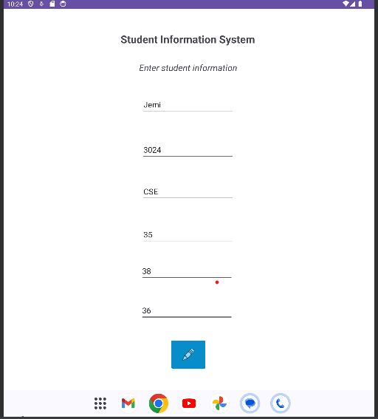

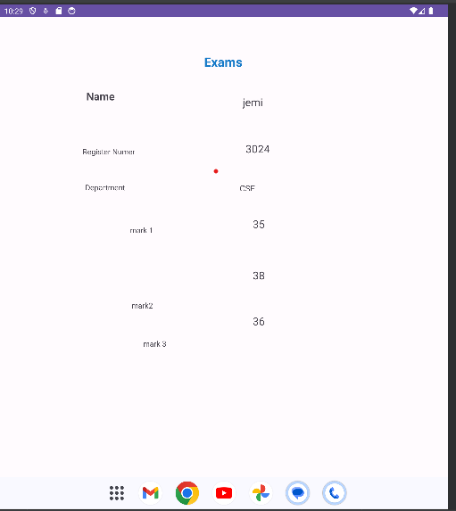

**Result**

The program for Student Information System is successfully implemented and verified.