|  |  |
| --- | --- |
| **Ex. No. 3** | **Employee Management System** |
| **Date of Exercise** | **01/09/2023** |

**Aim**

To design an Employee Management System using Room database.

**Description**

Room is a persistence library that provides an abstraction layer over the SQLite database to allow a more robust database. With the help of room, we can easily create the database and perform CRUD operations very easily.

Components of Room

The three main components of the room are Entity, Database, and DAO.

Entity: Entity is a modal class that is annotated with @Entity. This class is having variables that will be our columns and the class is our table.

Database: It is an abstract class where we will be storing all our database entries which we can call Entities.

DAO: The full form of DAO is a Database access object which is an interface class with the help of it we can perform different operations in our database.

**Program**

**XML code**

**Java code**

**(AppDatabase)**

package com.example.exp3_roomdatabase;

import android.content.Context;

import androidx.room.Database;

import androidx.room.Room;

import androidx.room.RoomDatabase;

@Database(entities = {Student.class},version=1,exportSchema = false)

public abstract class AppDatabase extends RoomDatabase{

static AppDatabase appDatabase;

public abstract StudentDao studentDao();

public static AppDatabase getAppDatabase(Context context){

if(appDatabase==null){

appDatabase = Room.databaseBuilder(context, AppDatabase.class,

"studDatabase").build();

}

return appDatabase;

}

}

**(MainActivity)**

package com.example.exp3_roomdatabase;

import androidx.annotation.NonNull;

import androidx.appcompat.app.AppCompatActivity;

import androidx.lifecycle.ViewModelProvider;

import android.content.Intent;

import android.os.Bundle;

import android.view.ContextMenu;

import android.view.MenuItem;

import android.view.View;

import android.widget.AdapterView;

import android.widget.ArrayAdapter;

import android.widget.ListView;

import androidx.room.Room;

import com.google.android.material.floatingactionbutton.FloatingActionButton;

import java.util.ArrayList;

import java.util.concurrent.Executors;

public class MainActivity extends AppCompatActivity {

ListView listView;

FloatingActionButton floatingActionButton;

ArrayList<String> studentDetailsList;

ArrayAdapter<String> stringArrayAdapter;

private StudentViewModel studentViewModel;

String name;

int registerNumber;

@Override

protected void onCreate(Bundle savedInstanceState) {

super.onCreate(savedInstanceState);

setContentView(R.layout.activity_main);

listView = findViewById(R.id.listViewId);

floatingActionButton = findViewById(R.id.floatingActionButtonId);

studentDetailsList = new ArrayList<>();

stringArrayAdapter = new ArrayAdapter<String>(this,android.R.layout.simple_list_item_1,studentDetailsList);

stringArrayAdapter.notifyDataSetChanged();

studentViewModel = new

ViewModelProvider(this).get(StudentViewModel.class);

studentViewModel.getAllRecords().observe(this,students -> {

studentDetailsList.clear();

for (Student student: students){

studentDetailsList.add(student.getRegisterNumber()+" "+student.getStudentName());

}

listView.setAdapter(stringArrayAdapter);

});

registerForContextMenu(listView);

floatingActionButton.setOnClickListener(new View.OnClickListener(){

@Override

public void onClick(View view){

startActivity(new

Intent(getApplicationContext(),StudentActivity.class));

}

});

}

@Override

public void onCreateContextMenu(ContextMenu menu, View v,

ContextMenu.ContextMenuInfo menuInfo){

super.onCreateContextMenu(menu,v,menuInfo);

getMenuInflater().inflate(R.menu.menu_student,menu);

AdapterView.AdapterContextMenuInfo info = (AdapterView.AdapterContextMenuInfo)menuInfo;

String data[] = stringArrayAdapter.getItem(info.position).split(" ");

registerNumber = Integer.parseInt((data[0]));

name = data[1];

}

@Override

public boolean onContextItemSelected(@NonNull MenuItem item){

if(item.getItemId()==R.id.deleteID){

Executors.newSingleThreadExecutor().execute(new Runnable(){

@Override

public void run(){

studentViewModel.deleteRecords(new

Student(registerNumber, name));

}

});

}

else if (item.getItemId()==R.id.updateId){

// Executors.newSingleThreadExecutor().execute(new Runnable() {

// @Override

// public void run() {

// studentViewModel.updateRecord(new

// Student(registerNumber,name));

// }

// });

Intent intent = new Intent(getApplicationContext(), StudentActivity.class);

intent.putExtra("registerNumber", registerNumber);

intent.putExtra("studentName", name);

startActivity(intent);

}

return true;

}

}

**(Student)**

package com.example.exp3_roomdatabase;

import androidx.annotation.NonNull;

import androidx.room.Entity;

import androidx.room.PrimaryKey;

@Entity

public class Student {

@PrimaryKey

@NonNull

int registerNumber;

@NonNull

String studentName;

public Student(int registerNumber, String studentName){

this.registerNumber = registerNumber;

this.studentName=studentName;

}

public int getRegisterNumber(){return registerNumber;}

public void setRegisterNumber(int registerNumber){this.registerNumber=registerNumber;}

public String getStudentName(){return studentName;}

public void setStudentName(String studentName){this.studentName=studentName;}

}

**(StudentActivity)**

package com.example.exp3_roomdatabase;

import androidx.appcompat.app.AppCompatActivity;

import androidx.lifecycle.ViewModelProvider;

import android.content.Intent;

import android.os.Bundle;

import android.view.View;

import android.widget.Button;

import android.widget.EditText;

import java.util.concurrent.Executors;

public class StudentActivity extends AppCompatActivity {

EditText editTextRegNo,editTextName;

Button buttonAdd,buttonDone;

StudentViewModel studentViewModel;

@Override

protected void onCreate(Bundle savedInstanceState) {

super.onCreate(savedInstanceState);

setContentView(R.layout.activity_student);

editTextName = findViewById(R.id.editTextNameId);

editTextRegNo = findViewById(R.id.editTextRegNoId);

buttonAdd = findViewById(R.id.buttonAddId);

buttonDone = findViewById(R.id.buttonDoneId);

studentViewModel = new

ViewModelProvider(this).get(StudentViewModel.class);

Intent intent = getIntent();

if (intent!=null){

int registerNumber = intent.getIntExtra("registerNumber",-1);

String studentName = intent.getStringExtra("studentName");

if(registerNumber!=-1 && studentName!=null){

//Pre-fill the UI elements with existing data for editing

editTextRegNo.setText(String.valueOf(registerNumber));

editTextName.setText(studentName);

}

}

buttonDone.setOnClickListener(new View.OnClickListener(){

@Override

public void onClick(View view){

finish();

}

});

buttonAdd.setOnClickListener(new View.OnClickListener(){

@Override

public void onClick(View view){

int regNo=Integer.parseInt(editTextRegNo.getText().toString());

String studentName = editTextName.getText().toString();

Executors.newSingleThreadExecutor().execute(new Runnable(){

@Override

public void run(){

//check if the new registration number already exists

Student existingStudent = studentViewModel.getStudentByRegisterNumber(regNo);

if (existingStudent!=null){

existingStudent.setStudentName(studentName);

studentViewModel.updateRecord(existingStudent);

}

else {

studentViewModel.insertRecord(new

Student(regNo, studentName));

}

}

});

}

});

}

}

**(StudentDao)**

package com.example.exp3_roomdatabase;

import androidx.lifecycle.LiveData;

import androidx.room.Dao;

import androidx.room.Insert;

import androidx.room.Query;

import androidx.room.Delete;

import androidx.room.Update;

import java.util.List;

@Dao

public interface StudentDao {

@Insert

void insert(Student student);

@Delete

void delete(Student... students);

@Update

void update(Student student);

@Query("select * from student")

LiveData<List<Student>> getAllStudents();

@Query("SELECT * FROM student WHERE registerNumber = :regNo")

Student getStudentByRegisterNumber(int regNo);

}

**(StudentRepository)**

package com.example.exp3_roomdatabase;

import android.app.Application;

import androidx.lifecycle.LiveData;

import java.util.List;

public class StudentRepository {

private StudentDao studentDao;//DAO interface

private LiveData<List<Student>> listLiveData;

public StudentRepository(Application application){

AppDatabase appDatabase = AppDatabase.getAppDatabase(application);

studentDao = appDatabase.studentDao();//our database name

listLiveData = studentDao.getAllStudents();

}

public void insertRecord(Student student){studentDao.insert(student);}

public void deleteRecords(Student... students){studentDao.delete(students);}

public void updateRecord(Student student){studentDao.update(student);

}

public Student getStudentByRegisterNumber(int regNo){

return studentDao.getStudentByRegisterNumber(regNo);

}

public LiveData<List<Student>> getAllStudentsInfo(){ return

studentDao.getAllStudents();}

}

**(StudentViewModel)**

package com.example.exp3_roomdatabase;

import android.app.Application;

import androidx.annotation.NonNull;

import androidx.lifecycle.AndroidViewModel;

import androidx.lifecycle.LiveData;

import java.util.List;

public class StudentViewModel extends AndroidViewModel {

private StudentRepository studentRepository;

public StudentViewModel(@NonNull Application application){

super(application);

studentRepository = new StudentRepository(application);

}

public LiveData<List<Student>> getAllRecords(){

return studentRepository.getAllStudentsInfo();

}

public void insertRecord(Student

student){studentRepository.insertRecord(student);}

public void deleteRecords(Student...

students){studentRepository.deleteRecords(students);}

public void updateRecord(Student

student){studentRepository.updateRecord(student);}

public Student getStudentByRegisterNumber(int regNo){

return studentRepository.getStudentByRegisterNumber(regNo);

}

}

**XML- activity_main**

<?xml version="1.0" encoding="utf-8"?>

<androidx.constraintlayout.widget.ConstraintLayout xmlns:android="http://schemas.android.com/apk/res/android"

xmlns:app="http://schemas.android.com/apk/res-auto"

xmlns:tools="http://schemas.android.com/tools"

android:layout_width="match_parent"

android:layout_height="match_parent"

tools:context=".MainActivity">

<ListView

android:id="@+id/listViewId"

android:layout_width="wrap_content"

android:layout_height="wrap_content"

app:layout_constraintBottom_toBottomOf="parent"

app:layout_constraintEnd_toEndOf="parent"

app:layout_constraintHorizontal_bias="0.0"

app:layout_constraintStart_toStartOf="parent"

app:layout_constraintTop_toTopOf="parent"

app:layout_constraintVertical_bias="0.04" />

<com.google.android.material.floatingactionbutton.FloatingActionButton

android:id="@+id/floatingActionButtonId"

android:layout_width="wrap_content"

android:layout_height="wrap_content"

android:clickable="true"

app:layout_constraintBottom_toBottomOf="parent"

app:layout_constraintEnd_toEndOf="parent"

app:layout_constraintHorizontal_bias="0.905"

app:layout_constraintStart_toStartOf="parent"

app:layout_constraintTop_toTopOf="parent"

app:layout_constraintVertical_bias="0.666"

app:srcCompat="@android:drawable/ic_input_add" />

</androidx.constraintlayout.widget.ConstraintLayout>

**(Activity_student)**

<?xml version="1.0" encoding="utf-8"?>

<androidx.constraintlayout.widget.ConstraintLayout xmlns:android="http://schemas.android.com/apk/res/android"

xmlns:app="http://schemas.android.com/apk/res-auto"

xmlns:tools="http://schemas.android.com/tools"

android:layout_width="match_parent"

android:layout_height="match_parent"

tools:context=".StudentActivity">

<Button

android:id="@+id/buttonDoneId"

android:layout_width="wrap_content"

android:layout_height="wrap_content"

android:text="DONE"

app:layout_constraintBottom_toBottomOf="parent"

app:layout_constraintEnd_toEndOf="parent"

app:layout_constraintStart_toStartOf="parent"

app:layout_constraintTop_toTopOf="parent" />

<EditText

android:id="@+id/editTextNameId"

android:layout_width="wrap_content"

android:layout_height="wrap_content"

android:ems="10"

android:inputType="text"

app:layout_constraintBottom_toBottomOf="parent"

app:layout_constraintEnd_toEndOf="parent"

app:layout_constraintHorizontal_bias="0.264"

app:layout_constraintStart_toEndOf="@+id/textView"

app:layout_constraintTop_toTopOf="parent"

app:layout_constraintVertical_bias="0.067" />

<EditText

android:id="@+id/editTextRegNoId"

android:layout_width="wrap_content"

android:layout_height="wrap_content"

android:ems="10"

android:inputType="text"

app:layout_constraintBottom_toBottomOf="parent"

app:layout_constraintEnd_toEndOf="parent"

app:layout_constraintHorizontal_bias="0.156"

app:layout_constraintStart_toEndOf="@+id/textView2"

app:layout_constraintTop_toTopOf="parent"

app:layout_constraintVertical_bias="0.15" />

<Button

android:id="@+id/buttonAddId"

android:layout_width="wrap_content"

android:layout_height="wrap_content"

android:text="ADD"

app:layout_constraintBottom_toBottomOf="parent"

app:layout_constraintEnd_toEndOf="parent"

app:layout_constraintStart_toStartOf="parent"

app:layout_constraintTop_toTopOf="parent"

app:layout_constraintVertical_bias="0.339" />

<TextView

android:id="@+id/textView"

android:layout_width="wrap_content"

android:layout_height="wrap_content"

android:text="Name"

android:textSize="20dp"

app:layout_constraintBottom_toBottomOf="parent"

app:layout_constraintEnd_toEndOf="parent"

app:layout_constraintHorizontal_bias="0.068"

app:layout_constraintStart_toStartOf="parent"

app:layout_constraintTop_toTopOf="parent"

app:layout_constraintVertical_bias="0.066" />

<TextView

android:id="@+id/textView2"

android:layout_width="wrap_content"

android:layout_height="wrap_content"

android:text="Identification Number"

android:textSize="20dp"

app:layout_constraintBottom_toBottomOf="parent"

app:layout_constraintEnd_toEndOf="parent"

app:layout_constraintHorizontal_bias="0.069"

app:layout_constraintStart_toStartOf="parent"

app:layout_constraintTop_toTopOf="@+id/textView"

app:layout_constraintVertical_bias="0.088" />

</androidx.constraintlayout.widget.ConstraintLayout>

**Output**

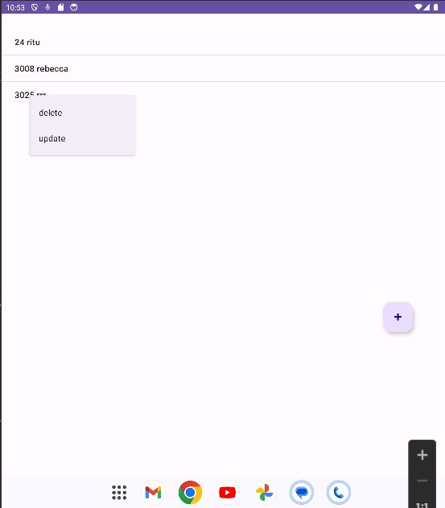

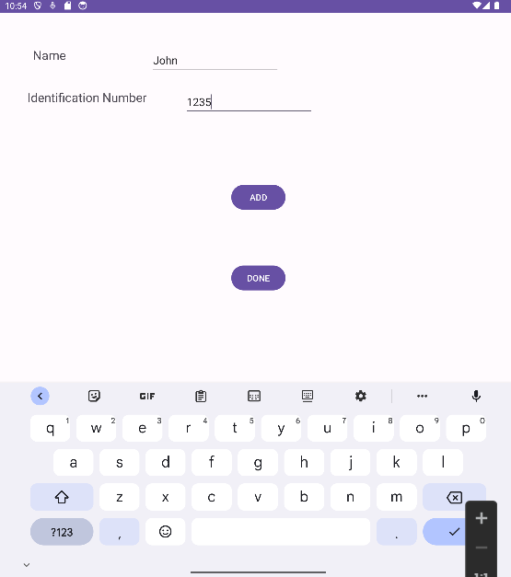

**Result**

The program for Employee Management System is successfully coded using SQLite database.