|  |  |
| --- | --- |
| **Ex. No. 4** | **Contact App using Recycler View Adapter** |
| **Date of Exercise** | **15/09/2023** |

**Aim**

To create a contact app using Recycler View Adapter in Android Studio.

**Description**

RecyclerView is a ViewGroup added to the android studio as a successor of the GridView and ListView. It is an improvement on both of them and can be found in the latest v-7 support packages. It has been created to make possible construction of any lists with XML layouts as an item which can be customized vastly while improving on the efficiency of ListViews and GridViews. This improvement is achieved by recycling the views which are out of the visibility of the user. For example, if a user scrolled down to a position where items 4 and 5 are visible; items 1, 2, and 3 would be cleared from the memory to reduce memory consumption.

* The Card Layout: The card layout is an XML layout which will be treated as an item for the list created by the RecyclerView.
* The ViewHolder: The ViewHolder is a java class that stores the reference to the card layout views that have to be dynamically modified during the execution of the program by a list of data obtained either by online databases or added in some other way.
* The Data Class: The Data class is a custom java class that acts as a structure for holding the information for every item of the RecyclerView.

The Adapter: The adapter is the main code responsible for RecyclerView. It holds all the important methods dealing with the implementation of RecylcerView. The basic methods for a successful implementation are:

* onCreateViewHolder: which deals with the inflation of the card layout as an item for the RecyclerView.
* onBindViewHolder: which deals with the setting of different data and methods related to clicks on particular items of the RecyclerView.
* getItemCount: which Returns the length of the RecyclerView.
* onAttachedToRecyclerView: which attaches the adapter to the RecyclerView.

**Program**

**XML code**

**(activity_main)**

<?xml version="1.0" encoding="utf-8"?>

<androidx.constraintlayout.widget.ConstraintLayout xmlns:android="http://schemas.android.com/apk/res/android"

xmlns:app="http://schemas.android.com/apk/res-auto"

xmlns:tools="http://schemas.android.com/tools"

android:layout_width="match_parent"

android:layout_height="match_parent"

tools:context=".MainActivity">

<androidx.recyclerview.widget.RecyclerView

android:id="@+id/recyclerViewId"

android:layout_width="409dp"

android:layout_height="729dp"

app:layout_constraintEnd_toEndOf="parent"

app:layout_constraintHorizontal_bias="0.0"

app:layout_constraintStart_toStartOf="parent"

app:layout_constraintTop_toTopOf="parent" />

</androidx.constraintlayout.widget.ConstraintLayout>

**(contact_details)**

<?xml version="1.0" encoding="utf-8"?>

<androidx.constraintlayout.widget.ConstraintLayout xmlns:android="http://schemas.android.com/apk/res/android"

xmlns:app="http://schemas.android.com/apk/res-auto"

xmlns:tools="http://schemas.android.com/tools"

android:layout_width="match_parent"

android:layout_height="wrap_content">

<ImageView

android:id="@+id/imageView"

android:layout_width="100dp"

android:layout_height="100dp"

app:layout_constraintBottom_toBottomOf="parent"

app:layout_constraintHorizontal_bias="0.051"

app:layout_constraintStart_toStartOf="parent"

app:layout_constraintTop_toTopOf="parent"

app:layout_constraintVertical_bias="1.0"

tools:srcCompat="@tools:sample/avatars" />

<TextView

android:id="@+id/nameId"

android:layout_width="265dp"

android:layout_height="32dp"

android:gravity="center"

android:text="Name"

android:textSize="25sp"

app:layout_constraintBottom_toTopOf="@+id/numberId"

app:layout_constraintHorizontal_bias="0.534"

app:layout_constraintStart_toEndOf="@+id/imageView"

app:layout_constraintTop_toTopOf="@+id/imageView"

app:layout_constraintVertical_bias="0.047" />

<TextView

android:id="@+id/numberId"

android:layout_width="269dp"

android:layout_height="30dp"

android:gravity="center"

android:text="Number"

android:textSize="25sp"

app:layout_constraintBottom_toBottomOf="parent"

app:layout_constraintEnd_toEndOf="parent"

app:layout_constraintHorizontal_bias="0.57"

app:layout_constraintStart_toEndOf="@+id/imageView"

app:layout_constraintTop_toBottomOf="@+id/nameId"

app:layout_constraintVertical_bias="0.1" />

</androidx.constraintlayout.widget.ConstraintLayout>

**Java code (main_activity)**

package com.example.exp4_contactview;

import androidx.appcompat.app.AppCompatActivity;

import androidx.recyclerview.widget.LinearLayoutManager;

import androidx.recyclerview.widget.RecyclerView;

import android.annotation.SuppressLint;

import android.os.Bundle;

import java.util.Arrays;

public class MainActivity extends AppCompatActivity {

RecyclerView recyclerView;

ContactAdapter contactAdapter;

@SuppressLint("MissingInflatedId")

@Override

protected void onCreate(Bundle savedInstanceState) {

super.onCreate(savedInstanceState);

setContentView(R.layout.activity_main);

recyclerView = findViewById(R.id.recyclerViewId);

contactAdapter = new ContactAdapter(this,

Arrays.asList("John", "Ria", "Maria"),

Arrays.asList("123","456","789"),

new int[]{R.drawable.p1, R.drawable.p2, R.drawable.p3}

);

recyclerView.setAdapter(contactAdapter);

recyclerView.setLayoutManager(new LinearLayoutManager( this));

}

}

**(contactAdapter)**

package com.example.exp4_contactview;

import androidx.appcompat.app.AppCompatActivity;

import androidx.recyclerview.widget.LinearLayoutManager;

import androidx.recyclerview.widget.RecyclerView;

import android.annotation.SuppressLint;

import android.os.Bundle;

import java.util.Arrays;

public class MainActivity extends AppCompatActivity {

RecyclerView recyclerView;

ContactAdapter contactAdapter;

@SuppressLint("MissingInflatedId")

@Override

protected void onCreate(Bundle savedInstanceState) {

super.onCreate(savedInstanceState);

setContentView(R.layout.activity_main);

recyclerView = findViewById(R.id.recyclerViewId);

contactAdapter = new ContactAdapter(this,

Arrays.asList("John", "Ria", "Maria"),

Arrays.asList("123","456","789"),

new int[]{R.drawable.p1, R.drawable.p2, R.drawable.p3}

);

recyclerView.setAdapter(contactAdapter);

recyclerView.setLayoutManager(new LinearLayoutManager( this));

}

}

**(contactViewHolder)**

package com.example.exp4_contactview;

import android.content.Context;

import android.content.Intent;

import android.net.Uri;

import android.view.View;

import android.widget.ImageView;

import android.widget.TextView;

import androidx.annotation.NonNull;

import androidx.recyclerview.widget.RecyclerView;

import java.util.List;

public class ContactViewHolder extends RecyclerView.ViewHolder implements View.OnClickListener{

public ImageView imageView;

public TextView nameTextView, numberTextView;

List<String> numberList;

public ContactViewHolder(@NonNull View itemView, List<String> numberList){

super(itemView);

itemView.setOnClickListener(this);

imageView = itemView.findViewById(R.id.imageView);

nameTextView = itemView.findViewById(R.id.nameId);

numberTextView = itemView.findViewById(R.id.numberId);

this.numberList = numberList;

}

@Override

public void onClick(View view){

int position = getLayoutPosition();

String element = numberList.get(position);

Context context = view.getContext();

context.startActivity(new Intent(Intent.ACTION_DIAL, Uri.parse( "tel:"+element)));

}

}

**Output**

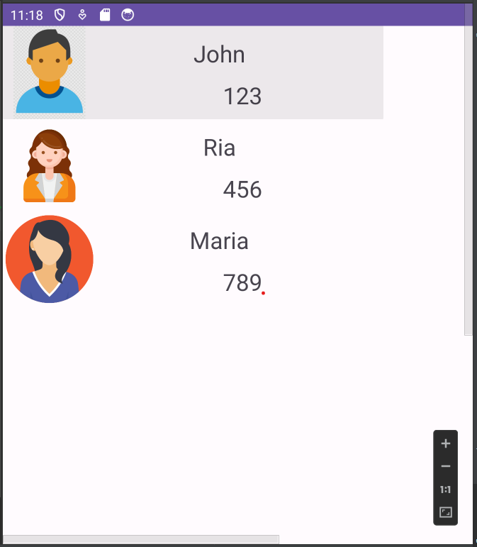

**Result**

The program for creating a contact app using Recycler View Adapter is successfully coded and verified.