**Software Requirement Specification (SRS)**

|  |  |
| --- | --- |
| **NAME:** | RUBASRI K |
| **ROLL NO:** | 7376222AL188 |
| **SEAT NO:** | 21 |
| **PROJECT ID:** | 21 |
| **PROJECT TITLE:** | INVENTORY SYSTEM |

**Problem Statement:**

Build a webapp for the complete inventory system which includes the following features: 1. Purchase Entry Portal 2. Sales Entry Portal 3. Availability of Stocks 4. Reporting System (Consolidated, Yearly, Monthly, Weekly and Daily Basis) 5. Get Remainders about the status. 6. Reports needs to share with the concern through WhatsApp or Messaging Services

**Scope of Project:**

The inventory management system will allow users to efficiently manage purchases, sales, stock availability, generate various types of reports, receive notifications, and share reports through messaging services.

**Features:**

* Purchase Entry Portal
* Sales Entry Portal
* Availability of Stocks
* Reporting System (Consolidated, Yearly, Monthly, Weekly, Daily)
* Remainder Notifications
* Integration with Messaging Services (WhatsApp, SMS)

**Stack holders:**

* **Administrator:** Manages system settings, user accounts, and overall configuration.
* **Inventory Manager:** Responsible for managing purchases, sales, and monitoring stock availability.
* **Reporting User:** Generates and accesses various reports.
* **Notification User:** Receives notifications about low stock levels or other important updates.

**Workflow:**

*User Authentication*:

Users authenticate themselves using their credentials (username and password) to access the system.

*Dashboard*:

Upon successful authentication, users are redirected to the dashboard. The dashboard provides an overview of various options available in the system.

*Purchase Entry*:

Inventory managers initiate a purchase entry by accessing the "Purchase Entry" portal. They fill in details such as item name, quantity, price, and vendor information. Upon submission, the system validates the input and saves the purchase record in the database.

*Sales Entry*:

Inventory managers initiate a sales entry by accessing the "Sales Entry" portal. They enter details such as item name, quantity sold, customer information, and sales price. The system validates the input and saves the sales record in the database.

*Stock Availability*:

Users access the "Availability of Stocks" section to view the current stock levels of various items. The system retrieves data from the database and displays it on the UI in real-time.

*Reporting:*

Users navigate to the "Reporting System" section to generate various types of reports. They select the desired report type (consolidated, yearly, monthly, weekly, or daily) and specify any additional parameters. The system processes the request, retrieves relevant data from the database, and generates the report. Users can then download the report in CSV or PDF format for further analysis.

*Remainder Notifications:*

The system continuously monitors stock levels. If stock levels fall below a predefined threshold, the system triggers a notification. Notifications are sent to users via integrated messaging services such as WhatsApp or SMS.

*Integration with Messaging Services:*

Users have the option to share generated reports with concerned parties through messaging services. They select the desired report and choose the recipient(s) from their contacts. The system sends the report to the selected recipients via the integrated messaging service.

*Logout:*

Users can log out of the system to end their session securely.

**Flowchart:**

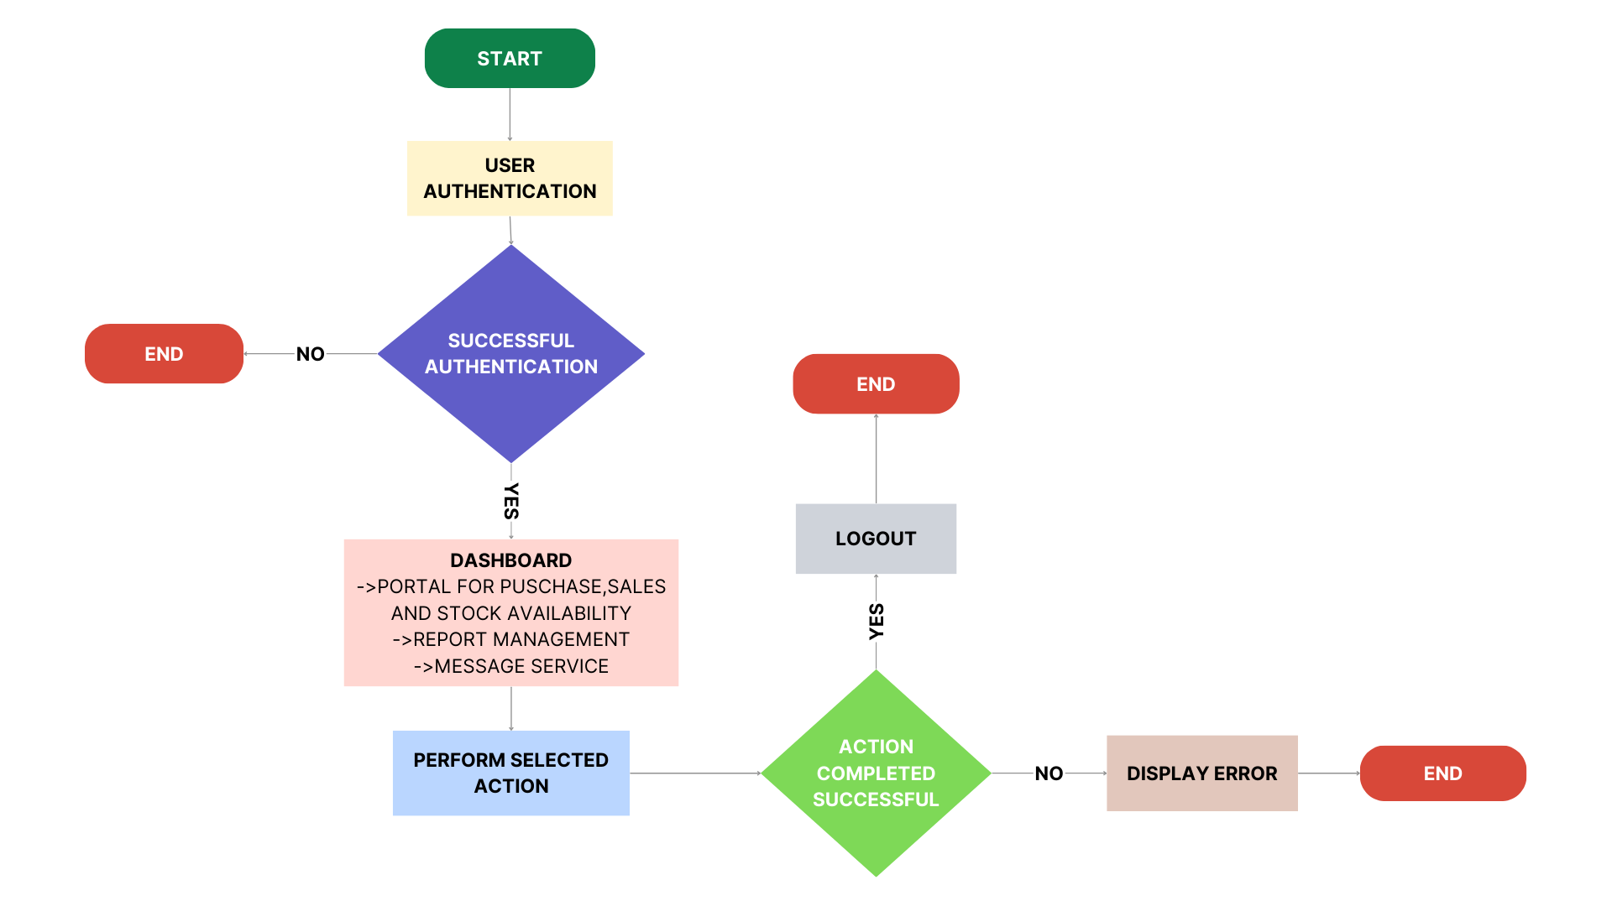

**Technical components:**

|  |  |
| --- | --- |
| **FRONTEND:** | React |
| **BACKEND:** | Node.js with Express.js |
| **DATABASE:** | MongoDB |