
REELVISTA AI: INTEGRATING BM25,
WORD2VEC, COSINE SIMILARITY, LSTM,
AND RAG FOR MOVIE RECOMMENDATION AND REVIEW SYSTEMS
IT3401 - WEB ESSENTIAL PROJECT

Submitted by
AKAASH S (311523205005)
AJAY SINGH I (311523205004)
RAJ PRIYAN S K (311523205045)
submitted to the Faculty of

INFORMATION TECHNOLOGY

in partial fulfillment for the IT3401 Web Essential Project Driven Course of
BACHELOR OF TECHNOLOGY
in
INFORMATION TECHNOLOGY

MEENAKSHI SUNDARARAJAN ENGINEERING COLLEGE
KODAMBAKKAM
(An Autonomous Institution)
ANNA UNIVERSITY::CHENNAI 600 025
MAY 2025
TABLE OF CONTENT

ABSTRACT ..................................................................................................................1
INTRODUCTION ........................................................................................................2
2.1 Domain Overview ............................................................................................ 2
2.2 Problem Statement ........................................................................................... 2
2.3 Project Objectives ............................................................................................ 2
LITERATURE SURVEY ............................................................................................4
3.1 Recommendation Systems in Entertainment ...................................................4
3.2 Conversational Interfaces in UX .....................................................................4
3.3 Gaps in Existing Platforms ..............................................................................5
EXISTING SYSTEMS ................................................................................................6
4.1 Netflix, IMDb, Rotten Tomatoes, and Others ................................................. 6
4.2 Feature Comparison ......................................................................................... 6
4.3 Limitations ....................................................................................................... 7
5.1 Feature Overview ............................................................................................. 8
5.2 Technology Stack ............................................................................................ 8
5.3 Benefits Over Existing Solutions ..................................................................... 9
ARCHITECTURE OVERVIEW .............................................................................10
6.1 System Flow Diagram ................................................................................... 10
6.2 Component-wise Description ........................................................................ 10
IMPLEMENTATION OVERVIEW ........................................................................12
7.1 Frontend (React, TypeScript, Framer Motion) .............................................. 12
7.2 Backend and API Integration (OMDb, Groq) ............................................... 12
7.3 Database (Neon PostgreSQL) ........................................................................12
USER INTERFACE SNAPSHOTS ..........................................................................13
8.1 Homepage ...................................................................................................... 13
8.2 Movie Detail Pages ........................................................................................ 13
8.3 Chatbot View ................................................................................................. 14
8.4 Oscar Section ................................................................................................. 14
8.5 Export to PDF / Share .................................................................................... 15
CHALLENGES FACED ...........................................................................................16
9.1 API Rate Limits ............................................................................................. 16
9.2 Animation Performance Optimization ........................................................... 16
9.3 Prompt Engineering for Chatbot .................................................................... 16

FUTURE SCOPE .......................................................................................................17
10.1 Voice Interaction............................................................................................ 17
10.2 Streaming Platform Integration ..................................................................... 17
10.3 Real-Time Trends with Machine Learning.................................................... 17
10.4 Sentiment Analysis for Reviews ...................................................................... 17 CONCLUSION ...........................................................................................................18
REFERENCE .............................................................................................................19

ABSTRACT

In an era of oversaturation with movie content, discovering a movie that actually speaks to one's individual taste is a daunting task. REELVISTA AI is the revolutionary answer — a no-login, smart movie recommendation and review site that makes discovery simple and maximizes user interaction. Unlike traditional sites built on account-based systems and data monitoring, REELVISTA AI makes real-time, hyper-personalized recommendations using an active conversational chatbot — all while securing user privacy.
Constructed with React.js and TypeScript, and driven by powerful integrations such as OMDb and Grok AI, the site provides fluid discovery via genre and director-based browsing, in-depth movie information pages complete with user-created reviews, and a specific Oscar highlight section complete with high-definition embedded video content within the app — no redirections, no mess. Adding to the experience is our very animated Miles Morales–branded chatbot, providing an engaging and immersive interface that walks users through their experience.
With instant PDF export, sharable movie lists, and slick UI animations powered by Framer
Motion, REELVISTA AI dispenses with sign-ins or authentication, making it easily accessible. Powered by Neon PostgreSQL and hosted on Render.com, the backend promises high performance, reliability, and scalability. By combining cutting-edge tech with an open, privacy-first design, REELVISTA AI is not another utility — it's a reimagined film experience designed for today's viewer.

INTRODUCTION
Cinema has long been regarded not only as a medium of entertainment but also as an art form capable of evoking powerful emotions, shaping cultural narratives, and provoking critical thought. In the digital age, the way people discover and engage with films has drastically evolved. Streaming platforms, online databases, and review aggregators have made movie information widely accessible. However, the overwhelming volume of choices has also introduced a new problem: decision fatigue. Users often find themselves spending more time browsing through lists than actually watching a film. This calls for intelligent systems that streamline the decision-making process while respecting user autonomy and privacy.

2.1 Domain Overview
The field of entertainment technology has witnessed rapid growth with the integration of artificial intelligence, data analytics, and interactive design. Within this domain, recommendation systems have emerged as a cornerstone for improving user experience. These systems analyze user preferences and behavior to offer curated content, thereby enhancing satisfaction and reducing search time. Simultaneously, user interfaces have evolved to become more immersive and human-centric. Chatbots and conversational agents are replacing static menus and filters, offering a natural and intuitive way to interact with digital platforms. With the rising demand for privacy-focused solutions, there is also a shift towards applications that provide full functionality without requiring user registration or authentication.

2.2 Problem Statement
Most existing platforms such as Netflix, Prime Video, and even IMDb focus on account-based personalization, relying heavily on user data for recommendations. While effective, this model has several drawbacks. First, it excludes users who prefer anonymity or casual browsing without login requirements. Second, the interfaces of such platforms are often designed with monetization in mind, leading to cluttered screens, promotional bias, and distractions. Third, the aesthetic and emotional appeal of the cinema is often lost in overly technical or data-driven environments. Users are given thumbnails, ratings, and generic synopses, but not the cinematic "feeling" that draws audiences to the medium in the first place. Lastly, these platforms rarely allow users to share or export information in meaningful ways such as creating personal movie guides or discussion references without tying those actions to a user account.

2.3 Project Objectives
- To create a no-login, fully open-access movie recommendation platform.
- To preserve the aesthetic and emotional depth of cinema while incorporating advanced technological features.
- To simulate the experience of conversing with a well-informed, friendly film companion through a Miles Morales-themed animated chatbot.
- To enable natural language interaction for movie-related queries using AI chatbot integration.
- To implement deep filtering functionality based on genre, duration, rating, and release year.
- To design a highly animated, responsive user interface using React, TypeScript, and Framer Motion.
- To embed high-quality Oscar highlight videos as native media within the application interface.
- To allow users to instantly export and share movie data with ease.
- To ensure a mobile-first, fully responsive design that enhances user experience across devices.
- To source real-time movie data via the OMDb API for up-to-date content.
- To manage user reviews and comments efficiently using a lightweight Neon PostgreSQL database.

LITERATURE SURVEY

3.1 Recommendation Systems in Entertainment
Recommendation systems have become an integral part of digital platforms, especially within the entertainment industry, where users are presented with an overwhelming array of choices. These systems primarily rely on three methodologies: content-based filtering, collaborative filtering, and hybrid approaches.
Content-based filtering uses the characteristics of items such as genre, cast, director, or keywords to recommend similar content to what a user has previously enjoyed. Collaborative filtering, on the other hand, examines the preferences of many users to suggest items based on shared interests and behavioural patterns. Hybrid recommendation systems combine both techniques to improve accuracy and user satisfaction.
Research in this area has shown that while such systems are effective at improving user engagement, they are usually dependent on large datasets tied to user accounts. This makes them less accessible in privacy-conscious or no-login environments. Additionally, traditional systems often lack context awareness and emotional intelligence, failing to understand users’ current moods or situations key factors in entertainment choices. Therefore, emerging research is exploring context-aware recommendation models and conversational systems that can dynamically interpret intent through dialogue.

3.2 Conversational Interfaces in UX
Conversational User Interfaces (CUIs), such as chatbots and virtual assistants, represent a significant shift from traditional UI paradigms. Instead of clicking through layers of menus or filters, users can simply ask for what they want using natural language. The rise of large language models (LLMs), particularly those built on transformer architectures like GPT-4, has dramatically improved the fluency, relevance, and personalization of chatbot responses.
In the context of entertainment, conversational interfaces serve multiple functions: they assist in content discovery, provide summaries or reviews, and act as companions for decisionmaking. Several experimental systems have shown that users prefer chat-based discovery over filter-heavy interfaces when the chatbot is responsive, context-aware, and stylistically engaging. However, most commercial implementations remain rudimentary limited to FAQs or basic keyword matching due to technical constraints or lack of creative investment.
Recent academic and industry research suggests that the next frontier for conversational UX lies in personalization without surveillance. That is, creating responsive systems that feel tailored without requiring user accounts or intrusive data collection. This aligns directly with the ethos of this project: to create a fun, engaging, and intelligent movie assistant that thrives in a no-login environment while delivering premium UX through stylized animation and rich content integration.

3.3 Gaps in Existing Platforms
While platforms like Netflix, Hulu, IMDb, and Rotten Tomatoes have advanced user bases and functional recommendation systems, they all share limitations that this project seeks to address. First, their reliance on user authentication excludes casual users who are unwilling to sign up. Second, their interfaces while modern are designed for scalability, often at the cost of emotional engagement and artistic coherence. Most platforms do not celebrate cinema as an art form but present it through a corporate, utilitarian lens.
Furthermore, none of these platforms effectively incorporate cinematic storytelling techniques into their UI/UX. There’s a lack of animation, character, or narrative in how movies are presented or recommended. Very few support exporting recommendations or reviews in a shareable format like PDF, and almost none embed high-quality award content (such as Oscars) within their interface. As such, they miss out on the emotional and cultural dimensions of film that users often crave.
By studying these gaps, this literature survey lays the foundation for a new kind of platform one that merges the emotional resonance of cinema with the technical elegance of modern web development and AI, all while removing friction and enhancing user agency.

EXISTING SYSTEMS

4.1 Netflix, IMDb, Rotten Tomatoes, and Others
The landscape of digital movie recommendation and review platforms is currently dominated by a few key players most notably Netflix, IMDb, Rotten Tomatoes, and Letterboxed. Each of these systems offers a unique approach to movie discovery and user engagement.
Netflix utilizes a highly proprietary, deep-learning-based recommendation engine. It personalizes movie suggestions using collaborative filtering, viewing history, content metadata, and even thumbnail optimization. However, this system is gated behind mandatory login, and the recommendations are tightly coupled with the user’s ongoing interactions with the platform. This makes Netflix highly tailored but not easily accessible for casual browsing or one-time visitors.
IMDb, in contrast, functions as a global repository of film data. It aggregates user ratings, reviews, cast information, trivia, and box office details in a database-like format. Although the site allows browsing without logging in, personalized features and community participation are limited to registered users. It also lacks interactivity, and the user experience is mostly static.
Rotten Tomatoes aggregates critic reviews and user feedback, offering a unique "Tomatometer" score to summarize general sentiment. The platform is known for its authority and credibility in review aggregation but does not offer conversational assistance or dynamic personalization for users. Moreover, its interface focuses more on critique than on recommendation, making it better suited for analysis rather than discovery.
Letterboxd, while community-driven and visually appealing, is primarily a social platform. It requires login for any meaningful interaction and targets cinephiles who actively review and track films. It is not optimized for anonymous, instant discovery or for providing recommendations via AI interfaces.

4.2 Feature Comparison
When compared feature-for-feature, these platforms have clear strengths but also critical limitations for a user base seeking simplicity, immediacy, and creativity. All major platforms rely heavily on account creation to unlock personalized or community-based features. Their recommendation engines are powerful but inaccessible to users who don’t wish to log in.
Interactivity is also limited. None of the current systems offer chatbot-driven movie discovery, real-time search assistance, or a dynamic interface with animations that respond to user input. Export functionality is virtually nonexistent users cannot easily generate shareable, printable PDFs of movie details or suggestions.
Additionally, while trailers and basic video content may be available, embedded high-quality cinema-related video content such as Oscar acceptance speeches or award ceremony highlights is typically hosted externally (e.g., YouTube) and requires redirection. These platforms do not emphasize visual storytelling or narrative-driven interfaces that emotionally connect with users.

4.3 Limitations
Despite their wide adoption, existing systems are not optimized for speed, visual experience, or frictionless exploration. Key limitations include:
- Mandatory sign-in or account creation for full functionality, limiting spontaneous or anonymous use.
- Lack of conversational interfaces that allow natural language interaction for discovery or filtering.
- Absence of real-time, animated UI feedback that enhances user immersion.
- No support for exporting or sharing curated movie suggestions in formal formats like PDFs.
- Minimal or no embedded award-related video content especially not in a native player integrated seamlessly into the platform.
- Interfaces designed for broad scalability often lack the charm, stylization, or thematic identity (like a superhero-inspired interface) that can make a platform feel personal and cinematic.
- Poor mobile-first design in some legacy systems or lack of creative adaptations for smaller screens.
Overall, while the existing systems are robust in terms of data and scale, they fall short in providing the seamless, aesthetic, and emotionally engaging experience envisioned by this project. This creates an exciting opportunity to build a next-generation platform that celebrates film in both function and form combining intuitive navigation, stylized animation, embedded award content, and AI-powered conversation, all without requiring users to sign up or log in.

PROPOSED SYSTEM

5.1 Feature Overview
The proposed system is a next-generation movie recommendation and review web application built specifically to overcome the limitations of existing platforms by offering a unique, nologin, cinematic experience. It is designed to combine modern web technologies, intuitive user interaction, and powerful data integration into a seamless platform that allows users to explore and discover movies without barriers. Unlike traditional systems, it provides a visually rich, animated user interface and includes features that emphasize discovery, emotion, and accessibility.
The application includes a Miles Morales-themed AI chatbot that serves as the central interactive interface, allowing users to search for movie recommendations using natural language. Users can explore top-rated movies, filter content based on rating, year, and duration, read reviews, and even leave their own. Additionally, users can export selected movie details into PDF format and share them without needing an account. A dedicated Oscar section with embedded high-resolution videos—presented natively within the platform’s layout—is also integrated, offering curated award-winning content. These features come together to create a platform that is powerful, aesthetic, and user-friendly.

5.2 Technology Stack
Frontend:
- React is used for building a modular, component-based UI.
- TypeScript adds static typing for enhanced code reliability and developer productivity.
- Framer Motion provides smooth animations and cinematic transitions throughout the interface.
Backend & APIs:
- OMDb API is integrated to fetch a wide range of movie data including titles, ratings, and posters.
- Groq API powers the AI chatbot, enabling intelligent conversational movie recommendations.
Database:
- Neon-hosted PostgreSQL is used for storing user-generated content like reviews and comments, even without login.
Deployment & Hosting:
- Render.com is the deployment platform, chosen for its scalability, continuous integration support, and fast load times.
Other Features:
- The platform is fully responsive and optimized for mobile devices, ensuring accessibility across all screen sizes and platforms.

5.3 Benefits Over Existing Solutions
This project offers several distinct advantages over traditional movie platforms. First and foremost, the elimination of user authentication ensures that visitors can access all functionalities instantly, without the friction of registration or privacy concerns. The Miles Morales-themed chatbot introduces a highly engaging way to search for content, creating a superhero-inspired narrative environment that resonates with users emotionally.
The system’s dynamic design stands in stark contrast to the static and often cluttered UIs of existing platforms. Through animations, visual feedback, and responsive elements, the interface feels alive and cinematic. Furthermore, the embedded Oscar videos integrated seamlessly into the UI without redirecting users to YouTube or external sites provide an elevated content experience that is both immersive and informative.
Additional capabilities, such as the ability to export and share movie recommendations in highquality PDF format, offer practical utility that most current platforms lack. Finally, by avoiding personalization through login and cookies, the application respects user privacy while still delivering high-quality recommendations, thus creating a lightweight, accessible, and modern entertainment discovery platform.

ARCHITECTURE OVERVIEW

6.1 System Flow Diagram
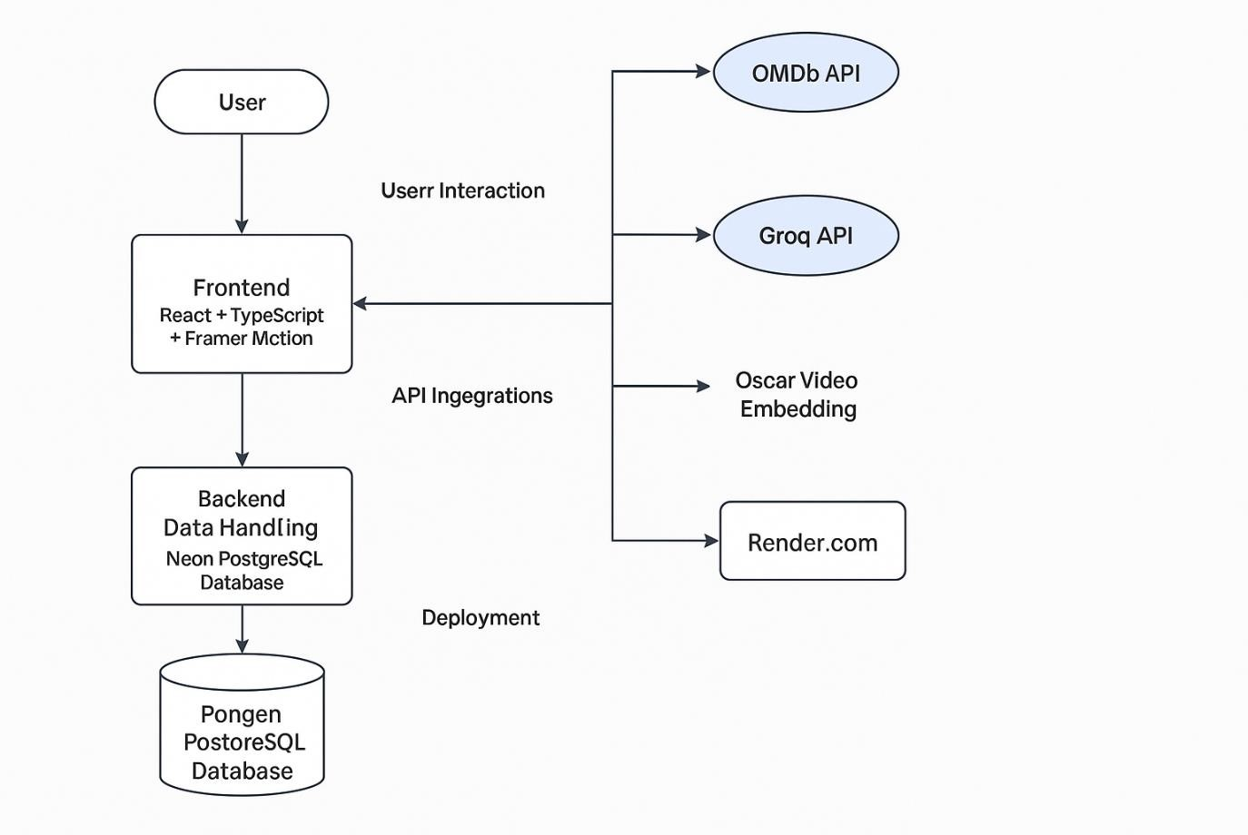

6.2 Component-wise Description
Frontend (React + TypeScript + Framer Motion):
- Handles user interface rendering, responsive layout, and animations.
- Renders key components like Home page, MovieClickPage, Genre & Director filters, Oscar video section, and Chatbot.
- Provides advanced filter controls and search bar for seamless navigation.
- Implements the Miles Morales-themed animated chatbot interface.
API Integrations:
- OMDb API: Fetches structured movie data used across all pages.
- Groq API: Handles conversational prompts and returns user-specific movie recommendations in natural language.
Backend Data Handling:
- Neon PostgreSQL Database:
  - Stores user-submitted reviews and comments.
  - Each movie entry can be associated with multiple user-generated posts.
  - Lightweight schema focused on read performance.
Deployment:
- Hosted on Render.com for continuous deployment and scaling.
- All assets and endpoints optimized for reduced load times and smooth performance.
Responsiveness & Export:
- Tailored CSS and media queries ensure complete mobile responsiveness.
- Built-in export feature converts movie info and reviews into downloadable PDFs.
- Shareable UI components allow external sharing without login.

IMPLEMENTATION OVERVIEW

7.1 Frontend (React, TypeScript, Framer Motion)
The frontend of the application is developed using React, a powerful JavaScript library known for its component-based architecture, allowing reusable and maintainable code. TypeScript is used in tandem to ensure type safety, early error detection, and improved developer productivity. The user interface is further enhanced with Framer Motion, a popular animation library that allows the creation of cinematic, fluid transitions. This gives the website a dynamic, engaging appearance, particularly evident in movie card hovers, page transitions, and the animated Miles Morales-themed chatbot. The application is also fully responsive, offering consistent and visually appealing performance across desktop and mobile platforms.

7.2 Backend and API Integration (OMDb, Groq)
The backend system is lightweight but highly integrated. Rather than maintaining a full server infrastructure, the application leverages RESTful APIs for core data functionalities. The OMDb (Open Movie Database) API serves as the primary source for movie data including titles, genres, ratings, durations, and descriptions. The application fetches this data dynamically based on user queries or chatbot prompts. In parallel, the Groq API is used to power the chatbot, enabling it to understand natural language and provide relevant movie recommendations or answers. This combination allows real-time communication and movie discovery without requiring backend processing power for AI computations.

7.3 Database (Neon PostgreSQL)
Neon-hosted PostgreSQL is employed for persistent storage of user-generated content such as reviews and comments. Even though the application does not require user authentication, the reviews are associated contextually with each movie using unique identifiers. This setup ensures that all interactions remain lightweight, fast, and stateless from a user’s perspective while still maintaining a structured backend record. PostgreSQL’s relational model and Neon’s cloud-native scalability make it a suitable choice for read-heavy, query-optimized operations such as retrieving reviews or listing top-commented movies.

USER INTERFACE SNAPSHOTS

8.1 Homepage
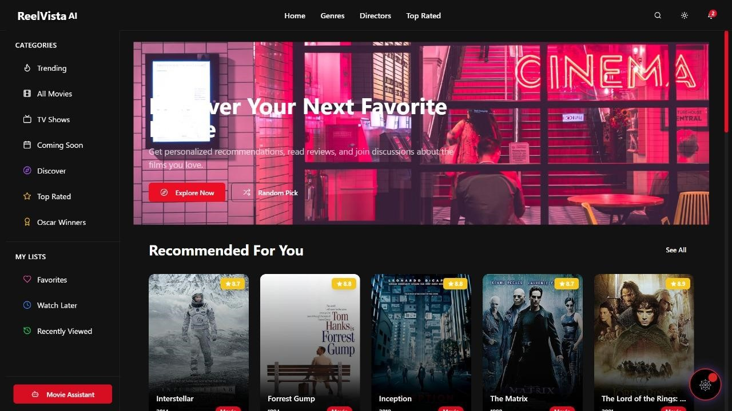

8.2 Movie Detail Pages
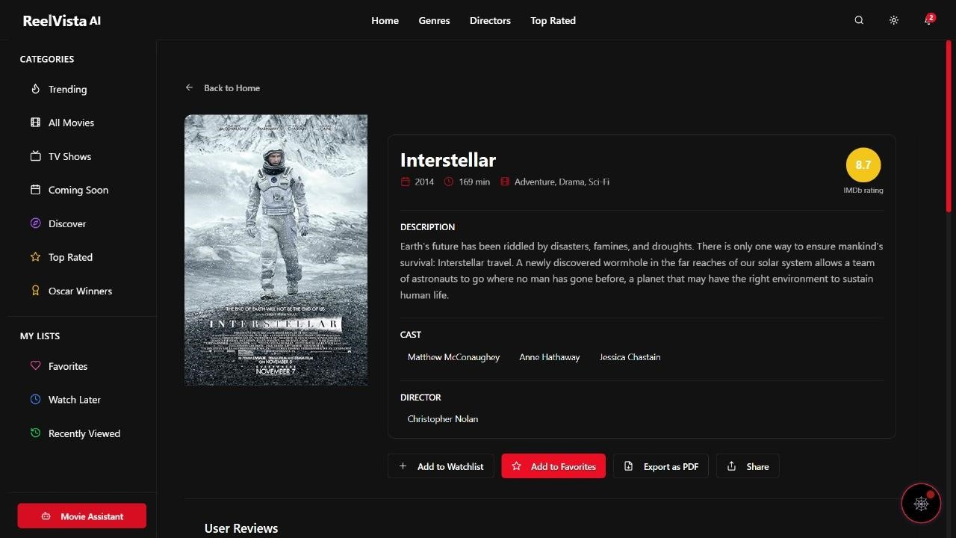

8.3 Chatbot View
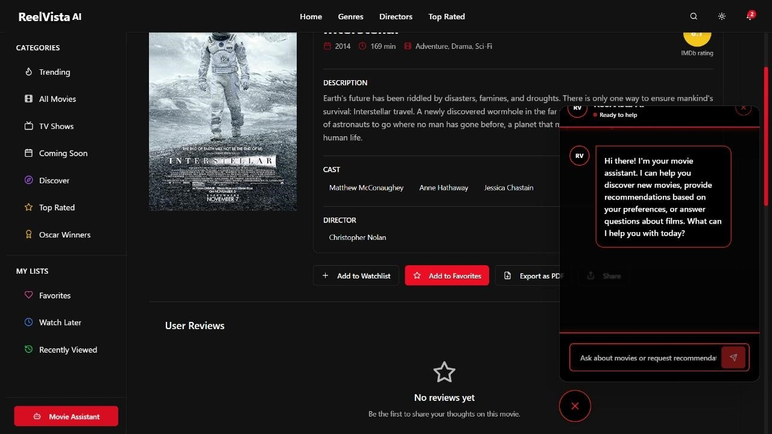

8.4 Oscar Section
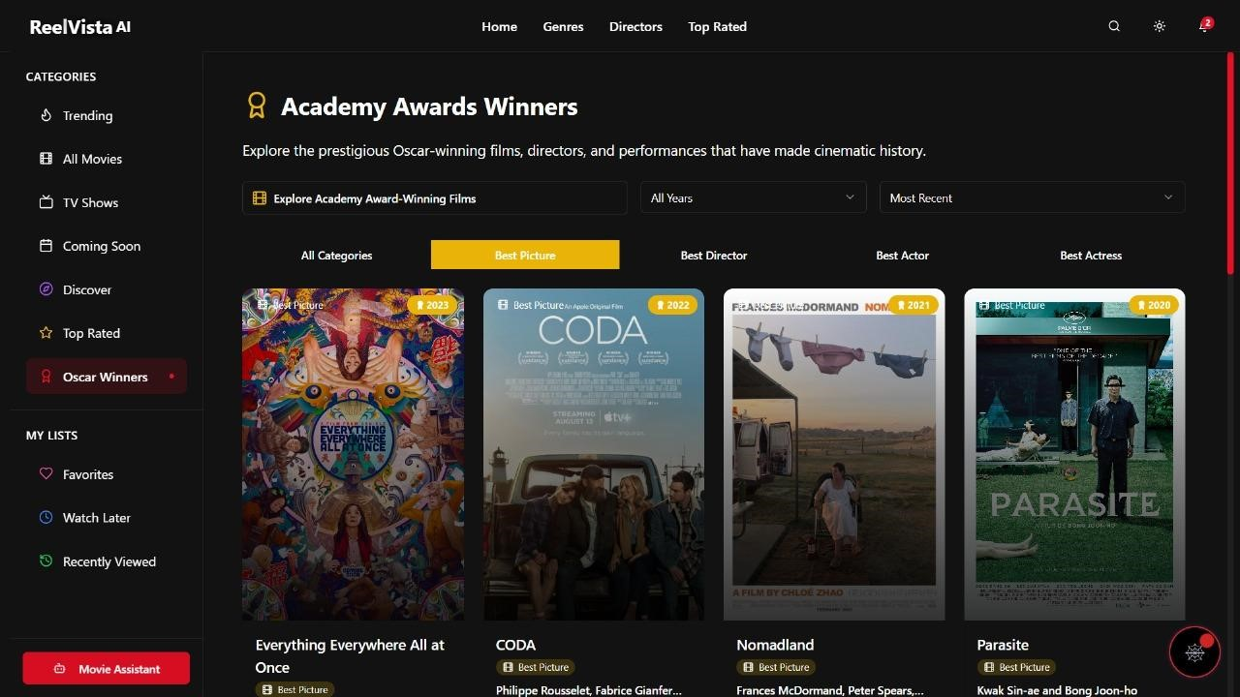

8.5 Export to PDF / Share
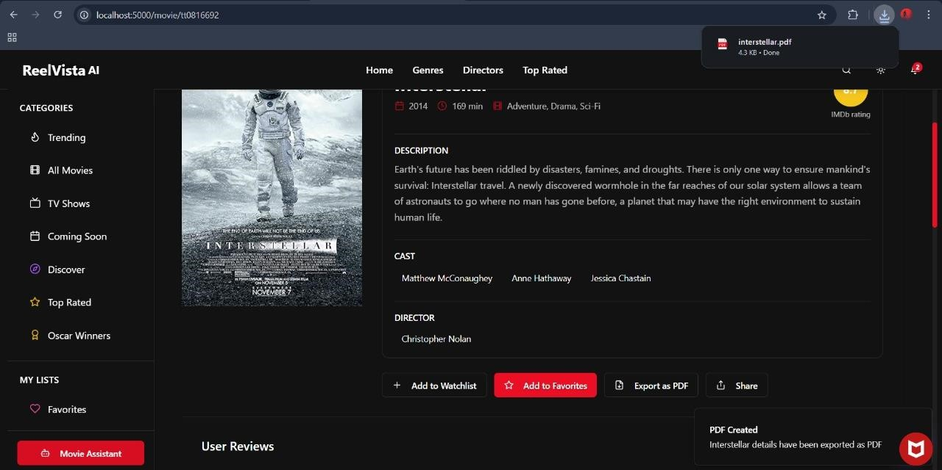

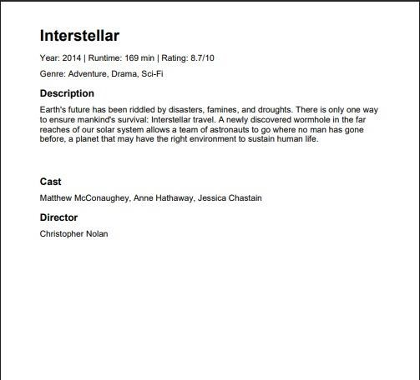

CHALLENGES FACED

9.1 API Rate Limits
One of the critical challenges encountered during the development process was the limitation imposed by the OMDb API’s rate cap. Since the application fetches real-time movie data for multiple user-triggered operations such as search, filtering, chatbot queries, and detail pages hitting the rate threshold occasionally disrupted the seamless flow of content. This required careful orchestration of API calls, local caching, and request optimization to minimize unnecessary or duplicate fetches while maintaining a responsive UI.

9.2 Animation Performance Optimization
The extensive use of Framer Motion to deliver fluid, cinematic animations introduced performance bottlenecks, particularly on low-end or older mobile devices. Complex animation sequences and simultaneous transitions, while visually stunning, led to frame drops or slow rendering during heavy interaction flows. The team had to fine-tune motion durations, simplify transition chains, and adopt lazy-loading strategies for animated elements to preserve performance without compromising the visual richness of the UI.

9.3 Prompt Engineering for Chatbot
Designing a movie recommendation chatbot using Groq API required iterative refinement of prompts to ensure relevance, tone, and precision. Ensuring that the chatbot did not respond with raw JSON or overly technical responses, but rather natural, friendly messages with clear movie suggestions, was challenging. Fine-tuning prompt templates to ensure the chatbot provided movie names and years only (without unnecessary detail) involved extensive trial and error and A/B testing. Additionally, making the chatbot responsive in real-time while visually animated (Miles Morales theme) demanded balancing aesthetic load and backend performance.

FUTURE SCOPE

10.1 Voice Interaction
To further elevate the user experience, the integration of voice-enabled interaction is a promising direction. Enabling users to speak their movie preferences or queries can make the interface even more intuitive and inclusive, particularly for users with accessibility needs or those on mobile devices. This would involve incorporating speech-to-text services and realtime voice command parsing to provide voice-driven recommendations and navigation across the platform.

10.2 Streaming Platform Integration
A significant enhancement to the current system would be the integration of streaming availability metadata. By incorporating APIs that check where a movie is available to watch (e.g., Netflix, Amazon Prime, Disney+), the application can offer direct utility—allowing users not only to discover movies but also to instantly know where to stream them. This bridges the gap between recommendation and action, adding real-world value to the platform’s suggestions.

10.3 Real-Time Trends with Machine Learning
Adding a real-time trending section powered by machine learning could make the platform more dynamic and current. By analyzing user interaction patterns, current popular titles, and real-world data such as box office reports or social media buzz, the application can display trending movies personalized to broader audience behavior. A lightweight ML model could be embedded into the app to predict trending genres or upcoming hits based on minimal user cues, even without account tracking.

10.4 Sentiment Analysis for Reviews
Although the platform is stateless and does not rely on authentication, future improvements could introduce basic sentiment analysis to enrich the user-generated review experience. Using NLP models, the system can automatically tag submitted comments as positive, negative, or neutral, and visually represent overall sentiment for a movie. This adds another layer of depth for users quickly evaluating a film's reception through community input.

CONCLUSION

The development of this no-login, AI-powered movie recommendation and review system marks a significant step toward redefining how users discover and interact with cinematic content online. Unlike traditional platforms that rely heavily on user accounts, data collection, and complex personalization models, this application prioritizes accessibility, speed, and user experience. With the integration of a Miles Morales-themed animated chatbot, powerful movie metadata from the OMDb API, and a seamless, cinematic UI built with React, TypeScript, and Framer Motion, the platform successfully delivers a modern, engaging environment for movie exploration.
One of the standout accomplishments of this project is its innovative approach to balancing conversational AI with content discovery in a lightweight, privacy-first model. The chatbot not only assists users in real time with intuitive suggestions but also contributes to the platform’s emotional and thematic depth. The addition of features like Oscar video highlights (embedded directly in-app), PDF export, director-centric navigation, and animated transitions enrich the overall experience, giving users a feeling akin to browsing through a virtual cinematic universe.
Furthermore, deploying this application on Render.com ensures it remains scalable and performant, with minimal loading time and full responsiveness across devices. The use of Neon PostgreSQL for storing user reviews, despite the lack of authentication, demonstrates thoughtful data design while respecting privacy. The decision to exclude login requirements challenges industry norms and champions a more open and inclusive approach to content discovery.
Ultimately, this project not only provides an innovative alternative to mainstream movie platforms but also lays a strong foundation for future enhancements such as voice interaction, real-time streaming integration, and machine learning-based personalization—without compromising on design integrity or user agency. It embodies a unique blend of art, technology, and user empathy, setting a new standard for what a modern cinematic platform can be.

REFERENCE

- OMDb API – The Open Movie Database. Available at: https://www.omdbapi.com/ Provides movie metadata such as title, year, genre, director, ratings, and poster URLs, essential for populating the movie listings and details.
- Groq API – Language Model API for AI Chatbot. Available at: https://groq.com/ Used for building the Miles Morales-themed conversational chatbot to assist users with movie recommendations through natural language interaction.
- React – A JavaScript library for building user interfaces. Available at: https://reactjs.org/
Core library used in the frontend to build a modular and dynamic interface.
- TypeScript – JavaScript with syntax for types. Available at: https://www.typescriptlang.org/
Used for safer, more maintainable code and improved developer tooling across the frontend.
- Neon.tech – Serverless PostgreSQL platform. Available at: https://neon.tech/ Database used for storing user-generated content such as movie reviews and comments without requiring login or authentication.
- Render – Cloud hosting platform for web apps. Available at: https://render.com/ Used to deploy and host the web application with support for scalability, CI/CD, and performance optimization.
- YouTube Embedded Player API. Available at: https://developers.google.com/youtube/iframe_api_reference
Used to embed Oscar videos into the application while customizing the player to avoid platform branding or redirection.
- ChatGPT and OpenAI GPT-4 Architecture. Available at: https://openai.com Utilized in ideation, prompt engineering, and chatbot design methodologies for responsive and human-like interactions.
- Netflix Technology Blog. Available at: https://netflixtechblog.com Reference for understanding how current platforms deliver personalized content and system-level performance optimization.
- Rotten Tomatoes. Available at: https://www.rottentomatoes.com/ Used for comparative analysis in the Literature Survey and Existing System sections regarding review aggregation and UI limitations.

